

**San Bernardino County Area Ontario Medical Center**

**CLS Annual Competency Quiz 2024**

**Passing Score: 80%**

**Name: _____________________________ Score: _______________**

**Date:________________________**

1. ***Do not report the presence of Trichomonas for Wet mount specimen that are received ≥ 2 hours from time of collection unless it is motile, instead click on the drop- down corner of the DTA result field and choose Unable to Determine. Under Result comment, type TRICH, then hit F9 on the keyboard to add the comment “The presence of Trichomonas vaginalis cannot be ruled out. Please reorder and submit another specimen if clinically indicated.***

***True False***

1. ***CSF culture requires inoculation to BAP/Choc agar plates and Thio. If <1ml volume is present on the tube used for culture, a green sticker should be attached to CSF plates.***

***True False***

1. ***It is OK to mix components from different kit lots or use leftover reagents from the old kit and mix with newly opened box for tests like Mono, Strep Pneumo, HIV-1/2.***

***a. True***

***b. False***

***c. It does not matter***

1. ***If the urine sample is orange, grossly bloody, green or displays any visible abnormality, in place of the first result (Ur Glucose), right click and select Comments. Under Result***

***Comment click EDIT/ F2 and template box will appear. Under Name type “INTERF”, select Find/ OK. The comment will translate to “Unable to report due to the***

***presence of interfering substances”. OK/ Close. On the result column convert all to free text and type “INTERF”. Under Micro Exam select “To Follow” and proceed to manual Micro Exam.***

***True False***

1. ***Each AmniSure ROM has built-in reagent and procedural controls to assure accurate reading of the results. The appearance of one or two lines in the test results area verifies the integrity of the test procedure.***

***Interpret each possible result below:***



Result: ______________________



Result: ____________________



Result: ______________________

1. ***Interpret the CDiff Quick Chek Complete results***

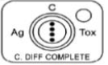

***Answer: __________________ Answer: _____________________***

1. ***In performing Malaria Rapid Test using the BinaxNow malaria test kit, interpret the following test results below.***

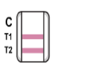***Result: ______________ 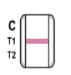Result: _________________***

1. ***Attaching a critical call notification to a positive/critical gram stain results from sterile sites should be documented in Micro Results Entry Comments viewer under “Order Comment”, “Edit”, Type “Crit F9” to get the canned comment. Document the critical result notification. Click “OK” , then “Close” and then go back and Verify the Performed gram stain result. Also, place the Cerner barcode label on the Gram stain log binder under the tab “Critical gram stain Notification” for the purpose of documentation tracking and audit.***

***True False***

1. ***In the Gram stain slide preparation, for smears of pus, aspirations, or similar exudates, the process is to spread the sample to a thin film over a large area on the slide by using a sterile loop or applicator stick. If in e-swab , vortex for 5 sec and place 1-2 drops of the fluid onto the slide then spread the sample using a sterile loop. Do NOT use the swab from the e-swab to spread the sample.***

***True False***

1. ***For a Reactive result in the Alere Determine ™ HIV- ½ Ag/Ab Combo, the intensity of the test line does not necessarily correlate with the titer of antigen or antibody in the sample.***

***True False***

**Identify the arrowed object**

**Urine sediment**

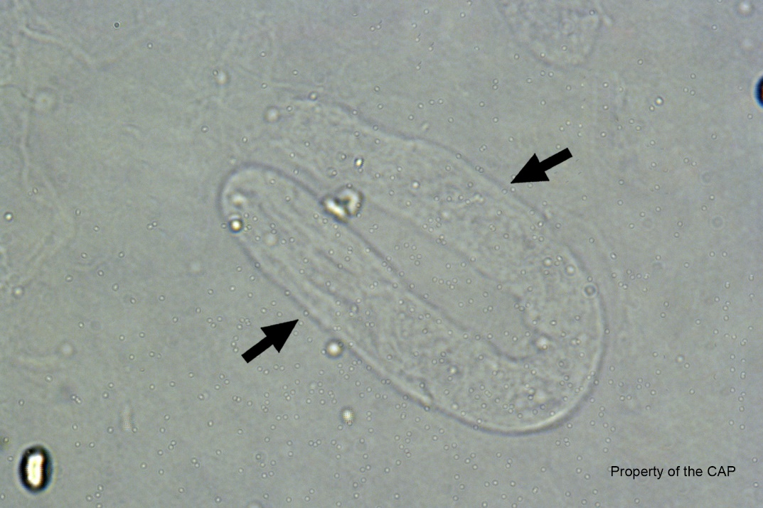

Answer: ___________________________

**Urine sediment**

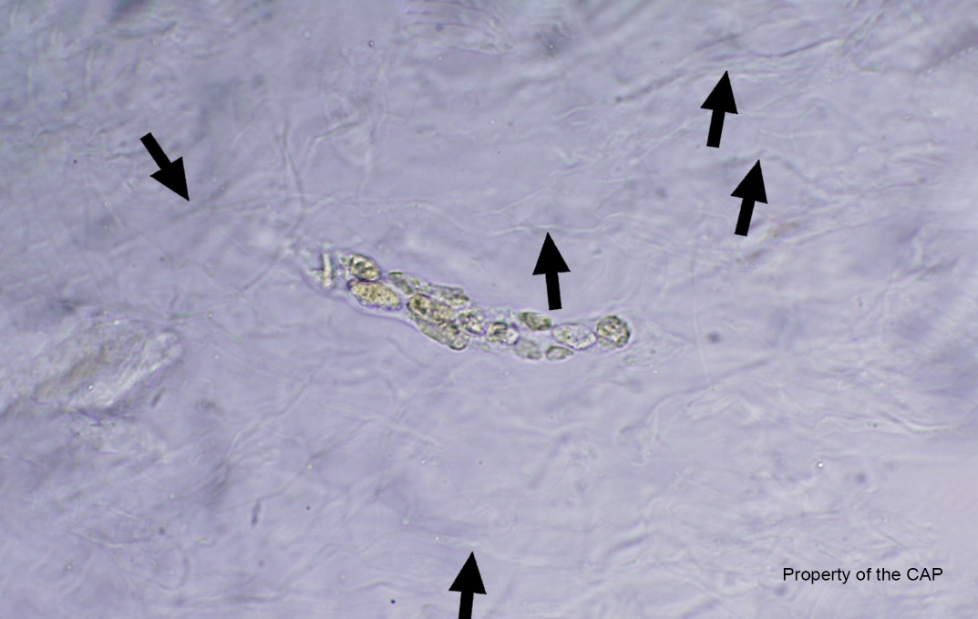

Answer: ____________________________

**Urine sediment**

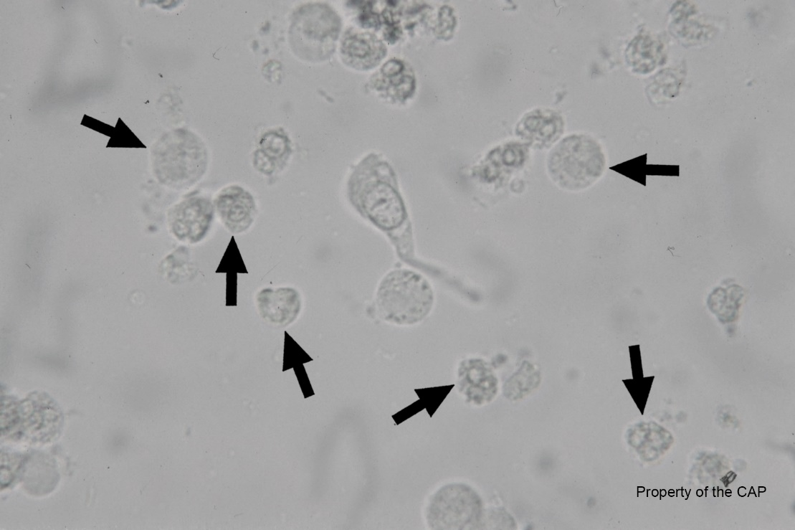

Answer: __________________________

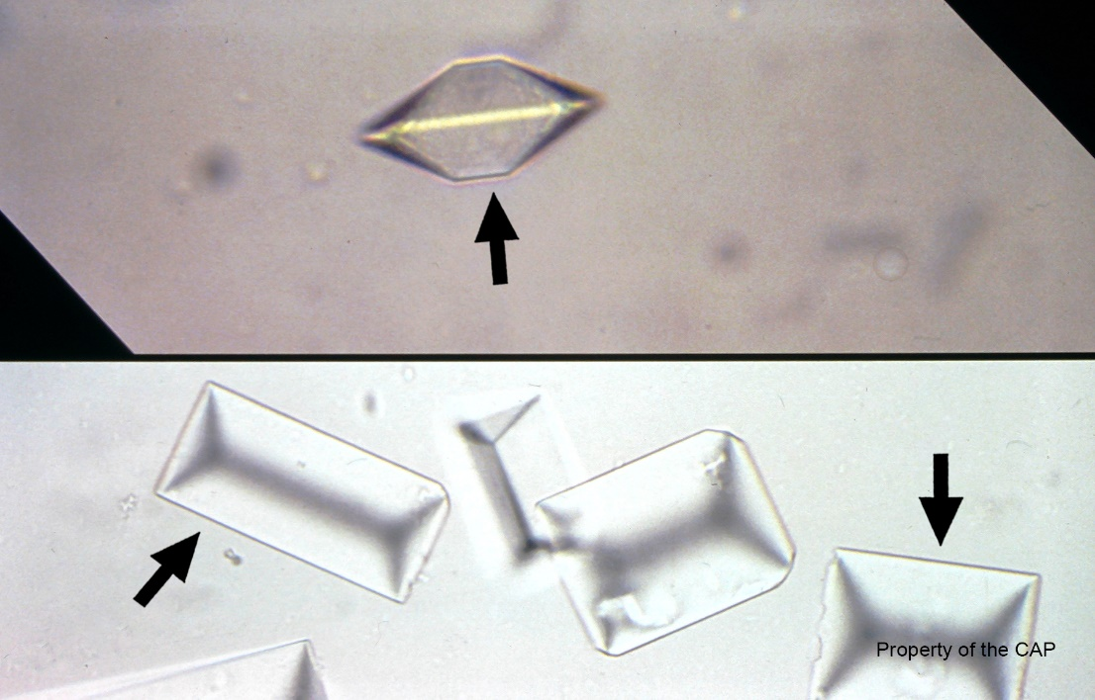

**Urine sediment**

Answer: _______________________

**Identify the object**

**Vaginal, unstained**

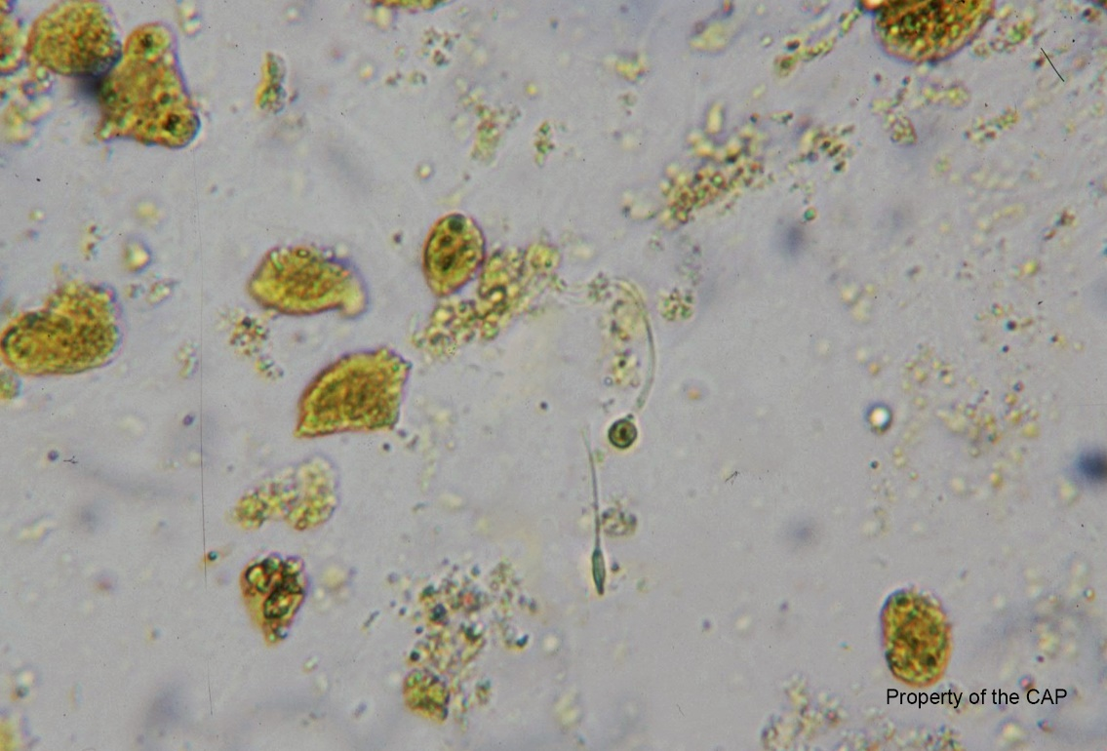

Spermatozoa are ________________ (present or absent)

**Vaginal, unstained**

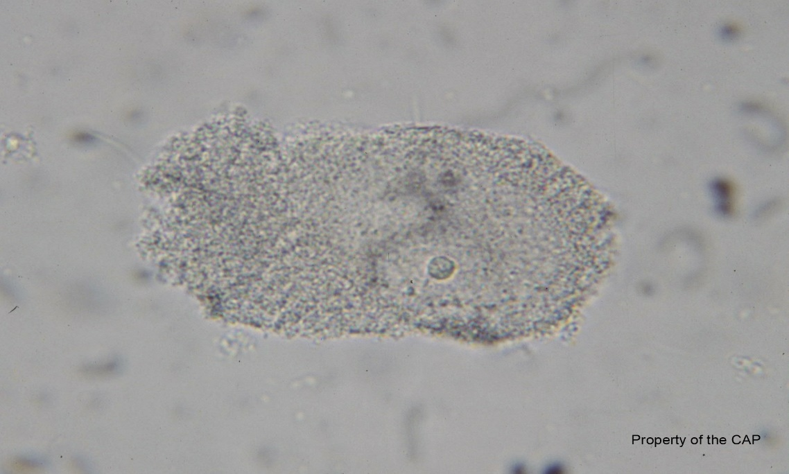

Answer: ___________________________

**Stool (Wright - Giemsa)**

Leukocytes are __________________ (present or absent)

**Vaginal, unstained**

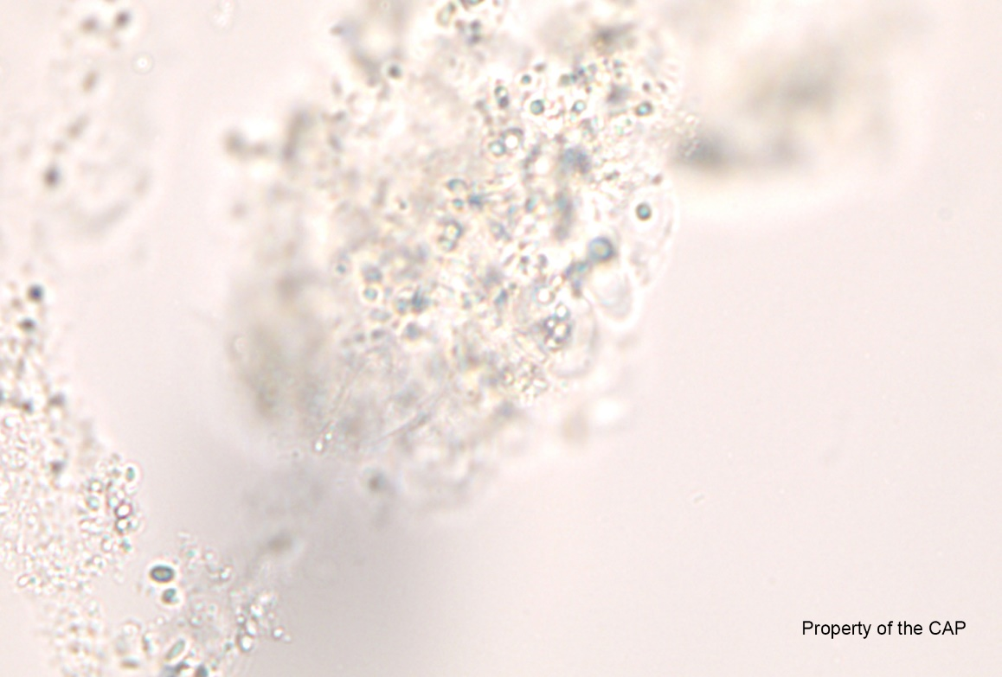

Pinworm/Pinworm eggs are ________________ (present or absent)

**Identify the arrowed object**

**Urine sediment**

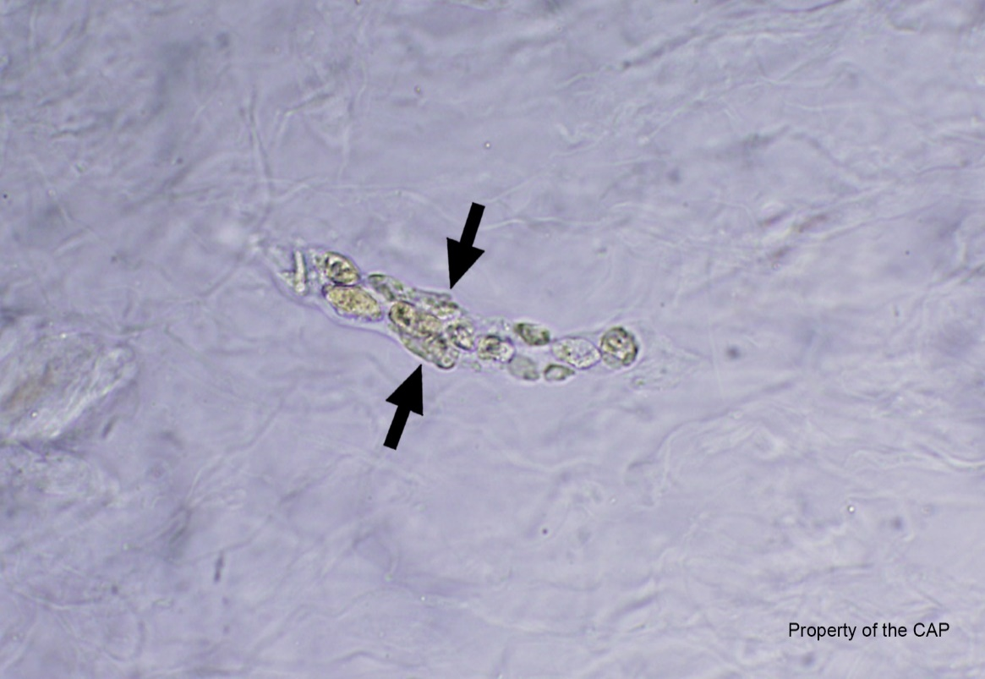

Answer: ____________________

**Gram stain**

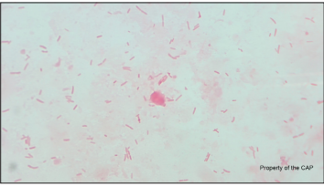

Answer: ___________________ (Gram stain reaction and morphology)