|  |  |  |  |  |  |
| --- | --- | --- | --- | --- | --- |
| **Document Title: Manual Differential Procedure**  **SH.CP.AU.hem.0007.0005** | | | | | |
|  | | | | | |
|  | | | | | |
| **Author** | **Effective Date:** | | | **Supersedes Procedure #** | |
| Jen Bianchi |  | | | **SH.CP.AU.hem.0007.0004** | |
|  | | | | | |
| **Revised by:** | **Date Revised:** | | | **Effective Date:** | |
| Jen Bianchi | 3/15/2016 | | |  | |
|  |  | | |  | |
|  |  | | |  | |
|  |  | | |  | |
|  | | | | | |
| **Approval Signature** | | | | **Approval Date** | |
| Robert Miller, Chief Supervisor, Hematology | | | |  | |
|  | | | |  | |
|  | | | |  | |
| James Corsetti, MD, PhD, Medical Director | | | |  | |
|  | | | |  | |
|  | | | |  | |
|  | | | |  | |
|  | | | | | |
| **Distributed to** | | **# of Copies** | **Distributed to** | | **# of Copies** |
| Hematology and Chemistry lab | | 1 |  | |  |
| http://sharepoint.mc.rochester.edu/sites/Pathology/AutoLab/Hematology/Forms/AllItems.aspx | | 1 |  | |  |
| QC-1547 | | 1 |  | |  |
|  | |  |  | |  |
|  | |  |  | |  |
|  | |  |  | |  |
|  | |  |  | |  |
|  | |  |  | |  |

**REVISION HISTORY**

|  |  |  |
| --- | --- | --- |
| **Procedure #** | **Revision Date** | **Reason for Revision** |
| **SH.CP.AU.hem.0007.0002** | 3/10/2010 | Update format |
| **SH.CP.AU.hem.0007.0003** | 11/13/13 | Content revised |
| **SH.CP.AU.hem.0007.0004** | 3/1/14 | added the critical value for bands |
| **SH.CP.AU.hem.0007.0005** | 3/15/2016 | Updated Quality Control section, deleted the notification of pathologist for new leukemia |
|  |  |  |
|  |  |  |
|  |  |  |

**Title: Manual Differential Procedure**

1. **PRINCIPLE**

The morphologic examination of a peripheral blood smear can give quantitative and qualitative information regarding the cellular elements of the blood. A careful and thorough microscopic examination of an appropriately prepared and stained blood smear serves two invaluable functions in the laboratory. It provides the most information possible in the diagnosis of disorders involving the hematopoietic system and it offers the most reliable means for checking the quality of results obtained from automated hematology analyzers.

A stained smear is examined in order to determine the percentage of each type of leukocyte present and assess the erythrocyte and platelet morphology. Increases in any of the normal leukocyte types or the presence of immature leukocytes or erythrocytes in peripheral blood are important diagnostically in a wide variety of inflammatory disorders and leukemia. Erythrocyte abnormalities are clinically important in various anemias. Platelet size irregularities are suggestive of particular thrombocyte disorders.

1. **PURPOSE**

The purpose of this document is to provide guidance on how to perform manual differentials.

1. **SCOPE**

This procedure will be used by the UR Medicine Labs at Strong Memorial Hospital Automated Hematology Laboratory staff.

1. **RESPONSIBILITIES**

|  |  |
| --- | --- |
| TITLE | RESPONSIBILITY |
| Laboratory Director | Approval of Procedure |
| Supervisory Staff | Implementation of procedure |
| Staff | Adherence to procedure |

1. **SPECIMENS**

Wrights Giemsa stained blood smear from EDTA whole blood sample.

1. **QUALITY CONTROL**

On a biannual basis competency is assessed using one of the following methods:

1. A Competency assessment test for diffing is to be performed on the medtraining.org website. A minimum score of 70% must be obtained to be considered passing.
2. An audit of a previously performed slide that was reviewed on the CellaVision system will be performed and evaluated for agreement with the examiner. The criteria for passing will be less than 6 misidentified cells or less than two misidentified pathologic cells. Pathologic cells include but are not limited to blasts, lymphoma cells, Sezary cells, hairy cells, plasma cells and prolymphocytes.
3. Any major problems will be discussed on an individual basis. If the technologist reports a value(s) outside the acceptable range, that technologist receives a "deficiency". Two consecutive deficiencies by the same technologist will result in remedial action.
4. **SPECIAL SAFETY PRECAUTIONS**

NA

1. **MATERIALS**
2. Equipment
3. Midas Stainer
4. SP 1000 automated slide maker stainer
5. Microscope- with 10x low dry objective lens,50x oil objective lens and 100x oil objective lens
6. Computer with appropriate differential counting software
7. Supplies

1. Wright’s Giemsa stain

2. Immersion oil

C. Reagents

NA

1. **PROCEDURE (Step/Action):**
2. Focus the microscope on the 10X objective (low power). Scan the smear to check for cell distribution, clumping, and abnormal cells. In scanning the smear it is important to note anything unusual or irregular, such as rouleaux or RBC clumping.
3. To perform the differential, choose the portion of the smear where there is close proximity but little overlapping of the red cells. They should have a central pallor. You should use the 100 X objective or 50X if available.
4. Begin the count in the thin area of the slide and gradually move the slide as shown below:

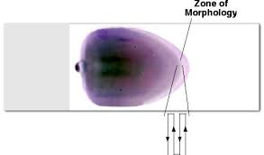

Pathway for differential cell count

Count each white cell seen and record on a differential cell counter, until 100 white cells have been counted. Use identification criteria described in reference documents listed in section **XIV**.

If WBC count is >50 x 103, count 200 cells or more for a more accurate differential.

While counting the cells, make a note of any abnormalities present in the cells. *It is important to examine cellular morphology and to count leukocytes in areas that are neither too thick nor too thin.* In areas that are too thick, cellular details such as nuclear chromatin patterns are difficult to examine. In areas that are too thin, distortion of cells makes it risky to identify a cell type.

1. Results are expressed as a percentage of the total leukocytes counted.

It is also helpful to know the actual number of each white cell type per µL of blood. This is referred to as the **absolute count** and is calculated as follows:

**Absolute number of cells/µl = % of cell type in differential x WBC count.**

1. Examine the red cell morphology, if RBC morphology is needed, in a thin area of the slide where the red cells slightly overlap. They should have a central pallor. Be conservative. In most cases an abnormality must be a consistent finding in order to be significant.

RBC Morphology - Manual RBC morphology is performed when indicated by Sysmex WAM middleware. This will occur if it is flagged by the automated analyzer and has not been performed within the last 30 days. In addition, RBC morphology will be added on samples that have a manual differential order and that have not had a RBC morphology performed in the past 720 days (see Sysmex WAM rules). Any abnormality seen in a moderate or more amounts should be reported. Report size, shape, and colorization of RBC using appropriate terminology. Any presence of red blood cell inclusions and abnormal distribution (i.e. rouleaux, agglutination) should be noted. See CAP Hematology, Clinical Microscopy, and Body Fluids Glossary or The Morphology of Human Blood Cells for further morphology description.

1. WBC <1.2 thou/µl - In the case of a low WBC, 100 cells may not be found in the appropriate area of the slide for identification. Count as many cells as possible and report the differential as percentages.
2. WBC ≤ 0.1 thou/ul - It is not necessary to perform differentials on any inpatient with a WBC ≤ 0.1. If the floor specifically requests a differential performed, it should be done.
3. **LIMITATIONS**
4. Specimen >24hrs old - Blood smears made on a sample >24hrs old will have EDTA induced artifact (i.e. crenated rbcs, large platelets and necrobiotic WBC).
5. Necrobiotic cells - If greater than 10% unidentifiable necrobiotic cells are present on the differential, the diff is not reported.
6. Staining quality - Lightly stained smears may hinder the identification of cells. Artifact on a smear due to improper drying or water present in methanol for fixation will effect the appearance of the rbcs.
7. Smear preparation - Smears that are too thick or too thin will effect WBC and RBC distribution.
8. If leukoagglutination is seen, add the comment “Interpret with caution leukoagglutination present”.

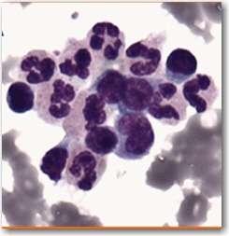

1. **CALCULATIONS**

NA

1. **INTERPRETATION**

*Cells to be aware of when performing manual differentials:*

1. Smudge Cells - These are the disintegrating bare nucleus of a ruptured white blood cell. They are usually an enlarged amorphous shape, reddish-purple staining, with no chromatin structure. These cells are difficult to classify and are not included in the differential count. If there is a significant number (>20/100 wbcs) a new slide is made using 1 drop of albumin to 5 drops of blood. They should be counted using the smudge cell key on the diff keypad. If the smudge cell count is still >20/100 wbcs, the result will automatically be converted to “numerous”. If the sample has necrobiotic/ smudge cells due to the age of the sample, refer to the section in this procedure on limitations. Smudge cells are normally present in certain pathologic cases such as Chronic Lymphocytic Leukemia (CLL), infectious mononucleolus, and acute leukemia due to the fragile nature of these cells. They may also be induced by cytotoxic or steroid drug therapy.

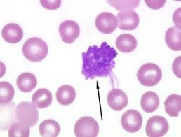

1. Necrobiotic Cells - These are dead or dying cells showing dense or pyknotic nuclear chromatin. The nuclear shape may be altered. These cells are rare in normal blood unless the sample is old. Necrobiotic segs can be confused with nucleated red blood cells. Care must be taken to recognize residual granules in the cytoplasm of the segs. Necrobiotic cells are not reported in a differential.

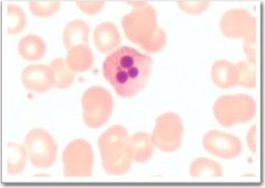

1. Nucleated RBCS - The number of nucleated red blood cells encountered during the differential count are tallied simultaneously but do not get added to the diff total. The WBC is automatically corrected by the automated analyzer when NRBCS are counted. If a manual WBC needs to be entered, the WBC must be corrected for the nucleated red blood cells and/or megakaroycytes if there are 8 or more using the calculation: **(total WBCs x 100) ÷ ( # of** **NRBCs/megakaryocytes + 100).** The comment “WBC corrected for NRBCs” is to be entered in the comment field associated with the reported WBC.

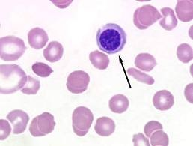

1. UNIDENTIFIED or MISCELLANEOUS CELLS - These cells are to be reported as “Unidentified cells pending hematopathologist review, revised report to follow”. These slides are reviewed by the hematopathologist on service. Any pathologic cells (i.e. unreported blasts, hairy cells, prolymphocytes, sezary cells, lymphoma cells, or myeloma cells.) should be tallied using the “other” or “unid” key and left unidentified or reported as established by the hematopathologist. The slide should be filed in the pathologist’s folder and added to the PATHR tasklist. If not previously reviewed, mark “yes” for Path Review and enter cell description in the comment field associated with path review. All slides with pathologic cells, previously reported or not, are put into the folder to be reviewed by the hematopathologist.

|  |  |  |
| --- | --- | --- |
|  | **Pathologic Cells** |  |
| Blasts | Lymphoma Cells | Prolymphocytes |
| Hairy Cells | Sezary Cells | Myeloma Cells |
| Leukemia / Lymphoma Cells | Blasts/Promonocytes |  |

E. Pathologist Review - This is used to mark a specimen to be reviewed by the pathologist. By answering “Y” in the “pthrev” field, a path review test will be reflex ordered. This should include smears with:

* + 1. Any unidentified cells or pathological cells seen not recently path reviewed and reported (i.e. > 3 months).
    2. Microorganisms - intracellular bacteria or yeast forms.
    3. Blood parasites - i.e. plasmodium (malaria), Babesia.

This test is also used for INTERNAL comments for the hematopathologist such as descriptions of unidentified cells when they are small in number(<10%). This will help the hematopathologist determine which cell population you need reviewed.

1. Morphology Comments - Differential comments are accessed using the Morphology tab in WAM with the option to report each individual comment as PRESENT. These are comments that pertain to the white blood cell portion of the differential (i.e. Toxic granulation, Dohle bodies, Hypersegmented neutrophils, etc).

G. COMMD – This is a comment field available when a DIFFM test is ordered. It is used for diff comments not included in the list (i.e. Auer rods, immature monocytes, etc.). Canned text is available here.

H. Hypersegmented neutrophils - Segmented neutrophils with 5 or more lobes should be noted as hypersegmented neutrophils if seen while performing a manual differential. It is considered clinically significant if more than 5/100 WBC are seen. These are reported as present.

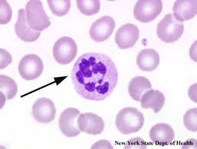

I. Pelger- Huet neutrophils - These are mature neutrophils that are unable to undergo proper segmentation. This results in a band, bilobed or dumbbell-shaped nucleus with coarsely, clumped chromatin. If over 75% of the neutrophils show this bilobed segmentation, it is a congenital disorder. Tally cells as segs and report Pelger-Huet as present.

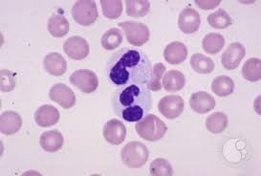

J. Pseudo-Pelger-Huet - These neutrophils can be morphologically identical to the hereditary type or show a single, round nucleus without segmentation and with very coarse, condensed chromatin. This is often drug induced or seen in myelodysplasia. Again, tally as mature segs and report pseudo-Pelger-Huet as present.

K. Immature eosinophils and basophils - Eosinophils and basophils are rarely seen in immature forms in the peripheral blood. When they are classify the cells by their secondary granulation (i.e. eos or baso) and note their presence in immature forms. It is not necessary to designate their stage of immaturity.

L. Mixed granulation - Granulocytes with both eosinophilic and basophilic granulation can be seen in CML and MDS. These cells should be reported as “cells with mixed granulation” in the miscellaneous (Other) cell category.

M. Dwarf megakaryocytes - These are abnormal, pathologic megakaryocytes sometimes seen in leukemic or myelodysplastic patients. They should be reported as “Present” for megakaryocytes.

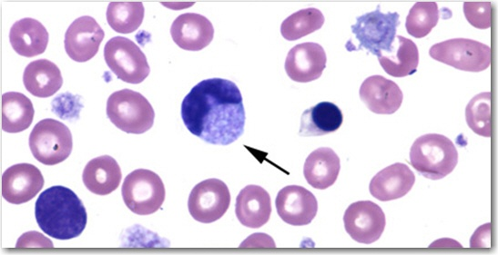

N. Megakaryocytic fragments - These are bare nuclei of mature, normal megakaryocytes. They are sometimes seen on blood smears of newborns. They should be reported as “Present” for megakaryocytes.

O. Reactive Lymphocytes - These stimulated lymphocytes are usually seen in viral infections and other normal immune responses. Include both downy cell type (large and irregular with basophilic cytoplasm) and plasmacytoid lymphocytes (eccentric nucleus and very basophilic cytoplasm) in this classification.

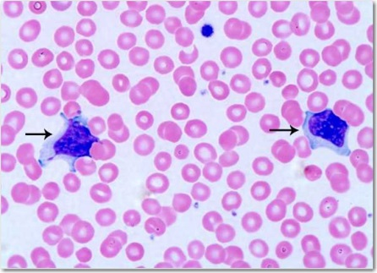

P. Platelets - See WBC and Platelet Review Procedure SH.CP.AU.hem.0009 for platelet morphology and review.

1. **RESULT REPORTING**
2. Any blood parasites (i.e. malaria) or microorganisms (bacteria, yeast) found on a blood smear are to be considered a life threatening result.

Refer to policy VI-14 Clinical Laboratory Critical Value Immediate Notification Policy for reporting and documentation.

1. Critical value for Bands- Bands of greater than 15% for infants up to 1 day old and greater than 10% for all others are considered critical values. Refer to policy VI-14 Clinical Laboratory Critical Value Immediate Notification Policy for reporting and documentation.
2. Reference ranges – see job aid SH.CP.AU.jad.0101.
3. **TRAINING**

Staff are trained by a laboratory designated trainer and a training record is completed and signed by both the trainer and staff (trainee).

1. **REFERENCES**
2. Hematology, Clinical and Laboratory Practice, Bick. volume one,4:39-48,1996.
3. Clinical Laboratory Medicine, McClatchey, 34:840-844 ,1994.
4. College of American Pathologists Hematology, Clinical Microscopy, and Body Fluids Glossary
5. NCCLS. Reference Leukocyte Differential Count and Evaluation of Instrumental Method. (GP20-A).
6. The Morphology of Human Blood Cells; Diggs, Sturm, Bell Seventh Edition
7. Hematography Plus – An Instructional Program and Atlas of Blood and Bone Marrow Morphology, Lofsness, Karen version 1.0.