# 

**Title: Operation of the IL HemoHub**

|  |  |  |
| --- | --- | --- |
| **Author:** | **Effective Date:**  *Note: The Effective Date is assigned after all approval signatures are obtained* | **Supersedes Procedure #** |
| Shannon Clare |  | New |

|  |  |  |
| --- | --- | --- |
| **Revised By:** | **Date Revised** | **Effective (adopted) Date:**  *Note: The Effective Date is assigned after all approval signatures are obtained* |
|  |  |  |

|  |  |
| --- | --- |
| **Approval Signature** | **Approval Date** |
|  |  |
|  |  |
| W. Richard Burack, MD |  |
|  |  |
|  |  |
| Julietta Fiscella, MD |  |
|  |  |
|  |  |
| Tamera Paczos, MD |  |
|  |  |
|  |  |
| Xiaolan Ou, MD, PhD |  |
|  |  |
|  |  |

|  |  |  |  |
| --- | --- | --- | --- |
| **Distributed to** | **# of Copies** | **Distributed to** | **# of Copies** |
| Bailey Rd Hematology | **1** |  |  |
| HH Hematology | **1** |  |  |
| SMH Hematology | **1** |  |  |
| Strong West | **1** |  |  |
|  |  |  |  |

**REVISION HISTORY**

|  |  |  |
| --- | --- | --- |
| **Procedure #** | **Revision Date** | **Reason for Revision** |
|  |  |  |
|  |  |  |
|  |  |  |
|  |  |  |
|  |  |  |
|  |  |  |
|  |  |  |
|  |  |  |
|  |  |  |
|  |  |  |
|  |  |  |
|  |  |  |
|  |  |  |
|  |  |  |
|  |  |  |
|  |  |  |
|  |  |  |

# TITLE: Operation of the IL HemoHub

1. Purpose
   1. HemoHub is a data management system for healthcare professionals to use in the hemostasis laboratories. It receives, processes, displays, and stores the data generated by the hemostasis analyzers, as well as providing connectivity to hospital information systems. HemoHub does not modify the data or modify the display of the data. HemoHub itself does not control the functions or parameters of any other medical device.
2. Scope
   1. To provide UR Laboratory personnel with a guide to day to day operation of the HemoHub software in conjunction with the ACL Top analyzers.
3. RESPONSIBILITIES

|  |  |
| --- | --- |
| **Roles** | **Responsibilities** |
| Quality Assurance | Supports the development of this document. |
| Medical Director | Review and approval of this document. |
| Management | Ensure that procedure is followed. |
| List role of applicable staff | Follow procedure. |

1. ACRONYMS/DEFINITIONS

|  |  |
| --- | --- |
| URMC | University of Rochester Medical Center |
| HH | Highland Hospital |
| BR | Bailey Road Laboratory |
| SMH | Strong Memorial Hospital |

1. SPECIMENS
   1. BD Vacutainer 1.8mL or 2.7 mL 3.2% Buffered Sodium Citrate vacutainers.
2. QUALITY CONTROL
   1. The quality control is used to monitor the accuracy and precision of the ACL TOP Family analyzers. Quality control is accomplished by processing the control fluids for each analyte. See section J. Quality Control/Reagents section of this SOP for additional information.
3. SPECIAL SAFETY PRECAUTIONS
   1. Observe universal precautions and use personal protective equipment as needed.
4. MATERIALS
   1. Equipment
      1. HemoHub software.
      2. ACL Top Family analyzer.
5. PROCEDURE
   1. Click on the HemoHub Icon to open the program.
   2. Log into the software with your unique sign on and password.
   3. The server location for the Live environment is <http://172.16.136.173:8888>
   4. Once you are logged in, you see the main screen, or Home Screen of the application.

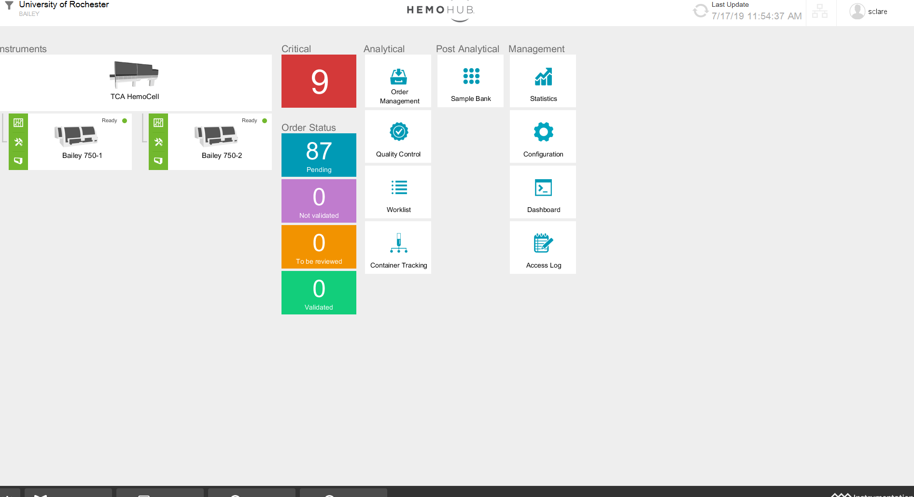

* 1. Click on the University of Rochester (Home screen Filter) on the top left of the screen to adjust the number of days you can see results. Click on the + to add days, then submit.
  2. Filter for lab section if necessary. Special coagulation samples may be older and require you to set your filter higher.
  3. As a safety measure, HemoHub times out after 20 minutes of inactivity.
  4. You can see the last update on the top right hand side of the screen- Status indicator. 
  5. The indicator to the right of the Status Indicator shows the status of the interface connection between HemoHub and LIS. 
  6. The three main sections on the home screen:
     1. Instruments: this section shows the instruments connected to HemoHub.
        1. The chart symbol gives you an indication of the QC status.
        2. The tools symbol gives you an indication of the Maintenance status.
        3. The Analyzer icon gives you an indication of the Fluidics and Cuvettes status.
     2. Orders Section
        1. Critical results will be under the CRITICAL button as well as the NOT VALIDATED or TO BE VALIDATED button.
        2. Pending samples are all samples ordered in the LIS for the selected time period without results.
        3. Not Validated contains samples with partially completed results.
        4. To Be Reviewed contains critical samples, samples waiting for extended test results, short samples, hemolyzed samples, icteric samples, and lipemic samples.
     3. Direct Access
        1. Order Management allows you to set filters and look up test orders.
        2. Worklist allows you to create and edit worklist, not used at this time.
        3. The Quality Control allows you to see a summary of the last QC status for each instrument connected to HemoHub, see the trends for each QC and add comments to QC results.
        4. The sample bank allows you to view the specimen container racks, remove samples from the rack, and discard the rack.
        5. The dashboard allows you to track Key Performance Indicators.
        6. Statistics allows you to access the engine where you can configure and build statistical reports, and view statistical reports already created.
        7. Configuration allows you to end the Configuration Module for HemoHub.
        8. Access Log opens a filter that allows you to select a group of users or a specific user, and view all the log in/log out actions that each user has performed in the system.
  7. Instrument Detail Screen

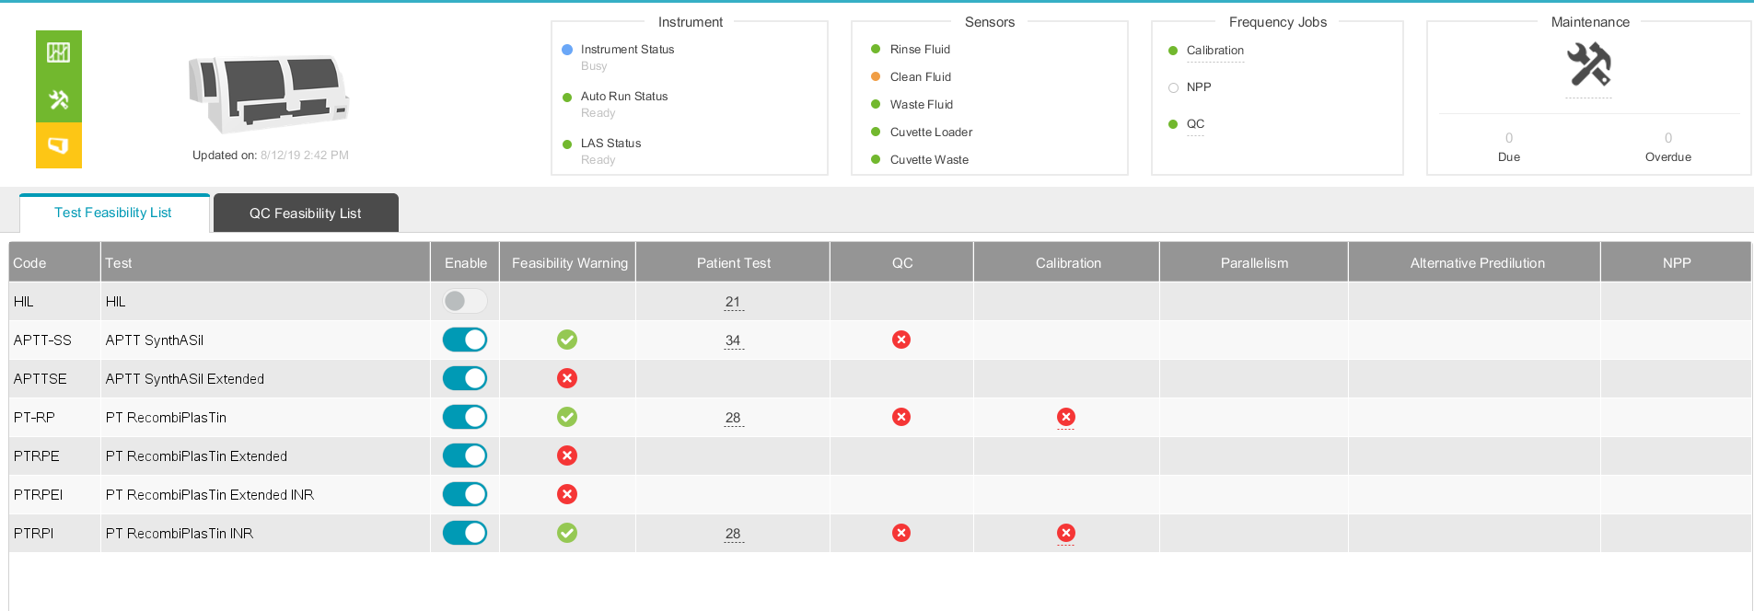

* + 1. Instrument

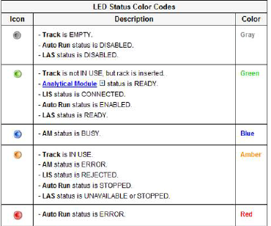

* + 1. Sensors

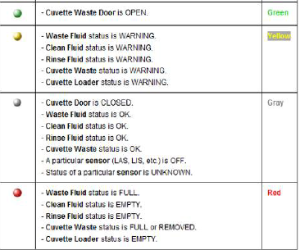

* + 1. Maintenance
       1. Shows the number of maintenance jobs due or overdue.
       2. Double click on the maintenance to see the instruments maintenance list.
    2. Test and QC Feasibility

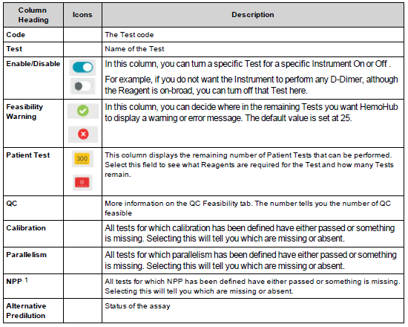

* 1. Set Up New Users
     1. From the main screen select Configuration.
     2. Select Security to expand the menu.
     3. Select Users.
     4. Choose the group you would like the user added to.
     5. Choose the User you would like to duplicate, this will copy all user configurations including libraries.
     6. Right click, choose Create Like…
     7. When the box pops up, fill in new user’s information.
        1. Full Name.
        2. Report Name (Full Name).
        3. First Name.
        4. Last Name.
        5. Assign temporary password.
        6. Choose group you would like the used added to.
        7. Select Create.
     8. You will need to close the tree and reopen it to see the user you just created.
  2. Setting up optional columns
     1. When you are in a screen that has multiple columns, such as Pending Orders, you can customize which columns are visible and in what order they appear.
     2. Select Options from the bottom right of the screen.
     3. In the fields tab choose the columns you would like included, for example Last Container Checkpoint will add the last location of the specimen sent to HemoHub.
     4. Move the fields you would like included to the right hand column and the fields you do not want included to the left hand column.
     5. When you are finished select submit.
     6. These changes will be linked to your user and will be the same wherever you sign on.
  3. Orders Search for sample
     1. From the main screen select Orders on the bottom of the screen.
     2. Enter the order number, including the suffix, and select enter.
     3. Make sure ALL is selected and not Closed or Not Closed.
     4. The sample information will be listed.
     5. Double click on the sample to open to the results screen.
  4. Empty Racks daily (HemoCell users only)
     1. After dumping your rack for the day, select Sample Bank from the Post Analytical column.
     2. Choose the rack number you just dumbed from the drop down menu.
     3. On the bottom of the screen, choose Empty Rack.
     4. When the pop-up box comes up, Select Yes.
  5. Specimen Resulting
     1. Hemolyzed
        1. The instrument will not send you the results.
        2. All you will see is the yellow exclamation point sign.
        3. The box will say Hemoglobin high.
        4. Select .ND from the drop down menu and add the sample hemolyzed comment from the Comment Library .
        5. Then select Validate & Next on the bottom of the screen.
        6. If it is the last sample in the file, Select Submit.
     2. Short sample (HemoCell flagged)
        1. All samples should be checked prior to being loaded on the HemoCell.
        2. The results will cross into HemoHub.
        3. The Yellow Exclamation point sign will say Underfilled Tube Warning.
        4. Remove the results from the Result field.
        5. Select .ND from the drop down menu and add the sample Inadequate for testing comment from the Comment Library .
        6. Then select Validate & Next on the bottom of the screen.
        7. If it is the last sample in the file, Select Submit.
     3. <19 PTT
        1. All PTT’s <19.9 will stop in HemoHub.
        2. Check the specimen for a clot.
        3. If not clotted added the Checked for Clot comment from the Comment Library .
        4. The comment ‘PTT < 20 SECONDS. SAMPLE MAY BE ACTIVATED. REPEAT SUGGESTED IF CLINICALLY INDICATED.’ is automatically attached to the result in Soft.
     4. Critical Result
        1. Critical results will stop in HemoHub under the To Be Reviewed and Critical Categories.
        2. To review the clot curve, select the  and choose More Information.
        3. The clot curve opens in a new screen.
        4. You will release the Extended results, so select the  and choose Reject Test on the ones you will not be releasing. Your reason will be Needs extended mode.
        5. Attach your comments from the Comment Library .
        6. Then Select Validate & Next.
        7. If it is the last sample in the file, Select Submit.
        8. The result will go to the Soft Interface for Calling and Verification.
        9. In HemoHub, the result will stay in the Critical list for 10 days before it drops off.
     5. Icteric
        1. The results with stop in the To Be Reviewed category.
        2. The Yellow Exclamation Point message will say Bilirubin High.
        3. Select the Rules button on the bottom of the screen and the ‘Interpret Caution, Bilirubin High’ comment will be attached.
        4. Select Validate & Next.
        5. If it is the last sample in the file, Select Submit.
     6. HIL pending
        1. If there is an error on the analyzer and the HIL could not be performed, the Yellow Exclamation sign with say HIL pending.
        2. Check the sample for Hemolysis, Icterus, and Lipemia.
        3. If the sample is acceptable, select Validate & Next.
        4. If it is the last sample in the file, select Submit.
        5. If the sample is unacceptable, follow the process for Hemolysis, Icterus, or Lipemia.
     7. Manually entered results
        1. Any results manually entered into HemoHub will not automatically have the rules applied. You will need to select the Rules button on the bottom of the screen in order for the rules to be correctly applies. For example, when you manually enter a PTT >200 result, the Rules button will need to be selected to make sure it results correctly.

1. LIMITATIONS N/A
2. CALCULATIONS N/A
3. INTERPRETATION N/A
4. RESULT REPORTING
   1. All results will be reported using IL HemoHub software into the Soft LIS System.
5. TRAINING

|  |  |
| --- | --- |
| **Role** | **Training Needed** |
| Management | Read |
| Technologist | Read and follow procedure |

1. REFERENCES
   1. HemoHub Configuration Manual, Instrumentation Laboratory Company, Bedford, MA 01730-2443, P/N 00011305001 R02, 2018.
   2. HemoHub User Guide, Instrumentation Laboratory Company, Bedford, MA 01730-2443, P/N 00011305002 R03, 2018.



**[Document title] - Knowledge Check**

In the event of a question answered incorrectly: Single-line through the incorrect answer, initial & date, then select the correct answer.

***ALWAYS HAVE CHANGES INITIALED BY YOUR TRAINER.***

***Circle True or False for each of the following statements.***

|  |  |  |
| --- | --- | --- |
| 1. | True or False |  |
| 2. | True or False |  |
| 3. | True or False |  |
| 4. | True or False |  |
| 5. | True or False |  |

Any incorrect answers I may have initially written have been discussed and corrected. I now understand the answers I may have gotten wrong.

***PASSING GRADE IS ”X%” (Customize to passing score that’s divisible by the number of questions to result in a whole number; use 100% requirement as applicable) OR GREATER***

### 

**________________________**

**Employee name (print)**

**________________________ ______________________**

**Employee signature (Date)**

**________________________**

**Supervisor/Manager name (print)**

**________________________ ______________________**

**Supervisor/Manager signature (Date)**

**[Document title] – Answer Key**

**All false answers must have correct answer with explanation.**

**All true answers must reference supporting statement in document.**

***<Revise for True or False as applicable>***

|  |  |  |
| --- | --- | --- |
| 1 | FALSE | State Question |
|  |  | Correct Answer: |
| 2 | FALSE | State Question |
|  |  | Correct Answer: |
| 3 | FALSE | Question |
|  |  | Correct Answer: |
| 4 | TRUE | State Question: |
|  |  | Supporting Statement: |
| 5 | TRUE | Question: |
|  |  | Supporting Statement: |