Title: Roche c311 General Operating Procedure

Author: | Effective Date:  Note: The Effective Date is assigned after all approval signatures are obtained | Supersedes Procedure #
S. Baker | 12/16/2020 | New

Revised By: | Date Revised | Effective (adopted) Date:  Note: The Effective Date is assigned after all approval signatures are obtained

Approval Signature | Approval Date
Dr. Xiaolan Ou, Medical Director Strong West
Barb Beck, Chief Supervisor, Chemistry
Sue Baker, Asst. Supervisor, Strong West

Distributed to | # of Copies | Distributed to | # of Copies

REVISION HISTORY

Procedure # | Revision Date | Reason for Revision

TITLE: Roche c311 General Operating Procedure

- Purpose

The purpose of this document is to provide instructions for the general operation of the Roche c311 analyzer for the analysis of clinical specimens.
- SCOPE

To provide URMC Strong West Laboratory personnel with a guide to operating the Roche c311 analyzer for the quantitative and qualitative determination of clinical chemistry and therapeutic drugs.
- RESPONSIBILITIES
Example:
Roles | Responsibilities
Quality Assurance | Supports the process including providing leadership and/or assistance in support of the process.  Review and approval of procedure (site dependent).
Medical Director | Supports the development of the document.  Review and approval of the document.
Management | Review and approve the document.  Ensure that procedure is followed.
Laboratory Technical staff | Follows procedure.

- ACRONYMS/DEFINITIONS
Example:
URMC | University of Rochester Medical Center
SW | Strong West
HH | Highland Hospital
BR | Bailey Road Laboratory
SMH | Strong Memorial Hospital
- SPECIMENS
- Universal Precautions apply
- Blood Samples are collected according to standard laboratory procedure. A minimum of 0.5 mL of whole blood is required. Serum or heparinized plasma that is not hemolyzed may be tested. Serum separator tubes (SST), red top vacutainer and green top (heparin) vacutainer tubes are accepted for Sodium, Glucose, BUN, Creatinine, Chloride, CO2, and Potassium testing. Only red top vacutainer and SST vacutainer tubes are accepted for Acetaminophen, ALT, Amylase, Salicylate, AST, CK, ETOH, Lipase, Total Protein, Bilirubin (Total and Direct), Calcium, CRP, Phosphorous, Magnesium, Albumin, and Alk phos/ testing. A sodium fluoride and/or potassium oxalate (gray top) tube is accepted for Lactate testing. Samples are transported to the laboratory at room temperature in sealed tubes. An EDTA blood collection tube (purple top) on ice is accepted for Ammonia testing.
- QUALITY CONTROL
- Quality Control should be performed regularly to monitor system performance and therefore assure reliable patient results. A minimum of two levels of quality control material for each analyte will be run at least once per 24 hours when patient samples are processed. Quality Control will also be run when a new reagent cartridge is added including new lot numbers, after every calibration and after any major maintenance or repair is performed. Refer to QC procedure SW.CP.GL.adm.0002
- CALIBRATION
- Calibration is the process that establishes a relation between measurement values such as absorbance values or ECL signals and corresponding results (concentrations of an analyte).
- Calibrations are performed per schedule as required by the analyzer. Calibrations must be performed for any of the following reasons:
  - A new lot of reagent is put into use.
  - QC fails and there is no other apparent reason
  - After major maintenance is performed.

- SPECIAL SAFETY PRECAUTIONS
- All patient specimens and reagents should be considered potentially infectious and must be handled with precautions used for human blood in accordance with laboratory safety policy (SW.CP.GL.adm.0005)
  - Spent cuvettes and empty reagent containers should be disposed of in a bio-hazardous waste container.
  - Liquid waste should be disposed of in a dirty sink and flushed with water.
  - Potential electrical hazards exist behind the side, front and back panels of the analyzer.
  - Protective equipment such as wearing gloves and buttoned lab coats should be always worn when operating.
  - Whenever there are moving parts, use caution with correcting malfunctions and when operating the system
  - Do not use solvents or cleaning solutions on the analyzer.
  - Safety data sheets available on request.
IX. MATERIALS
A. Equipment
1. Roche c311 analyzer
  - Control Unit (Monitor, Printer)
  - Analyzer Unit
  - Power components
  - Cobas link platform
- Supplies
- Type I distilled water
- Calibrator fluids
- QC material
- Diluents
- Reagent Packs
- Racks
- Sample Cups
- Cuvettes
- Gloves
- Maintenance supplies

- Methods
The cobas c311 analyzer is an automated system for qualitative and quantitative in vitro diagnostics. The ion-selective electrode (ISE) and the photometric measurement unit provide a wide variety of tests.

The graphical user interface provides quick and easy access to sample, control, and calibration data, while continuously monitoring all system functions. Color-coded icons alert you to changes in the system status. Connection to a host system allows for automatic transfer of results to and from the cobas c311 analyzer.

    - SYSTEM OVERVIEW
The cobas c311 is composed of:
          - Control Unit:
The Control Unit is located at the top left of the analyzer and consists of a touch screen monitor, an external printer and a host interface.

          - Analytical Unit:
The analyzer unit on the cobas c311 consists of the sample/reagent area, consumable area, measuring area, and operation switch.

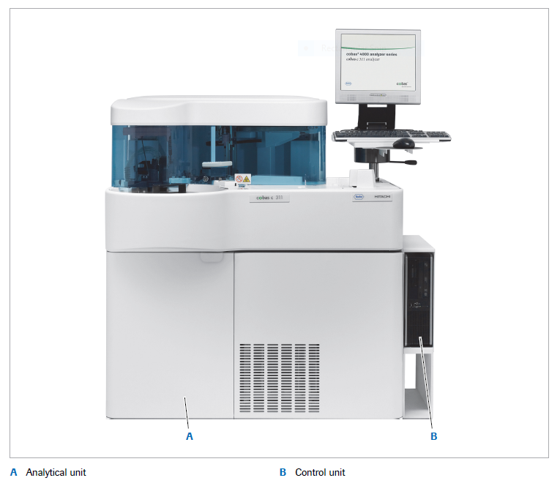
          - Additional Components
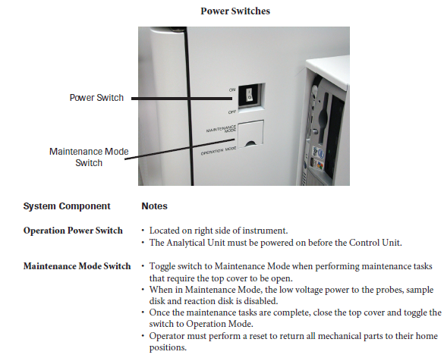
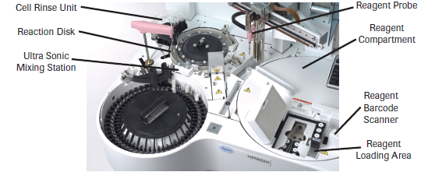
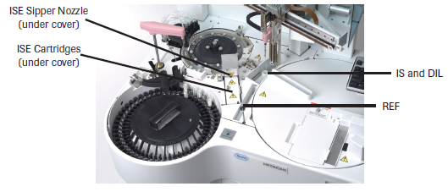
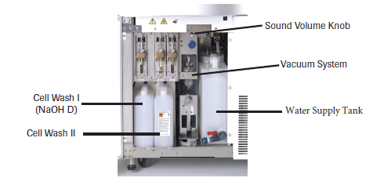
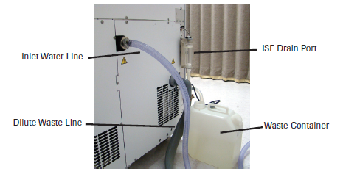
- System Overview
The System Overview screen has a central role withing the cobas c311 analyzer software. This screen provides an overview of the whole system at any given time. It can be used to prepare the analyzer for daily routine operation. The System Overview screen can be reached at a time by touching the two squares in the upper left corner of the screen.
The day-to-day operation of the instrument is controlled through the user interface. The screen is divided into various areas. Some of these areas do not change, and some differ according to the currently active function.

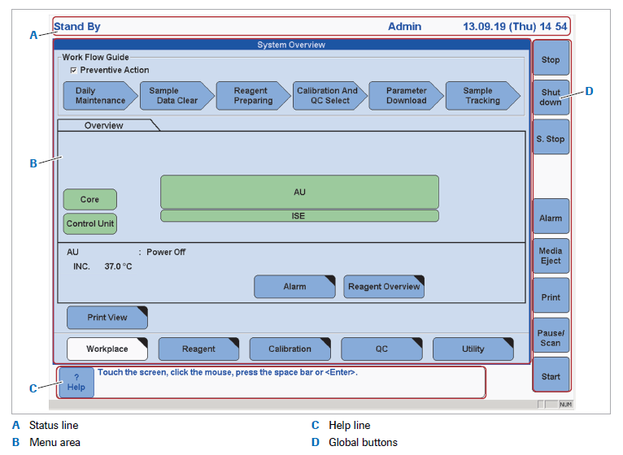
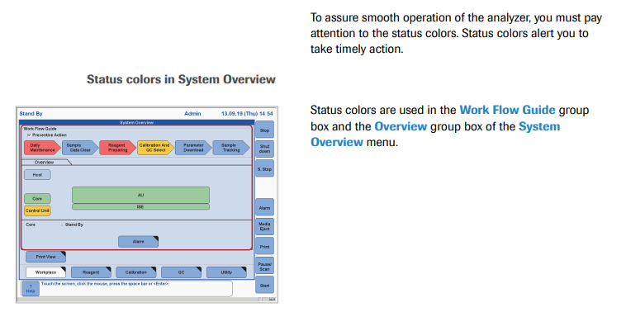
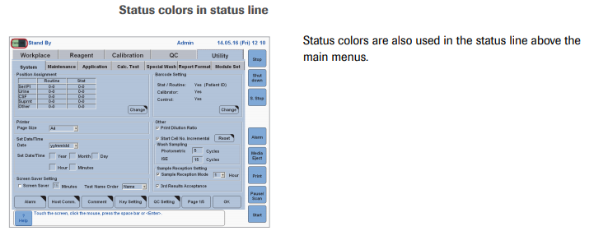
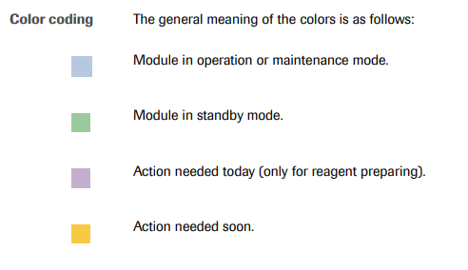
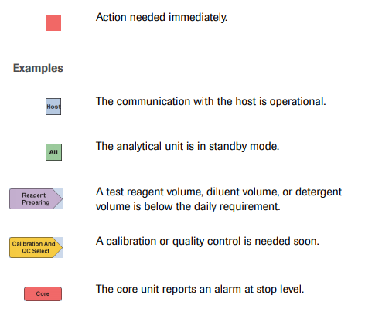

    - Status Line:
The status line is displayed across the top of each screen. The status line displays the current operational mode, sample reception mode remaining time, operator ID, date and time. The double system overview icon on the left changes colors to reflect the current operational status of the system. The color codes, listed from lowest to highest priority are:
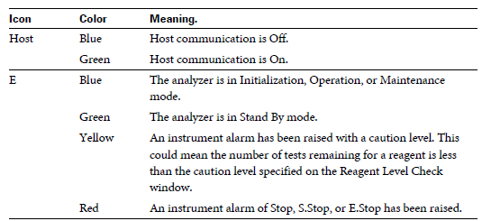

Choose the system overview icon at any time to display the system overview screen. The operational mode is displayed to the right of the system overview icon.

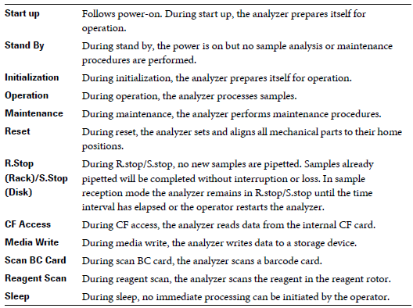
    - Guidance Prompt:
The guidance prompt is shown in the lower left of each screen. In this area, the software explains how you can use a specific text box. When you select a text box, the guidance prompt defines the information that you can enter. It may also give an action to take, such as choosing a button or pressing a key.
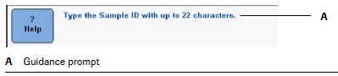
    - Main Menu Screens:
The graphical user interface used by the control unit consists of six main menu screens: system overview, workplace, reagent, calibration, QC, and utility. Through these screens all instrument functions are controlled. Access to some screens, especially those of the utility menu, is restricted by the access level of the user.
  - System Overview:
The System Overview screen is the central screen used for performing daily operation. From here the status of reagents, calibrations, and QC can be viewed. The quantities of consumables can be checked as well. The system overview screen consists of the workflow guide, inventory area, menu buttons and main screen buttons.
- Workflow Guide – Guides you through set-up through the pre-routine operations.
- Overview Area - Provides information about the selected unit including temperature.
- Print View button – Displays a preview of current data
- Main Menu Buttons – include Workplace, Reagent, Calibration, QC, Utility
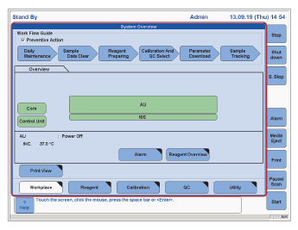
  - Workplace:
The workplace menu screen consists of two main tabs: Test Selection and Data Review. Test Selection is used to enter and review test selections for a sample. Data Review is used to search, review, export, delete, and send data to the host.
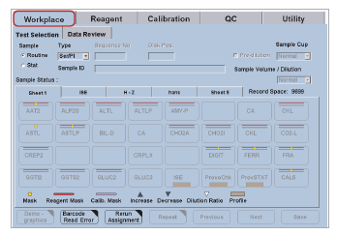
  - Reagent:
The reagent menu is used to view detailed reagent and consumables information.
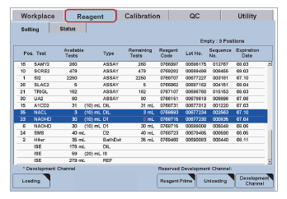
  - Calibration:
The calibration menu screen consists of three tabs; status, calibrator, and install. They are used to request calibrations, define calibrators, and view calibration results.
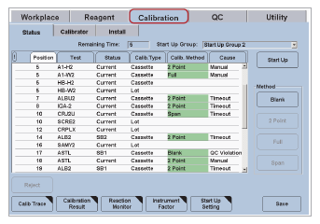

  - QC:
The QC menu consists of six tabs; status, run status, individual, cumulative, control, and install. Use these screens to install, view, request, and edit controls, and evaluate and accumulate quality control results.
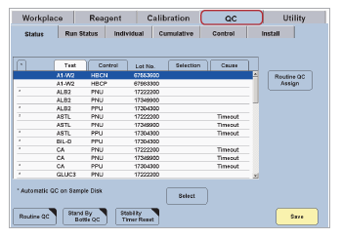
  - Utility:
The Utility menu screen consists of four tabs, system, maintenance, application and calculated test. These screens are used to enter system settings, application parameters, and access maintenance and service functions.
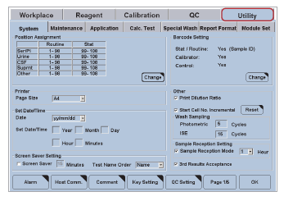

    - Menu Tabs:
The menu tabs are used to select screens and windows that are grouped together and used to perform related tasks. The menu tabs are accessible from every screen (but not from pop-up windows). This makes the software navigation within the menus, and between menus quite easy.

    - List Boxes:
List boxes display a list of choices. If there are more choices than can fit in a box, a scroll bar is displayed. List box is a generic term for any type of dialog box option containing a list of items the user can select.

    - Text Boxes:
A text box is used to type information on a screen. However, some text boxes are read-only. Select a text box by touching it on the screen. The full or numerical software keyboard will be displayed, depending on the entry field. After typing in text box choose Enter or Tab, for the information to be accepted and move to the next field.

    - Option Buttons:
Option buttons are used to select a particular function. Sometimes when an option is selected, other option buttons or test boxes become available. Select an option by touching it on the screen. An option is selected when the corresponding option button is colored light blue. If it is dark blue, the option is not selected.

    - Buttons:
- Buttons are used to start functions, confirm entries and selections, and display windows. The available buttons depend on the menu or tab that is active
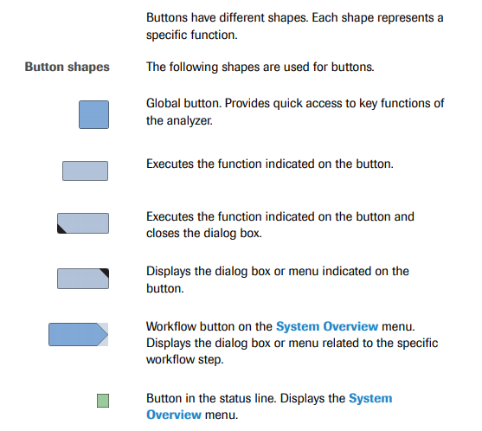
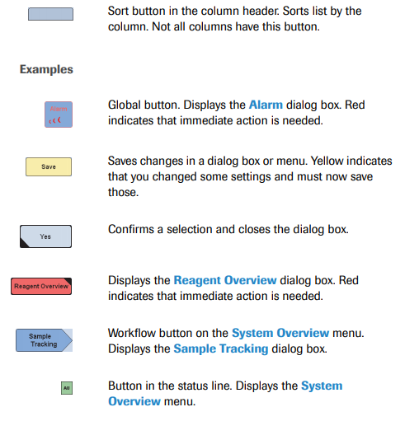
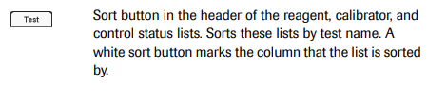
Button | Function
OK | Choose this button to accept the changes and entries made in a window and to close the window
Cancel | Choose this button to close the window without saving the changes and entries in the window
Yes | Choose this button to accept the changes made in a window, perform the action of the window and close the window.
No | Choose this button to close the window without saving the changes made in a window or without executing the function of the window.
Close | Choose this button to close the window
Save | Choose this button to save any changes made to the screen or window currently displayed. When changes have been made, this button turns yellow.
Update | Choose this button to update any changes made to the screen/window currently displayed. When changes have ben made this button turns yellow.
Page Buttons | Because space on screens is limited, it is not always possible to display all buttons on a screen. In this situation you can access the additional buttons using the page button. This age buttons are numbered (for example, x/3) to indicate the page you are on

- Global Buttons:
Use the global buttons to open screens that are used for specific functions. The global buttons are accessible from every screen and are located on the right side of the screen; except for the Help button, which is in the lower left corner of the screen. The global buttons include Stop, Logoff, S. Stop, Stat Mode, Alarm, Print, Start, and Help. The Stop, S. Stop, Stat Mode, and Start buttons are also the system control buttons. You can select the global buttons using the touch screen.
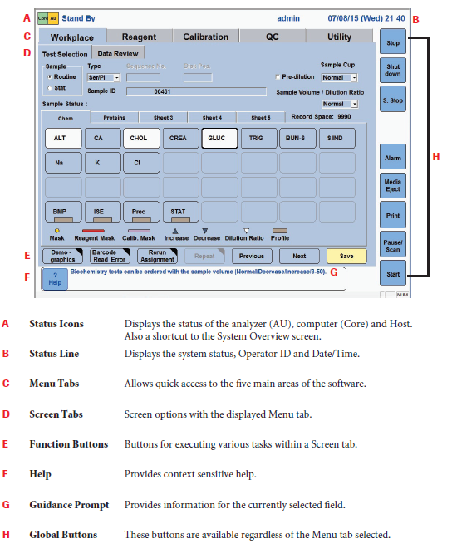

The functions of the global buttons are summarized in the table below.
Button | Function
Stop | Stops the analyzer at the end of the current mechanical cycle. Test in progress will not be completed
Logoff | Log off, change operator or shutdown the analyzer
S. Stop | Performs a sample stop. All tests that have been sampled will be completed before the analyzer returns to standby.
Start Mode | Puts the analyzer in STAT mode
Alarm | Opens the Alarm screen
Print | Opens the Print screen
Start | Starts the processing samples from the Start Conditions screen
Help | Opens the online Help System

    - Windows:
Windows containing additional information are displayed, overlaying part of the currently displayed screens or windows. Windows function in a similar way to screens. Information in a window can be entered or edited through list boxes, test boxes, and option buttons. Action buttons are also available.

Selection menu for multiple items:
The Sample Range Start and Select Sample buttons on the Workplace → Data Review screen are used to select consecutive or non-consecutive samples in a list

To select multiple non-consecutive samples:
- Select the first sample from the list. The selected sample is highlighted with a glue background and the results of the tests performed on the sample are displayed in the test results list.
- Choose Select Sample. The Select Sample button changes to white.
- Select the next sample. Use the scroll bar to display samples that are further down the list.
- Repeat steps 2 and 3 until you have selected are all highlighted with a blue background.
To select a range of consecutive samples:
- Select the first sample in the required range from the sample list on the left of the screen.
- Choose Sample Range Start. The button title changes to Sample Range End and the color turns white.
- Select the last sample in the range from the list on the left of the screen. Use the scroll bar to display samples that are further down the list.
- Choose the Sample Range End. The selected samples are highlighted with a blue background.
Online Help:
The cobas c311 analyzer has a context sensitive online Help to aid in operating the analyzer. The online Help offers a quick convenient way to find information, such as explanations of screens and windows and how to perform particular processes.

- Daily Operation
Daily Operation encompasses the routine tasks that are required to prepare the system, analyze samples, and maintain the system. The layout of the system overview screen gives you an intuitive guide for the tasks required for routine operation.

- Reagents and Solutions:
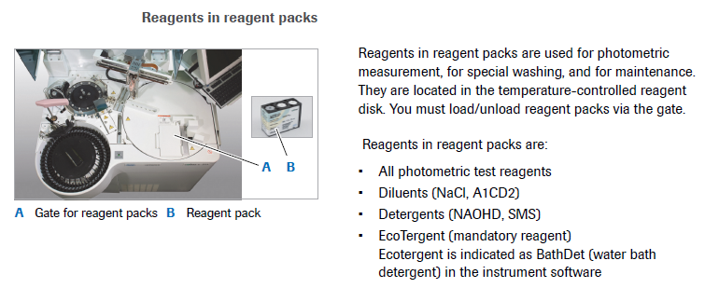
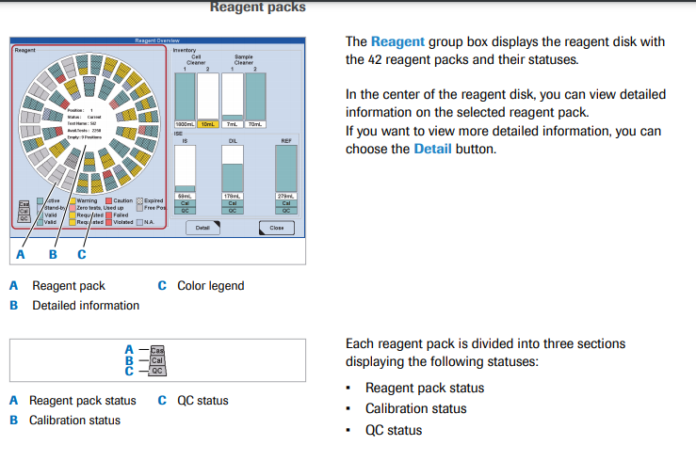
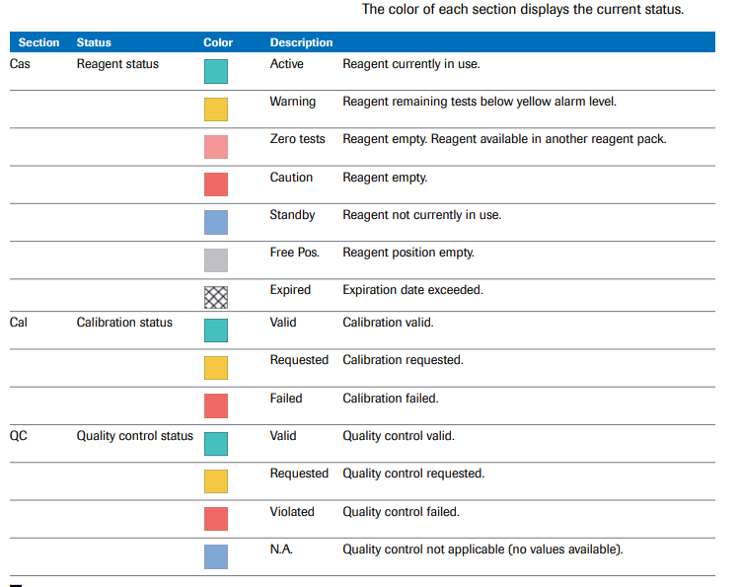
- Loading Reagents
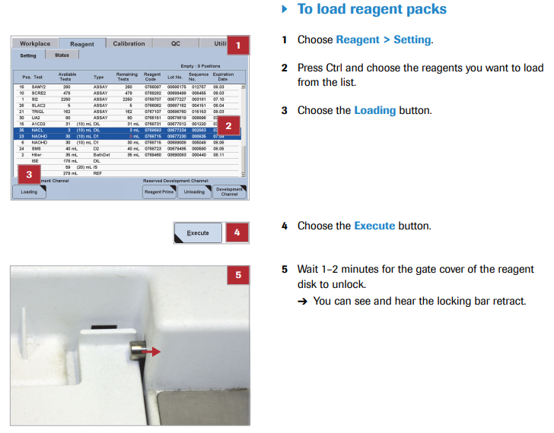
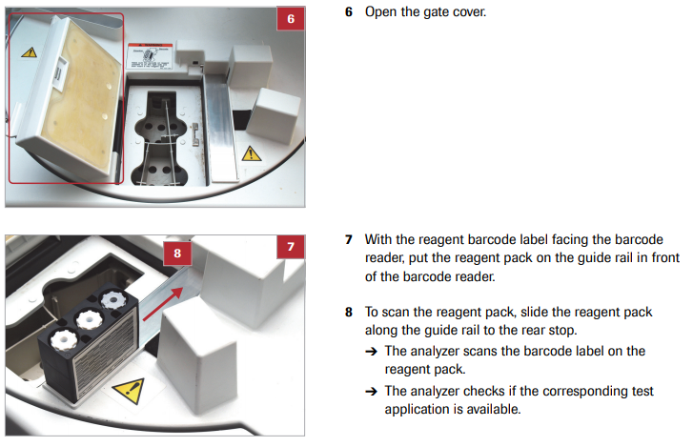
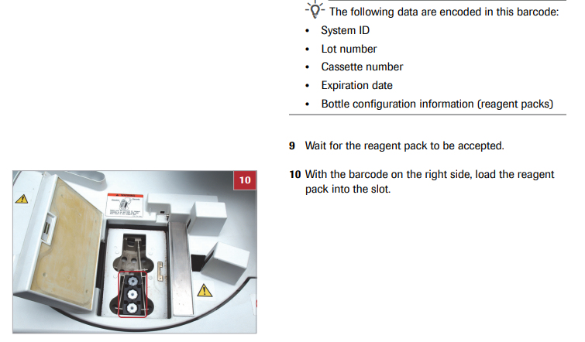
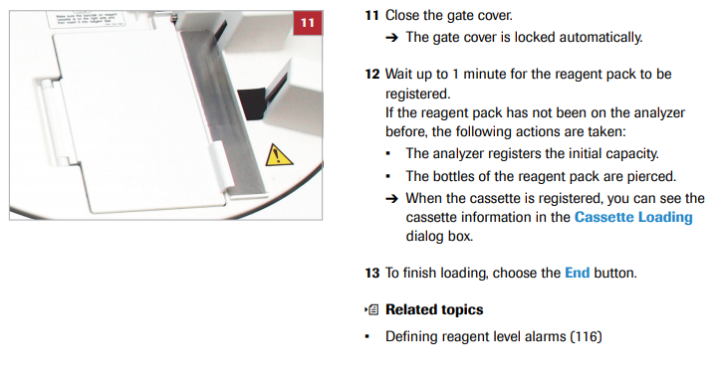
- Unloading Reagent Packs:
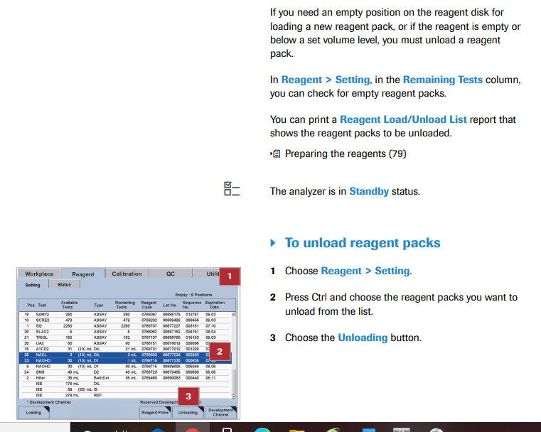
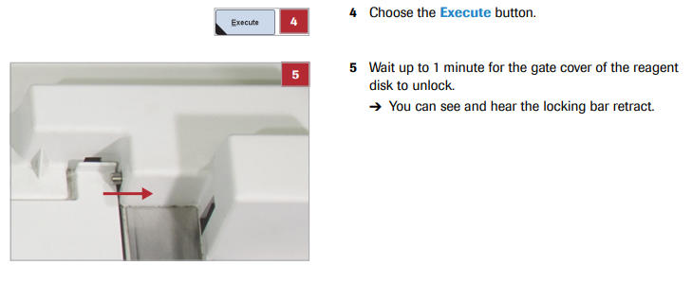
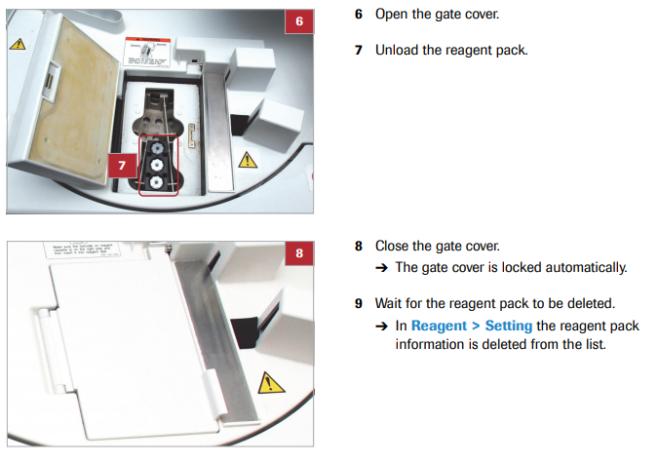
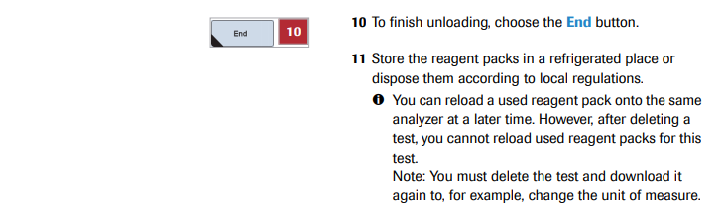

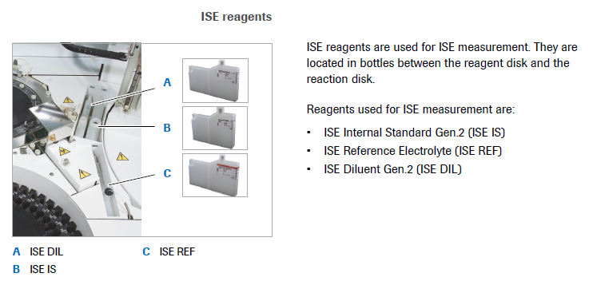
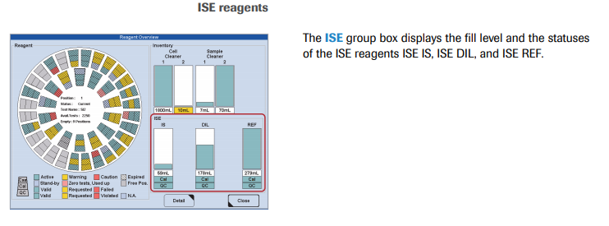
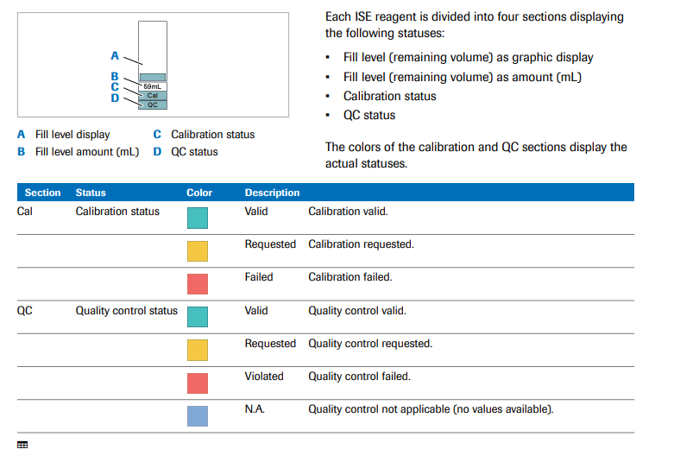

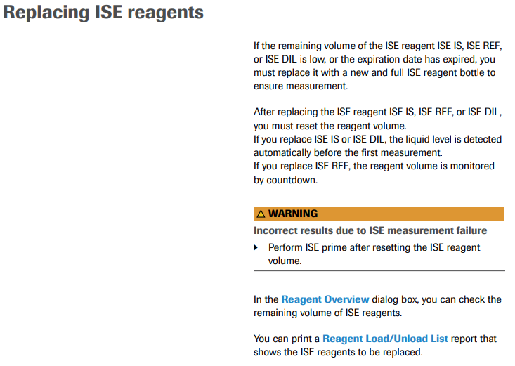
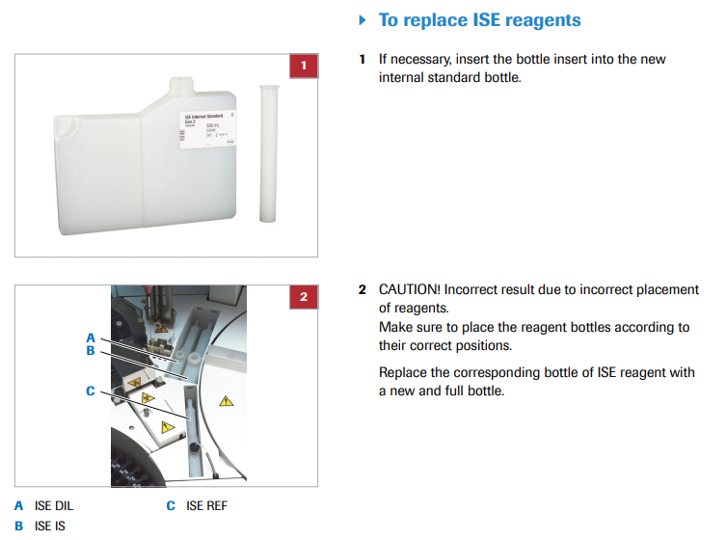
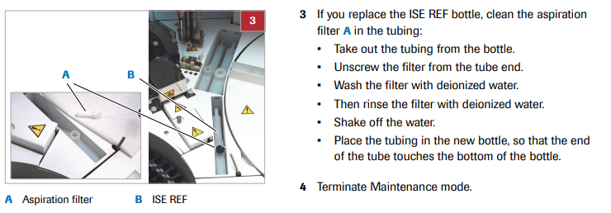
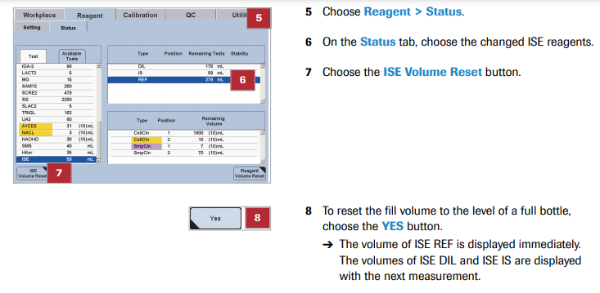
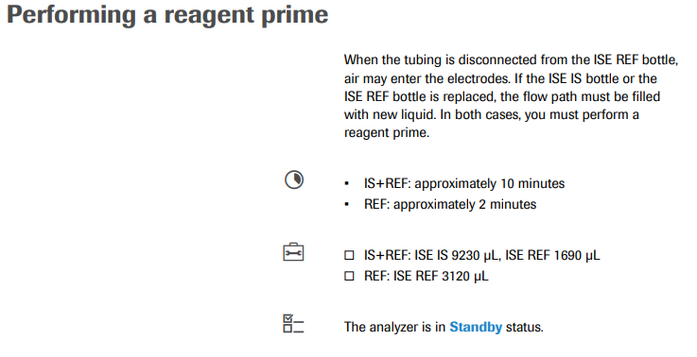
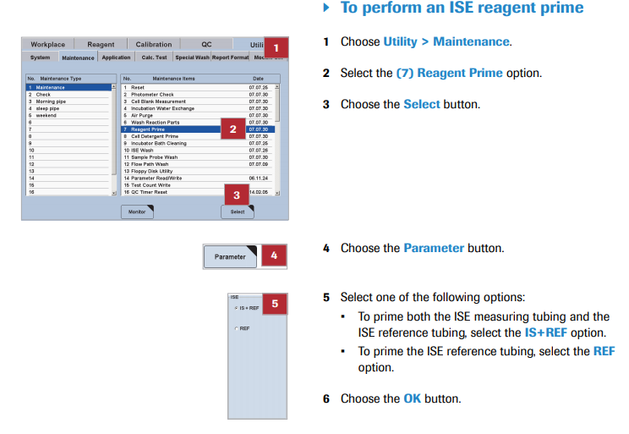
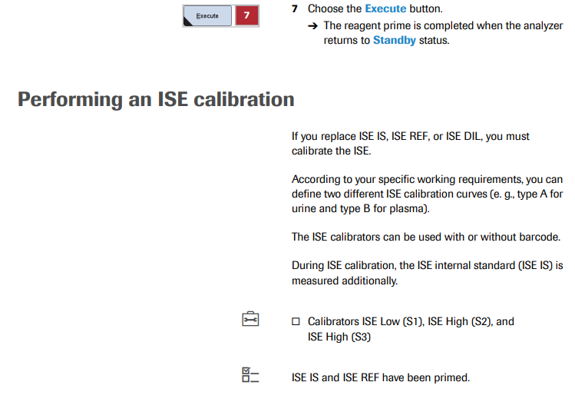
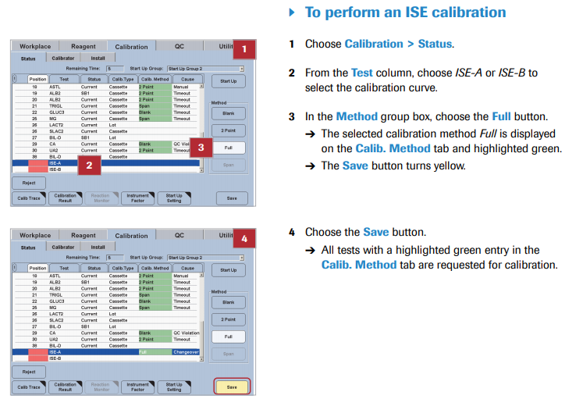
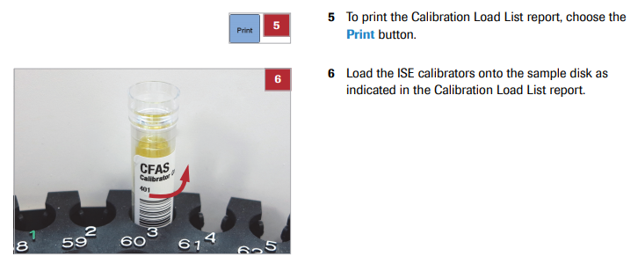
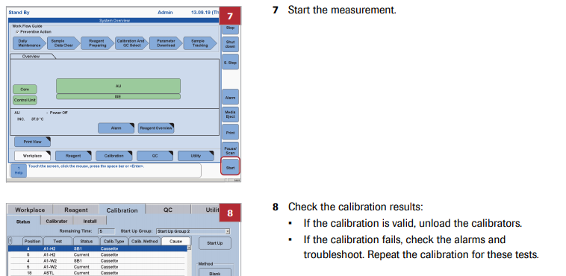

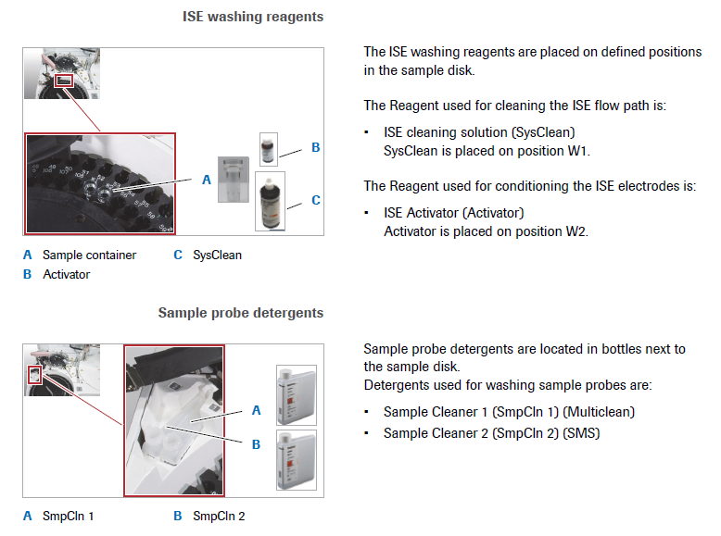
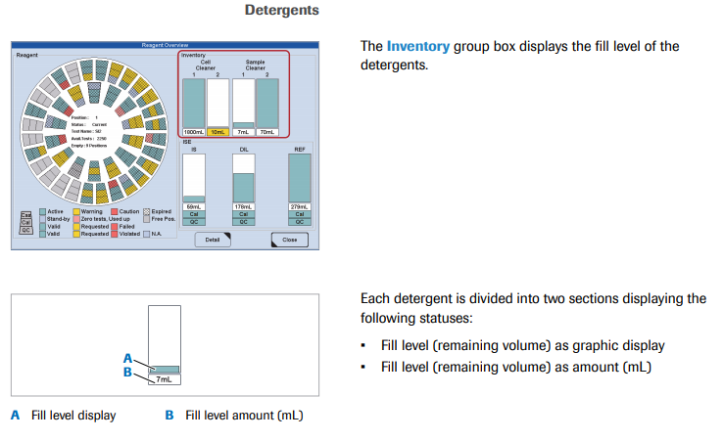
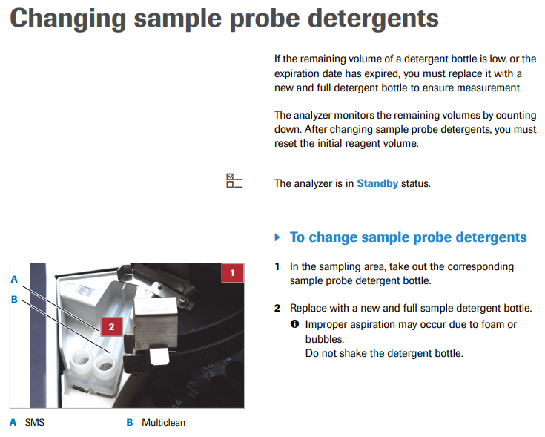
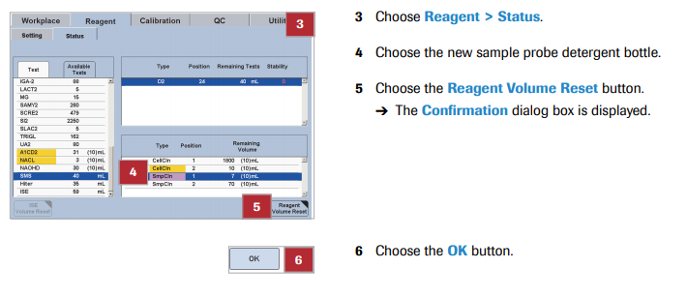

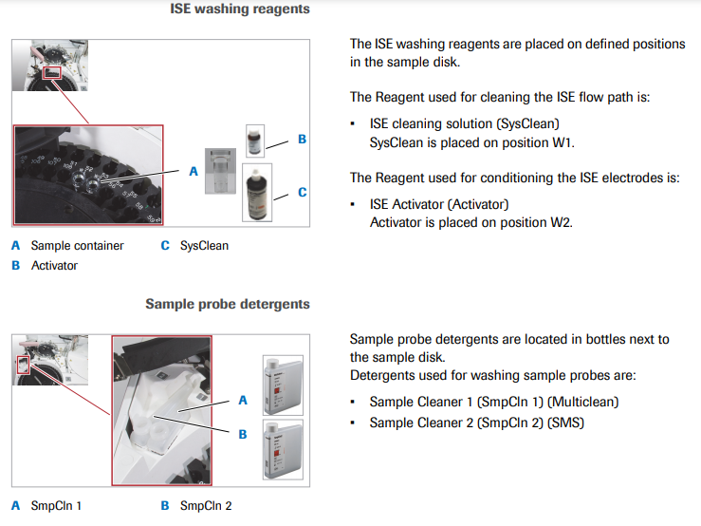
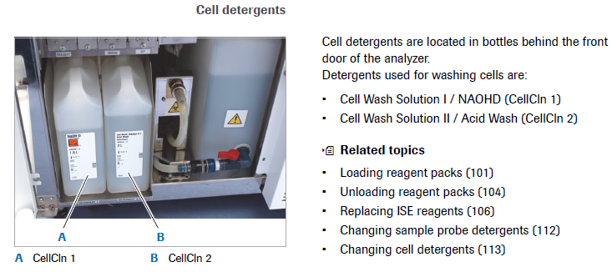

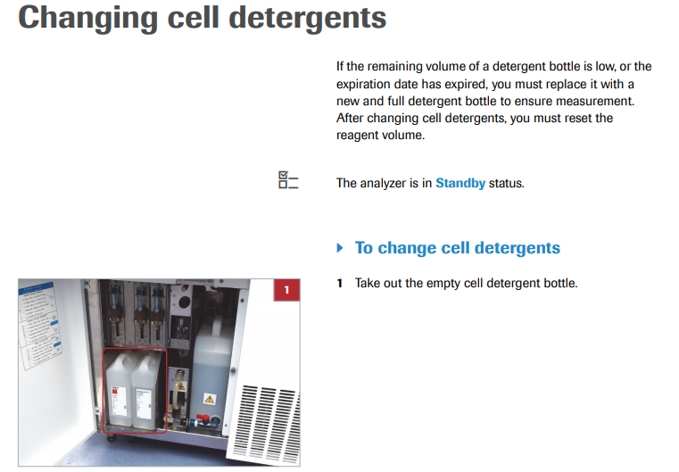

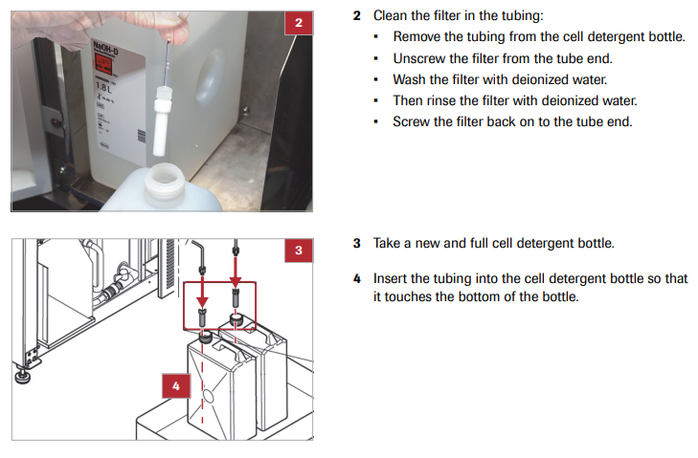
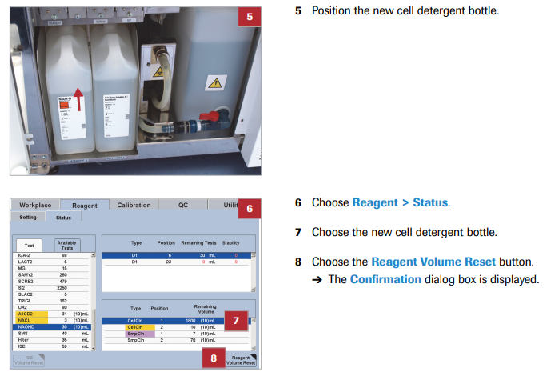
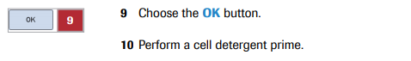
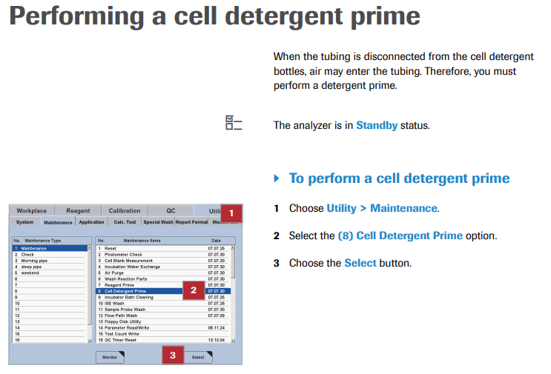
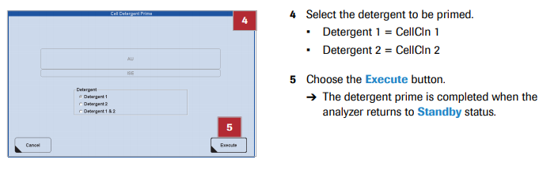

- Calibrations:
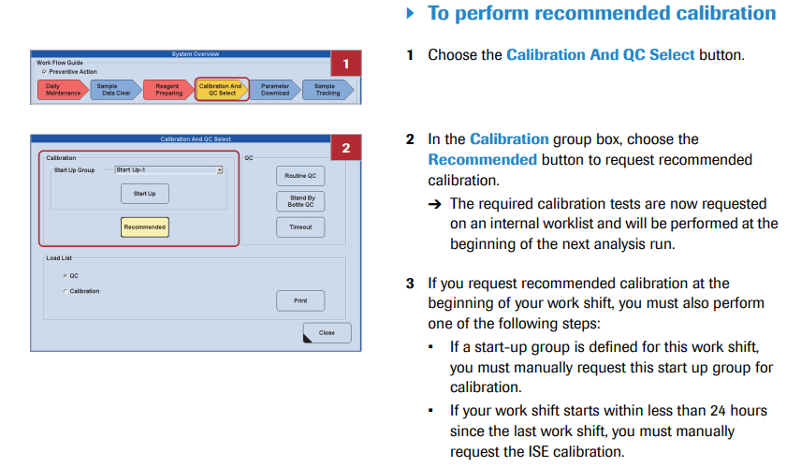

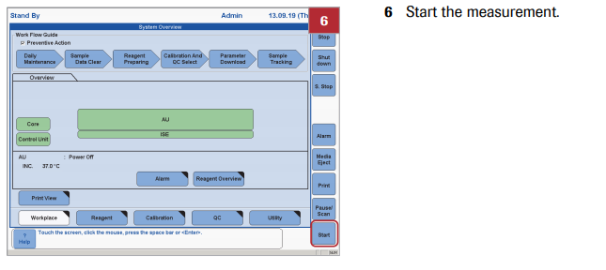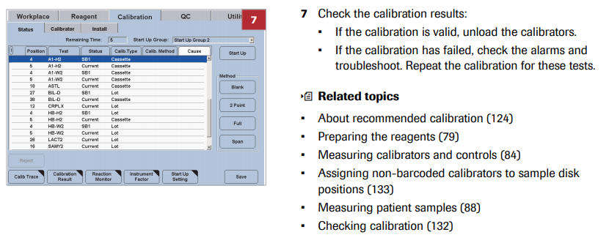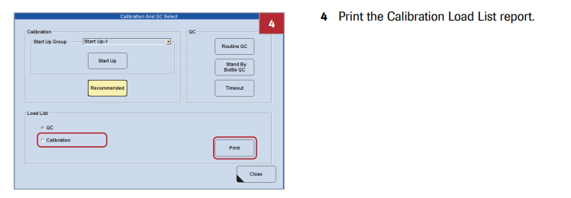
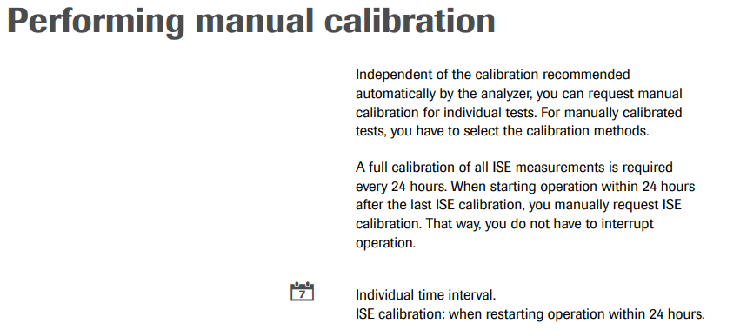
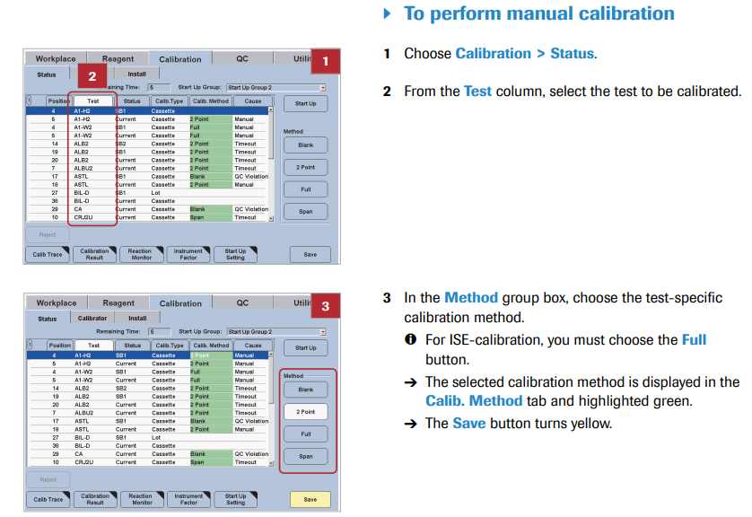
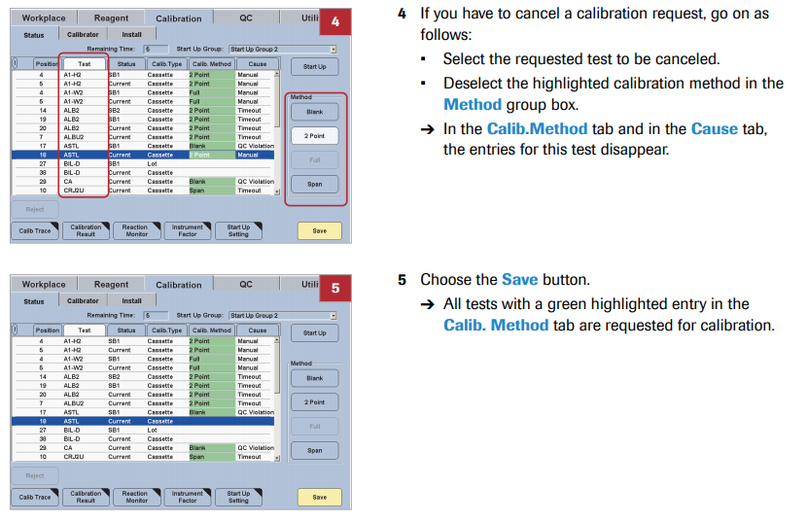
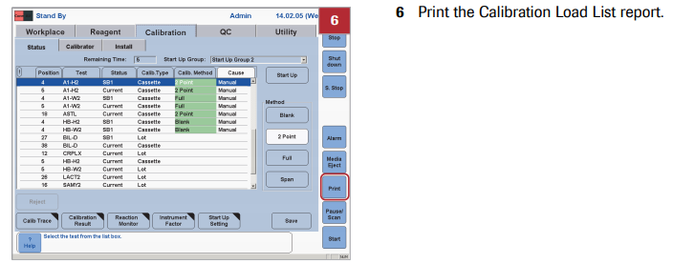
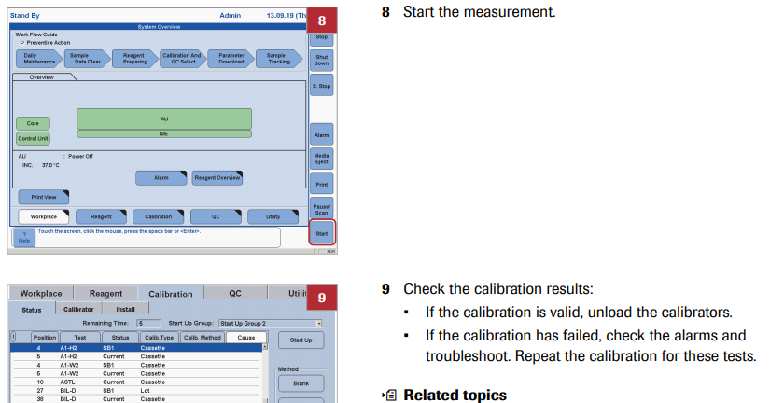

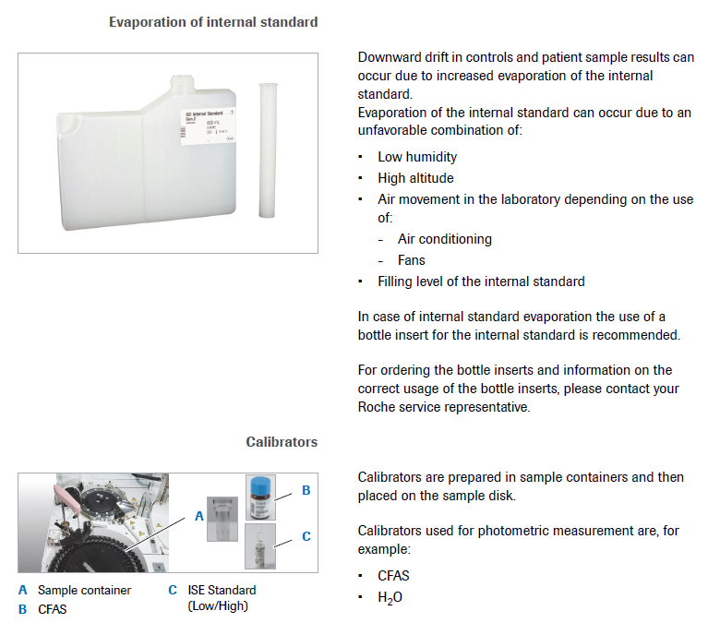
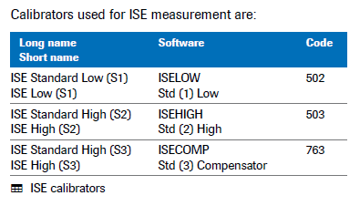

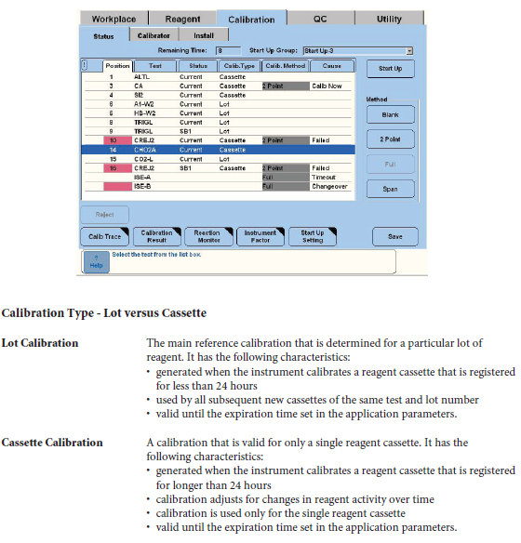
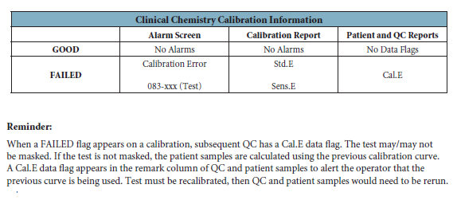
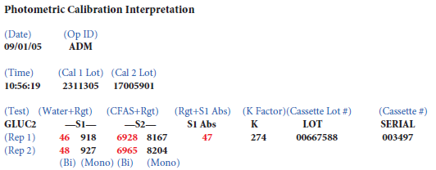

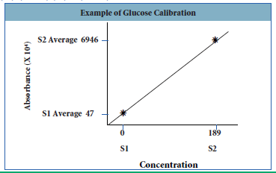

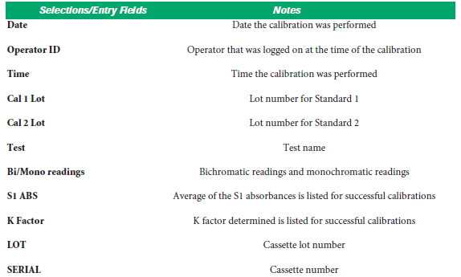

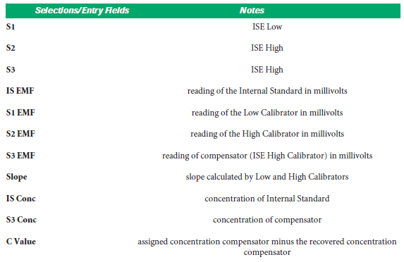

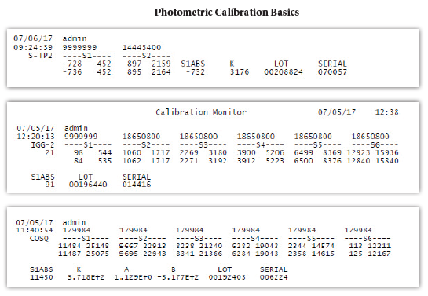
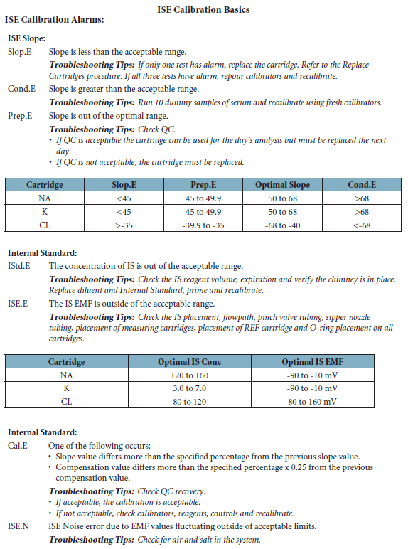

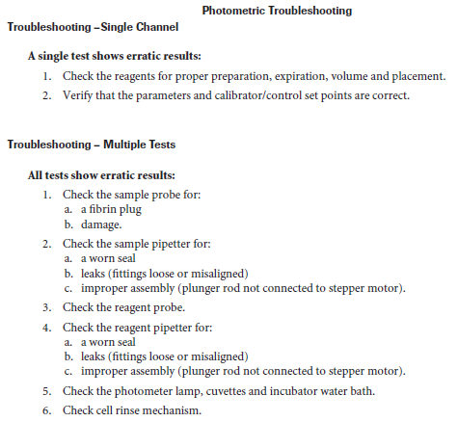
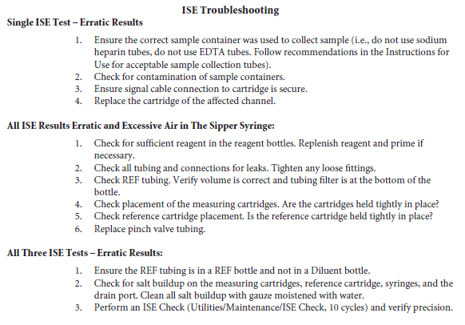
- QC:
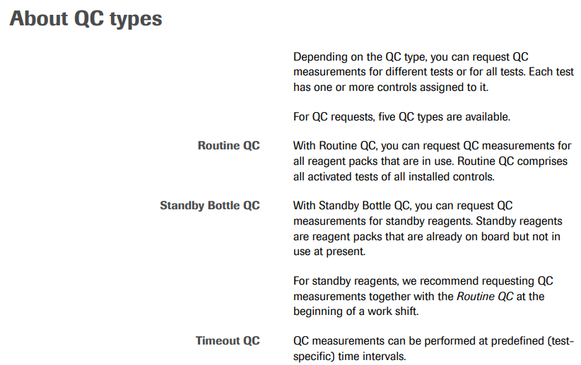
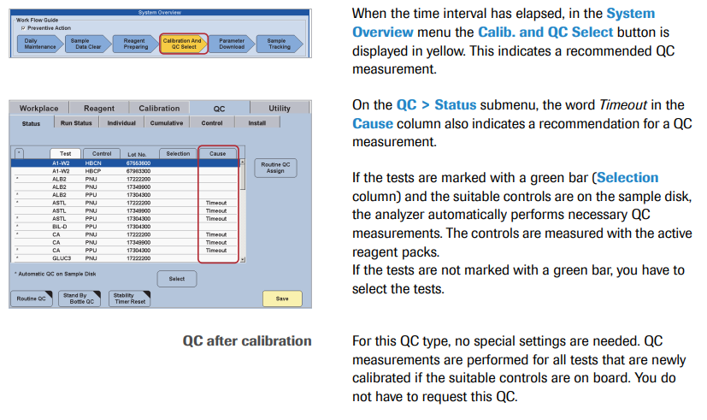
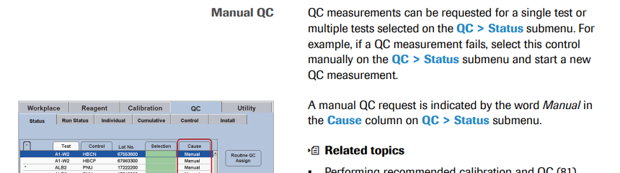

- Performing QC on individual tests:
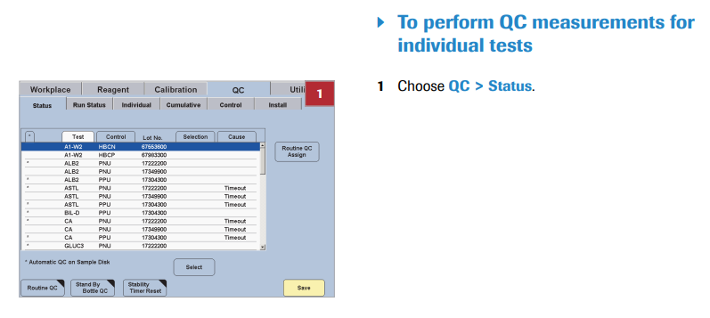
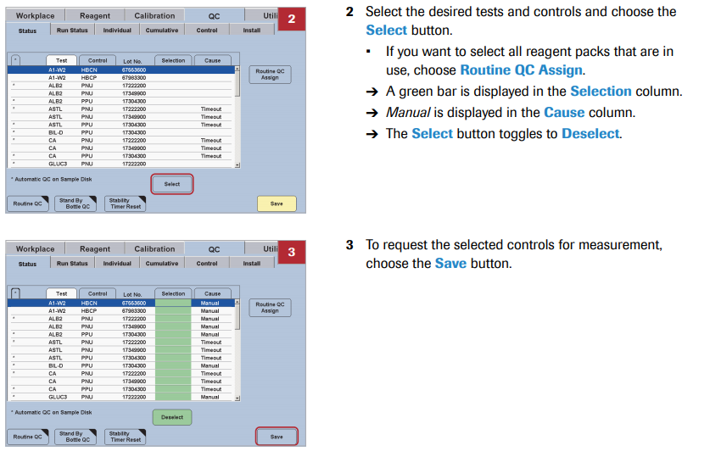
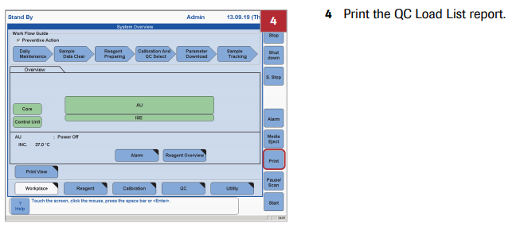
- Performing QC after Calibration
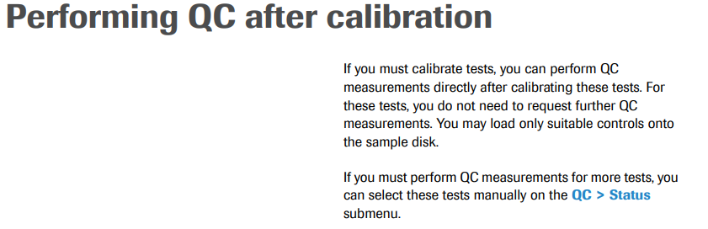
- Performing QC on individual Standby bottles:
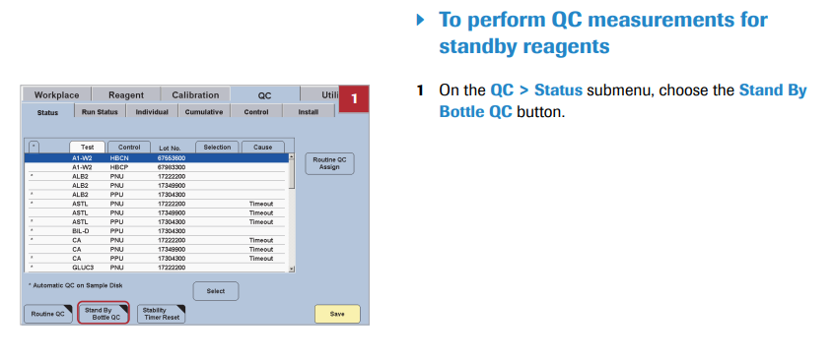
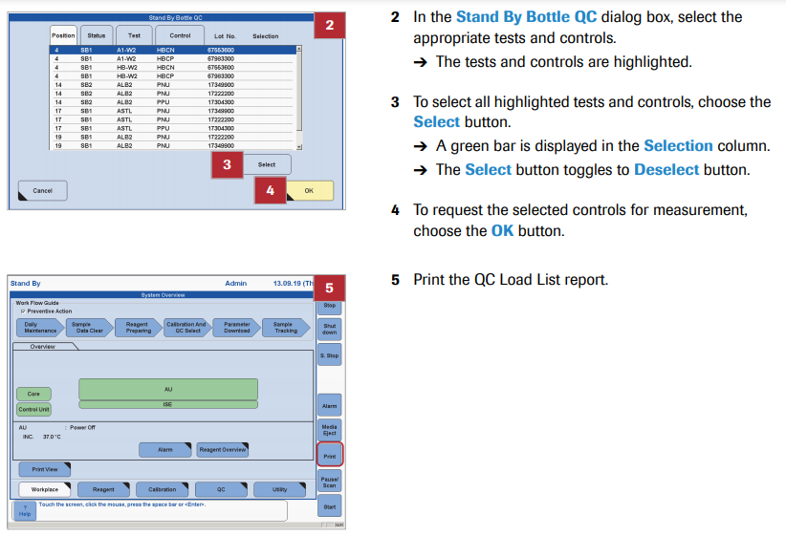

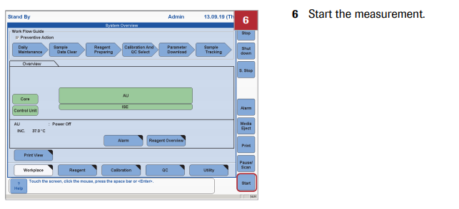

- Online Help:
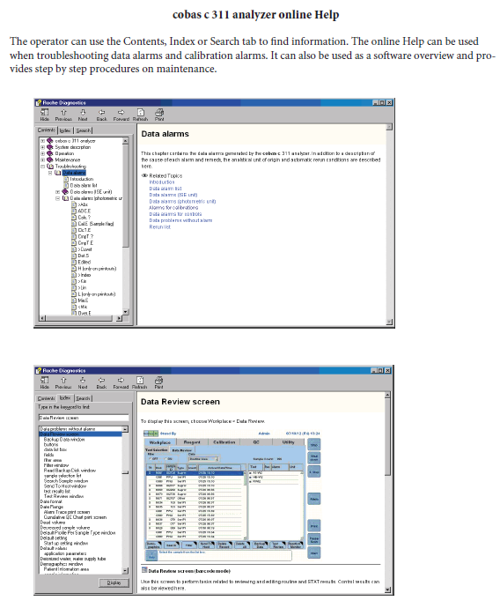
- Maintenance
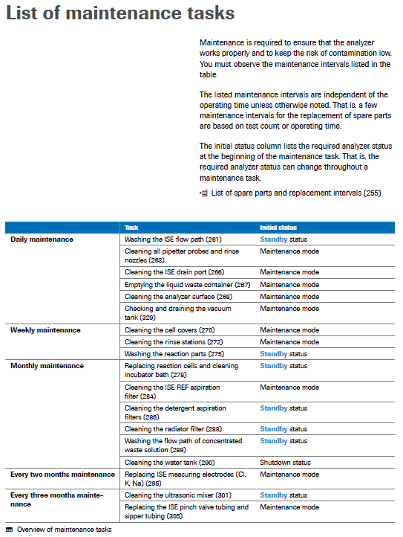
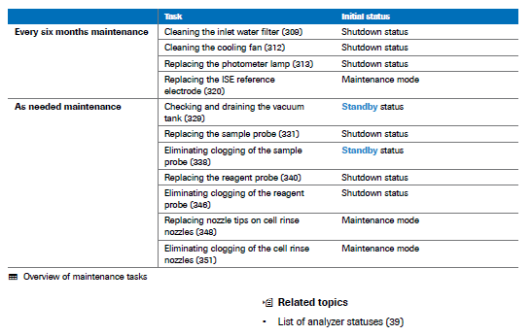
- Photometer Check
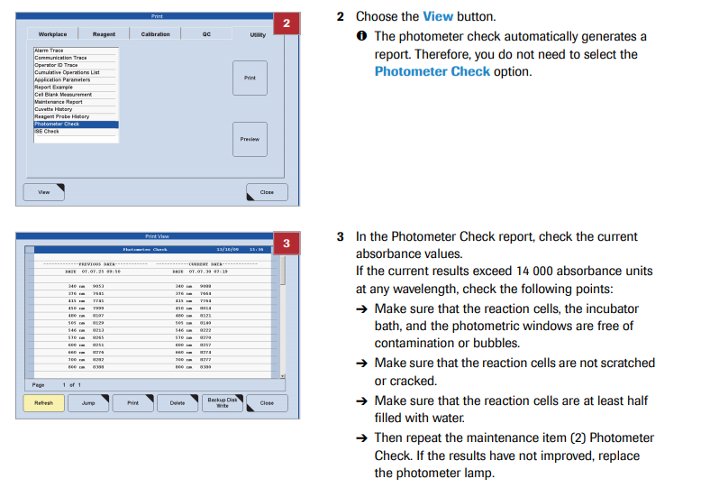

- Daily Maintenance:
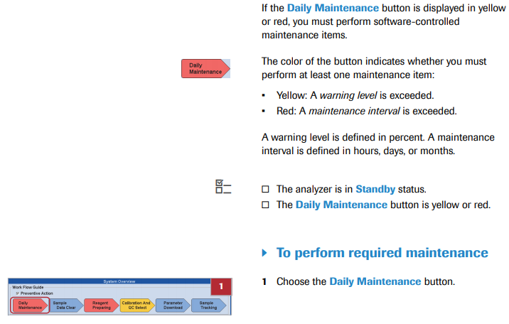
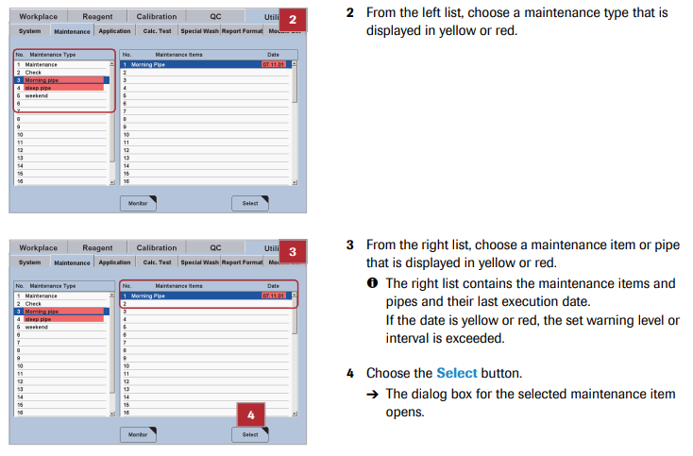

- Maintenance Mode
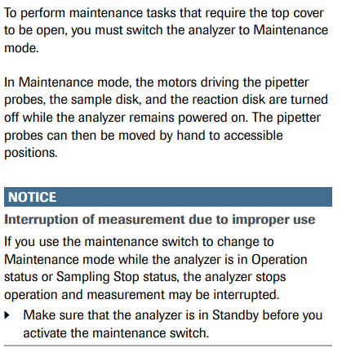
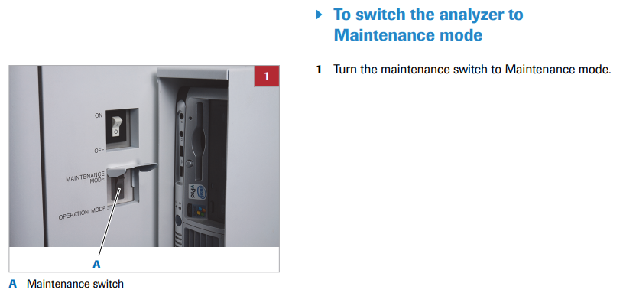
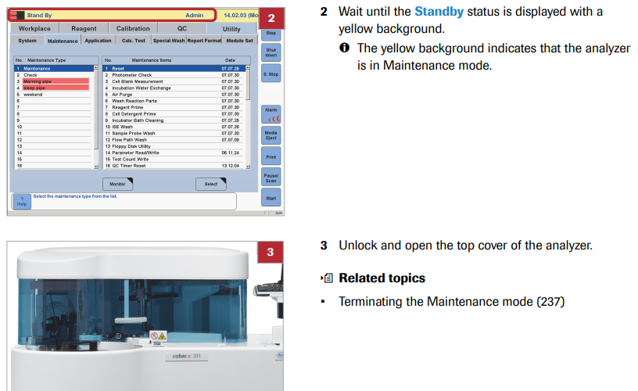
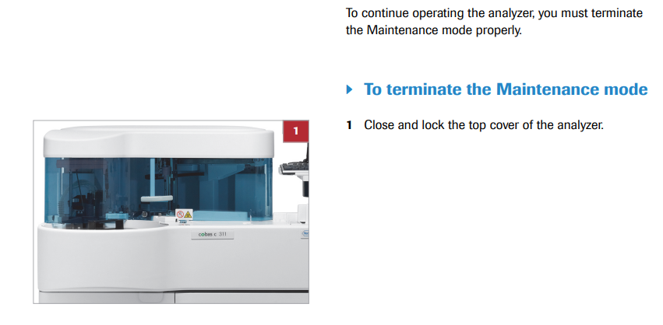
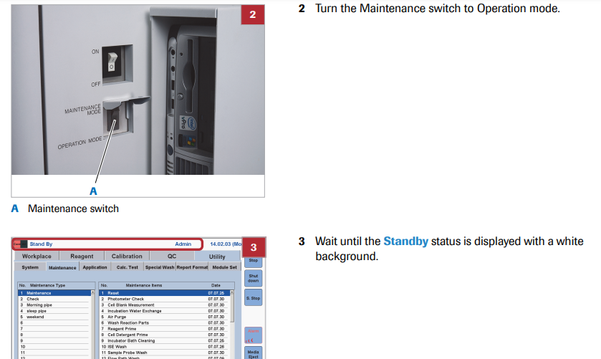
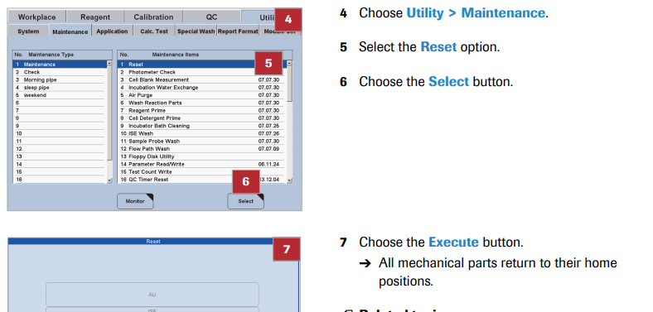

- Pipes:
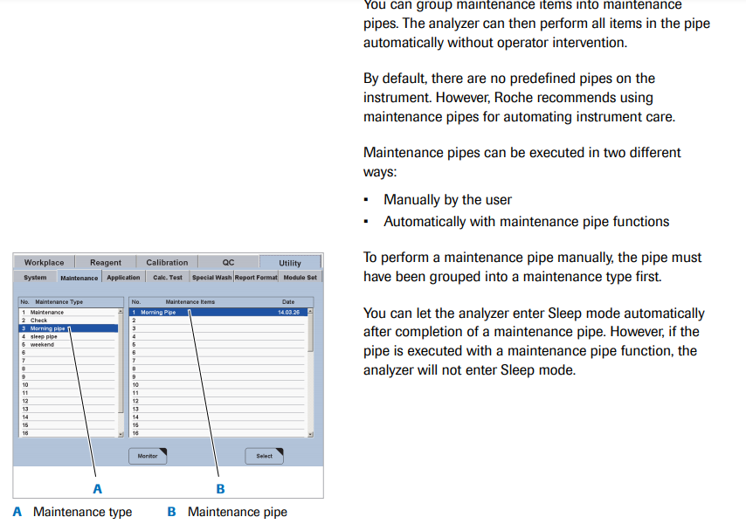

- Due time for Pipes:
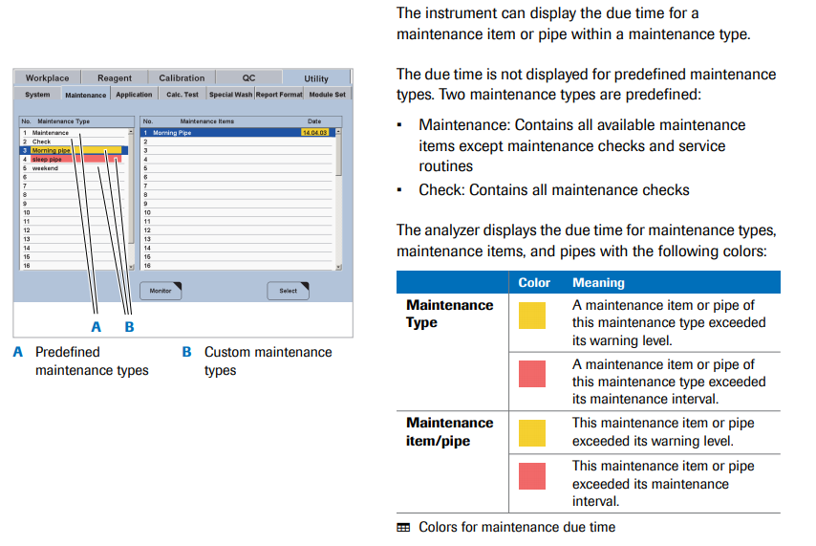

- Maintenance Items:
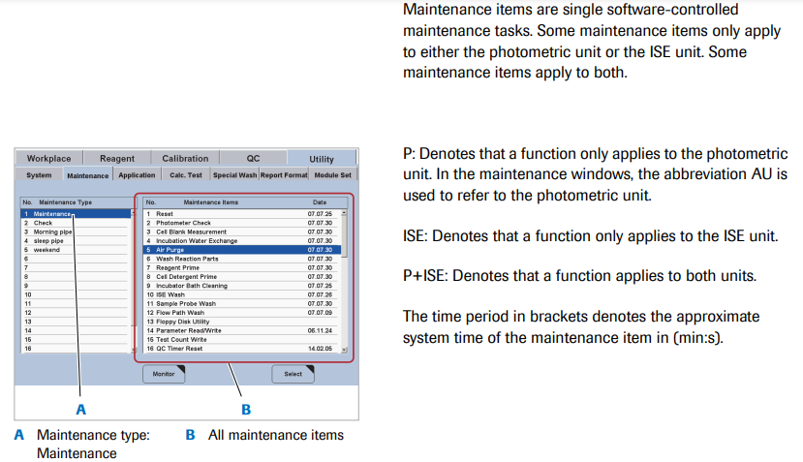
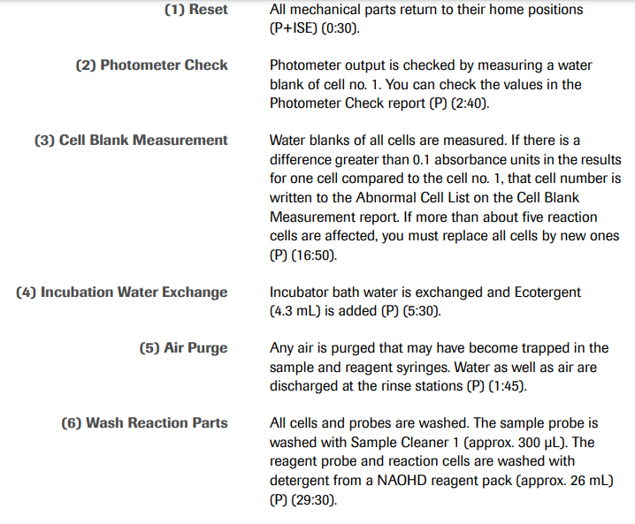
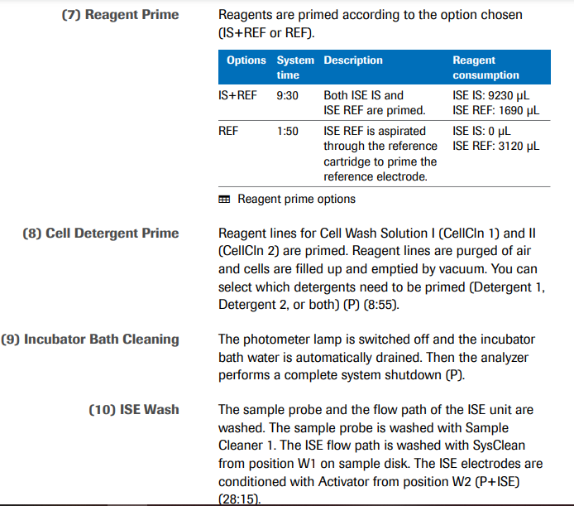
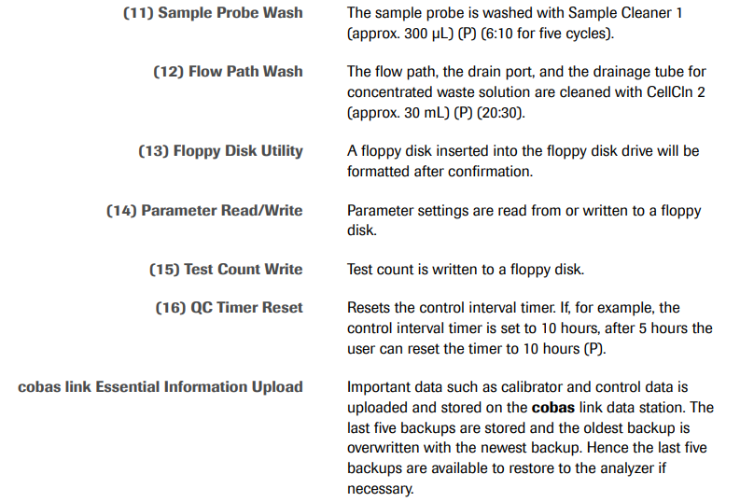
- Maintenance Checks:
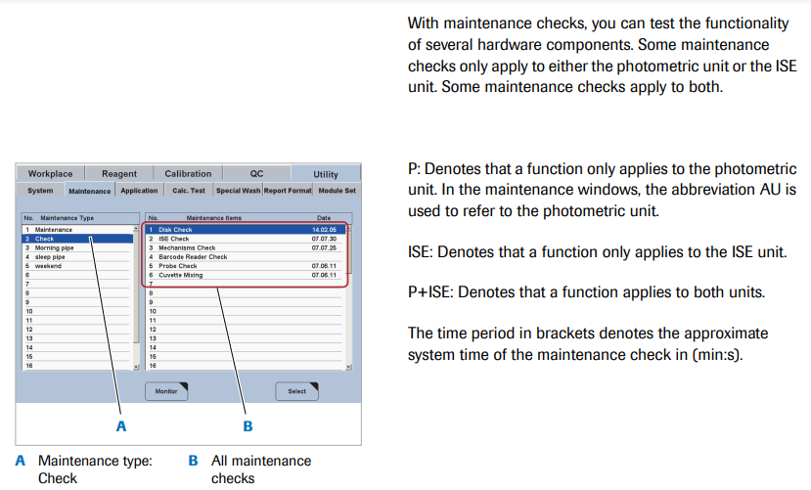
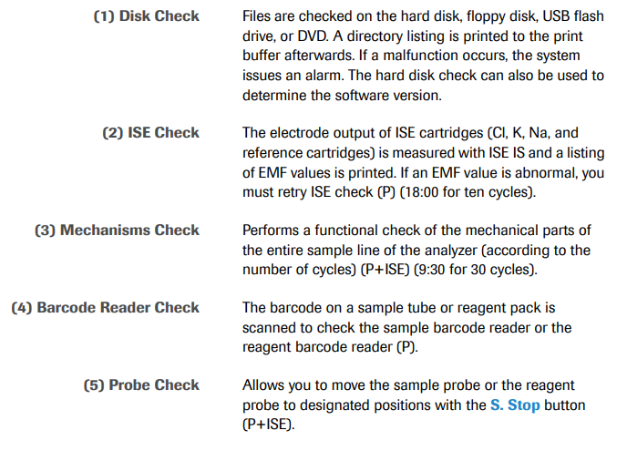
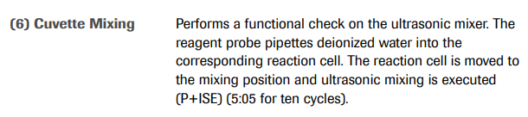

- Tools, Materials and Solutions:
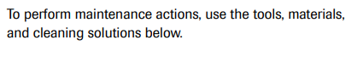
- Tools:
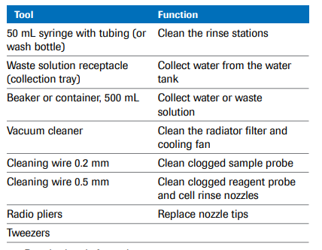
- Materials
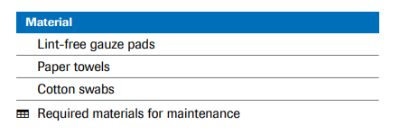
- Solutions:
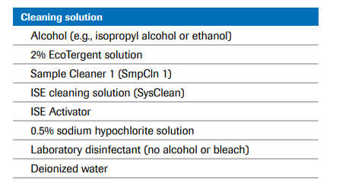

- Periodic Maintenance:

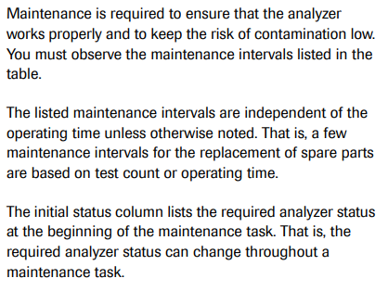
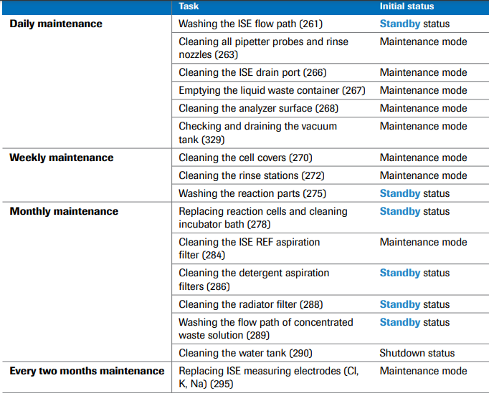
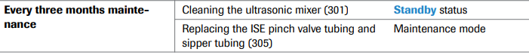
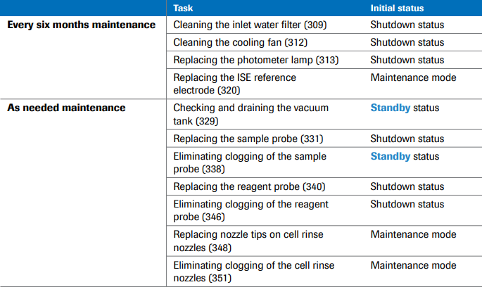

- Clearing the Sample Data Base
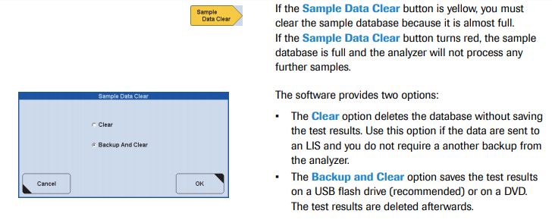
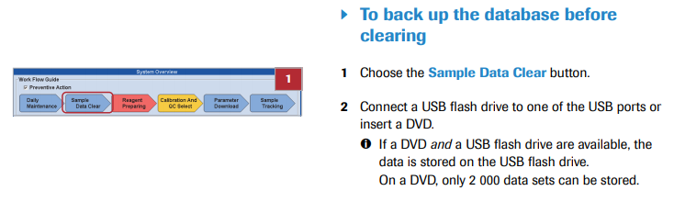
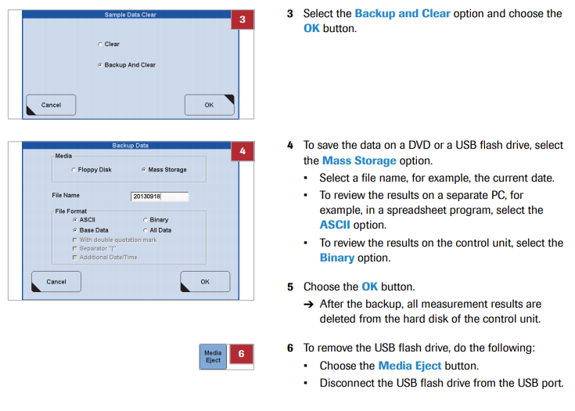
- Reagent Preparing:
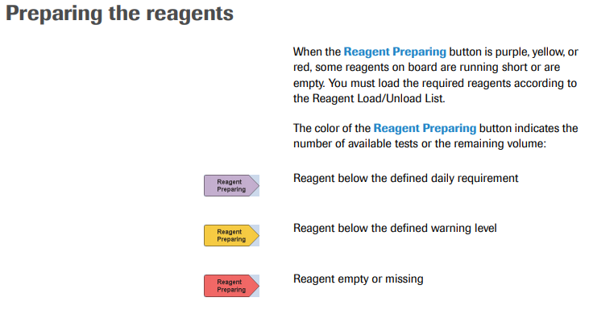
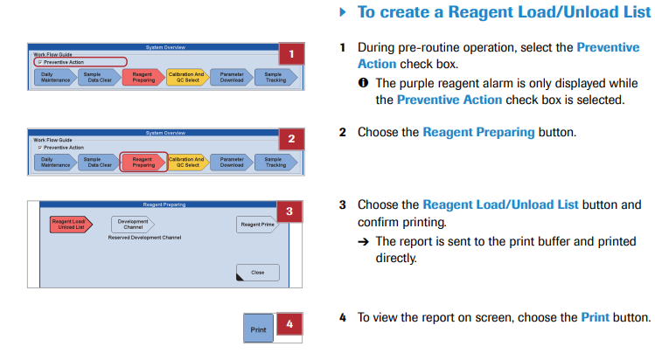
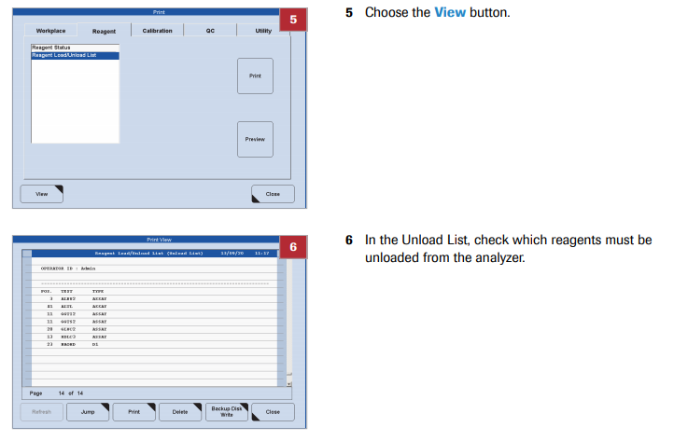
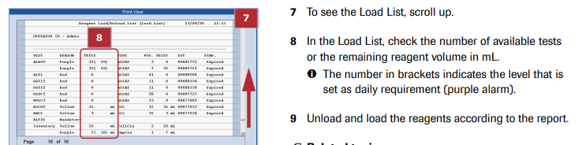

- Performing QC
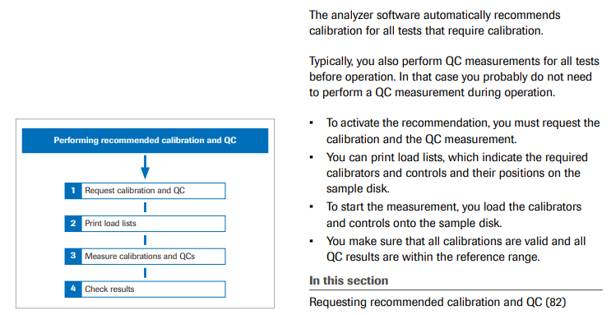
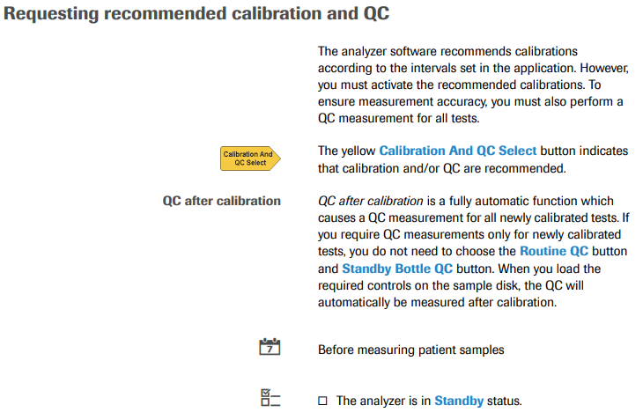
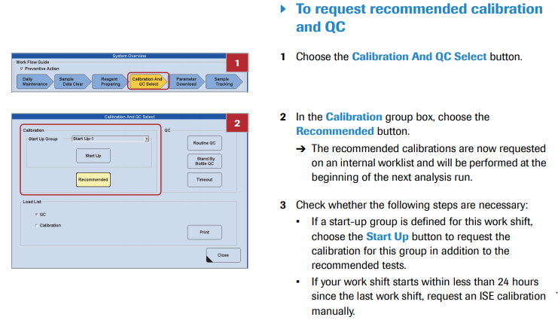
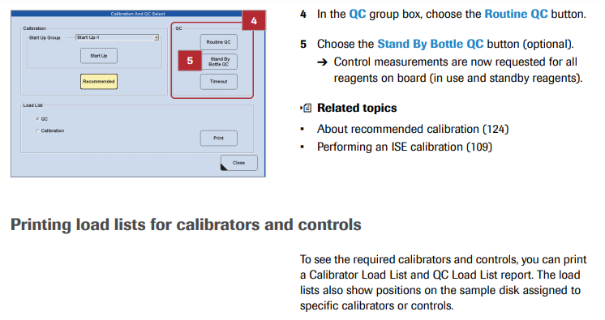
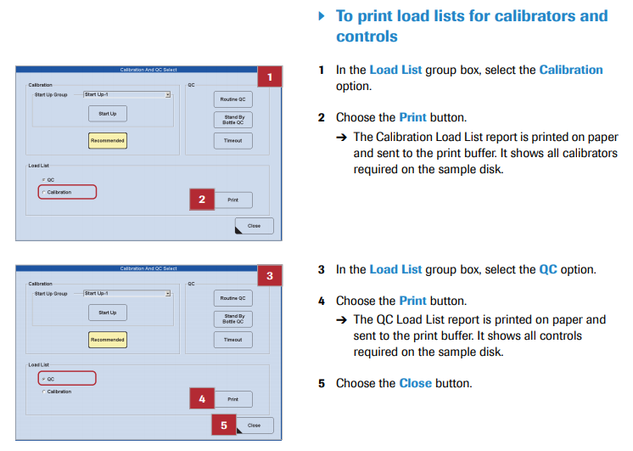
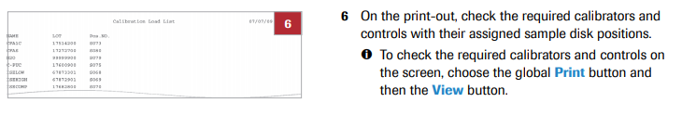

- Measuring Patient Samples:

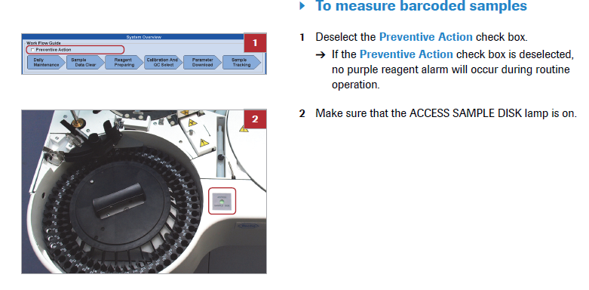
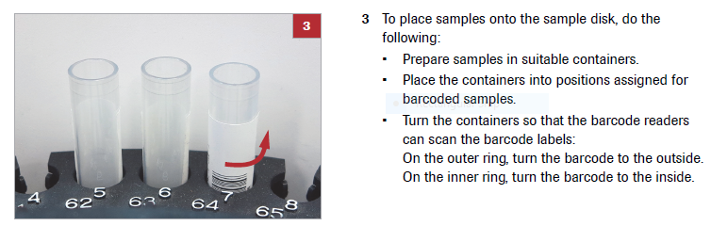
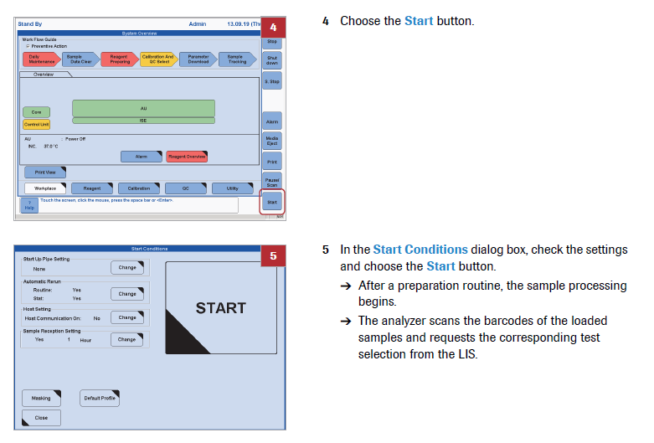
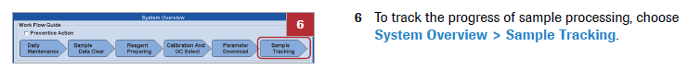
.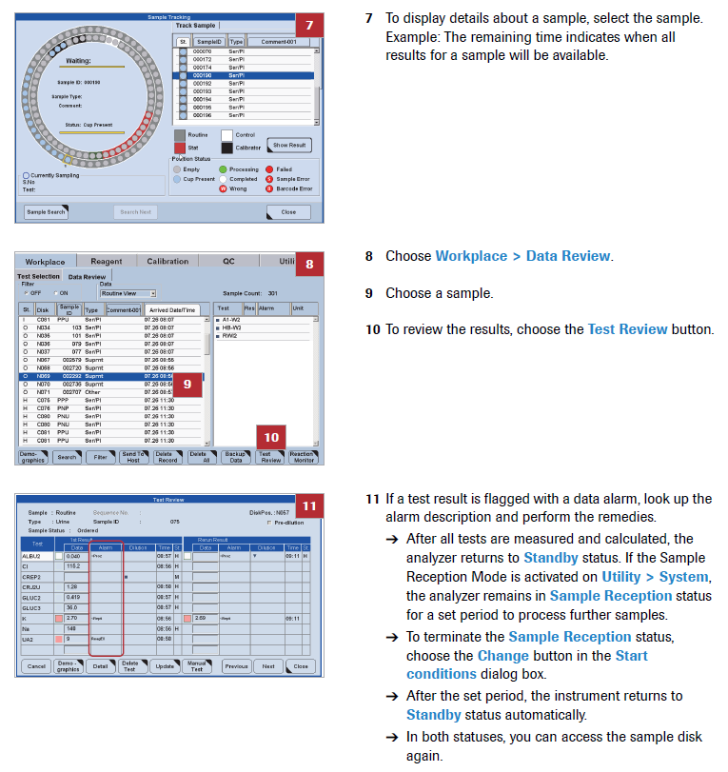

- Running Patient Samples
- Manual Order:
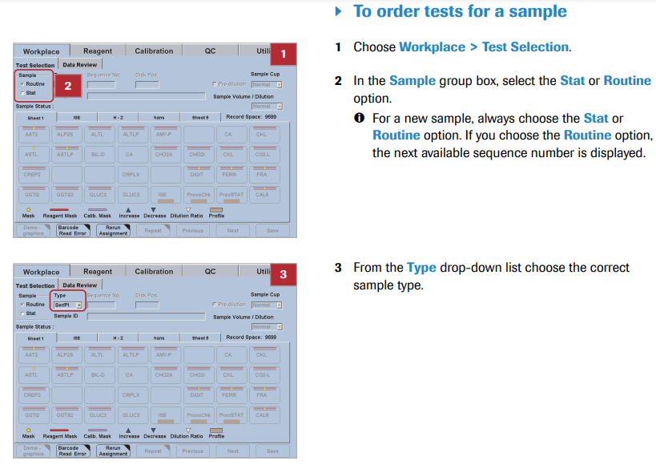
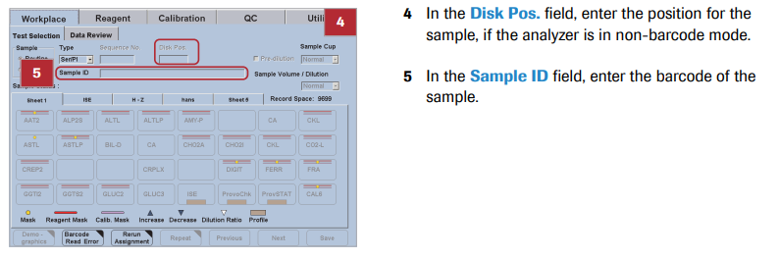
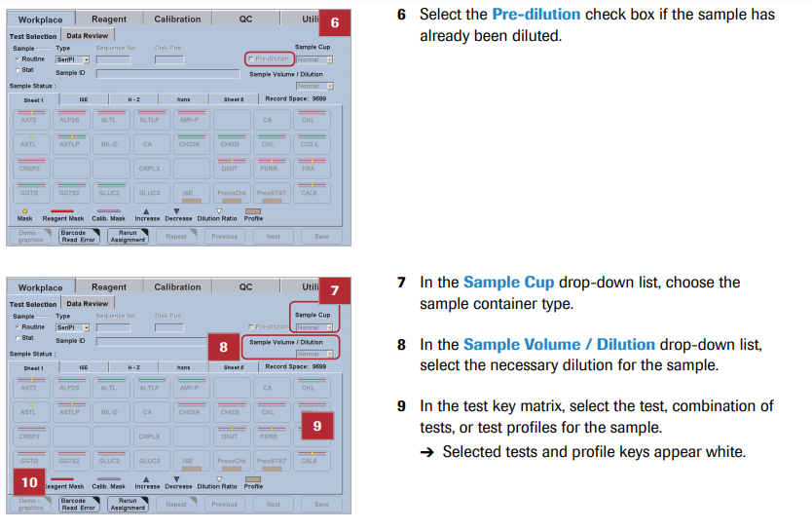
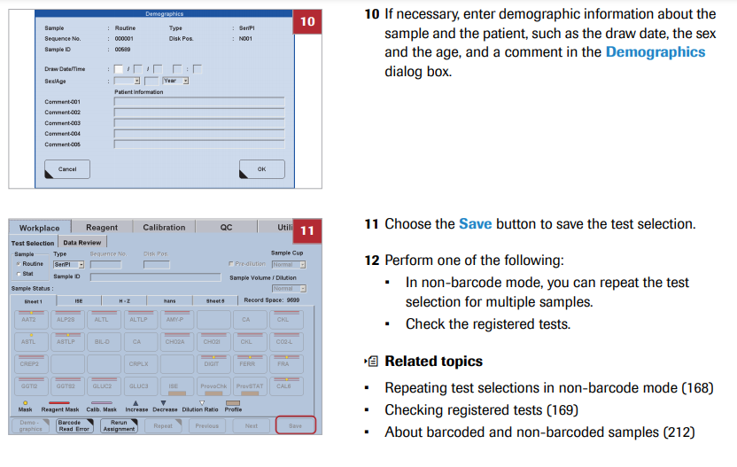
- Loading Samples:
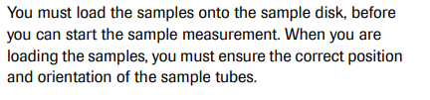
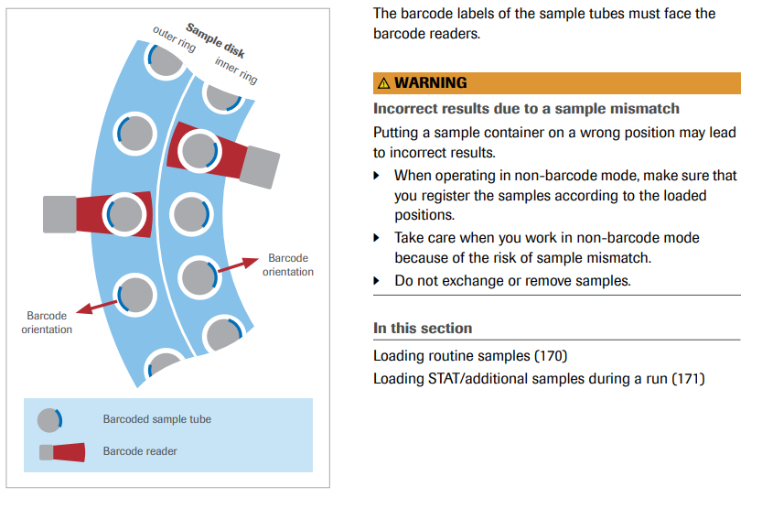
- Routine Samples:
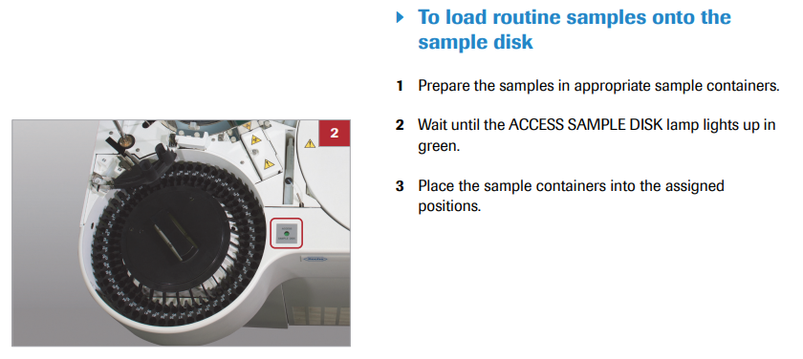
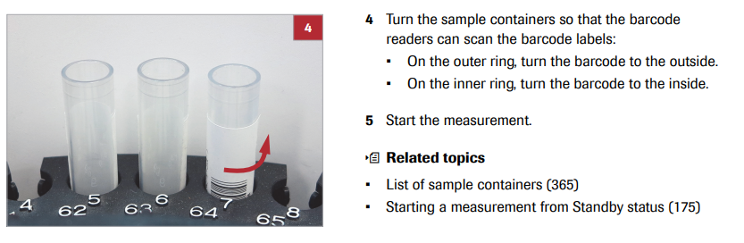
- STAT Samples:
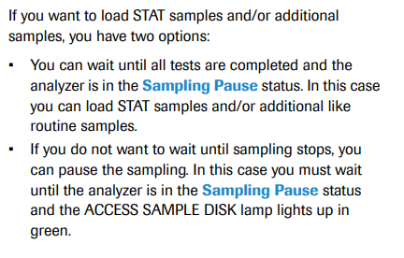
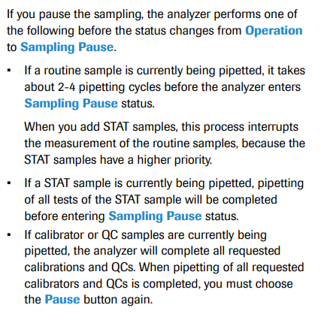
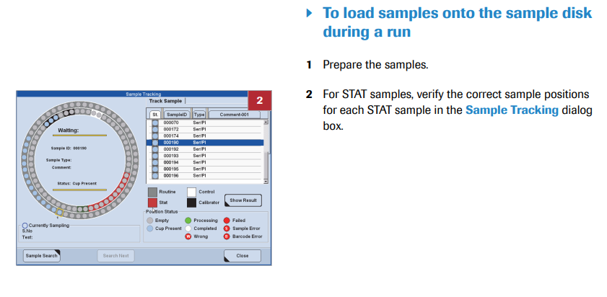
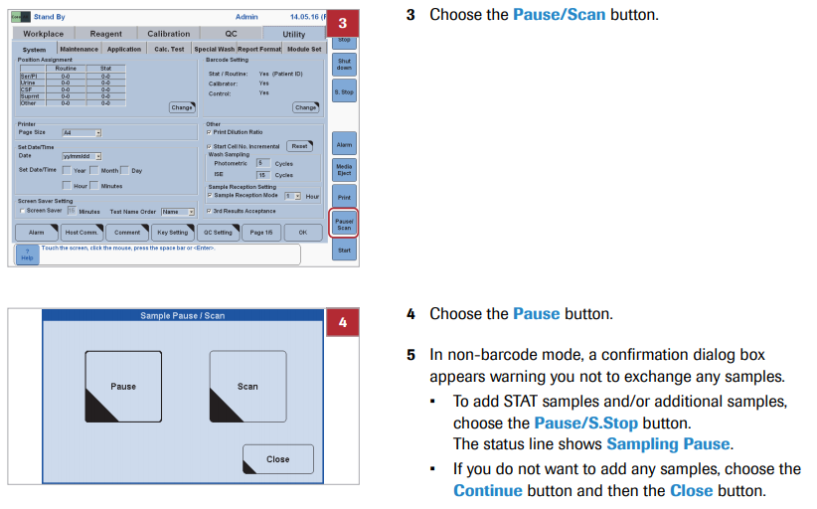
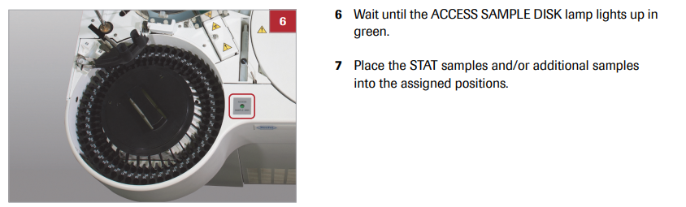

- Sample Tracking:

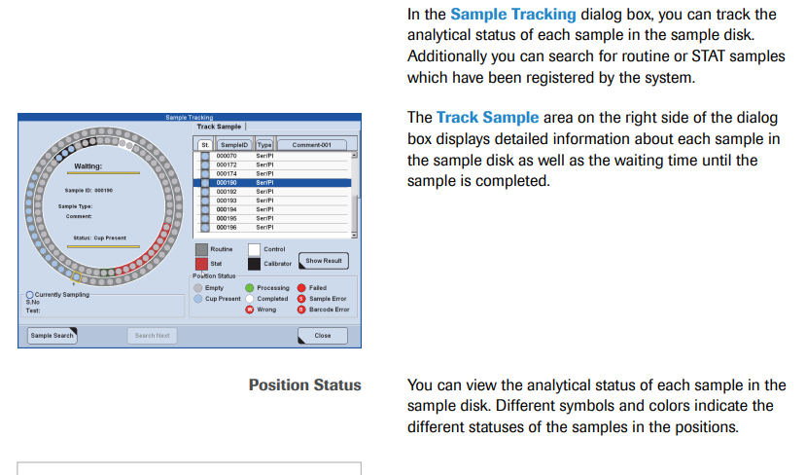
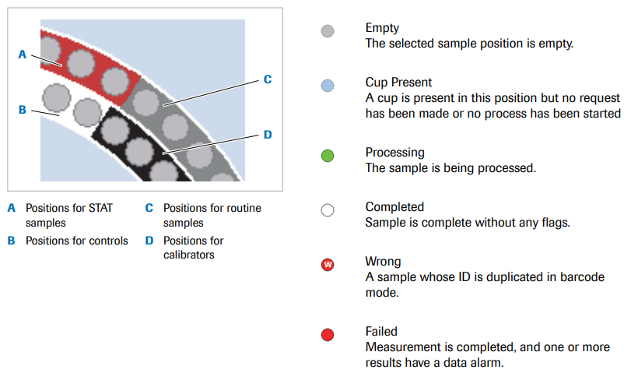
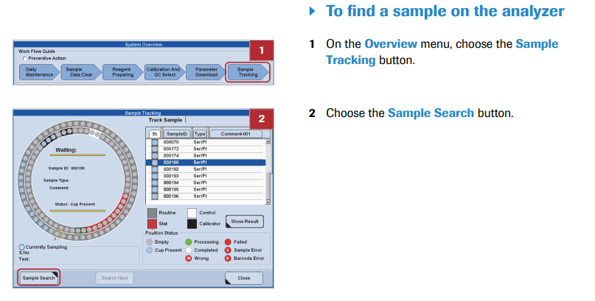
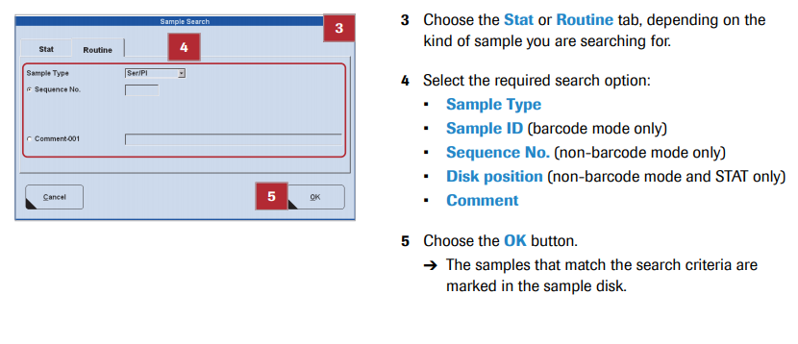
- Adding additional samples:
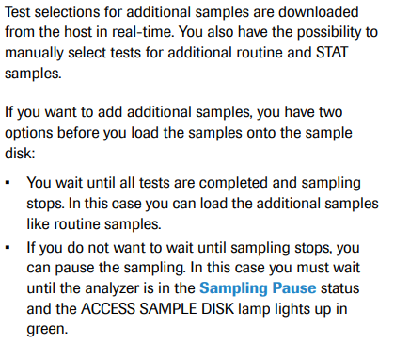
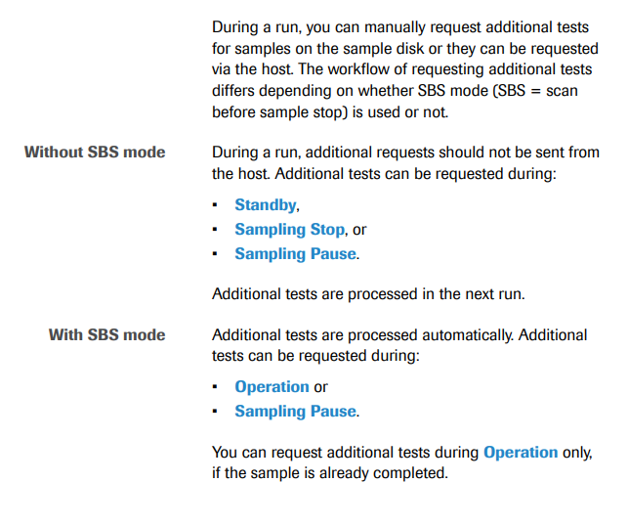
- Barcodes:
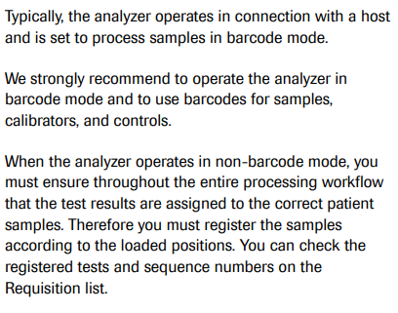
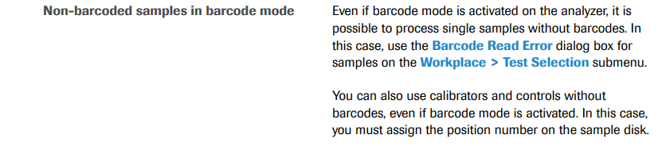
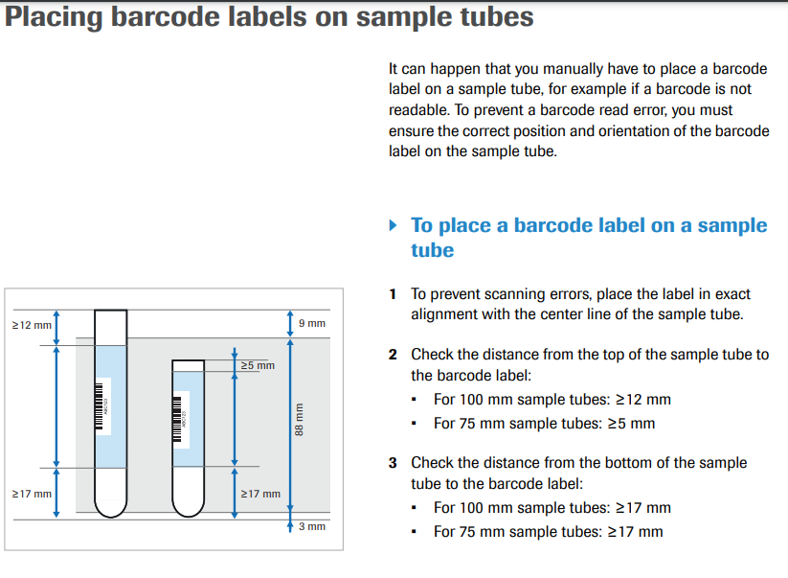
XI. LIMITATIONS
NA
XII. CALCULATIONS
Auto dilutions, manual dilutions

XI. INTERPRETATION
NA
XII. RESULT REPORTING
NA
XIII. TRAINING

Role | Training Needed
Management | Read
Employees | Read

XIV. REFERENCES
Roche Diagnostics cobas c311 Operator’s Manual, Version 2.1 2010

[Document title] - Knowledge Check

In the event of a question answered incorrectly: Single line through the incorrect answer, initial & date, then select the correct answer.

ALWAYS HAVE CHANGES INITIALED BY YOUR TRAINER.

Circle True or False for each of the following statements.

1. | True or False
2. | True or False
3. | True or False
4. | True or False
5. | True or False

Any incorrect answers I may have initially written have been discussed and corrected. I now understand the answers I may have gotten wrong.

PASSING GRADE IS 75% OR GREATER

________________________
Employee name (print)

________________________ ______________________
Employee signature (Date)

________________________
Supervisor/Manager name (print)

________________________ ______________________
Supervisor/Manager signature (Date)

[Document Name] - Skills Assessment

Trainee Name:

Trainer Name: Review Date:

Skill | Trainee  Initial and date | Trainer  Initial and date

________________________
Employee name (print)

________________________ ______________________
Employee signature (Date)

________________________
Supervisor name (print)

________________________ ______________________
Supervisor signature (Date)

[Document title] – Answer Key

All false answers must have correct answer with explanation.
All true answers must reference supporting statement in document.

<Revise for True or False as applicable>

1 | FALSE | State Question
 |  | Correct Answer:
2 | FALSE | State Question
 |  | Correct Answer:
3 | FALSE | Question
 |  | Correct Answer:
4 | TRUE | State Question:
 |  | Supporting Statement:
5 | TRUE | Question:
 |  | Supporting Statement:

