TITLE: Sysmex Molis WAM

- PURPOSE

Molis WAM is a software program designed to interface the specimen results and flagging generated by the Sysmex hematology analyzers with the Laboratory Information Sysmex – Soft Lab. Specimen “rules” were created to control auto-validation, direct the HST line to perform additional testing, repeat confirmation or make a blood smear slide. The middleware program displays the analyzer’s results and graphical information and operator alerts with instructions for the analyzer operators.

- SCOPE

To be used by personnel at URMC Strong Memorial Hospital, Automated Lab, Highland Hospital Hematology Lab, and Ridgeland Road Central Lab.

lll. RESPONSIBILITIES

Department and functional responsibilities are defined in the table below:

Group/Person | Responsibility
Quality Assurance | - Supports the development of this document.  - Review and approval of this document.
Medical Director | - Ensures that the procedure is followed.  - Review and approval of this document.
Supervisor | - Ensures that the procedure is followed.  - Review and approval of this document.
End User | - Follows the procedure.

- SPECIMENS

  - All lavender top samples with CBC/Differential/Retic counts requested processed on Sysmex hematology analyzers.

- QUALITY CONTROL

Not Applicable

- SPECIAL SAFETY PRECAUTIONS

Sysmex Molis WAM duties requires handling of patient samples. All patient specimens should be considered potentially infectious and must be handled with precautions used for human blood, as described in CDC (Center for Disease Control) recommendations and in compliance with the Federal OSHA (Occupational Safety and Health Administration) Blood-borne Pathogen Standard, 29 CFR (Code of Federal Regulations) part 1910.1030. Follow specimen handling as outlined by Laboratory Safety Policy, (SH.CP.AU.gen.0005.0001).

- MATERIALS

A. Equipment
1. All components necessary for sample processing via the Sysmex hematology analyzer systems.
2. PC with Sysmex Molis WAM program installed.
3. Sysmex Molis WAM server.
4. URMC/SH network connections

- PROCEDURE

A. All new employees will be assigned a user code and password; once assigned you may change your password at any time. From the desktop, use the Molis WAM icon to access the Molis WAM log in screen. Enter your user code and password as follows.

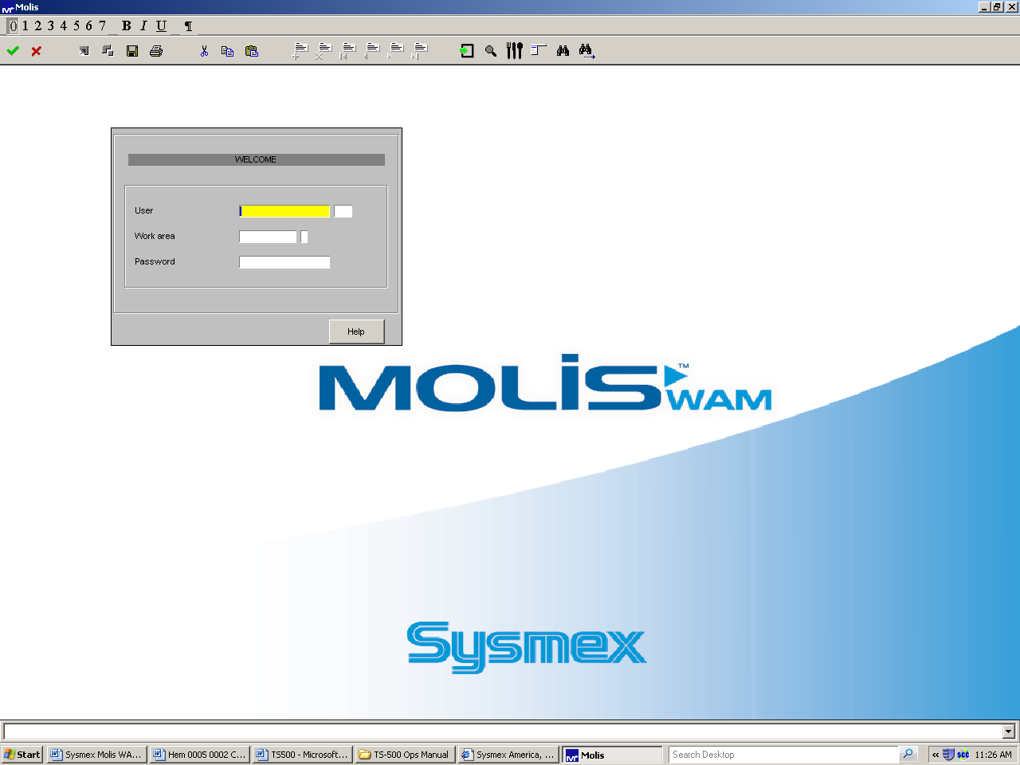
Enter user ID (your initials)
Enter password

1. Click on or tab over to the user ID. Enter your three digit ID code and press tab.
2 Enter your password (password is case sensitive) and hit the tab key or the enter key associated with the number keypad.

B. The Molis main menu appears

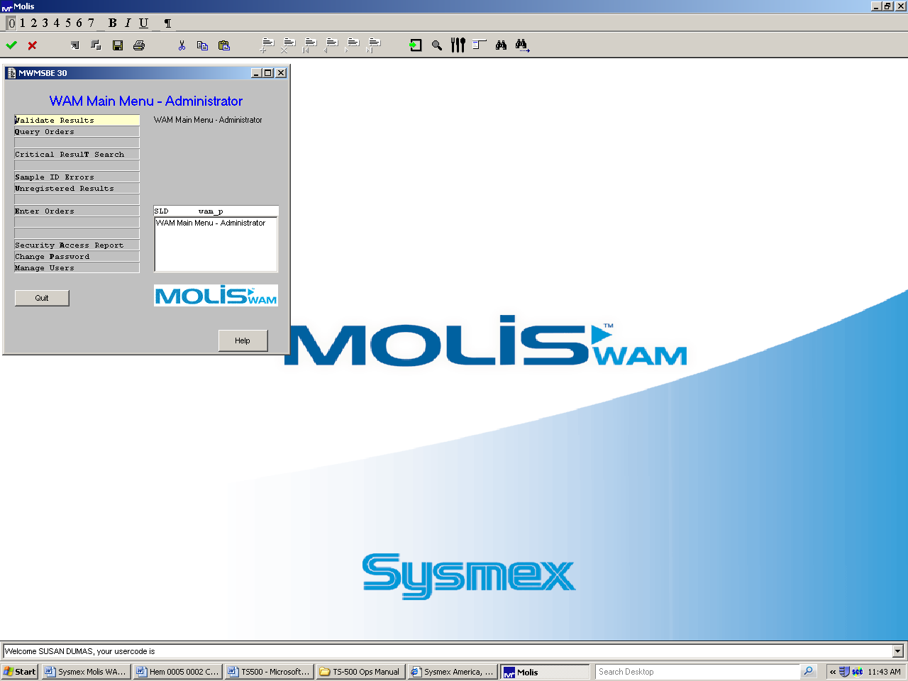

C. To navigate the Molis menus you will utilize F-functions, hot keys and the computer’s mouse.

Sysmex WAM Function Keys
Esc Gold
F1 Add Record
F3 Search
F4 Accept
F5 Detail
F6 Zoom
F7 Remove/Add Toolbar at Top of Screen
F8 Quit Without Saving Record
F11 Scroll by Record (move to next record)
F12 Scroll by Page (move to next page)
Alt , (arrow up) Next Order
Alt , (arrow down) Previous Order
F2L Log out
Gold F1 Copy Record
Gold F2 Delete Record

D. On-line Help

Each application provides an on-line help functionality. Press the Help button at the lower right of the screen. Help will take you directly to the section of the help document you are currently logged on to.

- Exiting from Molis WAM

To exit the application
  - Press F8
  - The Exit screen will appear – select Y to exit or N to return to the Molis main menu.

- Molis WAM main menu
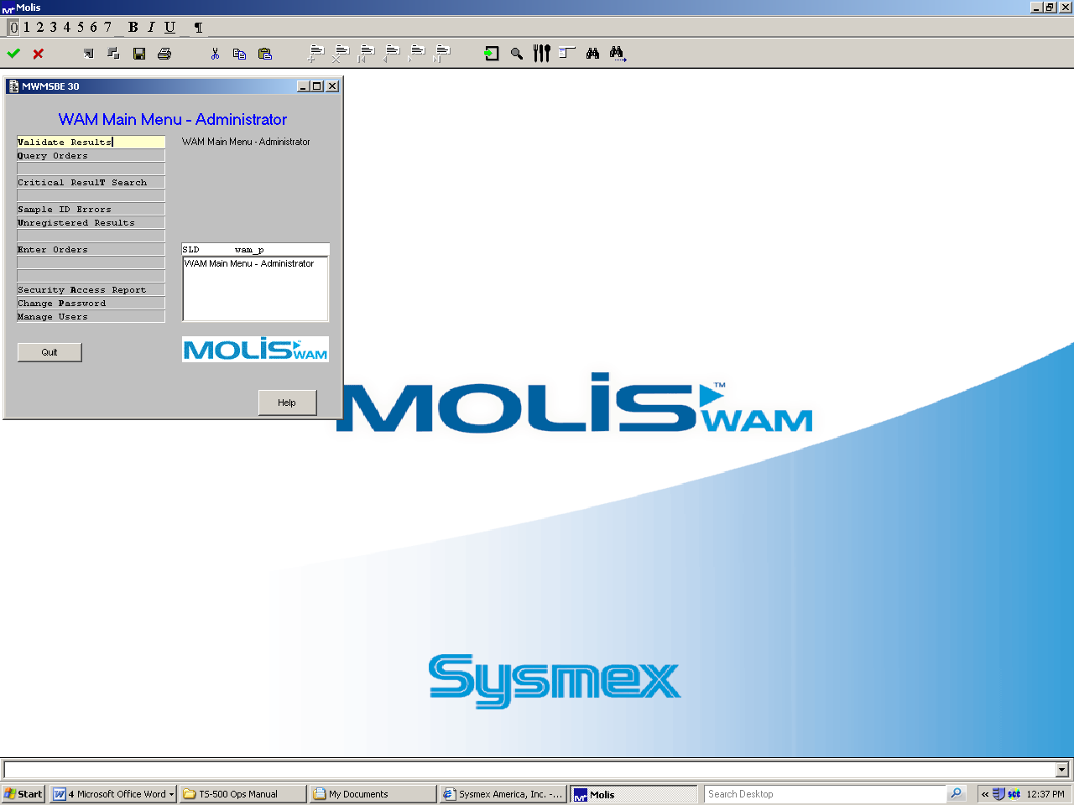

The available actions on the Molis WAM main menu are based on the user level. At the main menu, select an option by double clicking on it or use the appropriate hot key (the letter that is bold on the menu option – ex. V for validation).

G. Validate Results

  - Many of the samples will auto-validate in Molis WAM and be uploaded to Soft where it will auto-verify. Some samples will auto-validate only the CBC and hold the automated differential pending manual differential review. Sample results will not auto-validate for multiple reasons including: a reflexed rerun, platelet or differential flags requiring manual review, delta checks, or critical value results, etc.
  - View samples that did not auto-validate by accessing the validation menu.
  - Double click on Validate Results or press V from the main menu.
  - The Validation menu provides multiple search criteria. Use criteria 1 (patient’s order number including the Soft extension) or use the buttons located at the lower section of the menu. To access a particular specimen it is best to use the sample ID number, to review the current samples pending operator intervention, click on the CBC button at the bottom.
5. Unregistered samples (specimens that have no WAM test orders) will be discussed in a latter section of this manual.

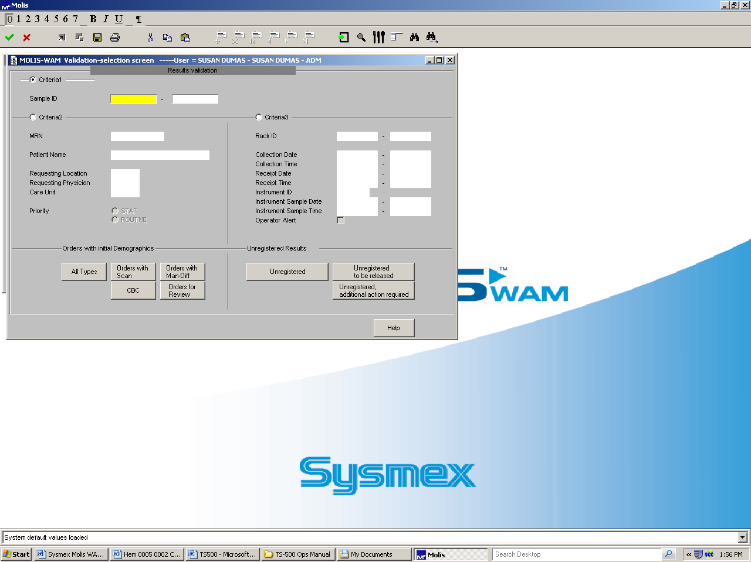
Order number
Menu buttons

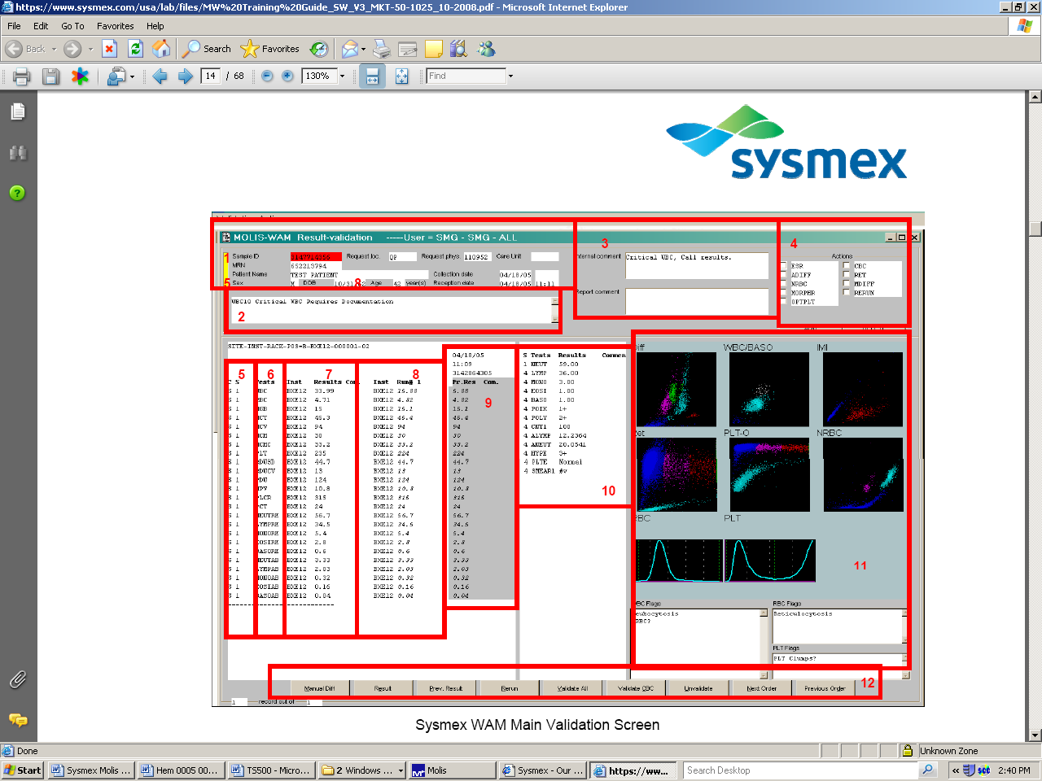
13

1 Demographic area: Patients name and demographics displayed. Stats appear backlit in red in sample ID.
2 Operator alert area (OPALERT) : any instructions related to rules will be displayed here. Many of the rules require a rerun. The operator alerts that appear in section 2 are based solely off the initial run of the sample, any subsequent run’s op alerts will populate the WBC, RBC and Plt flag boxes located at the lower right. When deciphering multiple run results; select the Rerun button to bring up the individual runs. Click on the Graphics box to see the results and flags for that run. Additionally, any manual diff and/or smear reflex requests come from the initial run. It is up to the operator to ensure the proper manual tests are generated.
3 Order comment area: Internal comments remain in Molis WAM. Use the internal comment box to send messages to techs at the scope area, e.g.. the platelet count results that require manual review.
4 Actions box: Used to add or delete tests or a slide order for the SP1000.

NOTE: only orders that are manually added through the Actions Box can be manually deleted. It is not possible to delete an action that was created by a Sysmex WAM rule.

5. Control and status:
0 - no rerun scheduled
S - rerun complete, select one
F – rerun complete, result selected
E – rerun pending
0 - test to be run
1 - result available
4 - result validated
5 – result sent to LIS

6. List of test codes downloaded from Soft.
AXE 11 = site A (Strong), XE #1
AXE 12 = site A (Strong), XE #2
AXE 13 = site A (Strong), XE #3

7. Most recently run results and analyzer used

8. Previous run and which analyzer resulted from.

9. Most recent previous sample results.

10. Reflexed manual tests/Manual differential and morphology results.

11. Graphics and flagging.

12. Menu bar.

13. Sample location: The rack and position, or the Tube Sorter location will display in this area.

6. The current list of Molis WAM rules can be found on the desktop of the PCs in the Sysmex area and on Sharepoint Auto Lab Sysmex folder– Strong Health MW_Rules..

7. When a specimen barcode is read by the analyzers, the patient demographics download to the analyzer from Molis WAM and the test requests download from the LASC. The specimen is processed and the results then upload to Molis WAM where the results will be applied to the Molis rules. The rules in turn will determine whether further testing is required or the sample is ready for auto-validation.

8. Stat samples are backlit in red.

9. Some of the rules are Preflex rules. That means that the rule is applied upon receiving the order from the LIS prior to being analyzed. Patients from certain locations have additional testing at the initial aspiration. An example would be samples with an MTC (Medicine Treatment Center) location have an optical platelet count “preflex” ordered for the first run of the sample.

10. Basic rule interpretation:

a. Some of the flags need a slide made for manual Diff or manual RBC review.
- All critical results will flag. Low platelet counts and low hematocrits also require clot and label checks to rule out false results due to a clotted/mislabeled specimen. Molis WAM alerts you to critical values, but all documentation of critical values is performed in the LIS. Hematology test critical results must be called if the patient has not had a critical result of that parameter in the last 48 hrs. To the right of the current results is the most recent previous result. You may also utilize the menu bar at the bottom of the screen; click on the Prev. Result button for past results, or the LIS can provide previous results. If the patient has had this critical value in the last two days, you document the previous in Molis, but you will have to finalize the results in Soft. In Soft go to the Instrument menu and select the appropriate instrument interface (SMOL, IMOL or RMOL). All critical results (whether a previous exists or not) will hold on this interface. Verify the results and document the call comment accordingly.
Note: if this sample requires any manual review, even if the critical result has been addressed, it will reappear on the Soft instrument interface. and will need to be monitored..

- Some of the rules will alert the operator to take an action:
- check the sample for a clot for platelet flags
- verify the label for MCV and Hct delta checks
- Set up a dilution (using Cellpack) for high end linearity violations, or Retic abnormal scatter.
- Work up high MCHCs which cause the Turbidity flag.
- Have a manual WBC set-up

d. Some of the rules require the operator to decide between multiple runs of a sample. The XE’s initial run only includes the requested tests. When the analyzer detects the possible presence of NRBCs or there is a WBC delta check to list a few examples; Molis will initiate a rerun to perform follow up testing. The operator must choose the “acceptable” run. To view the multiple runs click on the Rerun button at the bottom of the screen. Select the Graphics button to see the instrument flags from that run Review the results and choose the run by selecting the Run # and press F4. Some samples may need to be run a third time and some reruns may not be automatically ordered. In the case where an optical platelet is reflexed due to a “platelet abnormal distribution” flag, only the platelet count will display on the second run. Once any Molis WAM driven rules are satisfied, additional rules can be generated via the action box.
NOTE: when “rerun” is chosen in the action box, WAM will display exactly what the previous run requested i.e. if the rerun requested an optical platelet - WAM will only display the optical platelet results on the rerun. Be specific, if a CBC and ADIFF rerun is needed and the previous run is only an optical plt select CBC and ADIFF at the action box. If the previous run was a CBC and Diff, then select rerun.
While reviewing multiple runs of a sample look to see that the results match. An exception to this would be if the sample was rerun for NRBCs, then you would expect a difference between the two WBCs. A good understanding of XE flagging, histogram and scattergram interpretation is essential for proper run selection and reporting decisions. See interpretation guide MKT-40-1010.

e. For a sample to properly run in the closed mode, it must meet the minimum volume. When short volume samples are accidentally run on the line they may produce aspiration errors. While reviewing single and multiple runs of results; check to see if they make sense. Check the MCHC to see if it is between 27-37.4. If not go back to the sample and check the volume and/or check it for a clot before proceeding.

f. XE function errors – when an analyzer malfunction occurs an XE function error will be generated on the result. A Molis rule will reflex a rerun, but the rule also states that the operator must check the sample volume and check for a clot, as well as, determine the second run of the sample is analytically correct. XE function errors can be another tool to help the operator find sample aspiration problems due to clotted samples or short volumes.

g. The platelet flags are:

1. Platelet abnormal distribution –It occurs when the Impedance platelet histogram either does not start or return to the baseline. Samples either have already preflexed optical platelets or will rerun for the optical platelet. View the results for additional platelet flags.
2. Platelet abnormal scatter – this flag is due to interference in the optical scatter. This flag requires a clot check; if no clot - perform a platelet estimate. Type the analyzer’s platelet results in the Internal comment box. Next remove the platelet count out of the results by clicking on the Result button, scroll down to the platelet count and delete the platelet results. To the right of the result is a comment field. You can document clot checks in this field. To access the canned messages press the * key (the one above the 9 on the number pad) and then F5.
3. Plt Clump(s)? – note the s is in the ( ). This flag is generated by the Impedance histogram but will be disregarded if it does not occur with Plt Clumps? or abnormal scattergram. Review the results carefully.
4. Plt Clumps? – note the s is not in the ( ). This flag is generated by either the diff scatter, the IMI channel or the NRBC scatter. This flag will require a clot check; if no clot – perform a platelet estimate. Type the analyzers platelet results in the Internal comment box. Remove the platelet results by clicking on the Result button, scroll down to the platelet count and delete the platelet results. To the right of the result is a comment field. You can document clot checks in this field. To access the canned messages press the * key (the one above the 9 on the number pad) and then F5.
Summary –
- Platelet abnormal histogram – acceptable provided neither abnormal scatter or Platelet clumps? flags are present.
- Platelet Clump(s)? – acceptable provided neither abnormal
scatter or Platelet clumps? flags are present.
- Platelet Clumps? – check for a clot and review platelets
- Platelet abnormal scatter - check for a clot and review platelets
5. Citrate tubes for platelets
- check both the lavender and blue for a clot.
– run the citrate sample without allowing the instrument to see the entire barcode label (either run it in the open mode or in the closed mode with the barcode label covered up).
- If no clot – remove the EDTA platelet count from the results
Via the Result button, scroll down to the platelet count and delete the platelet results. To the right of the result is a comment field document the clot check.
- In the Internal comment box type both the lavender top platelet count and the corrected blue top (platelet count times 1.1) results for the technologist to review.

h. Dilutions
Some conditions will require verification via a dilution. The op alerts will indicate either linearity (1:2 dilutions) or abnormal scatter (1:5 dilutions) issues.
Using Cellpack reagent set up the appropriate dilution.
Run the dilution in the manual mode, but do not give it the full
Sample ID number (Type in the four digit sample number
leaving out the date and 18 extension).
Once complete – print the results from the XE
In Molis retrieve the original results and verify (using a parameter
which is not suspect) that the dilution results are truly ½ or 1/5 respectively; if not have the dilution set up again and rerun.
Press the Result key and scroll down to the parameter of issue.
If the dilution is for:
  - WBC >310 – multiply by the dilution factor and change
WBC to this number, and in the comment field indicate
the result was checked by a dilution.
  - RBC > 7.5 – multiply by the dilution factor and change
RBC to this number, but also change the HGB and HCT times the dilution factor and use the MCV, MCH and MCHC straight from the
dilution results and in the comment field indicate the result was
checked by a dilution.
  - Retic abnormal scatter – the op alert calls for a 1:5 dilution
Using Cellpack reagent set up the appropriate dilution.
Run the dilution in the manual mode, but do not give it the full
Sample ID number (Type in the four digit sample number
leaving out the date and 18 extension).
Once complete – print the results from the XE – verify the abnormal
Scatter flag is resolved.
In Molis retrieve the original results and verify (using a parameter
which is not suspect) that the dilution results are truly 1/5; if not have the dilution set up again and rerun.
Press the Result key and scroll down to the retic results.
Enter the dilutions retic percent at face value (the percentage of retics will remain consistent regardless of the number of RBCs) however for the absolute Retic count multiply dilution results by 5 and enter. Add a comment indicating the sample was checked by dilution. Retic linearity violations cannot be resolved via a dilution and will need a manual retic set up.
  - Absolute NRBC linearity violation - – the op alert calls for a 1:5 dilution
Using Cellpack reagent set up the appropriate dilution.
Run the dilution in the manual mode, but do not give it the full
Sample ID number (Type in the four digit sample number
leaving out the date and 18 extension).
Once complete – print the results from the XE – verify the NRBC abnormal scatter flag is not present.
In Molis retrieve the original results and verify (using a parameter which is not suspect) that the dilution results are truly 1/5; if not have the dilution set up again and rerun.
Press the Result key and scroll down to the NRBC results.
Use the NRBC/100 WBC straight from the dilution however for the absolute NRBC multiply by 5 and enter.
Add a comment indicating the sample was checked by dilution.

i.. As further testing is reflexed (i.e. manual diff) these tests will display in the section 10 of the validation screen. NEUT is for a manual diff, and with any NEUT a PTHREV (pathologist review) is included. RBCM is for manual RBC morphology. Smear 1 is for Platelet flags. Smear 2 is if a duplicate slide is ordered.
NOTE –Whenever a duplicate slide is ordered, the slide maker will always make two slides whether the sample results are positive or negative.
Because all reflex testing is based on the results and flags from the initial run of the sample (i.e a manual diff generated by a suspect flag) you may have to alter these additional tests/reviews depending on flags and codes generated by multiple runs.
When reviewing individual runs in the Rerun menu via the Graphics button; note what flags or rule violations are applicable to the run you have chosen and add/delete the appropriate test via the action box.

Note for the HST line operator:: when adding manual diffs to an order, check where the specimen tube is on the HST line, if it is past the slide makers at the time the test(s) are added, find the sample and it’s initial rack and position and restart the rack at the buffer. The sample will proceed to the slide maker for slide preparation.

j. Once the correct results have been determined; the next decision is whether to Validate CBC or Validate ALL. If a manual diff is required (Neut 0 ) then you want to validate only the CBC. If a manual diff is not required, but the platelets (Smear 1) or RBC morphology (RBCM) is required you would want to validate ALL. You may get a screen pop up asking if the smear reviewed or cancel smear or quit. Select quit to leave Smear 1 requested so the SP1000i will make the slide.
If a Retic is ordered, it will only validate with ALL. If a manual diff is required the Retic will be validated with the manual diff.

k. Functions of Menu bar buttons

    - Manual Differential – in the event a manual diff (not a DM-96 diff) is necessary we access the diff keypad via the Manual diff button. The abnormal RBC morphology options are part of manual diff. Performing a manual diff into Molis will be discussed later in this manual.
2. Result – the Result button allows you access to the numeric results and comments. For example if a manual platelet review is required, remove the platelet count so it does not upload to Soft .Once the technologists check the slide; the count can be re-entered to be validated. Add canned text messages by *F5 the comment box, select the canned message and press F4 to save or you can free text a message. Keep in mind that if you wish to keep a message internal to the lab, you must precede the message with the Soft designation for internal comment “?”.Expand the message box by placing the cursor in the field to the right of the parameter you wish to add the comment. Enter c and the expanded comment box appears.
3. Prev. Result – this option will access the previous samples for the current patient. Use this to check for previous differentials (blasts or unidentified cells), or looking for previous critical results, etc.
Note: Changes in SOFT after pathology reviews do not update in WAM.
4. Rerun – Use the rerun button to access/view multiple runs of the sample.
5. Validate All and Validate CBC – use when the sample has been reviewed and is ready for validation. If the sample needs a manual diff review then you would choose Validate CBC. If the sample is complete, or needs a platelet or RBC morphology review without a manual differential then you would choose Validate ALL.
6. Unvalidate – To unvalidate the sample results. If you
have already F4 (saved) validated results, they have been sent to the LIS and any changes would need to be made in Soft.
Changes in Molis will not re-upload and override the
results currently in Soft.
- Next and Previous Order – this will page forward or back-up through the current outstanding samples.

l. Sample Exceptions:
1. Clotted samples – If a sample is received in the lab with a clot large enough to “ND” the whole sample prior to running, then enter the “.ND” and comments directly into the Soft LIS and delete the order in WAM via the Action box on the top right. If the sample has already been aspirated,:-Press the Result button. Enter #c (Molis WAM code for canceled) in the WBC box.
- *F5 the comment field and select the clotted specimen option.
-Press F4
-All the results should change to #c, if not keep #c
Until all parameters are #c.
-#c will translate into Soft as .ND
-Validate and F4 the results in Molis
-In Soft – the #c will .ND the CBC and automated
differential, however the reported diff is still pending.
Access the SWAM template or the SHCBC workstation and .ND the reportable diff - verify the changes.
- Samples with a small clot whereby only the platelet count is invalid:
- Press the Result button.
- Remove only the platelet result
- Enter #c in the Platelet result box
-*F5 the comment field and select the clotted specimen option.
Press F4
-#c will translate into Soft as .ND
-Validate and F4 the results in Molis
3. SMH WBC counts less than 0.1 and a differential is also ordered:-The analyzer diff will automatically cancel when the WBC is less than 0.1 and is an inpatient sample at Strong Memorial.
-Delete any manual diff that is reflexed (neut 0) via the Action box on the top right Validate and F4 the results in Molis
-In Soft – the #c will .ND the automated differential, however the reported diff is stays pending. Access the LIS template SWAM, and .ND the reportable diff - verify the changes.

m. TS – 500 Tube Sorter – in section 13 of the validation screen it displays the sample location. Either the rack and position, or the tube sorter location, or no location when the specimen is run in the open mode.

n. Microtainers will continue to be tracked into Soft because the sorter can not accommodate the microtainers.

o. To obtain Tube sorter historical data

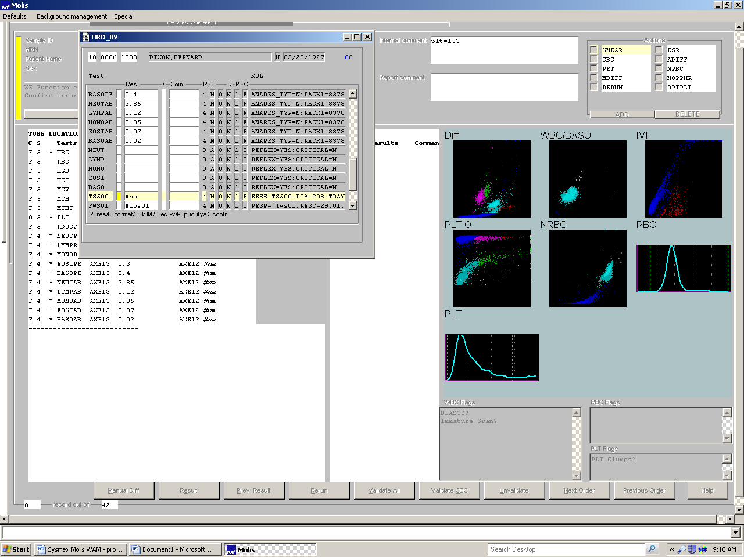

- Press F2 – (minus) at the tube sorter field.

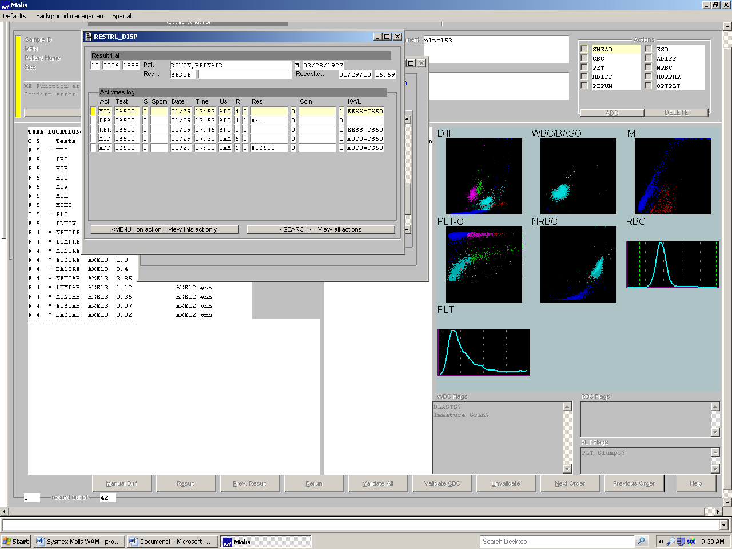

- Then move the cursor to the kwl area and arrow across to find the previous location of the specimen.

p. Query Orders:

To search for individual samples to a list of samples use Query Orders. From the main menu screen, select Query Orders or press Q. You can tighten or widen the search via the query filters, status buttons and desired tests. This can be used to find a sample for the DM-96 quality control slide.

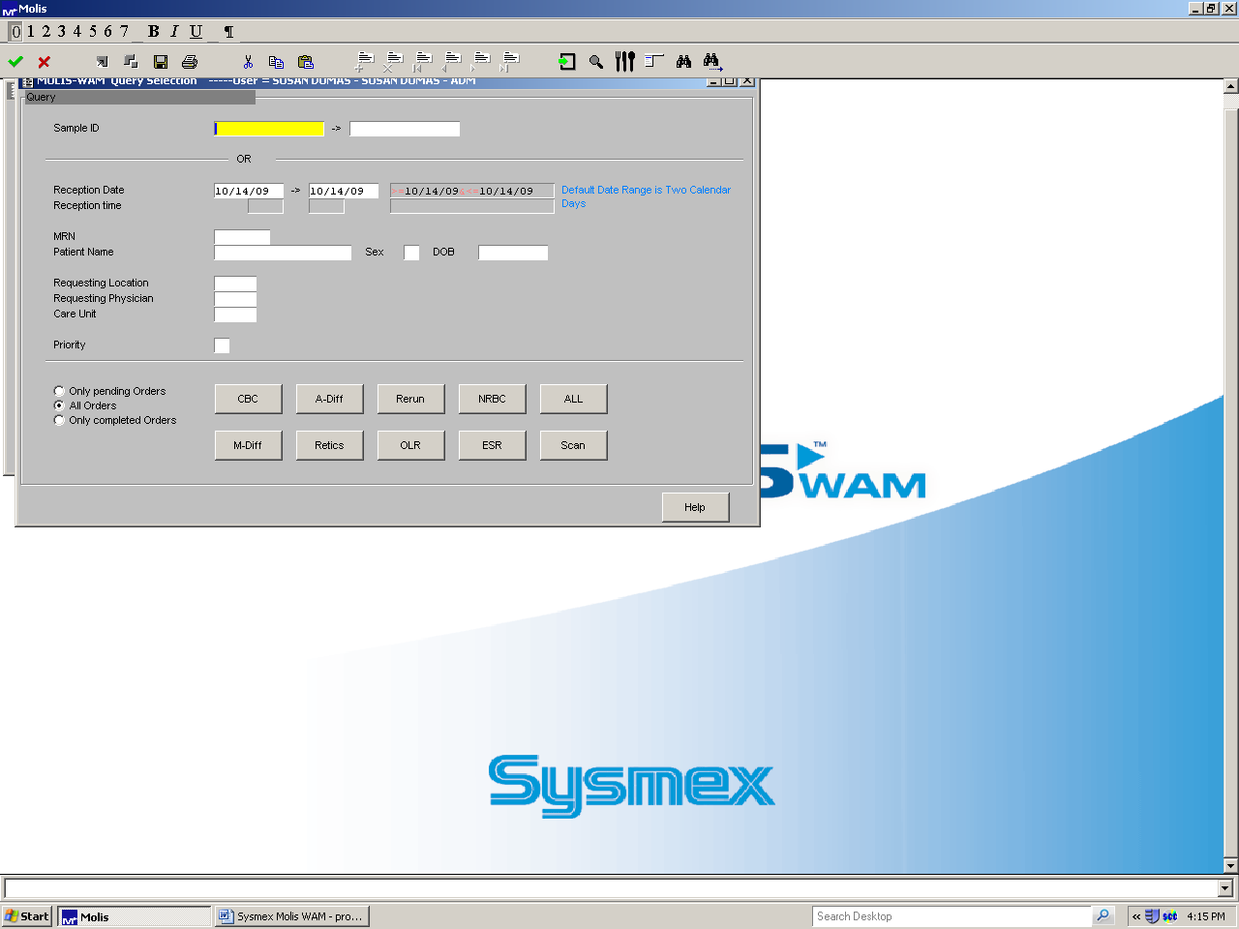

Once the sample(s) are displayed, we can see the ID, patient’s name, tube sorter location, etc. The result of the specimen that the cursor is on is displayed to the right. Functions on any or all of the displayed samples can be executed from this menu.

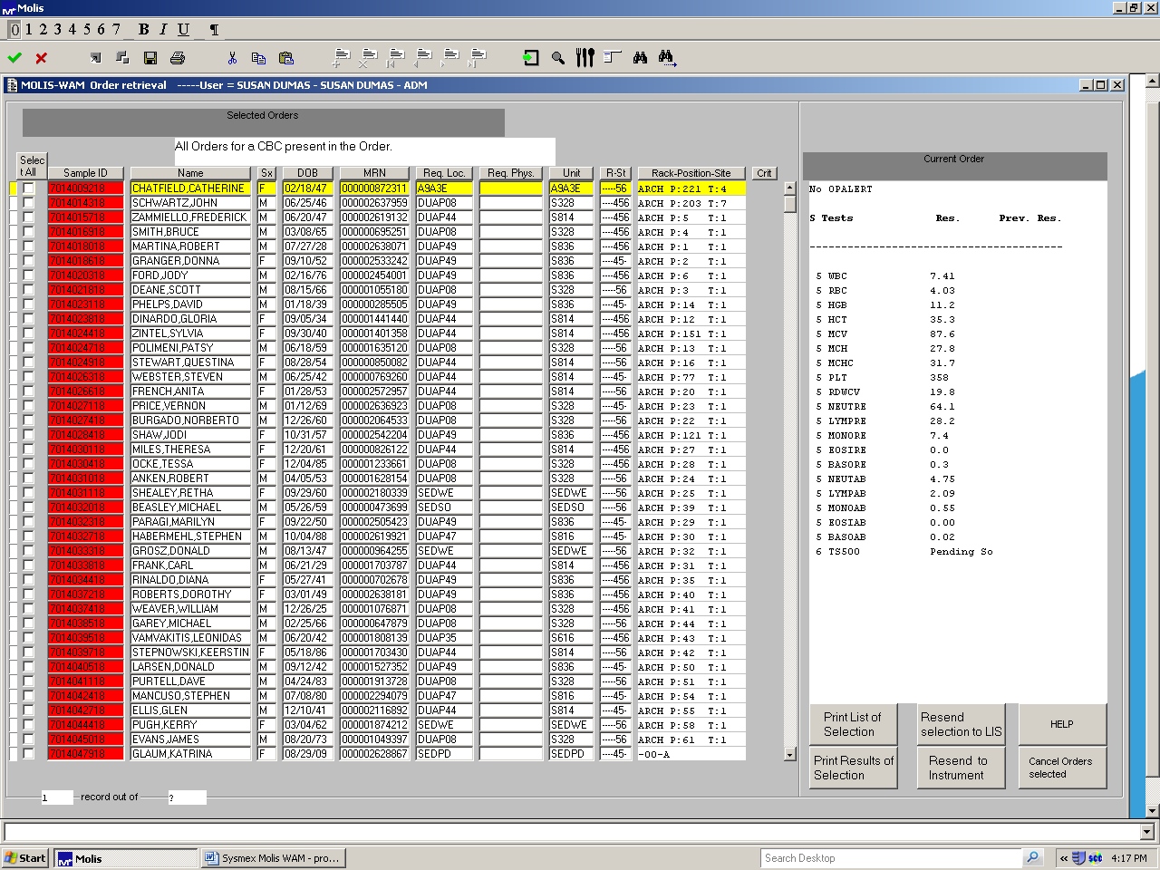

Click on the far left column (select all) to select the sample(s) and then press the appropriate button to i.e. Resend to the LIS, or Print a copy of the results, or Cancel the sample.

q. Unregistered Results:
A sample will be considered unregistered in WAM when there are no test orders for that sample barcode in WAM. This may be due to Soft interface downtime or the lavender top does not have any WAM defined tests ordered, e.g. send out tests. If a manually run sample has a non Soft order number entered in as the identifier it will also be found in the unregistered area.

Note – because the analyzers will run the default tests of CBC and Diff; any Retic requests will not be run. Add Retic in the action box of Molis.and rerun the sample. However, all reflex actions driven by Molis rules (e.g. run for NRBCs or slide for manual diff) will occur.

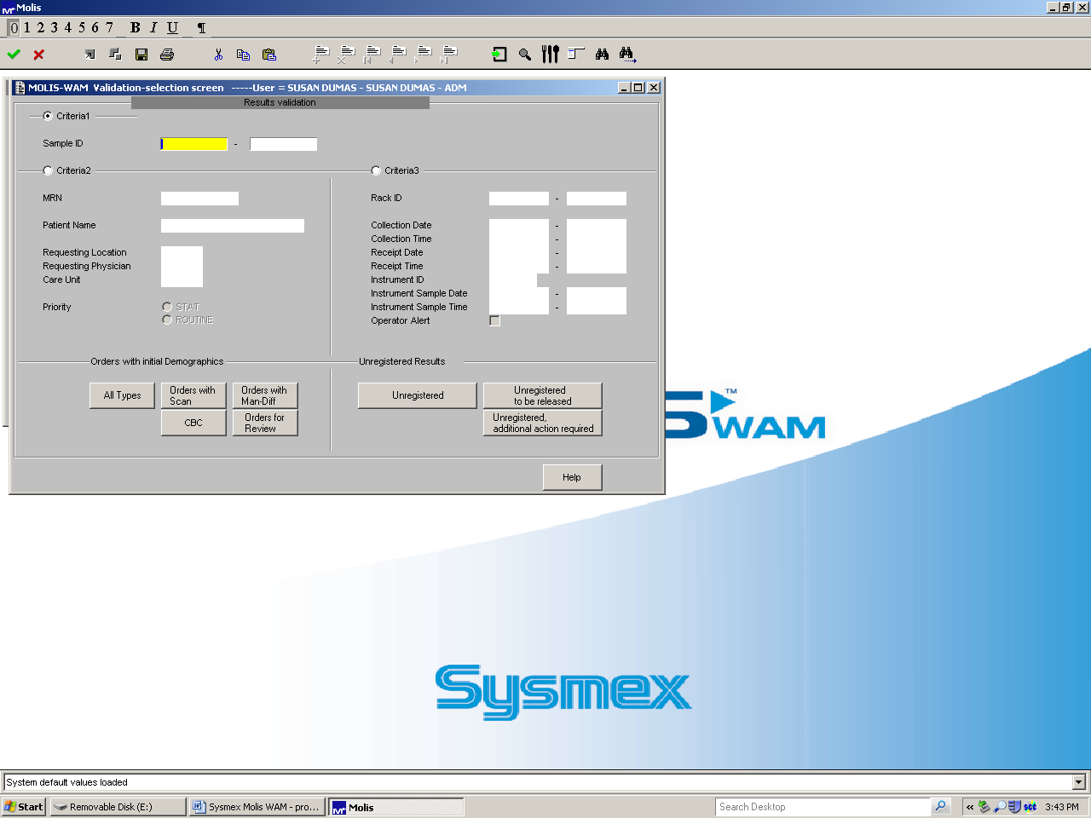

Unregistered to be released

If the problem was Soft downtime and the LIS column in the Unregistered Results menu is blank, you can manually initiate the upload from Molis to Soft by typing in LIS into the LIS column after the specimen has been logged into Soft post downtime. See the procedure for LIS downtime (SH.CP.AU.0105.0000). Another way to enter the LIS code is double click the LIS box associated with that particular sample and double click the LIS choice and F4 (save). Return to the validation menu and individually validate each sample.

All these samples will sort in the Tube sorter into the error section (refer to the Tube sorter manual SH.CP.AU.0104.0000)

Note – because the analyzers will run the default tests of CBC and Diff.
Any Retic requests will not run. Add Retic in the action box of Molis
and rerun the sample. CBC only orders will have a default differential with flags and possible unneeded reflexed tests. Delete the Auto and manual diffs. However, all reflex actions driven by Molis rules (e.g rerun for NRBCs or slide for manual diff) will occur.

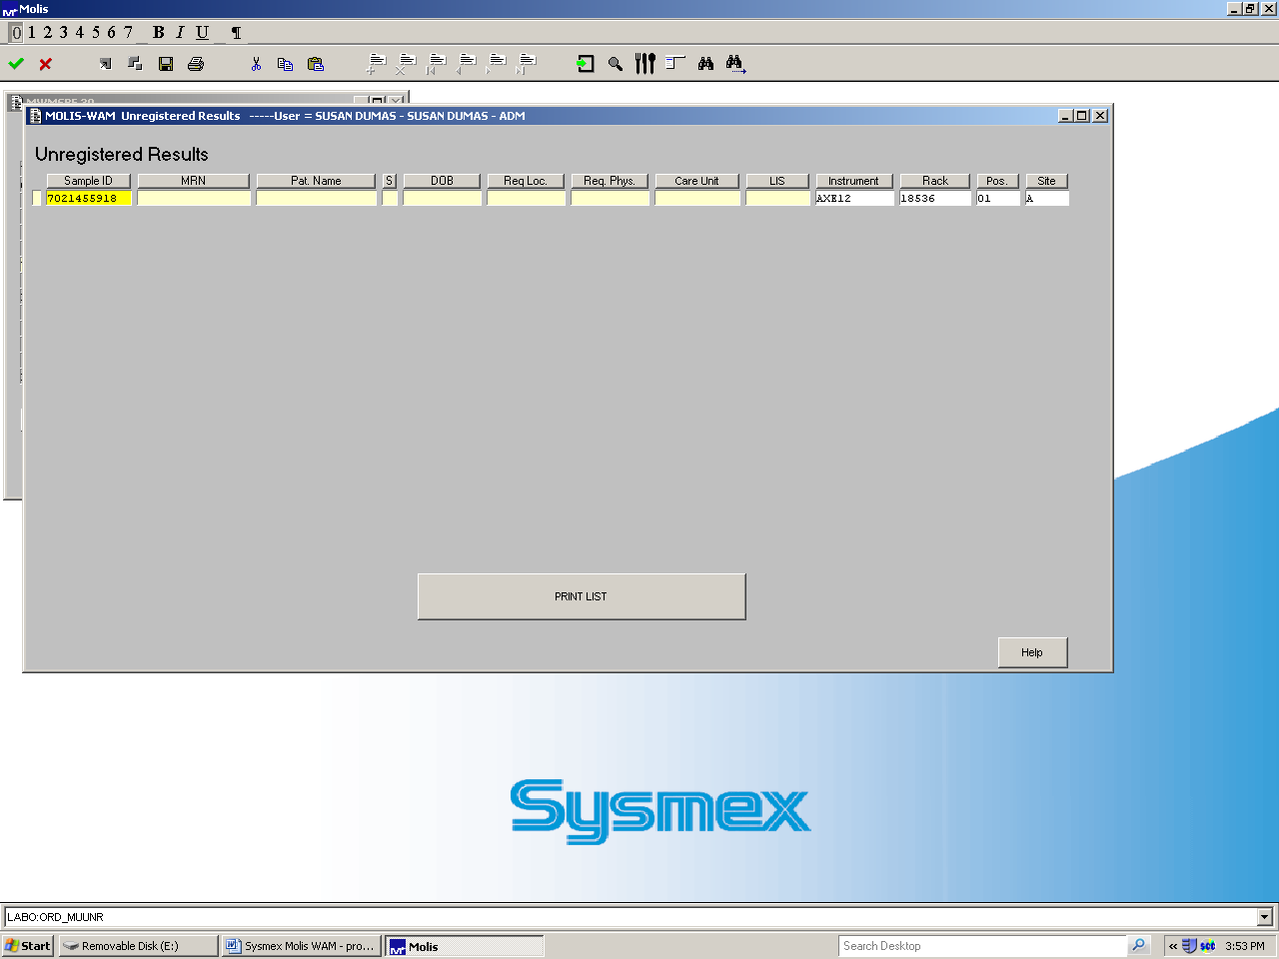

Type or click and choose LIS into highlighted box and press F4

r. Enter Orders:
This is a menu used to manually order sample tests and is mainly used when Soft is down. See down- time procedure (SH.CP.AU.0105.0000).

s. Change password:
A user may change their password at any time. Follow the prompts to change.
.

t. Manual Differential

To perform a manual differential click on the Manual diff button.
NOTE - All slide reviews performed by the DM-96 are reviewed via the Cellavision program not the Molis program. See Cellavision procedure SH.CP.AU.hem.0103.0001.
The manual differential screen is displayed over the main validation screen to allow you to view the associated histograms, scattergrams,
and flagging. Patient demographics along with manually counted cells, previous manually counted cells and the XE results are displayed on the manual differential screen.

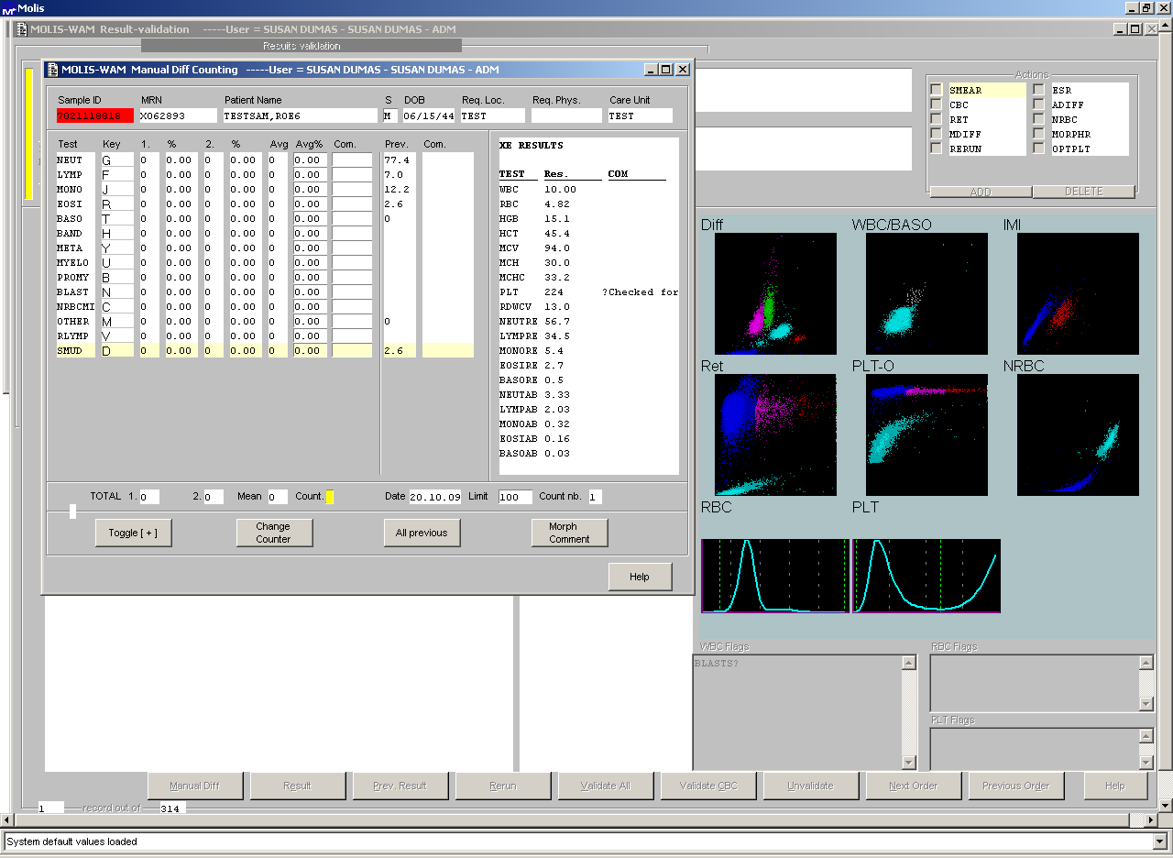

The following information is available on the manual diff screen:

Field | Description
Test | Test name column (i.e. neut)
Key | Key assigned for the test (i.e. G)
1. | First count in absolute
% | First count in relative percentage
2. | Second count in absolute
% | Second count in relative percentage
Avg. | Displays the average between the first count and the second count
Avg.% | Displays the average in % between the first count and the second count
Com. | Displays the comments associated with the individual cells
Prev. | Displays the previous manual count
Com. | Displays the comments from the previous manual count.

Field | Description
1. | Total number of cells counted for the first count
2. | Total number of cells counted for the second count
Mean | Mean number of cells counted (average if 2 counts were performed)
Count | The cursor must be set here to perform a count
Date | Date of the previous count
Limit | Maximum number of cells to be counted i.e.100 cells. Once this count is reached the user is informed by a beep sound that the limit count is reached. This can be changed if it is desired to count more or less cells.
Count b | Displays active count i.e. Count 1 or 2.

Field | Description
Toggle [+] | User can switch the count up or down by clicking the Toggle box. Toggle [+] increases the counting by 1 and Toggle [-] decreases the counting by 1 (may be used if an error happened). The toggle key stays in the [-] position until it is hit again. To continue with the differential the toggle key must be changed back to [+].
Change counter | If this box is clicked, the count will jump to the second count or back to the first count. This allows the tech to do a second differential count on the same sample. When the second count is completed, a pop up screen asks if you want to accept count number 1, 2 or the average.
All previous | Displays all previous results  Note: Changes made in SOFT after pathology review do NOT update in WAM.
Morph Comment | Displays the area to add morphology comments.

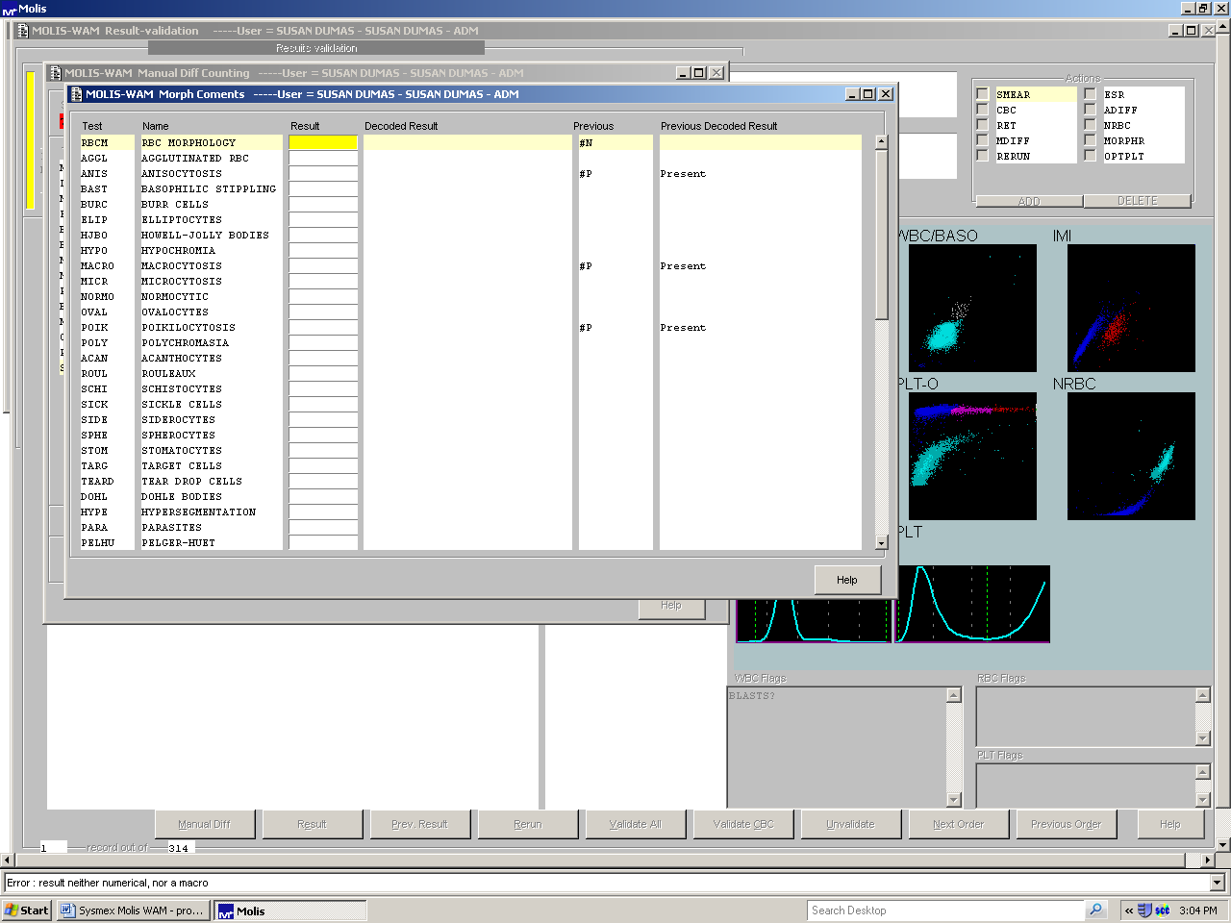

- If a manual RBC morphology review is requested select the Morph comments button to add morphology. When reporting a RBC morphology, it is necessary to report “present” in the RBCM test field in order for the morphology tests to report. To report any of the morphology tests, type “p” then press tab. Also use the Morph button to enter WBC morphology comments like Toxic Granulation. (If only WBC morphology comments are reported, it is not necessary to report “present” for the RBCM test).
- For samples with very low WBC counts, it may not be possible to tally 100 cells. If you save the diff before reaching 100 cells the following message will display – “You’ve counted less than 100 cells. Do you really want to store uncompleted results?” By selecting yes the diff will be reported as a percentage of the number of cells enumerated.

- If a platelet review is required, the differ will perform the review and then enter the appropriate result. The XE result should be in the internal comment box for the tech reviewing the slide to match. If there are no platelet clumps and the result is acceptable the count can be re-entered using the result button and then validated. If the platelet is unacceptable due to clumping or clotting the result must be canceled using “#c” in the result field. You can add canned text messages by *F5 the comment box, select the canned message and press F4 to save or you can free text a message. Keep in mind that if you wish to keep a message internal to the lab, you must precede the message with the Soft designation for internal comment “?”.

When the diff, RBC morphology and/or Platelet review is complete – press F4 to save results.

Validate ALL and F4.

Note – Samples with a critical result - if this sample requires any manual review, even if the critical result has been addressed, it will reappear on the Soft instrument interface.

Samples that require pathologist review:
Any samples with unidentified cells that require a pathologist review need to be “marked”. Select the Result button and scroll down to the PTHREV row and change the #n to #y to mark this sample for pathologist review.
Note – this is only applicable to samples that have cells that need identifying – not if these are known lymphoma cells etc.
You still need to add the order number to the Tasklist in Soft.

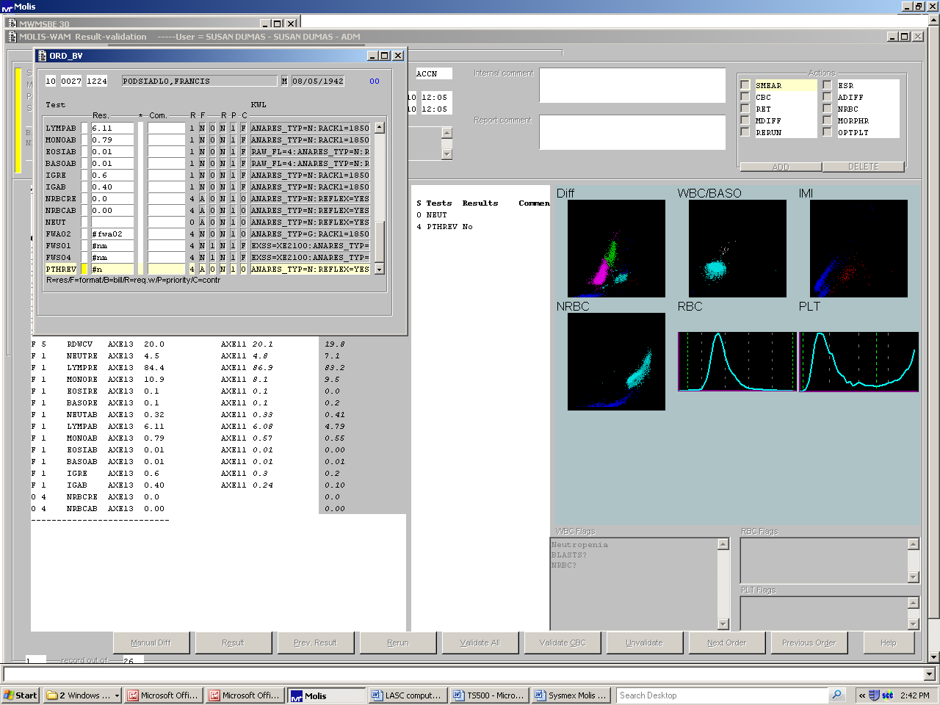

Change #n to #y

- LIMITATIONS

Not Applicable

- CALCULATIONS

Not Applicable.

XI. INTERPRETATION

Not Applicable.

- RESULT REPORTING

Only numeric data is resulted into Soft lab. None of the histograms or
scattergrams are reported. Result numbers are rounded to a whole
number or to the tenth. Not all parameters generated by the Sysmex
analyzer are currently reported.

If there is a dimorphic RBC population; the RDW will not be reported.

Normal ranges are posted with each sample’s results in Soft lab .

- TRAINING

Each new employee will complete the on-line training for the HST and Molis WAM. Each new employee will be shown and perform the HST training checklist and each new employee will perform a knowledge check at the end of training.

- REFERENCES

- Sysmex on line training
- Molis WAM quick guide – MKT-70-1074
- Molis WAM training guide – MKT-50-1025
4. Flagging Interpretation Guide MKT-40-1010

