- Principle

Light microscopy of thick and thin peripheral blood smears are examined for the presence of malaria and other blood parasites. With the use of Romanowsky stain ,examining red blood cells for intracellular forms of malaria and other blood parasite is possible.

- Reagents and Equipment

  - Modified Wright stain pak
  - Hematek 3000 stainer
  - Glass slides
  - Wintrobe tubes
  - Pasteur pipets and rubber bulb
  - 12 x 75mm glass tubes

- Sample

  - EDTA whole blood (freshly collected)

- Procedure

  - Thick and Thin Film Smear

    - Prepare at least two thick smears and two thin smears as soon as possible after specimen is collected and received for testing.

    - Bring a clean spreader slide, held at a 45° angle, toward a drop of blood on the specimen slide
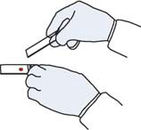
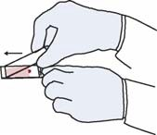
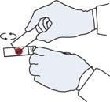

    - Wait until the blood spreads along the entire width of the spreader slide
    - While holding the spreader slide at the same angle, push it forward rapidly and smoothly
    - Using the corner of a clean slide, spread the drop of blood in a circle
    - The size of a dime (diameter 1-2 cm). Do not make the smear too thick or it will fall off the slide. (You should be able to read newsprint through it.)
    - Wait until the thin and thick films are completely dry before staining. The thick smear should be allowed to dry at least 2 hours.
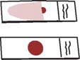
    - Dip the thick smear briefly in water to hemolyze the RBCs.
    - Stain the slides with the modified wright stain using the Hematek 3000 stainer
    - Examine the slides under low power and oil immersion looking for Malaria and/or other blood parasites. View a minimum of 300 fields
- Concentration (alternative method)

  - Fill four Wintrobe tube with blood from EDTA tube and label tubes
appropriately.

  - Centrifuge the tubes at 2500 rpm for ten minutes

  - Remove plasma from each tube with a 9-inch Pasteur pipet and save the plasma in a 12 x 75 mm glass tube

  - Remove and discard buffy coat from each tube.

  - Remove top layer of RBC’s from each tube with a clean pipet and transfer to a clean tube.

  - To each tube containing the RBC’s, add a few drops of the plasma obtained from step 4.1.2.3

  - Mix the RBC and plasma. Using a plain capillary tube, transfer one drop of the mixture onto a clean slide and prepare a thin smear of the mixture. A minimum of four slides (one from each Wintrobe tube) should be prepared for examination. So not fix slides.

  - Stain the slides with Wright stain using the Midas Stainer.

  - Examine slides using same guideline

- Results Reporting

  - Normal or Negative = No malaria or other blood parasites seen.
    - Report as “None Seen” 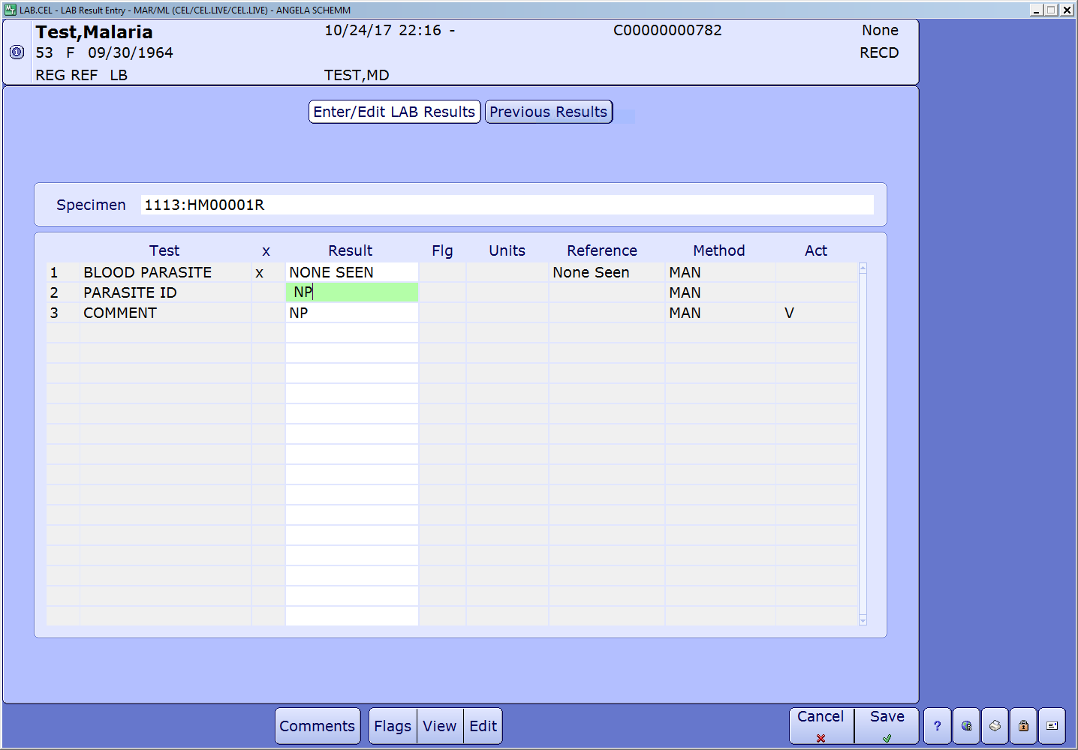

  - Abnormal or Positive = Presence of malaria or other blood parasite.

    - The following parasites may be present Plasmodium vivax, Plasmodium ovale, Plasmodium malariae, Plasmodium falciparum , Bartonella bacilliformis (Oroya fever), Babesia microti, Babesia species, Leishmania donovani (Kala-azar), Wuchereria bancrofti, Loa Loa, Trypanosoma brucei (African sleeping sickness), Trypanosoma cruzi (Chagas disease)

    - Review positive slides with other CLS, technical supervisor, or Pathologist before reporting if assistance is needed to verify your results.

    - Report as “Parasite Present” (A reply will auto-populate the result)
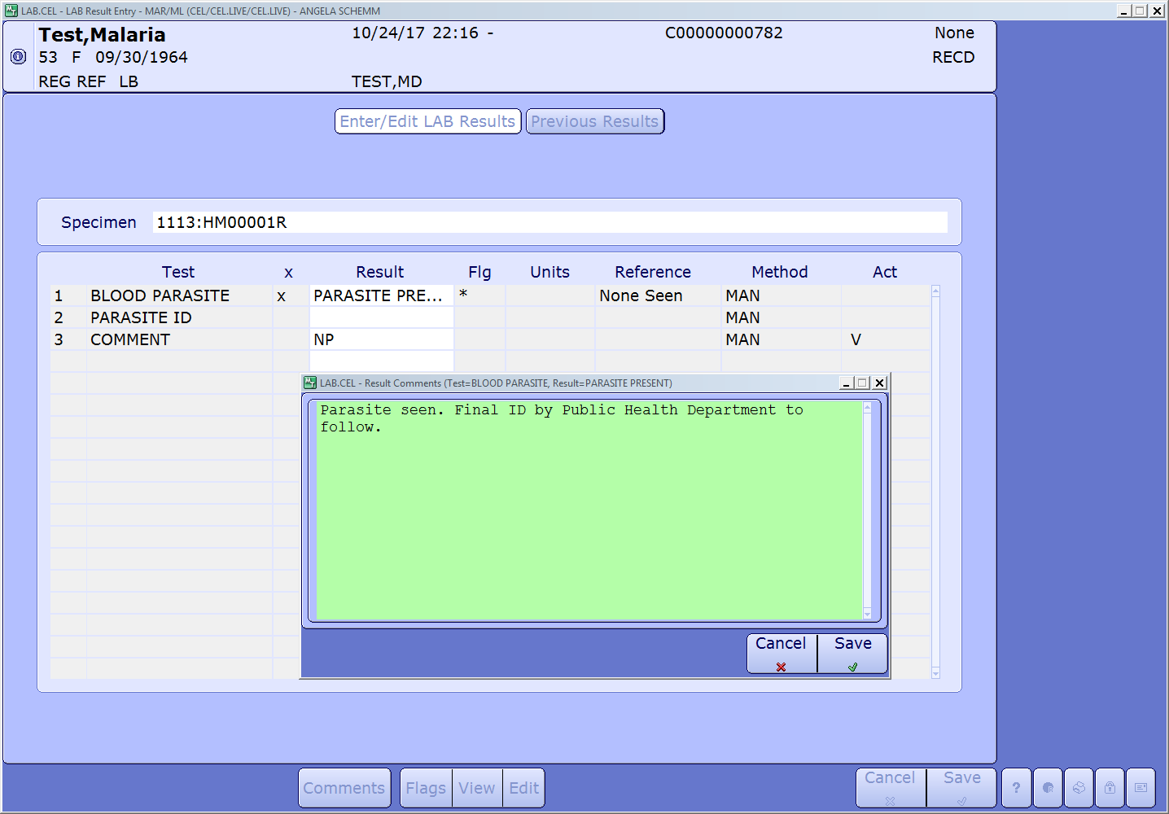

    - If Plasmodium species is present the percentage of parasitemia must be reported.

      - On the thin smear a minimum of 500 RBCs should be counted. The percentage of infected cells in relation to the uninfected RBCs determined;

% Parasitemia = # of infected RBCs x 100
Total RBC’s count

6.2.5 Result will post with identification status as Pending.
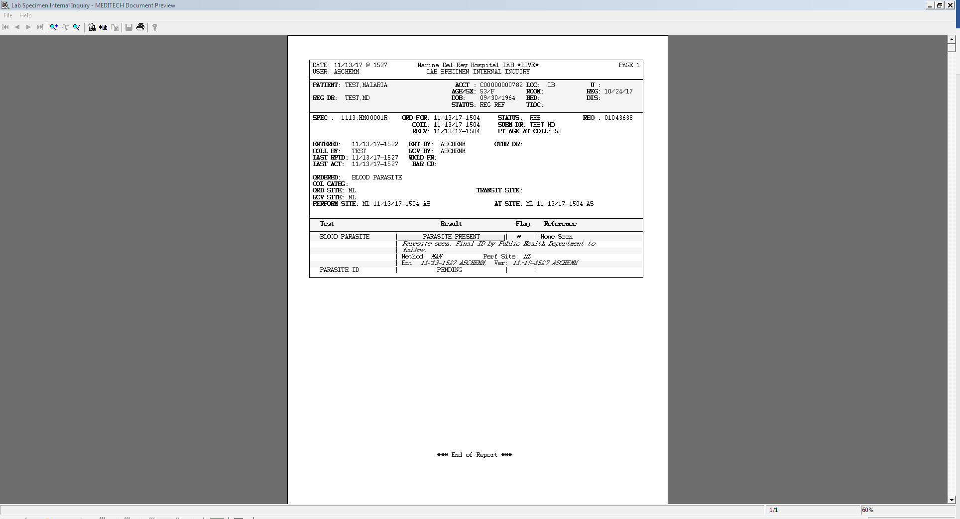

  - All positive findings must be called to the physician,

  - One or more blood smears must be sent to the County of Los Angeles Department of Public Health Laboratory for confirmation/identification.

  - Complete and fax a Confidential Morbidity Report to County of Los Angeles Department of Public Health at (888)397-3778. (For suspected Malaria )

      - Complete the Public Health Laboratory Test Requisition Form.

      - Be sure to include travel history (if known) and fax # for results.

      - Call (562)658-1300 and request a pick up.

      - Prepare smears, test requisition, and a copy of the Confidential Morbidity Report (for suspected Malaria) for the courier.

  - When results are returned from LA County Public Health lab enter “See Comment” in Parasite ID field. A response box will auto-populate for you to enter the Parasite ID received from the Public Health department.

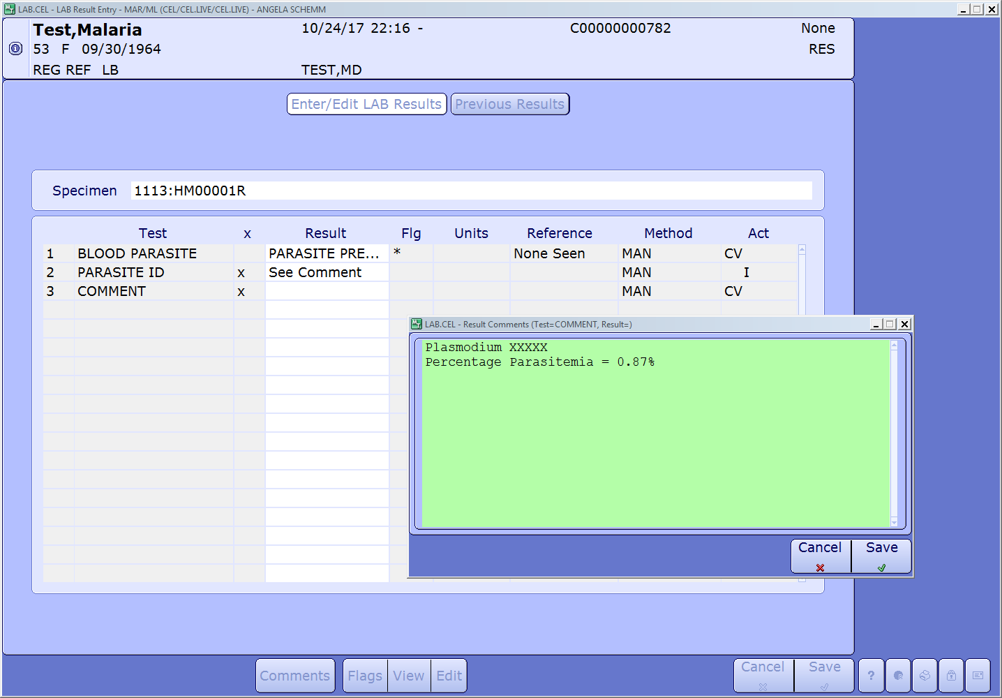

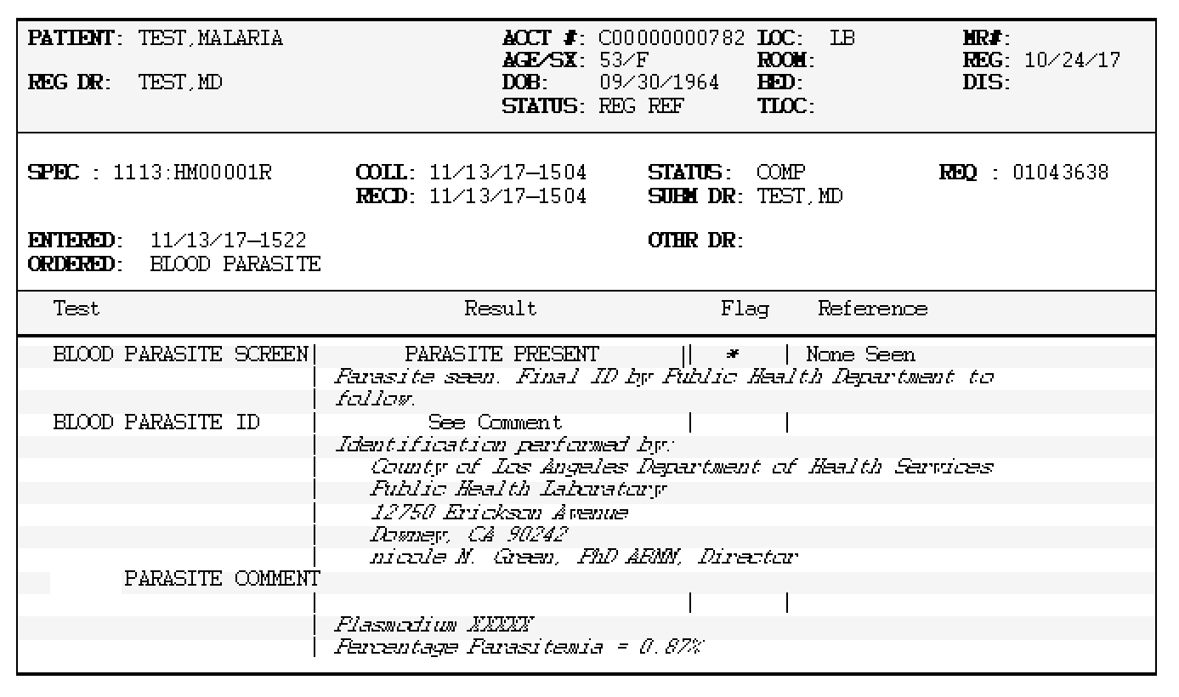
  - The result will file as final with the LA County Health Department information.

  - Copies of faxed Confidential Morbidity Report, Public Health Laboratory Requisition, and final results received from LA Country Health department are stored in designated notebook.

- Quality Control – A parasite positive and negative slide is run each day of patient testing and results recorded on FormH024/2017

  - Positive Control – Giemsa/Wright Stain control slide, Ref. 430, Scientific Device Laboratory

  - Negative Control – Selected peripheral blood smear slide prepared simultaneously with Positive Control slide.

- Attachments
  - FormH024/2017 – Blood Parasite Quality Control Log
  - Confidential Morbidity Report
  - Public Health Laboratory Test Requisition

- References

  - DPDx, Laboratory Identification of Parasitic Diseases of Public Health Concern, https://www.cdc.gov/dpdx/diagnosticprocedures/blood/specimenproc.html

  - DPDx Laboratory Identification of Parasites of Public Health Concern, Determination of Parasitemia, https://www.cdc.gov/dpdx/resources/pdf/benchAids/malaria/Parasitemia_and_Lifecycle.pdf

  - Henry’s Clinical Diagnosis and Management by Laboratory Methods, 22nd edition,Part 7, Blood and Tissue Protozoa, pg 1197-1207, Richard A, McPherson, MD and Matthew R, Pincus, PhD, Elsevier/Saunders, 2011

  - California Department of Health and Human Services Communicable Disease Control, Conditions for Which Clinical Laboratories Shall Submit an Isolate or Specimen to the Local Public Health Laboratory, June 2016

  - College of American Pathologist, Hematology and Coagulation Checklist, www.cap.org, August 2017

  - Malaria and Other Blood Parasites Identification, Marina Del Rey Hospital, effective 6/16/2010, supersedes 2/5/2008,



Revised Procedure Prepared by: _______________________Date: __12/11/2017

Revised Procedure Approved by: Date: _________

Document History Page

Change type: New, Major, Minor etc. | Changes Made to SOP - describe | Name responsible person/date | Med. Dir. Review Date | Adm Dir.  Review Date | Date change Imp.
Major | Included QC and updated results reporting procedure. | ASchemm / VStanley  12/11/2017 | Dr. James Keefe  12/11/2017 | R Gonsalves  12/11/2017 | 12/11/2017

Blood Parasite Quality Control Log
ATTACHMENT 8.1

Instructions
- Perform modified Wright stain on a positive and negative control smear each day of testing.
- Write lot# and expiration date of positive control smear.
- Write specimen# (ID#) of selected peripheral blood smear/sample used for negative control.

Date | Tech | Patient Name/I.D. | Test Result | Quality Control Results  P = Parasite Seen  N = No Parasite Seen |  |  |  |  | Manual Entry Review By/  Date
 |  |  |  | POSITIVE |  | NEGATIVE |  |  | Manual Entry Review By/  Date
 |  |  |  | P | N | P | N
 |  |  |  | Lot#  Exp. |  | ID#:
 |  |  |  | P | N | P | N
 |  |  |  | Lot#  Exp. |  | ID#:
 |  |  |  | P | N | P |  | N
 |  |  |  | Lot#  Exp. |  | ID#:
 |  |  |  | P | N | P |  | N
 |  |  |  | Lot#  Exp. |  | ID#:
Comment(s)/Remark(s):

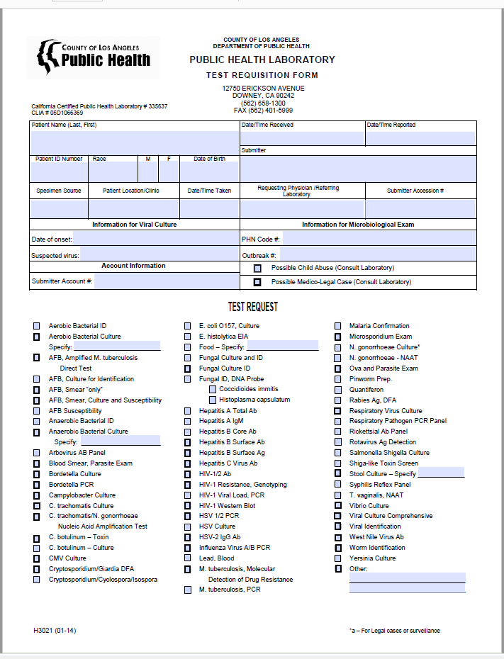
ATTACHMENT 8.2
ATTACHMENT 8.3

