- Purpose
ImmunoCard STAT! Flu A&B is an in vitro rapid qualitative test that detects influenza type A and type B nucleoprotein antigens directly from nasal swab, nasopharyngeal swab, and nasopharyngeal aspirate/wash specimens obtained from patients with signs and symptoms of respiratory infection. It is intended to aid in the rapid differential diagnosis of influenza A and B viral infections.

It provvides early differential diagnosis of influenza type A or type B which enables healthcare providers to initiate proper treatment with appropriate antiviral therapy while reducing the incidence of inappropriate treatment with antibiotics. Early diagnosis and treatment is of particular value in a clinical setting where accurate diagnosis can assist with management of influenza patients who are at risk for complications.

- Principle

ImmunoCard STAT! Flu A&B utilizes the chemical extraction of viral antigens followed by solid-phase immunoassay technology for the detection of extracted antigen, influenza A and/or B. In the test procedure, a specimen is collected and placed for one minute into the Extraction Well of the test device containing extraction solution, during which time antigen is extracted from disrupted virus particles. The test device is then raised, tapped and laid back down onto a level surface to allow the solution in the Extraction Well to migrate through the pads containing detector antibodies conjugated to gold dye and then through the test membrane. If influenza antigens are present in the specimen, they will react with anti-influenza antibody coupled to gold dye particles, migrate through the membrane as antigen-antibody-dye complexes, bind to the immobilized anti-influenza antibody on the membrane, and generate a colored line in the Test line position (A and/or B). The rest of the sample and unbound/bound dye complexes continue to migrate to the Control line position (C), where antibody to the anti- influenza antibody is immobilized, and forms the Control line. Formation of the Control line serves as an internal control to demonstrate that antibodies in the dye pad have been hydrated and that sufficient sample has been applied to allow for migration to the Test line and beyond. If the Control line does not appear within the designated incubation time, the result is invalid and the test should be repeated

- Specimen Collection
  - Nasal Swab Specimen:

Use the flocked swab provided in the ImmunoCard STAT! Flu A&B kit, gently insert the swab approximately 1/4” into the anterior nares (just inside the nasal orifice). Rotate the swab a few times, and repeat in the second nostril, using the same swab.

  - Nasopharyngeal Swab Specimen:

Use the flocked swab provided in the ImmunoCard STAT! Flu A&B kit. Insert the swab into the nostril, gently rotating the swab inward until resistance is met at the level of the turbinates. Rotate the swab a few times against the nasopharyngeal wall and then withdraw the swab.
- Reagents and Materials
  - Each ImmunoCard STAT! Flu A&B kit contains enough reagents and materials for 32 tests. The following components are included in a kit.
    - ImmunoCard STAT! Flu A&B test devices
    - Extraction Reagent in capsules for use with swab samples, 300 µL of Phosphate Buffer with detergents and preservatives
    - Sterile Swabs
    - Positive Control Swab (1): Influenza A and B antigens (non-infective recombinant nucleoprotein)
    - Negative Control Swab (1): Inactivated Group B Streptococcus antigen (non-infective)
- Equipment
  - Timer
  - Latex gloves

- Test Procedure
  - Tear the tab off the Extraction Reagent capsule.
  - Squeeze the Extraction Reagent capsule to dispense all of the solution into the Extraction Well of the test device.
  - Insert the specimen swab on the Swab Stand in the Extraction Well. Rotate swab 3 times to mix the specimen.
  - Incubate 1 minute with the swab in Extraction Well.
  - Rotate swab 3 times to mix the specimen. Remove and discard the swab.
  - Raise the device upright (see picture).
  - Let it stand for 1-2 seconds. Gently tap the device to ensure that the liquid flows into the hole.
  - Lay the device back down onto the flat surface. Start timing.
  - Read test results at 10-15 minutes. Confirm negative results at 15 minutes.

- Quality Control

The ImmunoCard STAT! Flu A&B kit contains two control swabs. Test the control swabs in the same manner as patient specimens. When the positive control is tested, reddish purple lines appear at the C, A and B positions. When the negative control is tested, a reddish purple line appears at the C position only. If the controls do not perform as expected, do not report patient results
  - Internal Quality Control:

    - Each ImmunoCard STAT! Flu A&B test device has built-in controls. The Control line at the C position can be considered as an internal positive procedural control; i.e., a proper amount of sample was used, sample was properly added to the Extraction Well, sample migrated properly, and the reagent system worked properly. A distinct reddish- purple Control line should always appear if the test has been performed correctly. If the Control line does not appear, the test result is invalid and a new test should be performed. If the problem persists, contact Meridian’s Technical Services Department at 1-800-343-3858 (US) or your local distributor for technical assistance. A clear background in the Test Result Window is considered an internal negative procedural control. If the test is performed correctly and the ImmunoCard STAT! Flu A&B test device is working properly, the background in the Test Result Window will be clear, providing a distinct result.

External Quality Control:
    - External control testing is performed w before using a new lot or shipment of ImmunoCard STAT! Flu A&B kits to confirm the expected Q.C. results, using the external controls provided in the kit. The frequency of additional Q.C. tests should be determined according to your laboratory’s standard Q.C. procedures and local, State and Federal regulations or accreditation requirements. Upon confirmation of the expected results, the kit is ready for use with patient specimens. If external controls do not perform as expected, do not use the test results. Repeat the tests. If the problem persists, contact Meridian’s Technical Services Department at 1-800-343-3858 (US) or your local distributor for technical assistance. The built-in reddish purple Control line indicates only the integrity of the test device and proper fluid flow.
- Results Interpretation

  - Positive: A reddish purple Control line (C position) and a reddish purple Test line (A or B position) indicate that Influenza A or B antigen has been detected. Lines at the A and C positions indicate the presence of Influenza type A viral antigen, and lines at the B and C positions indicate the presence of Influenza type B viral antigen in the specimen. A positive result does not rule out co-infections with other pathogens or identify any specific influenza A virus subtype. Determination of a positive result can be made as soon as both a visible Test line (either A or B) and Control line appear.
    - Note: The Test line (reddish purple line) may vary in shade and intensity (light or dark, weak or strong) depending on the concentration of antigen detected. The intensity of the Control line should not be compared to that of the Test line for the interpretation of the test result. Even a light or faint Test line must be interpreted as a positive result.

  - Negative: Only a reddish purple Control line (C position), with no Test line at the A or B position, indicates that Influenza A or B antigen has not been detected. A negative result does not exclude influenza viral infection. Determination of negative results should not be made before 15 min.

  - Invalid: A reddish purple line should always appear at the Control line position (C). If a line does not form at the Control line position in 15 minutes, the test result is invalid and the test should be repeated with a new ImmunoCard STAT! Flu A&B test device.

NOTE: Co-infection with Influenza A and B is rare. ImmunoCard STAT! Flu A&B “dual positive” clinical specimens (Influenza A and Influenza B positive) should be re-tested. Repeatable influenza A and B “dual positive” results should be confirmed by cell culture or PCR testing before reporting results.

CLS SHOULD SPEAK TO PROVIDER and suggest recollect and repeat test.

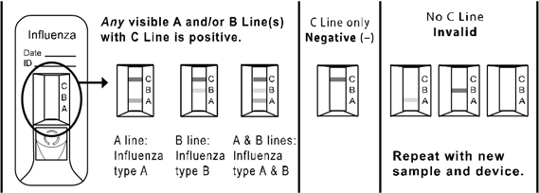

- Reference Range = Negative

- Results Reporting

  - In the laboratory information system (LIS)
  - Got to Menu options: Microbiology →Results Entry→Enter Results
  - At Results prompt →F9→Enter Results

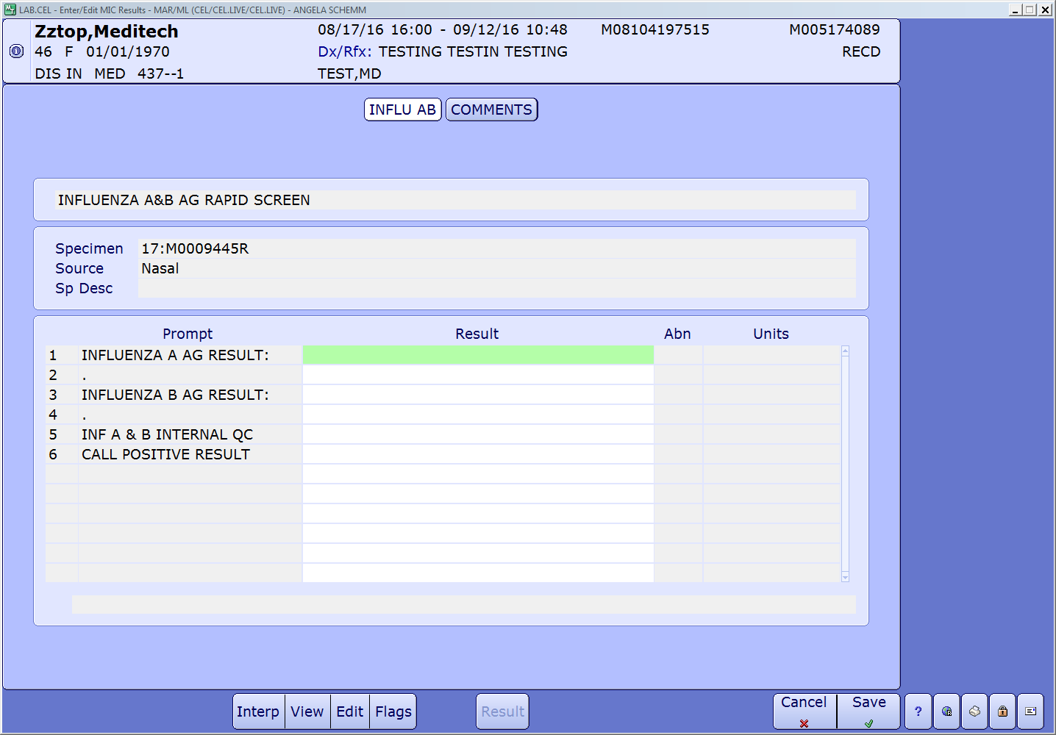

  - At Line 1 – Line 5→ F9 to select result
  - At Line 6 –
    - For negative results
      - Select N
      - Document comment by going to the COMMENT page and delete call comment
      - Select F5 then type MFLUABNEG
      - Result comment will appear, “This result does not exclude viral infection. Negative test should be confirmed by Tissue Culture or Molecular tests”
    - For positive results
      - Select Y for and document call in pop-up
    - Select F5 then type MFLUAPOS (if Influenza A positive), MFLUBPOS (if Influenza B positive), or MFLUABPOS (if both Influenza A and B are positive)
    - Result comment will appear as
      - MFLUAPOS: “This result does not rule out coinfection with other pathogens or identify any specific influenza A virus subtype”

      - MFLUBPOS: “This result does not rule out coinfection with other pathogens or identify any specific influenza B virus subtype”

      - MFLUABPOS: “This result does not rule out coinfection with other pathogens or identify any specific influenza A or influenza B virus subtype”

- Additional Limitations

    - See enclosed package insert for additional test limitations and procedureal considerations

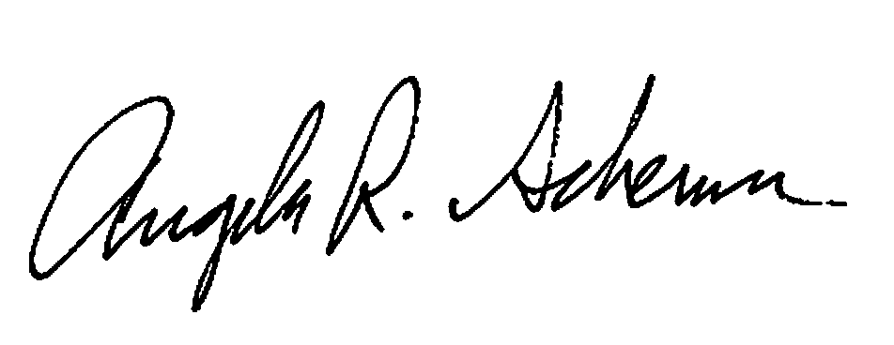

Procedure Prepared by:______________________________Date: 1218/2017

Procedure Approved by:_____________________________Date:_________

Document History Page

Change type: New, Major, Minor etc. | Changes Made to SOP - describe | Name responsible person/date | Med. Dir. reviewed/Date | Lab Manager reviewed/date | Date change Implemented

