- Principle

Appropriately stained, bilobed eosinophils may be noted in fresh urine sediments from patients with tubulointerstitial disease associated with hypersensitivity to drugs such as penicillin and its analogues. In allergic interstitial nephritis, the urine sediment cell pattern usually includes many red blood cells and some renal tubular epithelial cells.

- Materials and Equipments

2.1 Centrifuge

2.2 Centrifuge tubes

2.3 Pasteur pipettes

2.4 Glass microscope slides and cover slips

2.5 Hematek 3000 automated slide stainer (Wright’s stain)

2.6 Cytospin 2

3.0 Specimen

Fresh urine sample

- Quality Control Testing

  - Each day of QC check testing slide must be prepared and results recorded.
    - Review automated diff results of CBC specimens and select a sample with detectable eosinophils.
    - Prepare smear and stain slide with urine sample being tested.
    - Review smear for presence of eosinophils
    - Record results of QC check slide on FormU001/2017

5.0 Patient Test

  - Centrifuge 10 -12 ml of urine for 5 minutes at 1800 rpm.

  - Discard supernatant to obtain sediment.

  - Place a drop of sediment on slide with cover slip.
  - Examine sediment at high power for the presence of white blood cells or any other pathological matter.

  - Use another drop of the sediment to prepare cytospin slide.

  - Let sample dry and stain using the Hematek 3000 automated stainer

  - Examine stained slide for eosinophils.

- Result Reporting

  - Report “None seen” if no eosinophils are seen.

  - Report the number of eosinophils seen as “Rare”, “Few”, “Moderate”, or “Many”.

- Reference Range
None seen

- Attachment
  - FormU001/2017

- References
  - Davidson and Henry, Clinical Diagnosis by Laboratory Methods, Philadelphia.

  - Harris, C.J., Original procedure developed at DFH per request of staff urologists, 1988.

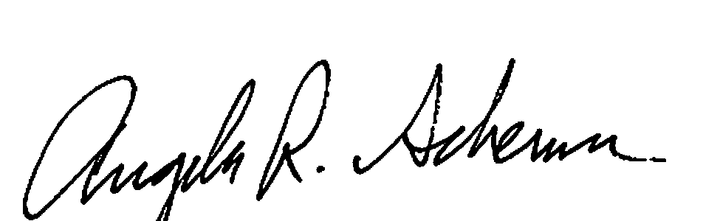

Revised Procedure Prepared by: __________________Date: ___2/2/2018_____________

Revised Procedure Approved by:__Dr.James Keefe____Date: ___2/5/2018____________
Lab Medical Director

Attachment: 8.1 – FormU001/2017 sample

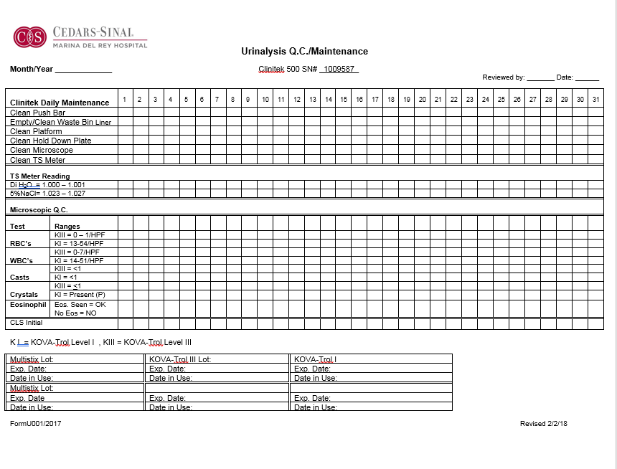
New row for documenting Urine Eos. QC Check.

Annual Review by Date _____________________

Annual Review by Date _____________________

Annual Review by Date _____________________

Annual Review by Date _____________________

Annual Review by Date _____________________

Annual Review by Date _____________________

Annual Review by Date _____________________

Annual Review by Date _____________________

Annual Review by Date _____________________

Annual Review by Date _____________________

Annual Review by Date _____________________

Annual Review by Date _____________________

Annual Review by Date _____________________

Annual Review by Date _____________________

Annual Review by Date _____________________

Annual Review by Date _____________________

Document History Page

Change type: New, Major, Minor etc. | Changes Made to SOP - describe | Name responsible person/date | Med. Dir. reviewed/Date | Lab Manager reviewed/date | Date change Imp.
Major | Added QC check and update with auto stain. | Angela Schemm  2/2/2018 | Dr. James Keefe  2/5/2018 | Richard Gonsalves  2/5/2018 | 2/6/2018

