1.0 Purpose

Microscopic exam of a direct smear from a stool specimen to assess the presence of WBC’s using Wright’s stain is helpful in diagnosing gastrointestinal tract infections.

At Marina Del Rey Hospital this is done on stool specimens received STAT and routine specimens without requests for other Microbiological examinations.

Stool specimens received with requests for other microbiological examinations must be sent to designated reference laboratory for testing

2.0 Specimen

2.1 Stool collected in clean container (sterile container may be used)

3.0 Materials

3.1 Cotton tipped sterile swab (sterile)

3.2 Microscope slide

3.3 Hematek stain pak (Modified Wright’s stain)
3.4 Hematek 3000 slide stainer

4.0 Procedure

4.1 Put on and use appropriate PPE (gloves, fume hood, safety shield)

4.2 Use sterile cotton tipped swab and gently roll out a drop of feces on a glass
slide.
4.2.1 Smear should be as thin as possible.

4.2.2 If specimen contains mucous or blood take sample from this area.

4.3 Let smear air dry

4.4 Stain smear using the Hematek 3000 stain procedure (See Hematology manual)

4.5 Read smear. Examine a representative portion of the slide for the presence of WBC’s noting the average number of cells per oil immersion field.

5.0 Reporting Results

5.1 Results are documented in the LIS.

5.1.1 Report any WBC’s seen.

5.1.2 Report yeast, if present in significant numbers.

5.1.3 If no WBC’s or yeast are present, report ‘No WBC’s seen’.

Note: Yeast do not need to be noted unless in significant quantity.

5.1.4 Significant quantity of RBC’s should be reported

5.4 Quantitation Guidelines

Rare = < 2 cell/organism per oil immersion field
Few = 2 – 3 cells/organisms per oil immersion field
Moderate = 3 - 9 cells/organisms per oil immersion field
Many = >10 cells/organisms per oil immersion field

6.0 Expected Results

6.1 Stool = No WBC’s Seen

7.0 Quality Control

See Wright’s stain performance of WBC’s in Hematology department. (FormH007/2016)

8.0 References

8.1 Leukocytes in Stool , Mary 31, 2018
https://healthhearty.com/leukocytes-in-stool

8.2 Standard Operating Procedure, Gundersen Health System, revised 5/11/2017
https://www.gundersenhealth.org/app/files/public/6619/Lab-Policies-Stool-for-WBC-
Lab-

8.3 Laboratory Medicine, Q & A Identifying Leukocytes in Fecal Specimens, Laboratory
Medicine, July 1996, volume 27, number 7, pg 433 Robert W. Novak, MD, director of
clinical pathology, Children’s Hospital, Akron, Ohio

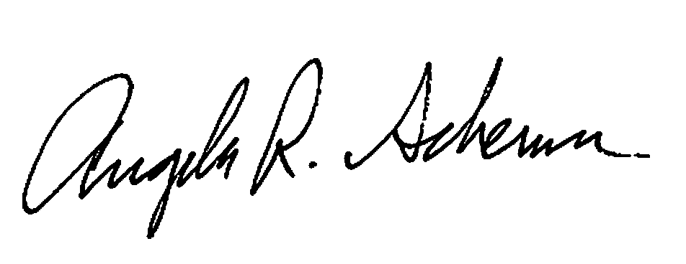

Procedure Prepared by Date__10/19/2018__

Procedure Approved by Date

Document History Page

Change type: New, Major, Minor etc. | Changes Made to SOP - describe | Name responsible person/date | Med. Dir. reviewed/Date | Lab Manager reviewed/date | Date change Imp.
Major | Updated for Core Lab use. | 10/19/2018  Angela Schemm | 10/19/2018  Dr. James Keefe | 10/19/2018  Emma Galdones | 10/19/2018

