- Purpose

To provide guidelines for handling “critical” Microbiology tests results.

- Definition(s)

The following test results are considered “Critical” and must be handled according to the directions in this procedure;

  - Positive Blood Culture grams stains

  - Positive CSF gram stain and or India Ink

2.3 Any results that has been communicated to the Clinical Laboratory from a reference lab as being a
critical result.

- Procedure

3.1. Notification of “critical” results that are obtained by in-house testing should be completed by the assigned CLS upon completion of the requested test. (See section 3.5)

3.2 Notification of “critical” results that are received by reference laboratory via telephone should be
completed a CLS upon verification via of the result in Meditech (See section 3.5)

3.3 In-House patients:

3.3.1 Phone the report to the RN in charge of the patient, available nurse or the unit charge
nurse.
3.3.2 Make sure that the RN reads back the result to you correctly.

3.3.3 Document the name of the RN, read back, date, time, and your initials when you call in Meditech. (See section 3.5)

3.4 Discharged patients or Out Patients:

3.4.1 Phone the report to the ordering physician.
Call Nursing/House Supervisor if you are not able to contact ordering physician.

3.4.3 Document the name of the who was notified, read back, date, time and your initials in LIS. (See section 3.5)

3.5 Documentation in LIS

3.5.1 Upon receipt of the telephone call obtain the patient name, date of birth and name of test result is being reported.

    - Go to Patient Inquiry to verify information (Patient Name, Date of Birth, Name of Test)

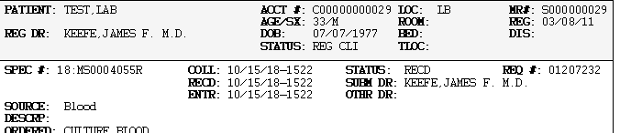

    - Go to Specimen Desktop to and Select 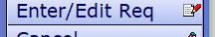

    - 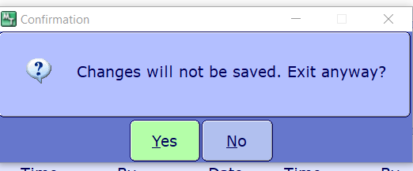 Select Yes.

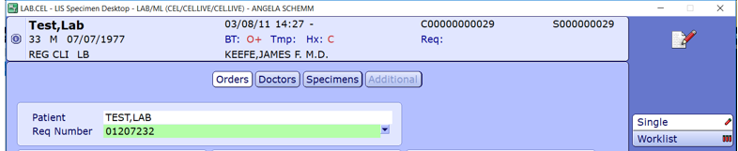
3.5.5 Enter patient name and Req Number

3.5.6 Scroll down to the Order and CRB = MICRO CALL and READ BACK
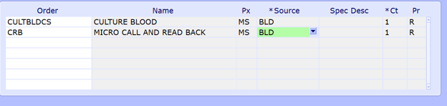

3.5.7 Then 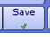

3.5.8 Then go to

3.5.9 Enter Specimen 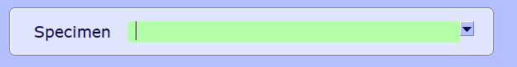

3.5.10 Select MIC C&RB

3.5.11 MIC C&RB is a Test Code for entering the MICRO critical value documentation. Therefore
you must enter E just like when entering a test result. Then click SAVE
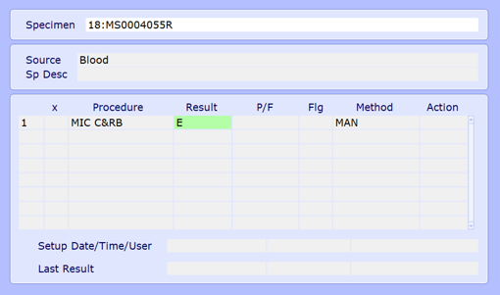

3.5.12 Select Yes at Receive specimen from LIS Site ML? prompt.

3.5.13 A pop-up window will appear.
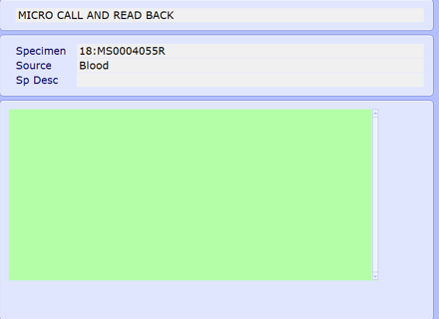

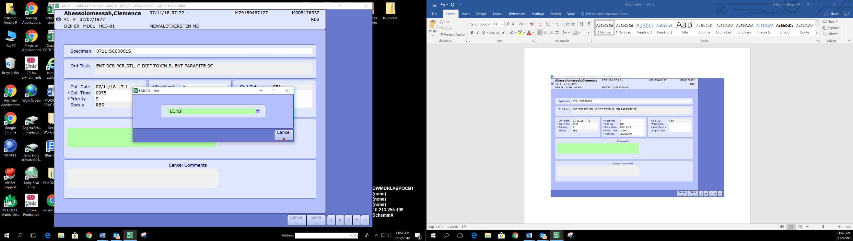

3.5.14 Type LCRB in pop-up and press ENTER key.

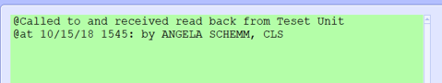
3.5.15 Insert the name of the person you gave result to after “from” in the canned comment as usual.

3.5.16 Click 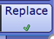

3.5.17 Review your comment then click Save.

3.5.18 File result as Final/Verified then Broadcast

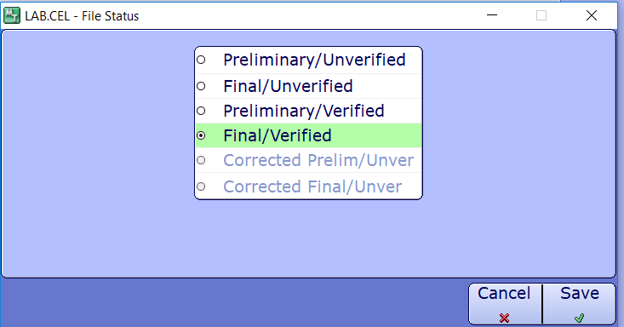

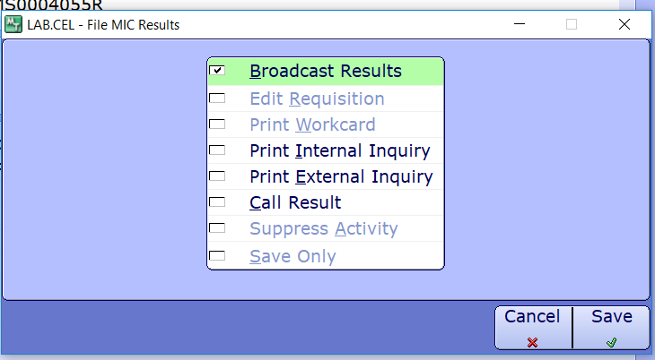

3.5.19 Your comment will file in the Micro Result and verified for QA purposes.

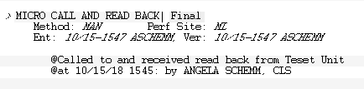

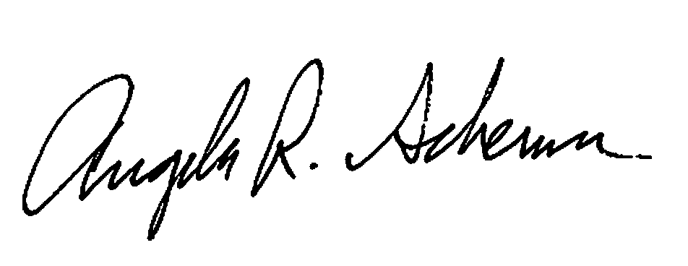

Revised procedure prepared by date__10/19/2018

Revised procedure approved by date___________
Document History Page

Change type: New, Major, Minor etc. | Changes Made to SOP - describe | Name responsible person/date | Med. Dir. reviewed/Date | Lab Manager reviewed/date | Date change Imp.
Major | Update for Core lab use after outsourcing to CSMC. | 7/12/2018  Angela Schemm | 7/12/2018  Dr. James Keefe | 7/12/2018  Anna Hamilton (interim) | 7/12/2018
Major | Update | Angela Schemm  10/19/2018 | Dr. James Keefe  10/19/2018 | Emma Galdones 10/19/2018 | 10/19/2018

