1. **Purpose**

Lactic Acid is an intermediate in carbohydrate metabolism present in red skeletal muscle, renal medulla, erythrocytes, brain and skin cells. Lactate concentration in the blood is dependent on metabolism rates in the liver and kidneys as well as the amount produced by these cells and tissues. As much as 65% of total basal lactate production is used in the liver in gluconeogenesis. Removal of lactate outside of the liver is achieved through red skeletal muscle and renal cortex oxidation. Although hepatic clearance is increased when lactate production increases, uptake of lactate by the liver is saturable when concentrations exceed 2 mmol/L, increasing rapidly during strenuous exercise. Lactate concentrations higher than 5 mmol/L and a pH less than 7.25 indicate lactic acidosis.

Lactic acidosis is categorized as Type A (hypoxic) and Type B (metabolic). Type A lactic acidosis is associated with shock, hypovolemia, and left ventricular failure. Type B is associated with disease (diabetes mellitus, neoplasia, liver disease), drugs or toxins (ethanol, methanol, salicylates) or inborn errors of metabolism. Type A is more common than B, and has a mortality rate greater than 60%, up to 100% with hypotension.1

1. **Scope**

Blood lactate concentration is tested to be used in the diagnosis of lactic acidosis, to monitor tissue hypoxia and strenuous physical exercise, and for the diagnosis of hyperlactatemia.

Diagnostic testing results should be evaluated by correlation with the patient’s full clinical assessment.2

1. **CLIA Complexity: Moderate Complexity**

Quality control (QC) is run with each new shipment, lot number and /or every 30 days. QC shall be performed in accordance with the i-STAT Lactate Individual Quality Control Plan (IQCP).2

1. **Intended Use**

i-STAT Lactate is intended for use in the in vitro quantification of lactate in whole blood.2

1. **Test Principle**

Lactate oxidase in the lactate biosensor within the reagent cartridge selectively converts lactate to pyruvate and hydrogen peroxide (H2O2). The hydrogen peroxide is oxidized at a platinum electrode, producing a current proportional to sample lactate concentration. Lactate is then measured amperometrically.2

Lactate Oxidase

L-Lactate + O2 Pyruvate + H2O2

Platinum Electrode

H2O2 2H+ + O2 + 2e-

1. **Specimen Collection and Handling**

i-STAT Lactate test is performed on whole blood using heparinized collection tubes. Testing shall be performed within 15 minutes of collection. Lactate increases as much as 70% within 30 minutes due to glycolysis.2

1. **Reagents and Materials**
2. CG4+ cartridge is used to perform the i-STAT Lactate test.
3. Testing is performed using the i-STAT handheld device.
4. Results are printed using the i-STAT remote printer.
5. **Storage and Stability**

CG4+ cartridges are stable until the manufacturer’s expiration date when stored at 2-8ºC and for 2 months when stored at 15-30ºC.2

1. **Rejection Criteria**

Specimens received in lab more than 15 minutes past time of draw will be canceled and redrawn. Only heparinized collection tubes and syringes may be used. Specimens collected using any other anticoagulants will be rejected and a redraw requested by lab.

1. **Precautions**

Testing shall be started within 15 minutes of collection. Lactate increases as much as 70% within 30 minutes to due glycolysis.2

1. **Quality Control**

Quality control is performed upon arrival of new shipments, with new reagent lot numbers and/or monthly according to the i-STAT Individual Quality Control Plan.

1. **Test Procedure**
2. **INTRODUCTION: BASIC COMPONENTS OF THE I-STAT SYSTEM**
3. The i-STAT handheld

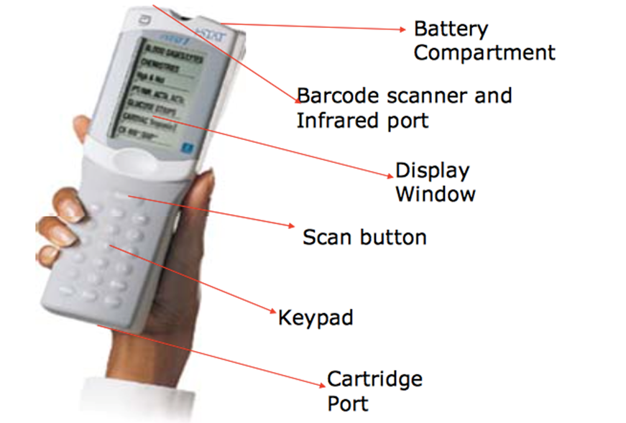

1. The Docking Center: Place the i-STAT handheld in the docking center to recharge. Keep the I-Stat in the docking center when not in use. A green light will blink at the top right corner of the docking center when the I-Stat has properly connected to the dock.

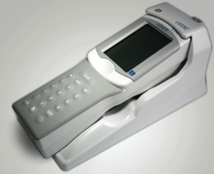

1. i-STAT Cartridges: Cartridges contain the test system. Each cartridge is sealed within a foiled pouch. The pouch should be opened ONLY when testing is to begin.

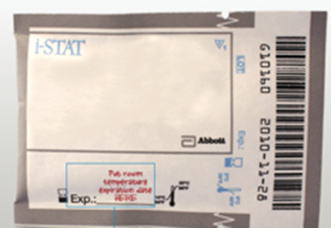

1. Blue **CG4+** Cartridges are used for lactate testing. A transfer pipette is used to fill the cartridge up to the arrow fill mark.

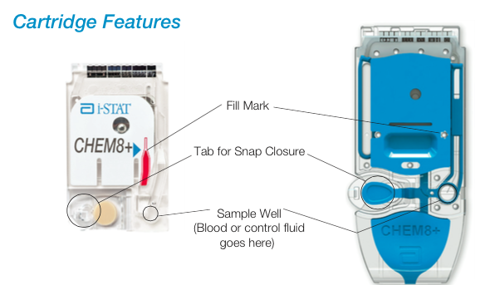

1. Remote printer is used to print patient results. Line the infrared scanner on the handheld up with the infrared scanner on the printer and press “print results”.

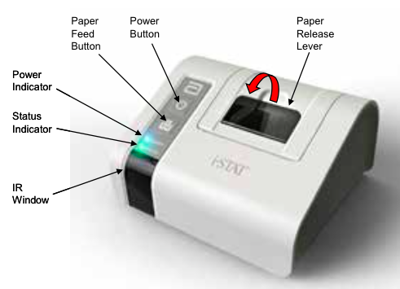

1. **ANALYSIS: TESTING THE PATIENT SAMPLE WITH THE I-STAT HANDHELD**
   1. Always place the handheld on a level surface with the display screen facing up.
   2. TURN ON the Martel PRINTER, make sure the top light is GREEN and the bottom light blinks GREEN.

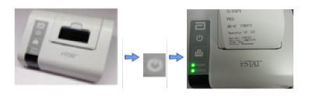

* 1. **TURN ON** the I-Stat handheld by pressing Description: Macintosh HD:Users:marlenegreenan:Desktop:Screen Shot 2014-11-16 at 3.13.24 PM.png
  2. Press **MENU** to choose **TEST MENU** (Pressing MENU will allow you to alternate between the Administration menu and the Test menu.)
  3. Press **2** for i-STAT **CARTRIDGE**
  4. **SCAN** your **badge ID** and press **ENTER**
  5. SCAN the specimen barcode or enter the barcode number and press **ENTER**
  6. **SCAN** the lot number (barcode) on the test cartridge pouch and press **ENTER**
     1. Position barcode 3-9 inches from scanner window on the handheld
     2. Align the red laser light so it covers the entire barcode
     3. The handheld will beep when it reads the barcode successfully.
  7. You will be prompted to **INSERT CARTRIDGE**
  8. Properly fill the cartridge – INSERT CARTRIDGE
  9. Wait until results are displayed.
  10. Align the IR window of the I-stat handheld directly with the IR window of the Printer.
  11. Press **PRINT**
  12. Enter patient results manually into MediTech.
  13. Initial and date patient result printout and affix to the i-STAT Lactate Patient Result Log.

1. **MEDITECH RESULT ENTRY**
   1. From the home screen, choose “SPECIMEN DESKTOP”
   2. Next, choose “ENTER RESULTS” from the menu on the right hand side
   3. At the prompt “CHANGES WILL NOT BE SAVED, EXIT ANYWAY?” choose “YES”
   4. Enter the accession number or barcode number (you may also search by MRN or patient’s name)
   5. Enter results from printout and “SAVE”
   6. Make sure “VERIFY ALL RESULTS” and “BROADCAST RESULTS” are checked and “SAVE”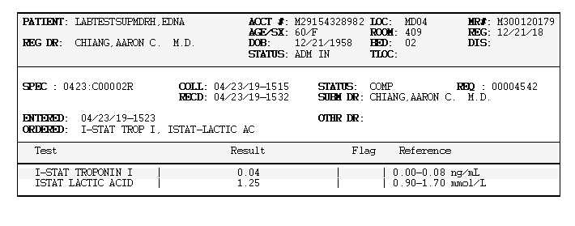
2. **ANALYSIS: EXTERNAL QUALITY CONTROL**
   1. Non-patient tests can be initiated from the Quality Tests menu.
      1. Options are: 1 – Control

2 - Proficiency (external quality control)

3 - Cal Ver (Calibration Verification for cartridges)

4 - Simulator (cartridge-reading function only)

* 1. Scan or enter the Operator ID; the Control Lot number, and the Cartridge Lot Number.
  2. Use one free flowing drop to fill the cartridge to the arrow mark.
  3. Insert the cartridge--testing will automatically begin
  4. Print the result and secure it to the i-STAT QC Log.
  5. When the Quality Tests option is used, results can be reviewed according to the corresponding options under the Data Review option.

1. **Result Interpretation**

All calculations performed on i-STAT handheld device. Results are displayed with units.

* 1. **Suppressed Results**
     1. Three conditions under which the I-Stat will not display results:
        1. Results outside the reportable, **< or >,** indicating that the result is below the lower limit or above the upper limit of the reportable range. **Report results as “less than” or “greater than.”**
        2. Cartridge results, which are not reportable based on **internal QC rejection** criteria, are flagged with **\*\*\***
           + Action: **Analyze the specimen again using a fresh sample and another cartridge**. If the specimen integrity is not questionable, the non-suppressed results are reported in the usual manner.
           + If results are not obtained using repeat sample, cancel and reorder using alternate methodology.
        3. A **Quality Check message** will be reported instead of results if the handheld detects a **problem with the sample, calibrant solution, sensors, or mechanical or electrical functions** of the handheld during the test cycle.
           + Action: Take the action displayed with the message that identifies the problem. **For quick assistance, refer to the “Technical Support: Quick Guide and Resources Section” of the I-Stat binder**. You may also refer to the i-STAT instrument, “i-STAT 1 System Manual” trouble-shooting sections, or the “Analyzer Coded Messages” Technical Bulletin for details.
        4. For all other problems
           + Refer to the “Technical Support: Quick Guide and Resources Section” of the i-STAT binder. You may also refer to the i-STAT instrument, “i-STAT 1 System Manual”.
  2. **Interpretation of Results**
     1. The Physician, RN, or other health care provider, is responsible for correlating test results with the clinical presentation of the patient.
     2. If results are questionable, the i-STAT operator may refer to the operator’s manual for interfering substances that may decrease or increase results, and for a table outlining the “Clinical Significance” of common clinical presentations leading to decreased or increased “abnormal” values.
     3. The specimen can be retested, a new specimen can be collected and retested, or a new specimen may be submitted to the laboratory for confirmation. Instrument performance can be checked (although the internal QC will do this,) the i-STAT operator may check the integrity of the cartridge “system” by performing the External Electronic Simulator test.
     4. In addition, the i-STAT binder will be used to document patient testing.

1. **Limitations**

When added to a plasma pool the following substances (at the concentrations indicated) were found to interfere with the i-STAT lactate assay

|  |  |  |
| --- | --- | --- |
| Substance | Test Concentration (mmol/L) | Interference |
| Bromide | 37.5 | Use another method |
| Glycolic Acid | 10.016 | False increase, use another method |
| Hydroxyurea | 0.92 | False increase, use another method |

Notes:

1) Hydroxyurea is a DNA synthesis inhibitor used in the treatment of various forms of cancer, sickle cell anemia, and HIV infection. This drug is used to treat malignancies including melanoma, metastatic ovarian cancer, and chronic myelogenous leukemia. It is also used in the treatment of polycythemia Vera, thrombocythemia, and psoriasis. At typical doses ranging from 500 mg to 2 g/day, concentrations of hydroxyurea in patients’ blood may be sustained at approximately 100 to 500 μmol/L. Higher concentrations may be observed soon after dosing or at higher therapeutic doses.

2) Glycolic acid is a product of ethylene glycol metabolism. Unexpected increased lactate concentrations caused by glycolic acid may be a clue to the possibility of ethylene glycol ingestion as the cause of an otherwise unknown high anion gap metabolic acidosis.21,22 In a study of 35 patients who had ingested ethylene glycol, initial glycolic acid concentrations of 0 to 38 mmol/L corresponded to ethylene glycol levels of 0.97 - 130.6 mmol/L.22

3) Bromide has been tested at two levels; the CLSI recommended level and a therapeutic plasma concentration level of 2.5 mmol/L. The latter is the peak plasma concentration associated with halothane anesthesia, in which bromide is released. APOC has not identified a therapeutic condition that would lead to levels consistent with the CLSI recommended level. Bromide at a concentration of 37.5 mmol/L decreased i-STAT lactate results, while a therapeutic range of bromide (2.5 mmol/L) did not significantly interfere with i-STAT lactate results.2

* It is possible that other interfering substances may be encountered. The degree of interference at concentrations other than those listed might not be predictable

1. **References**
   1. (6th ed.) Burtis, C. A., Ashwood, E. R., & Bruns, D. E. (2012). Tietz Textbook of Clinical Chemistry and Molecular Diagnostics. London: Elsevier Health Sciences.
   2. *Lactate/LAC* [Abbott Point of Care Test Information Sheet]. (2018, April 23). 100 and 200 Abbott Park Road, Abbott Park, IL.

**PROCEDURE HISTORY**

Document Owner: Dawn Marquette, Lead CLS

Reviewed by: Terry Snyder, QA Manager

Approval: Emma Galdones, Lab Director

|  |  |  |  |
| --- | --- | --- | --- |
| DATE OF CHANGE | SOP NO | APPROVAL HISTORY | REASON FOR CHANGE |
| 04/30/2019 | MCM.001 | Approval: James Keefe, MD | IMPLEMENTATION, NEW METHODOLOGY |
|  |  |  |  |
|  |  |  |  |
|  |  |  |  |
|  |  |  |  |