CLINITEK Status®+Analyzer

Operator’s Guide for End Users

**For West Texas VA**

**Parts not applicable to day to day routine operation have been removed.**

**A complete copy of the** **Operators Guide will be provided in case of need.**

**Please note page numbers in text of manual ay refer to the complete manual. Not this copy.**

10490853 Rev. E, 2022-05



© 2011-2022 Siemens Healthcare Diagnostics Inc. All rights reserved.

No part of this operator’s guide or the products it describes may be reproduced by any means or in any form without prior consent in writing from Siemens Healthcare Diagnostics.

CLINITEK, CLINITEK Status, CLINITEK Advantus, Clinitest, Multistix, Multistix PRO, Uristix, and Chek-Stix are trademarks of

Siemens Healthcare Diagnostics.

Presept and Cidex are trademarks of Johnson & Johnson. Theracide is a trademark of Lafayette Pharmaceuticals, Inc. Amphyl is a trademark of Linden Corporation.

Kimwipes is a trademark of Kimberly-Clark.

The information in this operator’s guide was correct at the time of printing. However, Siemens Healthcare Diagnostics continues to improve products and reserves the right to change specifications, equipment, and maintenance procedures at any time without notice.

If the system is used in a manner differently than specified by

Siemens Healthcare Diagnostics, the protection provided by the equipment may be impaired. See warning and hazard statements.

1. **Introduction**

Intended Use 7

Summary and Explanation 7

Getting Started 8

Unpacking the Clinitek Status+ Analyzer 8

Assembling the Clinitek Status+ Analyzer 10

Powering On/Off 16

Hardware Overview 18

Display 18

Test Table 19

Printer 20

Connections and Power 20

Memory Card Slot 20

Software Overview 21

Touch Screen 21

Entering Information 27

1. Operations

Performing a Urinalysis Strip Quick Test 29

Preparing a Urinalysis Strip Quick Test 29

Running a Urinalysis Strip Quick Test 30

Viewing the Urinalysis Strip Quick Test Results 32

Viewing Sample Interference Notes 33

Printing the Urinalysis Strip Quick Test Results 33

Completing the Urinalysis Strip Quick Test 34

Performing a Urinalysis Strip Full Test 38

Entering Operator and Patient Information 38

Preparing a Urinalysis Strip Full Test 40

Running a Urinalysis Strip Full Test 40

Selecting the Appearance of the Urine Sample 41

Viewing the Urinalysis Strip Full Test Results. 42

Printing the Urinalysis Strip Full Test Results 43

Completing the Urinalysis Strip Full Test 44

1. Calibration & QC

Calibration Overview 51

Cleaning the White Calibration Bar 51

Quality Control Overview 53

Urinalysis Strip Quality Control Testing 54

hCG Cassette Quality Control Testing 54

Quality Control Troubleshooting 55

1. Maintenance

Weekly Cleaning of the Test Table and Test Table Insert 57 Cleaning the White Calibration Bar 58

Disinfecting the Test Table and Table Insert 60

Cleaning the Outside of the Analyzer 62

Changing the Batteries 63

1. Troubleshooting

Error Messages 65

Errors That Require Correction 65

Advisory Error Messages 66

Results Alert 66

Errors and Advisory Messages 66

Troubleshooting the Analyzer Operation 74

Calling for Assistance 76

Technical Support 76

Customer Support 77

Problem List 77

1. File Management

Recalling the Patient Test Results 80

Sending All the Test Results to a Computer 81

Sending Individual Test Results to a Computer 82

Deleting Patient Results 82

1. System Configuration

Most of this section is deleted. See full manual if necessary

Running Diagnostics 126

Viewing the System Information 126

Viewing and Printing the System Configuration Settings 127

Appendix A: Safety Information

Protecting Yourself from Biohazards 129

Recognizing Sources of Contamination 129

Preventing Contamination 129

References 130

Appendix B: Support Information

Installation Details 131

Limitations of Liability 131

Legal Information 131

When to Contact Technical Support 131

Appendix C: Orderable Supplies

Supplies and Optional Equipment 133

Supplies 133

Optional Equipment 133

Replacement Parts 133

Documentation 134

Appendix D: Specifications

Analyzer Specifications 135

Analyzer Dimensions 136

Environmental Specifications 136

Electrical Requirements 136

Safety Standards 137

Safety Certifications 137

Electromagnetic Compatibility (EMC) 137

Tables of Results 137

English, Units – Conventional 138

English Units – International (SI) 143

English Nordic, Units – Nordic Plus System 148

Appendix E: Symbols

Analyzer and Labeling Symbols 153

Analyzer and Packaging Symbols 153

Analyzer Symbols 154

Display Icons 156

Appendix F: Glossary

Hardware Terms 159

Software Terms 160

Acronyms 165

Index 167

# 1 Introduction

**Introduction**

The introduction explains how to get started, unpack, and install your CLINITEK Status®+ analyzer. The introduction also includes an overview of the analyzer.

## Intended Use

The CLINITEK Status+ Urine Chemistry Analyzer is a portable, easy to use analyzer. It is designed to read only

Siemens Healthcare Diagnostics Reagent Strips for Urinalysis and Clinitest® hCG tests.

This analyzer is intended for the measurement of the following in urine: Albumin, Bibilirubin, Blood (Occult), Creatinine, Glucose, Ketone, Leukocytes, Nitrite, pH, Protein, Protein-to-Creatinine Ratio, Albumin-to-Creatinine Ratio, Specific Gravity, Urobilinogen, and human Chorionic Gonadotropin (hCG).

These measurements are used to assist diagnosis in the following areas:

* Kidney function
* Urinary tract infections
* Metabolic disorders (such as diabetes mellitus)
* Liver function
* Pregnancy

Tests perfomed using the CLINITEK Status+ analyzer are intended for *in vitro* diagnostic use only.

The CLINITEK Status+ analyzer is intended for near patient (point-of- care) facilities and centralized laboratory locations.

## Summary and Explanation

The urinalysis strips also measure physical characteristics, including acid-base balance and urine concentration. Test results can be used along with other diagnostic information to rule out certain disease states and to determine if microscopic analysis is needed.

Multistix PRO® urinalysis strips are ready to use upon removal from the bottle and the entire strip is disposable. The strips may be read visually, requiring no additional laboratory equipment for testing.

**Introduction**

The strips can also be read on an instrument, using the

CLINITEK® family of Urine Chemistry Analyzers and the appropriate software; Multistix PRO 11 Reagent Strips are for use on the CLINITEK 500 and CLINITEK Advantus® Analyzers only. The

CLINITEK Status systems, CLINITEK 50 and CLINITEK 100 instruments automatically identify the strip being tested, using the ID bands near the handle of the strip. Contact your product representative for further information.

Multistix PRO urinalysis strips are for *in vitro* diagnostic use. They have been determined to be nonhazardous under the guidelines issued by OSHA in 29 CFR 1910.1200(d).

**Figure 1-1: Clinitek Status+ Analyzer Components**

**Introduction**

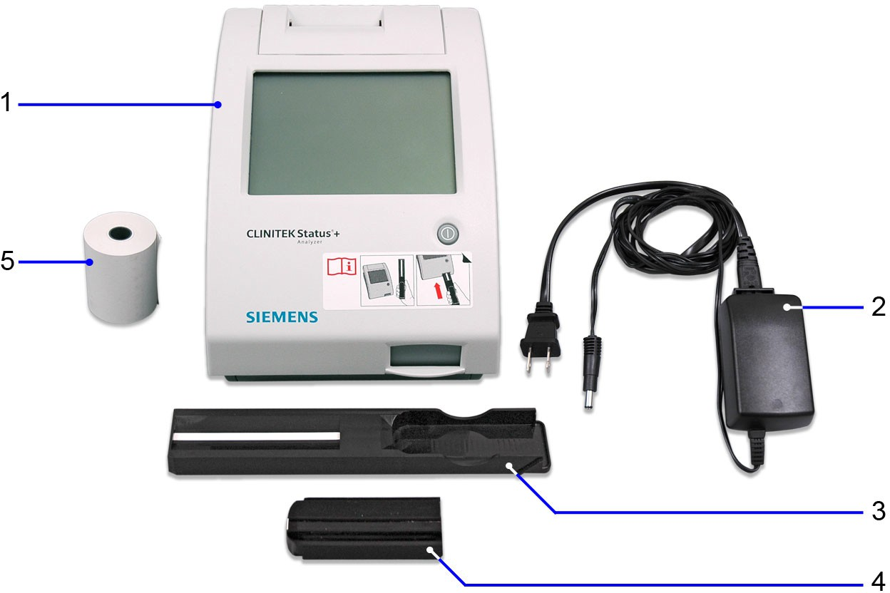

1. Clinitek Status+ Analyzer
2. Power supply adaptor and AC power cord (Figure shows US version)
3. Test table with calibration bar
4. Test table insert
5. Paper roll

1. Place the analyzer on a level work surface where the temperature and humidity are fairly constant.

**Introduction**

#### CAUTION



The best temperature for using the analyzer is between 22° and 26°C (72° and 79°F). Do not place the analyzer outdoors or near windows, ovens, hot plates, or radiators.

1. Connect the appropriate end of the power cord into the power inlet socket located on the back of the analyzer (see *Figure 1-2*).

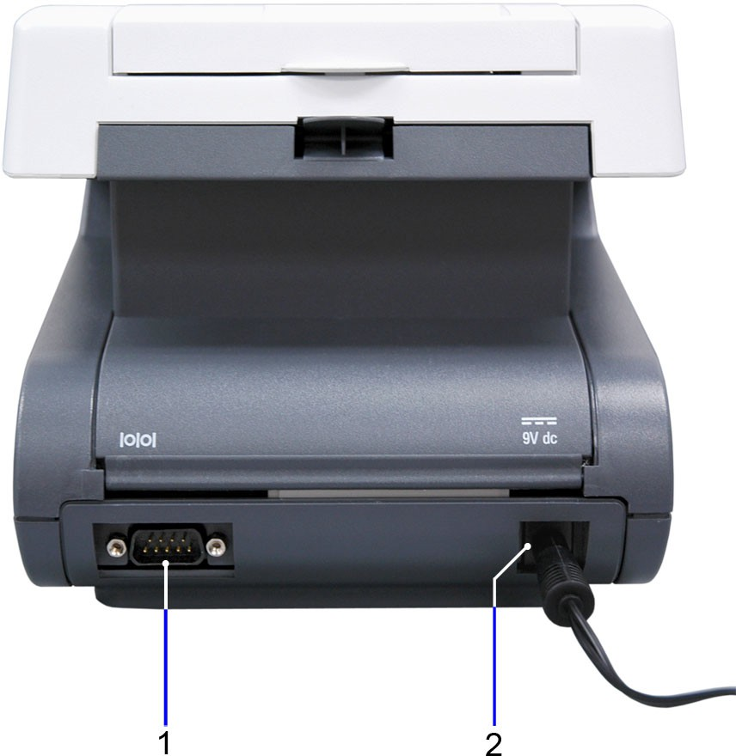**Figure 1-2: Assembling the Clinitek Status+ Analyzer**

1. Serial port
2. Power cord

Connect the other end of the power cord into an AC electrical wall outlet.

#### CAUTION



Use only the power supply adapter included with the analyzer. A different power supply adapter might damage the analyzer.

##### Inserting the Batteries (optional)

**Introduction**

To power the Clinitek Status+ Analyzer by batteries (optional), perform the following steps:

1. Place the analyzer on its side.
2. Remove the battery cover on the bottom of the analyzer by pressing down on the tab and pulling out the cover.
3. Place 6 new alkaline AA-size batteries into the battery compartment.
4. Place the battery cover back on the compartment and turn the analyzer back on its base.

#### CAUTION



Do not use batteries in the analyzer, if you attach the analyzer to a CLINITEK Status connector. Leaving the batteries in the battery compartment may corrode the batteries.

##### Inserting the Test Table and Test Table Insert

To insert the test table and test table insert, perform the following steps:

1. Insert the test table into the analyzer by holding it by the end opposite the white calibration bar and with the white bar facing up.
2. Push the test table into the analyzer, pushing it in just over halfway.

#### CAUTION



Do not push the test table fully into the analyzer. The test table may become jammed and prevent the use of the analyzer.

Do not touch the white calibration bar on the test table. Damage to the calibration bar could affect the test results.

1. Place the test table insert into the test table (see *Figure 1-3*).

**Note** The test table insert adapts for use with a Siemens urinalysis strip or an hCG cassette. Use one side for a strip test and the other side for a cassette test.

**Introduction**

**Figure 1-3: The Test Table and Test Table Insert**

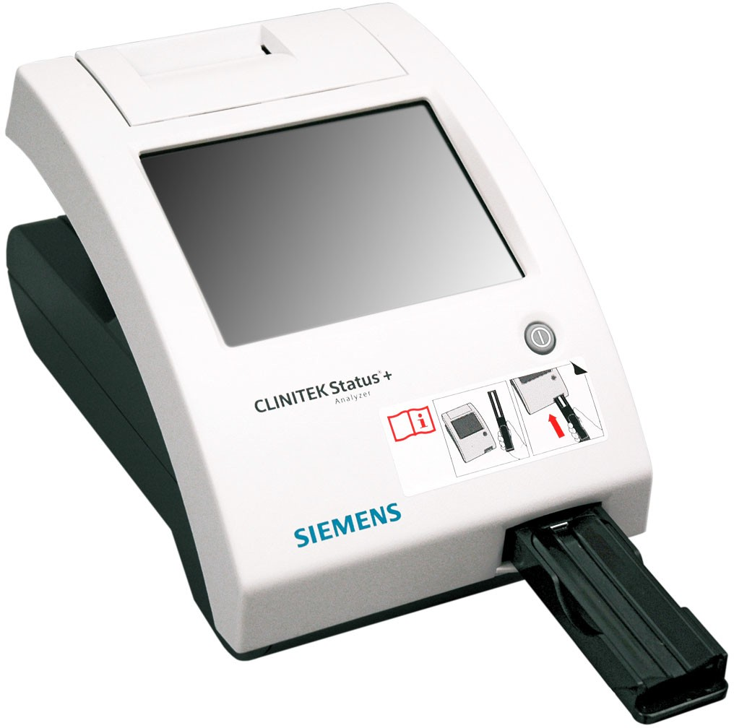

##### Loading the Printer Paper

The analyzer uses ordinary thermal paper as provided, or label stock. For more information about ordering supplies, see *Appendix C,**Orderable* *Supplies*. Please contact the ATC for supplies until they can be set up with Logistics.

To load the printer paper or label roll, perform the following steps:

* 1. With the back of the analyzer facing you, open the printer cover by pulling up on the tab.
  2. Open the paper roll compartment cover by pressing down on its tab and pulling out the cover.
  3. Lift the paper holding arm into the open, upright position.
  4. Place the new paper roll into the printer paper compartment with the paper unrolling from underneath and toward the compartment wall.
  5. Feed the paper up along the wall and through the printer until you have approximately 10 cm (or 4 inches) of paper through the printer.
  6. Feed the edge of the paper through the printer cover.

**Introduction**

* 1. Push the paper holding arm down in the closed position (see

*Figure 1-4*).

* 1. Close the paper roll and printer covers by clicking them into position.

**Note** By default, the analyzer automatically prints the test results. To disable the automatic print function, see Section 7, *System**Configuration*, *Changing the System Settings*‚ page 107.

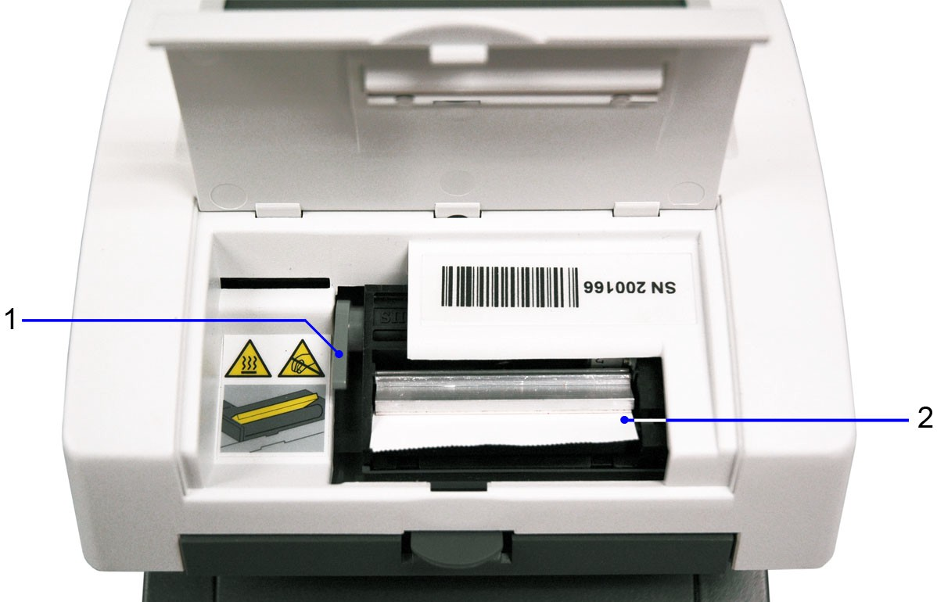**Figure 1-4: Printer Paper Compartment**

1. Paper holding arm
2. Printer paper

### Powering On/Off

**Introduction**

If you power on the analyzer for the first time, the Start Up Wizard prompts you through a set-up procedure. Also, you must enter a startup code when you use the analyzer for the first time.

To power on the analyzer, perform the following steps:

1. Press the on/off button on the front of the analyzer.

The analyzer runs a diagnostic test each time you power on the analyzer.

If this is the first time you powered on the analyzer, the Start Up Wizard displays and prompts you to select a region.

1. Select a region.

**Note** If your region does not display in the list, select **Other**. The **Authorization Code** screen displays.

1. For the start up code, enter **2664**.

**Note** If you enter an incorrect start-up code, the Incorrect Authorization Code error message displays. Select **No** to return to the **Authorization Code** screen and enter **2664**.

To power off the analyzer, perform the following steps:

1. Before you power off the analyzer, always ensure that no strip or cassette is on the test table and that the table and insert are clean.
2. Press the on/off button for at least 2 seconds.

**Introduction**

The analyzer pulls in the test table. If no strip or cassette is on the test table, the test table door closes and the analyzer powers off.

If a strip or cassette is still on the test table, the analyzer pushes out the test table and powers off. The test table remains out.

To pull the test table into the analyzer, power on the analyzer, remove the strip or cassette on the test table, and then power off the analyzer.

#### CAUTION



Do not push the test table fully into the analyzer. The test table might become jammed and prevent the use of the analyzer.

## Hardware Overview

**Introduction**

The CLINITEK Status+ analyzer consists of the following hardware components:

* Display
* Test table
* Printer
* Connections and power
* Memory card slot

### Display

You interact with the CLINITEK Status+ analyzer through an integrated touch screen display. The touch screen displays messages, options, and requests for information. You respond by selecting a button or an area on the screen (see *Figure 1-5*).

#### CAUTION



Do not use anything hard or pointed on the touch screen. It might damage the screen.

DO NOT USE A PEN OR PENCIL. A touch screen stylus will be provided by the ATC.

**Note** If you run a CLINITEK Status+ analyzer with a CLINITEK Status connector, you can use a handheld bar-code reader to enter information into the analyzer. .

**Introduction**

**Figure 1-5: Touch Screen Display**

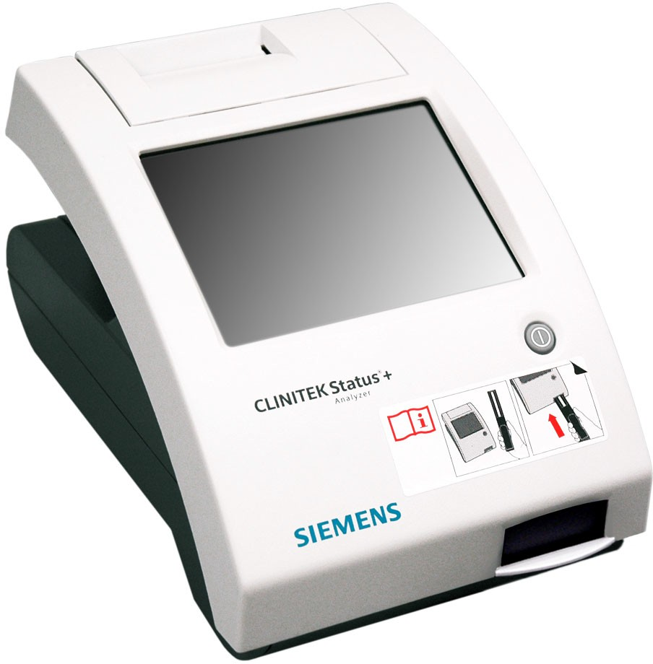

### Test Table

All testing takes place on the test table.

1. Place the strips on the test table insert.

**Note** If you use a urinalysis strip that has 4 or fewer test pads, such as Uristix 4 reagent strips, use a short test table insert. You need to order the short test table insert separately from the analyzer (see *Appendix C, Orderable Supplies*).

1. The analyzer pulls in the test table partially for calibration and then pulls in the test table completely to read and test the strip .
2. When the test finishes, the test results display on the screen.
3. You can transfer the test results to a computer by using the RS-232 serial port on the back of the analyzer. Results will be transmitted via the Connect base.

**Introduction**

If you run a CLINITEK Status+ analyzer with a CLINITEK Status connector, you can transfer the test results through a wireless or wired Ethernet connection.

### Printer

An internal thermal printer prints the test results.

### Connections and Power

Connect the analyzer into an electrical outlet to use on a benchtop, or use batteries so you can freely move the analyzer from one testing site to another.

### Memory Card Slot

The memory stores the analyzer software, operating parameters, settings you select, up to 950 patient test results, and 200 authorized operators. The information is stored in the memory, whether the analyzer is powered on or off.

You can update the software by inserting a memory card into the slot under the printer cover (see *Figure 1-6*). The ATC will either walk you through the update or come to the clinic to do the update.

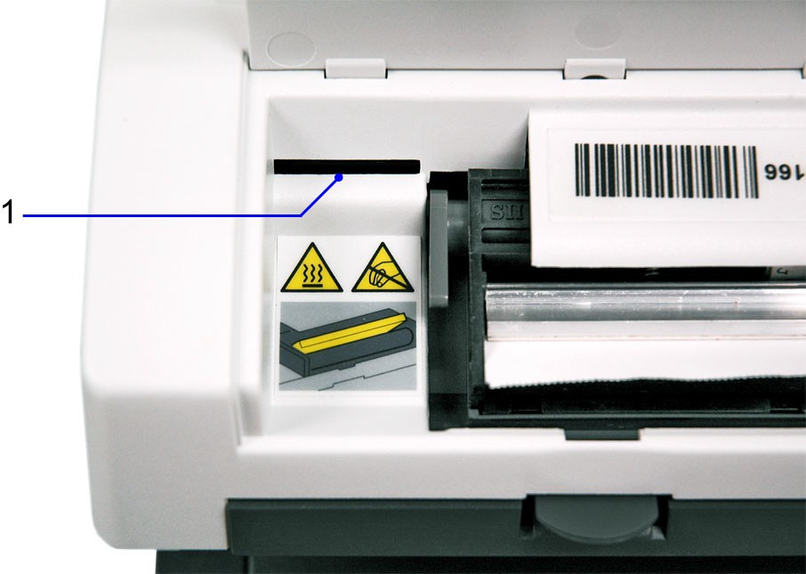**Figure 1-6: Memory Card Slot**

1. Memory Card Slot

**Note DO NOT USE A MEMORY STICK SINCE ENCRYPTED MEMORY STICKS WILL NOT WORK ON THIS SYSTEM. Only encrypted memory sticks are permitted on VA equipment.**

**Introduction**

## Software Overview

The CLINITEK Status+ analyzer user interface consists of a touch screen with an onscreen alphanumeric keyboard.

### Touch Screen

Use the **Select Ready** screen to configure the analyzer, run tests, recall results, and navigate to any point in the software (see *Figure 1-7*).

The **Select Ready** screen contains the following elements:

* **Title bar** Contains the current screen name, date, and time.
* **Selection area** Includes Instrument Set Up, Recall Results, Cassette Test, and Strip Test.

For a complete list of icons with their descriptions, see *Appendix E,**Symbols*.

**Note** Depending on the screen that displays, when the analyzer is idle for a period of time, the analyzer returns to the **Select Ready** screen.

**Introduction**

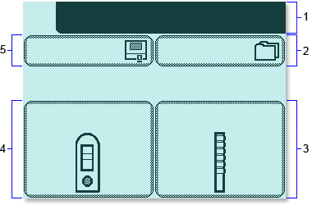**Figure 1-7: Select Ready Screen**

1. Title bar
2. Recall Results
3. Strip Test
4. Cassette Test
5. Instrument Set Up

Each subsequent screen can display an icon in the upper left corner to indicate an analyzer mode or action (see *Figure 1-8*). For example, the battery icon indicates that the analyzer is powered by batteries. A screen also can display buttons, instructions, alert messages, and error messages.

**Introduction**

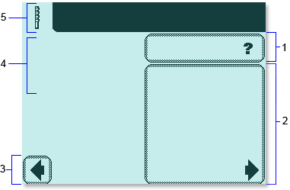**Figure 1-8: Screen Elements**

1. Help
2. Selection Area
3. Button
4. Instructions
5. Icon

Tap the screen lightly in a selection area or button to select an option or button, or to navigate in a list of items.

#### CAUTION



Do not use anything hard or pointed on the touch screen. It might damage the screen.

DO NOT USE A PEN OR PENCIL. A touch screen stylus will be provided by the ATC.

The CLINITEK Status+ analyzer provides several screen elements: option, area, button, arrow, and double arrows.

**Introduction**

|  |  |  |
| --- | --- | --- |
| **Screen** **Element** | **Example** | **Description** |
| Option | Round option buttons display on screens where you select an option. The option button with a filled circle is the current selection. For example, **Sound on**, **Sound off**, and **Key clicks only** are instrument setup options. | |
|  | To change your selection, select an option button with an unfilled circle. The newly selected circle (round option button) is highlighted. In the example, the **Sound on** option is selected. | |
| Selection Area | Selection areas enclosed in boxes on the screen indicate functions that you can select. Select a boxed area to activate that function. For example, **Strip Test**. | |
|  | An area varies in size. For example, the boxes on the **Select Ready** screen are large areas. | |

|  |  |  |
| --- | --- | --- |
| **Screen Element** | **Example** | **Description** |
| Button | Several buttons display at the bottom of the screens, which include **Select** and **Done**.  To navigate the screens, the analyzer displays left and right arrow buttons. To move to the previous screen, select **Previous** (left arrow). To move to the next screen, select **Next** (right arrow). | |

**Introduction**

|  |  |  |
| --- | --- | --- |
| **Screen Element** | **Example** | **Description** |
| Arrow | Select the up and down arrows on the right side of the screen to scroll through the items in a list and highlight an item on the left side of the screen. Select the **Select** button to confirm your selection and move to the next screen. | |
|  | When an arrow is highlighted, you can use it to scroll. When an arrow is dimmed, you are viewing the first item or last item in the list, and cannot scroll beyond that page. | |
|  | **Note** When an item in a list displays a highlighted bar, you can select that item. | |
| Double Arrows | When double arrows display on the screen, you select these arrows to move to the  top or bottom of the page. | |
|  | When a double arrow is highlighted, you can use it to scroll. When a double arrow is dimmed, you are viewing the first page or last page of the list, and cannot move beyond that page. | |

**Introduction**

### Entering Information

Some options require you to enter information. For example, the analyzer prompts you to enter an Operator ID, Patient Name, and Patient ID. Depending on how you set up your analyzer, an alphabetic or numeric keyboard displays on the screen.

To switch between the onscreen keyboards, follow these steps:

* To display the numeric keyboard, select **123**.
* To display the alphabetic keyboard, select **ABC**.

To specify which onscreen keyboard you want to display by default, use the **Keypad Priority** option, as explained in Section 7, *System**Configuration*, *Custom Set Up*‚ page 96.

**Note** By default, some screens display an alphabetic or numeric keyboard, and override the keyboard default you specify.

If you run a CLINITEK Status+ analyzer with a CLINITEK Status connector, you can connect a handheld bar-code reader to the analyzer, and scan information for some values.

You also can connect a keyboard to the analyzer, where the analyzer recognizes only the keyboard input equivalent to the alphabetic and numeric characters on the onscreen keyboards. For example, to enter a name, number, or birth date, select the alphabetic or numeric characters on the keyboard. Those selections display in the data entry box.

**Note** When you switch between the alphabetic and numeric onscreen keyboards, the analyzer retains the values in the data entry box on both keyboard screens.

For most data entry boxes, you can enter a minimum of 6 and a maximum of 63 characters, depending on the type of entry. An audible tone sounds when you exceed the maximum number of characters.

After you finish entering the information, select **Enter** (from either onscreen keyboard).

# Operations

**Operations**

You can perform a Quick Test or a Full Test with a urinalysis strip or an hCG cassette. Place a strip or a cassette on the test table. The analyzer calibrates and begins testing.

**Note** You can configure the Quick Test or Full Test, as explained in Section 7, *System Configuration*, *Setting up Operator and Patient**Information*‚ page 95.

With a Full Test, enter the Operator Name, and Patient Name, and Patient ID from the analyzer display. If you run a CLINITEK Status+ analyzer with a CLINITEK Status connector, enter the information from a bar-code reader.

**Note** You cannot cancel a test before the analyzer finishes the test. View and print the test results that display on the screen.

### Viewing Sample Interference Notes

**Operations**

Sample interference notes inform you about the test results that can be affected by components detected in the urine sample. By default, sample interference notes display and print. To set up sample interference notes, see Section 7, *System Configuration*, *Setting up**Sample Interference Notes*‚ page 119.

Depending on the strip and sample, sample interference notes could include the following statements:

* High SG may cause falsely lowered GLU results.
* Elevated GLU may cause falsely lowered LEU results.
* Visibly bloody urine may cause falsely elevated PRO results.
* High SG may cause falsely lowered LEU results.
* High pH may cause falsely elevated PRO results.

.

## Performing a Urinalysis Strip Full Test

With a urinalysis strip full test, you can enter an Operator Name, Patient Name, and Patient ID. When you place the strip on the test table, the analyzer calibrates and starts to perform the analysis.

Perform the following procedures to test a strip.

#### BIOHAZARD



Wear personal protective equipment. Use universal precautions. For recommended precautions when you work with biohazardous materials, see *Appendix A, Safety*

*Information*.

### Entering Operator and Patient Information

Enter or select an operator ID (use ID assigned by ancillary testing coordinator), patient name, and patient ID.

To enter operator and patient information, perform the following steps:

1. On the **Select Ready** screen, select **Strip Test**.
2. On the **Operator Name** screen, to enter the operator name OR YOUR POINT OF CARE ID NUMBER, perform the following steps:
   * Only if configured, if you are the last operator, select **Last Operator**.
   * If you are a new operator:

**Operations**

1. Select **Enter New Operator**.
2. Enter your name (a maximum of 13 characters) on the **Enter Operator Name** screen. **Or enter you POC ID number**
3. Select **Enter**.

For more information about how to use the keyboard, see Section 1, *Introduction*.

You also can enter the Operator Name or ID from a computer keyboard, or if you run the analyzer with the CLINITEK Status connector, scan it from a bar-coded label using the handheld bar-code reader.

1. On the **Patient Information** screen, to enter the patient information, perform the following steps:
   * To enter a previous patient:
2. Select **Recall Patient**.
3. Scroll through the patient name list.

The most recently performed test displays at the top of the list.

1. Highlight the patient name and select **Select**.

**Note** The patient name list displays up to 200 patients in chronological order. When the list reaches 200 patients, the analyzer deletes the oldest name from the list. You cannot retrieve the deleted name.

* + To enter a new patient:

1. Select **Enter New Patient**.
2. Enter the patient name (maximum of 20 characters) on the

**Enter Patient Name** screen.

1. Select **Enter**.

You also can enter the patient name from a computer keyboard.

If you run a CLINITEK Status+ analyzer with a CLINITEK Status connector, you can scan the patient name from a bar-coded label using the handheld bar-code reader.

1. Enter the patient ID (maximum of 13 characters) on the **Enter Patient ID** screen, and select **Enter**. **YOU MUST ENTER THE FULL SOCIAL SECURITY NUMBER WITH NO DASHES.**

**Operations**

### Preparing a Urinalysis Strip Full Test

Before you run a urinalysis strip Full Test, prepare the strip and the analyzer.

To prepare a urinalysis strip Full Test, perform the following steps:

**Note** If you use a reagent strip that has 4 or fewer test pads, such as Uristix 4 reagent strips, use a short test table insert. You need to order the short test table insert separately from the analyzer (see *Appendix**C, Orderable Supplies*).

1. If you enabled lot information with Instrument Set Up, enter the strip lot number and expiration date, as follows; otherwise, go to step 2. This will be activated during setup.
   * To use the last strip number and begin the test, select **Use Last Lot**.
   * To enter new strip data, select **Enter new lot and expiration**. Enter the strip lot number and select **Enter**. Use the arrow keys to enter the strip expiration date and select **Enter**.
2. Make sure the reagent strip holder faces upward in the test table insert.
3. Have the urinalysis strip and paper towel ready.

### Running a Urinalysis Strip Full Test

When you run a urinalysis strip Full Test, the analyzer calibrates and then analyzes the strip.

To run a urinalysis strip Full Test, perform the following steps:

**Note** After you select **START**, you have 8 seconds to dip the reagent strip in the urine sample and place the strip in the test table channel.

1. Select **START**.

The **Prepare Test** screen displays steps on how to perform the test. A timer displays the amount of time remaining to complete the task.

**Note** To display the strip testing steps on the screen, select **Help**.

**Operations**

1. Dip the reagent strip in the urine sample and wet all the pads.

The ID band allows auto-strip identification to ensure that the analyzer reports the correct strip configuration when you perform a urinalysis test.

**Note** Be sure to use the proper dipping technique.

1. Immediately remove the strip from the urine.
2. Drag the edge of the strip against the side of the sample container as you remove it.
3. Blot the edge of the strip on a paper towel to remove the excess urine.
4. Place the reagent strip in the test table channel with the test pads facing up.
5. Slide or push the strip to the end of the channel. Do not touch the pads on the strip.

After the 8-second countdown ends, the analyzer pulls in the test table and strip, and then calibrates.

**Note** Each time you run a test, the analyzer calibrates.

#### CAUTION



Do not push or pull the test table because the calibration might fail or the movement might cause table positioning errors.

Do not move or bump the table while the analyzer calibrates. The calibration might fail.

After the calibration finishes, the analyzer starts analyzing the strip, and the **Analyzing** screen displays.

### Selecting the Appearance of the Urine Sample

While the analyzer analyzes the strip, a **Select Appearance** screen displays.

To select the appearance of the urine sample, perform the following steps:

* 1. Visually observe the urine sample and determine the appropriate color and clarity.

**Operations**

* 1. Select the urine sample color and clarity:
     + If the urine sample is yellow and clear, select **Yellow and Clear**.
     + If the urine sample is not yellow and clear, select **Other**, and select a color. Next, select a **Clarity** option and select **Next**.

A time indicator on the **Select Appearance** screen counts down the time remaining in the analysis of the strip. The analyzer displays either of the following screens:

* + - **Analyzing** if the strip is still being analyzed.
    - **Results** if analyzing the strip is complete.

A timer counts down the time remaining in the strip analysis process. After the countdown ends, the analyzer displays the first page of the test results on the **Results** screen.

The results display on the screen for 2 minutes. Then, the display returns to the **Select Ready** screen.

The test table and strip move out of the analyzer.

**Note** If you set up the analyzer to print the test results automatically, the **Printing** screen displays until the printout finishes. If you set up the analyzer with a connection to a PC, the analyzer sends the test results to the PC.

### Viewing the Urinalysis Strip Full Test Results

The first page of test results display on the **Results** screen. You can view additional pages of the test results and sample interference notes (if configured) on the **Results** screen.

To view additional pages of the urinalysis strip Full Test results and the sample interference notes, perform the following steps:

1. Select **Mo****re** to view the remaining test results.

If you use reagent strips with an ID band, you can view sample interference notes for this test.

1. Select **Notes** to view the sample interference notes, if the analyzer generated them for the test.

**Operations**

The **Interference notes** screen displays up to 5 sample interference notes.

**Note** If you disable the **Sample Interference Notes** setting in Instrument Set Up, or the analyzer does not generate sample interference notes, the **Notes** button does not display. If you run a test with this feature disabled, the analyzer does not generate notes at the time of the actual test. If you enable the **Sample Interference Notes** setting, and then recall the test results, the analyzer generates notes for this patient test.

1. Select the up and down arrows to scroll through the notes.
2. Select **Done** to return to the main **Results** screen.

### Printing the Urinalysis Strip Full Test Results

Print the urinalysis strip Full Test results manually or automatically, or send the results to a computer.

To print the urinalysis strip Full Test results manually, select **Print** to print the test results.

The test results printout includes the following information:

* + Patient name and Patient ID
  + Urinalysis strip type
  + Lot number, if configured
  + Lot expiration date, if configured
  + Test date
  + Test time
  + Operator
  + Test number
  + Color
  + Clarity
  + Results (If the results are positive, an asterisk (*) displays next to the results, only if you selected Mark Positive Results in Instrument Set Up.)
    - Sample interference notes (if enabled in Instrument Set Up)

**Operations**

For instructions on how to set up the analyzer so that you can print the results automatically or send the results to a computer, see Section 7, *System Configuration*, *Changing the Connectivity**Settings*‚ page 110.

### Completing the Urinalysis Strip Full Test

Complete the testing for one strip or continue testing one strip at a time, until you finish testing all the strips you want to analyze.

To complete the urinalysis strip Full Test, perform the following steps:

1. Remove the used urinalysis strip from the test table, and dispose of it according to your standard laboratory procedures.
2. Wipe the table insert, if necessary (see Section 4, *Maintenance*, *Weekly Cleaning of the Test Table and Test Table Insert*‚ page 57).
3. Report the results to a laboratory supervisor or physician.
4. Select **Done** to complete the test and return to the **Select Ready**

screen.

1. Select **Done** to return the **Strip Test Prepare** screen.

You are ready to start the next test. If you completed your testing, select **Back** to return to the **Select** screen.

# Calibration & QC

**Calibration & QC**

This chapter covers calibration and quality control (QC).

## Calibration Overview

The CLINITEK Status+ analyzer calibrates automatically before each measurement. The analyzer calibrates by reading the white calibration bar at the appropriate wavelengths to ensure accurate test results (see *Figure 3-1*).

**Figure 3-1: Calibration Bar**

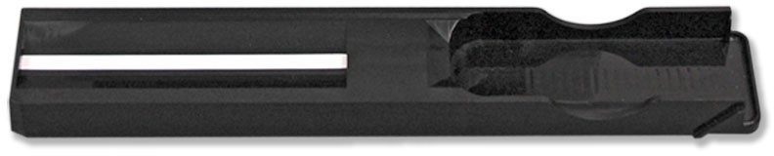

The calibration bar was tested on a reference spectrophotometer. By calibrating the reference spectrophotometer with the National Institute of Standards and Technology (NIST) traceable calibrators, Siemens can show traceability to NIST.

**Note** Keep the calibration bar clean to ensure accurate results. For details about cleaning the calibration bar, see the next section on *Cleaning the White Calibration Bar*.

## Cleaning the White Calibration Bar

For the CLINITEK Status+ analyzer to perform as intended and provide reliable test results, the white calibration bar on the test table needs to be clean and not discolored. With normal use, the white calibration bar should not become dirty or discolored.

#### BIOHAZARD



Wear personal protective equipment. Use universal precautions. For recommended precautions when you work with biohazardous materials, see *Appendix A, Safety*

*Information*.

To clean the white calibration bar, perform the following steps:

**Calibration & QC**

* 1. Remove the insert from the test table.
  2. Remove the test table by pulling it slowly out of the analyzer.
  3. Drain the drip tray, if necessary.
  4. Examine the white calibration bar on the test table for dirt or discoloration.

#### CAUTION



Do not touch the calibration bar while you examine it or after you clean it. Your fingerprints or lint on the bar could cause unreliable test results. When you examine the white calibration bar, do it carefully under good lighting.

* 1. If the white calibration bar appears clean and unmarked, perform the following steps:

1. Place the test table into the analyzer by holding the table at the end opposite the white calibration bar, with the white calibration bar facing upward.
2. Push the test table firmly but slowly, just over halfway into the analyzer.

#### CAUTION



Do not push the test table fully into the analyzer. The test table might jam and prevent you from using the analyzer.

1. Place the test table insert.
2. If the white calibration bar is dirty or discolored, perform the following steps:

**Calibration & QC**

* 1. Wet a new cotton-tipped stick or lint-free cloth with distilled water and gently wipe and clean the calibration bar.

#### CAUTION



Do not scratch the white calibration bar. Marks and stains could cause inaccurate test results, especially for hCG tests. Severe marks could cause errors.

Do not use solvents of any kind to clean the bar. They could destroy the bar.

* 1. Allow the calibration bar to air dry.
  2. Inspect the surface for dust, foreign material, scratches, or scuffs.

If you cannot completely clean the calibration bar or if the bar still has marks, order a new test table. Contact your Siemens representative.

* 1. Place the test table, as described in step 5.

## Quality Control Overview

Quality Control (QC) testing helps ensure that the urinalysis strips and cassettes are reacting correctly and that the analyzer is accurately reading them. QC also helps detect errors that result from user techniques.

QC should be performed in accordance with local, state, and federal guidelines.

This chapter provides only a general overview of quality control testing. To run quality control, follow the instructions in the quality control instructions for use product insert.

If you run a CLINITEK Status+ analyzer with a CLINITEK Status connector, you can configure QC testing with reminder prompts and the lockout feature. For more information about the QC configuration settings, see the *CLINITEK Status Connect System Operator’s Guide.*

### Urinalysis Strip Quality Control Testing

**Calibration & QC**

Urinalysis controls in use for point of care are the Alta Diagnostic controls consisting of a positive and a negative. Control acceptable values are lot specific and will be found on the data sheet in the box.

Test negative and positive controls each day of use. Water should NOT be used as a negative control. Each laboratory should establish its own goals for adequate standards of performance. For information about control manufacturers, contact the Siemens Customer Service Department.

Compare QC results to the QC manufacturer’s acceptable results list. If the QC results are not acceptable, do not test the patient samples until you solve the problem. Repeat QC tests until you have acceptable results.

For expected values for each analyte, see the quality control instructions for use product insert.

**Troubleshooting quality control Failure:**

1. Make sure the controls and strips are at room temperature.
2. Verify control and strips are not expired.
3. If either is expired replace it with a new set or vial.
4. Repeat the control.
5. It the control is still out check to see if the calibration strip needs to be cleaned per the procedure under maintenance.
6. If the calibration strip is damaged a new calibration strip will need to be purchased. If that is the case urines cannot be run on the instrument and will have to be done using alternate method such a reading the strips visually.
7. If the calibration strip is in good shape, try a different vial of strips. It is possible the strips in the open vial may have been open too long or were handled with gloves that were not dry. If the new vial passes QC discard the other vial as faulty.
8. If you are unable to determine a cause for the failure contact the ATC at ext 7232.
9. All steps will need to be documented on a action log supplied by the ATC. You must be sure to document if the instrument is usable at the end of troubleshooting.
10. For more troubleshooting information, see Section 5, *Troubleshooting*, or contact your local technical support providerfor assistance.

**Maintenance**

**Calibration & QC**

**Maintenance**

Clean the test table and table insert weekly or more frequently, if necessary, to maintain the analyzer for the following reasons:

* Ensure that the analyzer operates properly
* Provide accurate test results
* Prevent contamination
* Avoid bacterial growth

Siemens recommends that you check the calibration bar for cleanliness weekly, and when you clean the test table. Also, check the calibration bar for cleanliness if you remove a strip from inside the analyzer. Clean the calibration bar, only if needed.

#### BIOHAZARD



Wear personal protective equipment. Use universal precautions. For recommended precautions when you work with biohazardous materials, see *Appendix A, Safety*

*Information*.

## Weekly Cleaning of the Test Table and Test Table Insert

Clean the test table and test table insert on a weekly basis or more frequently if necessary, to ensure test result accuracy and prevent contamination and bacterial growth.

To clean the test table and test table insert, perform the following steps:

1. Remove the test table by pulling it slowly out of the analyzer.
2. Lift the table insert to remove it from the test table.
3. Drain the drip tray, if necessary.
4. Wet a cotton-tipped stick with water and thoroughly scrub the test table and table insert, except for the white calibration bar.
5. Rinse both sides of the table insert and test table under running water.
6. Dry the test table thoroughly (except for the white calibration bar) with a soft cloth or lint-free tissue.

**Maintenance**

#### CAUTION



Do not to scratch the white calibration bar. Marks and stains could cause inaccurate test results, especially for hCG tests. Severe marks can cause errors.

1. Examine the white calibration bar on the test table for dirt or discoloration.

#### CAUTION



Do not touch the calibration bar while you examine it or after you clean it. Your fingerprints or lint on the bar could cause unreliable test results. When you examine the white calibration bar, do it carefully under good lighting.

* + If the white calibration bar appears clean and unmarked, go to step 9.
  + If the bar appears dirty or discolored, clean the calibration bar, as described in *Cleaning the White Calibration Bar*‚ page 58.

1. Insert the test table, pushing it in more than halfway into the analyzer.

#### CAUTION



Do not push the test table fully into the analyzer. The test table might jam and prevent you from using the analyzer.

1. Insert the table insert.

## Cleaning the White Calibration Bar

For the CLINITEK Status+ analyzer to perform as intended and to provide reliable test results, the white calibration bar on the test table needs to be clean and not discolored.Siemens recommends that you check the calibration bar for cleanliness weekly, and when you clean the test table. Also, check the calibration bar for cleanliness if you remove a strip from inside the analyzer. Clean the calibration bar, only if needed.

**Maintenance**

#### BIOHAZARD



Wear personal protective equipment. Use universal precautions. For recommended precautions when you work with biohazardous materials, see *Appendix A, Safety**Information*.

To clean the white calibration bar, perform the following steps:

1. Remove the insert from the test table.
2. Remove the test table by pulling it slowly out of the analyzer.
3. Drain the drip tray, if necessary.
4. Examine the white calibration bar on the test table for dirt or discoloration.

#### CAUTION



Do not touch the calibration bar while you examine it or after you clean it. Your fingerprints or lint on the bar could cause unreliable test results. Examine the white calibration bar carefully under good lighting.

1. If the white calibration bar appears clean and unmarked, perform the following steps:
   1. Re-insert the test table into the analyzer by holding the table at the end opposite the white calibration bar, with the white calibration bar facing upward.
   2. Push the test table firmly but slowly, just over halfway into the analyzer.

#### CAUTION



Do not push the test table fully into the analyzer. The test table might jam and prevent you from using the analyzer.

* 1. Insert the test table insert.

1. If the white calibration bar appears dirty or discolored, perform the following steps:

**Maintenance**

1. Wet a new cotton-tipped stick or lint-free cloth with distilled water and gently wipe and clean the calibration bar.

#### CAUTION



Do not scratch the white calibration bar. Marks and stains could cause inaccurate test results, especially for hCG tests. Severe marks can cause errors.

Do not use solvents of any kind to clean the calibration bar. They could destroy the bar.

1. Allow the calibration bar to air dry.
2. Inspect the surface for dust, foreign material, scratches, or scuffs.

If you cannot completely clean the calibration bar or if the bar has scratches, order a new test table. Contact your Siemens representative.

1. Insert the test table and table insert, as described in step 5.

## Disinfecting the Test Table and Table Insert

Disinfect the test table and the test table insert as necessary, following your lab guidelines. Use a recommended disinfection solution for the following reasons:

* Prevent contamination
* Prevent bacterial growth
* Avoid damage to the test table and insert

#### CAUTION



Do not autoclave the test table or the insert because it would destroy them.

To disinfect the test table and the table insert, perform the following steps:

**Maintenance**

1. Prepare one of the following solutions in a tall, narrow container (such as an empty Multistix® bottle) to a depth of about 10 cm (or 4 inches):
   * **Household Bleach (5% sodium hypochlorite)** use as full strength or dilute with water to as much as 1:20 (mix 5 mL bleach with 95 mL water for a total of 100 mL).
   * **Isopropyl Alcohol (70% to 85%)** use as full strength.

#### CAUTION



Any solutions other than the ones mentioned might damage the test table and the table insert.

1. Remove the table insert from the test table.
2. Remove the test table by pulling it slowly out of the analyzer.
3. Drain the drip tray, if necessary.
4. Place the table insert and test table into the solution, with the white calibration bar on the test table above the liquid level.

#### CAUTION



Be sure the cleaning solution does not come in contact with the white calibration bar. Cleaning solution can discolor or damage the calibration bar.

1. Soak the test table and the table insert for a minimum of 2 minutes and a maximum of 10 minutes.

#### CAUTION



Do not soak the test table and the table insert longer than 10 minutes. You could damage them.

1. Rinse the test table and the table insert thoroughly with water.

**Maintenance**

#### CAUTION



Rinse away all the solution residue, as any remaining solution might affect the reagent pad chemistries.

1. Dry the test table and the table insert thoroughly with a soft cloth, except for the white calibration bar.
2. Insert the test table and the table insert in the analyzer, as described in *Weekly Cleaning of the Test Table and Test Table**Insert*‚ page 57.

## Cleaning the Outside of the Analyzer

Always keep the outside of the CLINITEK Status+ analyzer clean and free of dust.

#### BIOHAZARD



Wear personal protective equipment. Use universal precautions. For recommended precautions when you work with biohazardous materials, see *Appendix A, Safety**Information*.

To clean the outside of the analyzer, perform the following steps:

1. Power off the analyzer by pressing the on/off button for 2 seconds.
2. Wipe the outside (including the display) with a damp (not wet) cloth and a mild detergent.

#### CAUTION



Do not use any type of solvent, oil, grease, silicone spray, or lubrication on the analyzer.

Do not spray glass cleaner directly onto the screen.

Do not use laboratory wipes, such as Kimwipes, because they might scratch the screen.

Prevent liquid from entering inside the printer compartment. You could damage the analyzer or the printer.

1. Disinfect the display with the same solution you use for the test table, as described in *Disinfecting the Test Table and Table Insert*‚ page 60.

**Maintenance**

* 1. Wipe the solution on the display and let it remain for 10 minutes.
  2. Wipe the display with a clean cloth dampened with water.
  3. Dry the display with a clean cloth.

## Changing the Batteries

The CLINITEK Status+ analyzer allows you to run approximately 100 tests from a set of batteries. To achieve this, the Power Save feature is always activated when you power the analyzer by batteries.

**Note** The test result printout might be lighter when you use batteries to power the analyzer.

If you do not use the analyzer in 3 minutes when it is battery-powered, it automatically powers off.

When you power the analyzer by batteries, a battery power icon displays near the title bar. The icon contains up to 4 vertical bars to indicate the amount of power left in the batteries.

When the batteries run low, the testing continues, but a Low battery message displays on the **Select Ready** screen.

**Note** If you do not change the batteries and the power level becomes too low to power the analyzer, a Critical low battery message displays. You cannot run a test until you replace the batteries.

#### CAUTION



Do not operate the analyzer with batteries, if you send data through a serial port, or to an LIS. The data might become corrupted.

The CLINITEK Status+ analyzer uses 6 AA-size batteries.

**Maintenance**

#### CAUTION



Do not use batteries in the analyzer, if you run a

CLINITEK Status+ analyzer with a CLINITEK Status connector. Be sure to remove the batteries because they could leak and damage the analyzer and the connector.

To change the batteries, perform the following steps:

1. Remove the test table by pulling it slowly out of the analyzer.
2. Drain the drip tray, if necessary.
3. Place the analyzer on its side.
4. Remove the battery cover on the bottom of the analyzer:
   1. Press down on the tab.
   2. Pull out the battery cover.
5. Replace the batteries:
   1. Remove the current batteries.
   2. Place 6 new AA-size batteries into the analyzer.
6. Insert the battery cover.
7. Turn the analyzer back onto its base.
8. Insert the test table and table insert.

# Troubleshooting

**Troubleshooting**

If an operational or analyzer problem occurs, in most cases, an error number with an explanation of the problem displays on the

**Select Ready** screen. If a problem persists, write down the error number that displays and contact your local technical support provider for assistance. Local support will start with the ATC at ext 7232. If the ATC is unable to resolve the issue you will need to call a support line. The ATC will give you the number and will call you through Teams while you talk to the technical support. Since the ATC is not on site they will not be able to do what technical support asks to be done.

If you think a Siemens urinalysis strip or an hCG cassette is causing the problem, see its product insert for troubleshooting information.

After an error occurs, if you power off the analyzer, be sure to retest the sample that was in progress. When you power on the analyzer, restart the test.

## Error Messages

Error messages display to help you when the CLINITEK Status+ analyzer detects an issue that needs your attention. The type of error message depends on the importance of the problem and the mode in which you use the analyzer. The error messages include the following types:

* Errors that disable the analyzer
* Errors that require correction
* Advisory error messages
* Results alerts

**Note** For a list of errors and advisory messages and how to correct them, see *Errors and Advisory Messages*‚ .

### Errors That Require Correction

Certain errors must be corrected to enable testing. These errors do not prevent you from using other analyzer functions. An error message displays with a corrective action. Perform the corrective action to enable testing.

### Advisory Error Messages

**Troubleshooting**

An advisory error message is of less importance, and displays on the **Select Ready** screen the next time the **Select Ready** screen displays. When you perform the corrective action, the analyzer removes the message from the screen.

If more than one advisory error occurs, when you clear the first advisory error message, the analyzer displays the next advisory error message.

### Results Alert

If an error occurs during testing and the test cannot continue because of the error, a message displays on the **Results Alert** screen. The results alert error message provides details about the error and shows that the test was cancelled. The analyzer pushes out the test table so that you can remove the urinalysis strip or cassette.

## Errors and Advisory Messages

The following table contains the error codes and descriptions, with their probable causes and corrective actions.

**Note** If you cannot troubleshoot an error, call local technical support provider or distributor, as described in *Appendix B, Support**Information*.

**Troubleshooting**

**For errors that say call techinacl support the ATC will advise the same. However the ATC should be notified in case they need to come to the clinic based on what the technical support tells you. Reasons for them to come include that they are sending replacement parts that need install.**

|  |  |  |
| --- | --- | --- |
| **Error Code** | **Error Message** | **Action** |
| E01 | Low battery power | The battery level is too low to power |
|  |  | the analyzer. |
|  |  | Replace the batteries by using any of |
|  |  | the following instructions: |
|  |  | On the screen, select **Error Report** to |
|  |  | view the instructions. |
|  |  | See Section 4, *Maintenance*, |
|  |  | *Changing the Batteries*‚ page 63. |
|  |  | Change the Power Save setting to |
|  |  | extend the battery life. For details, |
|  |  | see *Section 7, System Configuration*, |
|  |  | *Changing the System Settings*‚ |
|  |  | page 107. |
| E02 | Failure of | Contact your local technical support |
|  | calibration data | provider or distributor. |
| E03, | Failure of | Contact your local technical support |
| E04, | computer software | provider or distributor. |
| E05, |  |  |
| E06, |  |  |
| E07, |  |  |
| E08, |  |  |
| E21, |  |  |
| E22, |  |  |
| E90, |  |  |
| E91, E92 |  |  |
| or E93 |  |  |
| E10 or | Loss of test results | 1. Power off the analyzer by |
| E48 |  | pressing the on/off button for 2 |
|  |  | seconds. |
|  |  | 2. Power on the analyzer by |
|  |  | pressing the on/off button. |
|  |  | 3. Repeat the test. |

|  |  |  |
| --- | --- | --- |
| **Error Code** | **Error Message** | **Action** |
| E11 | Failure of test table | The test table is positioned improperly. |
|  |  | 1. Make sure that the test table is in place. |
|  |  | 2. Move the test table in or out of the analyzer slightly to reposition the test table. |
|  |  | 3. If the error remains, with the analyzer powered on, disconnect the power cord from the back of the analyzer and connect it back in. Press the on/ off button to power on the analyzer. |
|  |  | 4. If the error remains with the test table in place, contact your local technical support provider or distributor. See *Appendix B,**Support Information*, *When to**Contact Technical Support*‚ page 131. |
| E12 | Failure of LED | An LED light source failed. |
|  |  | Contact your local technical support provider or distributor. |
| E20 | Failure of clock | Contact your local technical support provider or distributor. |

**Troubleshooting**

|  |  |  |
| --- | --- | --- |
| **Error Code** | **Error Message** | **Action** |
| E23 | Low battery power | When the battery level becomes too |
|  |  | low to power the analyzer, error |
|  |  | code E01 displays. |
|  |  | Replace the batteries by using any of |
|  |  | the following instructions: |
|  |  | * On the screen, select **Error** |
|  |  | **Report** to view the |
|  |  | instructions. |
|  |  | * See Section 4, *Maintenance*, |
|  |  | *Changing the Batteries*‚ |
|  |  | page 63. |
|  |  | Change the Power Save setting to |
|  |  | extend the battery life. For details, |
|  |  | see Section 7, *System Configuration*, |
|  |  | *Changing the System Settings*‚ |
|  |  | page 107. |
| E24 | No printer paper | Replace the printer paper by using |
|  |  | any of the following instructions: |
|  |  | * On the screen, select **Error** |
|  |  | **Report** to view the |
|  |  | instructions. |
|  |  | * Lift the printer paper |
|  |  | compartment cover to view the |
|  |  | instructions inside. |
|  |  | * See Section 1, *Introduction*, |
|  |  | *Loading the Printer Paper*‚ |
|  |  | page 14. |
| E25, | Failure of | Clean the calibration bar. |
| E64, or E65 | automatic calibration | If the error remains after cleaning,  order a new test table. Contact your local technical support provider or |
|  |  | distributor. |

**Troubleshooting**

|  |  |  |  |
| --- | --- | --- | --- |
| **Error Error Message Action Code** | | | |
| E27 | Setup failure | 1. | Power off the analyzer by pressing the on/off button for 2 seconds. |
|  |  | 2. | Power on the analyzer by pressing the on/off button. |
| E28 | Printer error | 1. | Lift the printer cover. |
|  |  | 2. | Push the paper holding arm back into position. |
| For the location of the paper holding arm, see Section 1, *Introduction*, *Loading the Printer Paper*‚ page 14.  E50 Incorrect strip type **Note** For ID band urinalysis strips, or tilted strip skip step 1.   1. Ensure that the strip type you selected in Instrument Set Up is the type you use (see Section 7, *System Configuration*, *Changing**the Urinalysis Test Settings*‚ page 112). 2. Verify that you correctly placed the strip on the test table insert.   If you used the correct type of strip and you correctly placed the strip on the test table insert, check the analyzer operation by running either of the following tests:   * + Test a yellow and clear sample.   + Run a Chek-Stix QC test (see Section 3, *Calibration & QC*).   E52 Invalid barcode Repeat the test using the correct  Siemens cassette. | | | |

**Troubleshooting**

|  |  |  |
| --- | --- | --- |
| **Error Code** | **Error Message** | **Action** |
| E53 | Strip Test selected | Repeat the test using the Cassette |
|  | but cassette | Test routine (see Section 2, |
|  | detected | *Operations*, *Performing an hCG* |
|  |  | *Cassette Quick Test*‚ page 35). |
| E54 | Cassette Test | Repeat the test using the Strip Test |
|  | selected but strip | routine (see Section 2, *Operations*, |
|  | detected | *Performing a Urinalysis Strip Quick* |
|  |  | *Test*‚ page 29). |
| E56 | Incorrect size test | Repeat the test using the correct test |
|  | table | table (see Section 2, *Operations*, |
| *Performing a Urinalysis Strip Quick* |
|  |  | *Test*‚ page 29). |
| E57 | Missing strip or | Repeat the test and ensure that you |
|  | cassette | correctly position the strip or |
|  |  | cassette on the test table (see |
|  |  | Section 2, *Operations*, *Performing a* |
|  |  | *Urinalysis Strip Quick Test*‚ page 29 |
|  |  | or *Performing an hCG Cassette Quick* |
|  |  | *Test*‚ page 35). |
| E58 | Misplaced strip | 1. Repeat the test and ensure that |
|  |  | you correctly position the strip |
|  |  | on the test table (see Section 2, |
|  |  | *Operations*, *Performing a* |
|  |  | *Urinalysis Strip Quick Test*‚ |
|  |  | page 29). |
|  |  | 2. If the error remains, examine the |
|  |  | test table insert to ensure that |
|  |  | the small, white line located |
|  |  | near the tip of the strip (on the |
|  |  | strip side of the insert) is present |
|  |  | and not damaged. |
|  |  | 3. If this line is damaged, contact |
|  |  | your local technical support |
|  |  | provider or distributor. |

**Troubleshooting**

|  |  |  |
| --- | --- | --- |
| **Error Code** | **Error Message** | **Action** |
| E59 | Inverted strip | Repeat the test with a fresh strip and |
|  | positioned on the | ensure that the strip is correctly |
|  | test table | positioned on the test table (see |
|  |  | Section 2, *Operations*, *Preparing a* |
|  |  | *Urinalysis Strip Quick Test*‚ page 29). |
| E60 | Tilted strip | Repeat the test with a fresh strip and |
|  |  | ensure that the strip is correctly |
|  |  | positioned on the test table (see |
|  |  | Section 2, *Operations*, *Preparing a* |
|  |  | *Urinalysis Strip Quick Test*‚ page 29). |
| E61 | Dry strip | Repeat the test with a fresh strip and |
|  |  | ensure that the strip has been in |
|  |  | contact with the sample (see Section |
|  |  | 2, *Operations*, *Preparing a Urinalysis* |
|  |  | *Strip Quick Test*‚ page 29). |
| E62 | Light Ingress | Too much light is reflecting on the |
|  |  | analyzer. Move the analyzer to a |
|  |  | location with lower lighting. |
|  |  | Contact your local technical support |
|  |  | provider or distributor. |
| E63 | Failure to find end | Repeat the test with a fresh strip and |
|  | of strip | ensure that the strip is correctly |
|  |  | positioned on the test table (see |
|  |  | Section 2, *Operations*, *Preparing a* |
|  |  | *Urinalysis Strip Quick Test*‚ page 29). |

**Troubleshooting**

|  |  |  |
| --- | --- | --- |
| **Error Code** | **Error Message** | **Action** |
| E67 or E68 | Sampling Error | A sample flow issue with the cassette test might have been detected. One or more test indicator lines might be missing or indiscernible from the background, or you applied insufficient or excess sample to the cassette. Ensure you correctly fill the pipette and dispense the correct volume of sample into the well of the cassette (see Section 2, *Operations*, *Running a Cassette**Quick Test*‚ page 36). |
|  |  | If the error occurs with a highly colored or visibly bloody or viscous sample, collect a fresh sample and repeat the test. |
|  |  | If the error occurs with quality control testing, consider using a different control solution product. |
| E69 | Strip quality problem | When the analyzer performed a quality check, the strip quality failed. The quality check detects whether the strip was compromised due to humidity exposure. Also, some commercially available quality controls and patient samples that are highly pigmented or have very high leukocyte levels might falsely cause this error. |
|  |  | 1. Remove the defective strip and discard. |
|  |  | 2. Repeat the test with a fresh strip that meets the quality requirements. |

**Troubleshooting**

## Troubleshooting the Analyzer Operation

**Troubleshooting**

The following table contains the analyzer operation icons that can display near the title bar on the **Select Ready** screen when an operation issue occurs.

##### Icon Description Action



Low Battery Power Displays on the **Select Ready**

screen, indicating that the battery power level is low. An advisory message also displays when the battery power level is low. The power level decreases while the testing continues.

If the battery level falls too low to power the analyzer, you cannot run a test until you replace the batteries.

* Replace the batteries. For instructions, see Section 4, *Maintenance*, *Changing the**Batteries*‚ page 63.

No Printer Paper Displays on the **Print Help** button on

the **Select Ready** screen, indicating that the printer is out of paper or a label roll. An advisory message also displays.

* Replace the empty paper or label roll with a new one, as instructed in Section 1, *Introduction*, *Loading the**Printer Paper*‚ page 14.

|  |  |  |
| --- | --- | --- |
| **Icon** | **Description** | **Action** |
| No Connector  No Remote Connection | | Displays only if you run a CLINITEK Status+ analyzer with a  CLINITEK Status connector. Indicates that the analyzer is not connected to the connector.  You had enabled the Instrument Settings, Connectivity Platform setting but the analyzer cannot communicate with the connector platform.  The cables on the analyzer and the connector are not connected physically, a cable broke, or the connector platform stopped working.   * Check the connectors and cables. * If the connectors physically connect the analyzer to the connector platform and the cables are not broken, call your local technical support provider or distributor.   Displays only if you run a CLINITEK Status+ analyzer with a CLINITEK Status connector.  Indicates that the wired (Ethernet) or wireless connection between the analyzer and the server on a remote computer does not exist.  The remote connection issue could be caused by the Ethernet card, network host PC, or server software. |

**Troubleshooting**

The following table contains the issues that can occur when you operate the analyzer.

##### Description Action

Display shows dashes Dashes in a field indicate where you

disabled a an option.

Dashes also display when you exclude urinalysis tests for chemistries from the test results.

You can write the information on the blank lines in the test result printout, if needed.

Test table movement is irregular or slow

Heavy buildup of dried urine on the test table.

* Clean the test table and insert as described in Section 4, *Maintenance*, *Weekly Cleaning of**the Test Table and Test Table Insert*‚ page 57.

Low battery power.

* Replace the batteries as described in Section 4, *Maintenance*, *Changing the Batteries*‚ page 63.

## Calling for Assistance

**Troubleshooting**

If your CLINITEK Status+ analyzer displays corrective actions for a detected problem, carry out the instructions provided before you call for assistance. If your actions do not correct the problem or the instructions do not display, contact your local technical support provider or distributor.

### Technical Support

When you call for assistance about an error message, have the following items ready. These items help the technical support representative work on the issue as quickly as possible.

* Error number
* Completed problem list (see *Problem List*‚ page 77)

For technical support provider or distributor contact information, see *Appendix B, Support Information*, *When to Contact Technical Support*‚ page 131.

### Customer Support

For customer support, contact your local technical support provider or distributor. For contact information, see *Appendix B, Support**Information*, *When to Contact Technical Support*‚ .

## Problem List

Complete the following form. Have it ready when you speak to your local technical support provider or distributor.

##### Clinitek Status+ Analyzer Problem List

Serial Number Installation Date Software Version

1. Have you reviewed the error messages on pages

53 to 62?

1. Record any error messages that display.

#### YES NO

**Troubleshooting**

1. Does the test table move out to the “load” position when the analyzer is first turned on?
2. If Question #3 is NO, then answer the following questions:
   * Is the power cord connected to a live electrical outlet, into the transformer, and then into the analyzer?
   * If using batteries, are they fully charged and correctly placed in the analyzer?

##### Clinitek Status+ Analyzer Problem List

**Troubleshooting**

1. Does the display show the **Select Ready** screen or the **Results** screen as expected?
2. Does the test table move into and out of the analyzer?
3. Does a quality control solution give the expected result?
4. Is the name of the Siemens Healthcare Diagnostics urinalysis strip or Clinitest immunoassay cassette shown on the display the same as the product being used?
5. Does the display or printout show the correct test names and expected results?
6. Is the white calibration bar on the test table dirty, scratched, or damaged?
7. Additional problem observations, please describe:

# File Management

**File Management**

The system stores the following information:

* System configuration settings
* Up to 950 patient test results

**Note** When the results list reaches 950 patient tests, the analyzer deletes the oldest test from the list. You cannot recall the deleted test.

You can perform the following tasks with the results:

* Recall, search, and view the patient test results
* Automatically send all the test results or individual test results to a computer (if connected)
* Automatically sends the test results to a computer while you test the sample and when you recall results (if configured, and if connected)
* Print all the test results or individual test results
* Delete the test results

If you connect the analyzer to a computer through a serial port, you can send the test results to the host computer. You also can set up the analyzer to automatically transfer the test results to the computer each time the analyzer completes a test. For information about connecting your analyzer to a computer, see Section 1, *Introduction*, *Connecting**the Analyzer to a Computer*.

If you run a CLINITEK Status+ analyzer with a CLINITEK Status connector, see the *CLINITEK Status Connect System Operator’s Guide*.

## Recalling the Patient Test Results

**File Management**

You can search for the patient test results by patient name or patient ID, or by date. You also can view all the results, and print the patient test results you want.

To search for and recall the patient test results, perform the following steps:

1. At the **Select Ready** screen, select **Recall Results**. The **Recall Options** screen displays.
2. Select **Recall Patient Tests** or **QC Tests**.

**Note** The QC feature is available only with a CLINITEK Status connector. For details, see the *CLINITEK Status Connect System Operator’s Guide*.

The **Recall Options** screen displays.

1. Select **Patient Tests** (default), if necessary, and select **Next**.
2. Search for the results in either of the following ways, or view all the results by skipping to step 5.

To search by patient name or patient ID, perform the following steps:

* 1. Select **Search for name or ID**.
  2. Enter the patient name or patient ID and select **Enter**. To search by date, perform the following steps:

1. Select **Search by date**.
2. Enter the earliest date by using the scroll arrows.
3. Enter the latest date by using the scroll arrows.
4. Select **Select**.
5. Select **View all results**.

**File Management**

The **Recall Results Search Results** screen displays with the stored patient results, arranged in chronological order. The most recent test results display at the top and the oldest test result displays at the bottom of the list. The most recent test result is highlighted in the list.

The first page of the patient test results display. If the test results display on more than one page, the **More** button displays. Select **More** to view additional pages of test results.

1. Select the up and down arrow keys to scroll through the results.
2. To print all the results, select **Print All**.

Any information you entered for a patient displays on the printout.

1. Select **Back > Done** to return to the **Select Ready** screen.

To view and print individual patient test results, perform the following steps:

1. Highlight the result you want to recall.
2. Select **Select** to view the result details.
3. Select **Print** to print the result.
4. When you finish viewing the result, select **Done**. The **Select Test Results** screen displays.
5. Select **Back > Done** to return to the **Select Ready** screen.

## Sending All the Test Results to a Computer

## This will be set up by the ATC and Biomed engineering.

You can send all the test results to a PC or host computer.

To send all the test results to a computer, perform the following steps:

1. Verify that you connected the analyzer to a PC or a host computer.
2. Display the search results on the screen (see *Recalling the Patient**Test Results*‚ page 80).
3. Select **Send all data**.

To automatically send the test results to a PC, host computer, or Laboratory Information System (LIS), enable a Connectivity setting, as explained in Section 7, *System Configuration*.

**File Management**

**Note** After you set the analyzer to transmit the results automatically, the **Send all data** button remains enabled. If you inadvertently select **Send all data**, the system transmits all data contained in the system memory, and might duplicate the patient records on the host computer or LIS.

## Sending Individual Test Results to a Computer

To send individual test results to a computer, perform the following steps:

* 1. Enable the **Allow results to be sent to PC** option in Instrument Set Up.
  2. On the **Select Ready** screen, select **Recall Results**. The **Recall Options** screen displays.
  3. Select **Recall Results**.

The **Recall Results Search Results** screen displays with the stored patient results.

* 1. Using the scroll arrows, scroll down to highlight the patient record and then select **Select**.

The system resends the data.

* 1. To return to the **Select Ready** screen, select **Done > Back > Done**.

## Deleting Patient Results

You can delete all the patient test results for any of the following reasons:

* + - Download the results to a host computer
    - Move the analyzer from one site to another
    - Send the analyzer for repair
    - Protect patient confidentiality and comply with HIPAA regulations
    - Discard the analyzer

**Note** The QC feature is available only with a CLINITEK Status connector. For details, see the *CLINITEK Status Connect System Operator’s Guide*.

**File Management**

To delete the patient test results, perform the following steps:

#### CAUTION



Before you delete any test results, be sure that the loss of the test results is acceptable. If you did not send the test results to a host computer or printer, Siemens recommends that you perform those tasks before you delete the results. Keep in mind, the system erases the results from the database, and you can no longer recall them.

1. On the **Select Ready** screen, select **Recall Results**. The **Recall Options** screen displays.
2. Select **Delete Records**.

The system displays a confirmation message.

1. Select **Yes**.

**File Management**

### Changing the Display Contrast

**System Configuration**

You can increase or decrease the display contrast to suit your work area and lighting where you operate the system. A higher contrast level makes the screen easier to read. The contrast levels range from the darkest at +3 to the lightest at -3. The default contrast level is 0.

To change the display contrast, perform the following steps:

1. On the **Select Ready** screen, select **Instrument Set Up**.
2. On the **Choose Settings** screen, select **Instrument Settings**.
3. On the **Instrument Settings** screen, select **Display Contrast**.
4. On the **Display Contrast** screen, use the up and down arrows to view each contrast setting.
5. When you find the contrast setting you want, select **Select**.
6. Select **Done** twice to return to the **Select Ready** screen.

.

1. screen.

### Setting up Sample Interference Notes

Sample interference notes inform you about test results that can be affected by components detected in the urine sample. By default, sample interference notes display and print.

Depending on the strip and sample, sample interference notes could include the following statements:

* High SG may cause falsely lowered GLU results.
* Elevated GLU may cause falsely lowered LEU results.
* Visibly bloody urine may cause falsely elevated PRO results.
* High SG may cause falsely lowered LEU results.
* High pH may cause falsely elevated PRO results.

To set up sample interference notes, perform the following steps:

1. On the **Select Ready** screen, select **Instrument Set Up**.
2. On the **Choose Settings** screen, select **Instrument Settings**.
3. On the **Instrument Settings** screen, select **Sample Interference Notes**.
4. On the **Notes Settings** screen, perform the following steps:
   * To include sample interference notes, select **Enabled**

(default).

* + To exclude sample interference notes, select **Disabled**.

1. Select **Done** twice.

### Changing the Quality Control Settings

The Quality Control settings display but they are disabled. If you run the CLINITEK Status+ analyzer with a CLINITEK Status connector, the Quality Control settings are available. For instructions on how to set up the Quality Control settings, see the *CLINITEK Status Connect System Operator’s Guide*.

### Restoring the Default Settings

You can restore the original settings (see *Default Settings*) for the system.

### Updating the Analyzer Software

Periodically, Siemens adds new features and makes improvements to the CLINITEK Status+ analyzer software. These software updates are available on a memory card that you insert beneath the printer cover.

To upgrade the analyzer software, perform the following steps:

**System Configuration**

#### CAUTION



Ensure you have printed or recorded the most recent patient results before you perform the software upgrade because the upgrade process deletes all patient records and all patient test results in the system. For more information about recall results, see Section 6, *File Management*.

1. If the CLINITEK Status+ analyzer is on, press the on/off power button until the analyzer powers off.

The test table retracts.

1. Prepare the analyzer:
   1. Ensure the CLINITEK Status+ analyzer connects to external power and not battery power.

#### CAUTION



Do not use battery power when you upgrade the software. If you do, the software installation might fail.

* 1. Do not power on the analyzer.
  2. Turn the analyzer so that the back of the analyzer faces you.
  3. Lift the printer cover.

#### CAUTION



Do not use gloves when you insert or remove the memory card. Using gloves can result in electrostatic damage to the card.

Ensure you wear gloves as required by your facility to perform other tasks.

1. Insert the memory card (label side up, arrow facing the slot) into the memory card slot to the left of the printer mechanism, until the card stops and then clicks (see *Figure 7-1*).

**System Configuration**

**Figure 7-1: Memory Card Slot**

1 Memory Card Slot

1. Power on the analyzer by pressing the on/off power button.

* The analyzer beeps repeatedly in a low tone for up to 90 seconds.
* The **System Test in progress** screen displays briefly.
* The test table extends.
* The **Software Update** screen displays.

1. Select **Install Software**.

#### CAUTION



Do not remove the memory card or disconnect the unit from the power supply during an upgrade. If you do, the installation fails.

A blank screen displays for up to 3 minutes during the following installation process:

* The analyzer beeps repeatedly in a low tone for up to 75 seconds.
* Next, you hear 1 longer beep.
* Then, you hear repeated beeps at a higher tone for up to 2 minutes.

**System Configuration**

When the installation finishes, the analyzer performs the following operations:

* The screen displays the message, Performing a System Diagnostic Test.
* The test table retracts and extends.
* The **Software Update** screen displays a message that the software was successfully installed.

1. Select **Done**.

If you upgrade from software Version 1.x, the system displays the message E27, Set Up Failure. Clear the error message by continuing with the steps in the next section on how to complete the software upgrade.

**Note** The E27 message indicates that a significant change was made to the system database and occurs with a successful software upgrade from software Version 1.x.

To complete the software upgrade, perform the following steps:

1. Press the on/off power button until the analyzer powers off. The test table retracts.
2. Remove the memory card from the memory card slot.

#### CAUTION



Do not leave the memory card in the slot after you finish the upgrade. If you do, the system deletes all sample results and performs an unnecessary upgrade each time you power on the analyzer.

1. Close the printer cover.
2. Power on the analyzer.

### Running Diagnostics

**System C****onfiguration**

You can run the following diagnostics on the analyzer:

* + Display
  + Touch Screen
  + Printer
  + Test Table
  + Light Source
  + Electronics
  + Check cassette

#### CAUTION



Do not run the Check Cassette diagnostics on your own. Run the Check Cassette diagnostic tests only when your local technical support provider or distributor asks you to do so. The representative will lead you through the test procedure. For local technical support providers and distributors, see *Appendix B, Support Information*.

To run the diagnostics, perform the following steps:

1. On the **Select Ready** screen, select **Instrument Set Up**.
2. On the **Choose Settings** screen, select **Instrument Settings**.
3. On the **Instrument Settings** screen, select **Diagnostics**.
4. On the **Select Diagnostics Test** screen, select a diagnostic test
5. Select **Select**.
6. Read the onscreen instructions.
7. Select **Run Test**.
8. Select **Done** twice.

### Viewing the System Information

You can view the following system information:

* + Serial number
  + Software version

To view the system information, perform the following steps:

**System Configuration**

1. On the **Select Ready** screen, select **Instrument Set Up**.
2. On the **Choose Settings** screen, select **Instrument Settings**.
3. On the **Instrument Settings** screen, select **System Information**.

The **System Information** screen displays with the serial number and software version.

### Viewing and Printing the System Configuration Settings

You can view and print the system configuration settings.

**Note** If you run an analyzer with a CLINITEK Status connector, you can copy the configuration settings to and from a memory stick. For more information, see the *CLINITEK Status Connect System Operator’s Guide, Section 6, System Configuration*.

To view and print the system configuration settings, perform the following steps:

1. On the **Select Ready** screen, select **Instrument Set Up**.
2. On the **Choose Settings** screen, select **Instrument Settings**.
3. Select **System Configuration**.

The **System Configuration** screen displays with the current system configuration details for the options you can change through **Input Settings** and **Instrument Settings**.

1. Scroll through the list to view the details.
2. Select **Print** to print the system configuration information.

**Note** If you need to replace the printer paper roll, the **Print** option is disabled. For instructions on replacing the printer paper, select **Help** or see *Introduction*‚ page 7, *Loading the Printer Paper*‚

page 14.

1. Select **Done** twice.

**System Configuration**

# Appendix A: Safety Information

**Safety Information**

Read the following safety information for your protection in the laboratory.

## Protecting Yourself from Biohazards

The established guidelines for handling laboratory biohazards are based on the guidelines developed by the Centers for Disease Control, the Clinical and Laboratory Standards Institute, and the Occupational Safety and Health Administration.

Use these safety guidelines for general information only. It is not intended to replace or supplement your laboratory or hospital biohazard control procedures.

By definition, a biohazardous condition is a situation involving infectious agents biological in nature, such as the hepatitis B virus, the human immunodeficiency virus, and the tuberculosis bacterium. These infectious agents may be present in human blood, blood products, and other body fluids.

### Recognizing Sources of Contamination

When you handle potentially infectious agents, keep in mind the following major sources of contamination:

* Hand-to-mouth contact
* Hand-to-eye contact
* Direct contact with superficial cuts, open wounds, and other skin conditions that might permit absorption into subcutaneous skin layers
* Splashes or aerosol contact with skin and eyes

### Preventing Contamination

To prevent accidental contamination in a clinical laboratory, strictly adhere to the following procedures:

* Wear gloves while servicing parts of the analyzer that have contact with body fluids such as serum, plasma, urine, or whole blood.
  + Wash your hands before going from a contaminated area to a noncontaminated area, or when you remove or change gloves.

**Safety Information**

* + Perform procedures carefully to minimize aerosol formation.
  + Wear facial protection when splatter or aerosol formation are possible.
  + Wear personal protective equipment such as safety glasses, gloves, lab coats, or aprons when working with possible biohazard contaminants.
  + Keep your hands away from your face.
  + Cover all superficial cuts and wounds before starting any work.
  + Dispose of contaminated materials according to your laboratory’s biohazard control procedures.
  + Keep your work area disinfected.
  + Disinfect tools and other items that have been near any part of the analyzer sample path or waste area with 10% v/v bleach.
  + Do not eat, drink, smoke, or apply cosmetics or contact lenses while in the laboratory.
  + Do not mouth pipette any liquid, including water.
  + Do not place tools or any other items in your mouth.
  + Do not use the biohazard sink for personal cleaning such as rinsing coffee cups or washing hands.

### References

1. Centers for Disease Control. Update: Universal precautions for prevention of transmission of human immunodeficiency virus, hepatitis B virus and other bloodborne pathogens in healthcare settings. 1988. MMWR, 37:377-382, 387, 388.
2. Clinical and Laboratory Standards Institute (formerly NCCLS). Protection of Laboratory Workers from Occupationally Acquired Infections; Approved Guideline - Third Edition. Wayne, PA: Clinical and Laboratory Standards Institute; 2005. CLSI Document M29-A3. [ISBN 1-56238- 567-4].
3. Federal Occupational Safety and Health Administration. Bloodborne Pathogens Standard. 29 CFR 1910. 1030.

# Appendix B: Support Information

**Support Information**

This appendix provides the technical support information for your CLINITEK Status+ analyzer.

## Installation Details

Please record the following information and keep this sheet in your laboratory for future reference.

Date of Installation Serial Number

## Limitations of Liability

In no event shall Siemens be liable for indirect, special or consequential damages, even if Siemens has been advised of the possibility of such damages.

For warranty service, contact your local technical support provider for assistance, instructions, repair, or replacement of this instrument.

## Legal Information

To contact a legal representative for Siemens Healthcare Diagnostics in the European community, contact the Siemens Authorized Representative.

## When to Contact Technical Support

Call for assistance if the following circumstances occur:

* An error message continues to display after you perform the steps as described on the screen and in Section 5, *Troubleshooting*.
* You need additional assistance about an analyzer problem.
* The problem is beyond the scope of this guide.
* You cannot solve the problem and an analyzer failure is apparent.

Our local technical support providers are available to help you. Before calling, please complete the *Problem List*. The ATC will provide blank copies of the problem list. Please keep them in the ACTION LOG. This information helps your local technical support provider to identify the probable cause of the problem.

To order supplies or replacement parts, or to obtain service, contact your Ancillary Testing Coordinator.

Origin GB

**Support Information**

Siemens Healthcare Diagnostics Inc.

511 Benedict Avenue Tarrytown, NY 10591-5097 USA

**Siemens Healthineers Headquarters**

Siemens Healthcare GmbH Henkestr. 127

91052 Erlangen Germany

Phone: +49 9131 84-0

siemens-healthineers.com

# Appendix C: Orderable Supplies

**Orderable Supplies**

**Contact the main lab at ext 7232 or email the ancillary testing coordinator for supplies.**

This appendix contains the supplies you can order from your local technical support representative.

## Documentation

**Orderable Supplies**

The following documentation is available for your CLINITEK Status+ analyzer. Contact your local technical support representative to order any documentation.

* + Clinitek Status+ analyzer (printed manual, multiple languages available)
  + Clinitek Status+ analyzer multilingual CD
  + Quick Reference Card (printed manual, multiple languages available)
  + LIS Interface Guide

# Appendix D: Specifications

**Specifications**

This appendix contains the analyzer specifications and tables of results.

## Analyzer Specifications

This appendix summarizes the design specifications for the

CLINITEK Status+ analyzer and provides summary tables of test results from the CLIA waiver and the physician office studies.

### Analyzer Dimensions

|  |  |
| --- | --- |
| **Dimension** | **Value** |
| Depth | 272 mm (10.7 inches) |
| Width | 171 mm (6.7 inches) |
| Height | 158 mm (6.2 inches) |
| Weight | 1.66 kg (3.65 lb) CLINITEK Status+ |
|  | analyzer only (unpacked, without |
|  | batteries or power supply) |

### Environmental Specifications

##### Specification Value

Ambient Operating Temperature Range

Ambient Operating Humidity Range

Optimum Operating Temperature Range

Optimum Operating Humidity Range

18° to 30°C (64° to 86°F)

18% to 80% Relative Humidity (non-condensing)

22° to 26°C (72° to 79°F)

35% to 55% Relative Humidity (non-condensing)

Optimum ranges insure that the reagent results are optimized for performance. For example, at temperatures under 22°C (72°F), urobilinogen and leukocyte results might decrease, and at temperatures above 26°C (79°F), increase.

Altitude 2000 m (6562 ft)

**Specifications**

Pollution Degree 2

### Electrical Requirements

Power 9V DC, 7.2 VA

Battery Powered Operation Size 6 AA alkaline batteries

**Value**

**Requirement**

### Safety Standards

**Specifications**

The CLINITEK Status+ analyzer is classed as a Class A computing device in accordance with Part 15 of the FCC Rules.

**Note** This equipment has been tested and found to comply with the limits for a Class A digital device, pursuant to Part 15 of the FCC Rules. These limits are designed to provide reasonable protection against harmful interference when the equipment is operated in a commercial environment. The equipment generates, uses, and can radiate radio frequency energy and, if not installed and used in accordance with the instruction manual, may cause harmful interference to radio communications. Operation of this equipment in a residential area is likely to cause harmful interference in which case the user will be required to correct the interference at his own expense.

### Safety Certifications

For safety certifications information, see the Declaration of Conformity (DoC). Contact your local technical support provider for the DoC.

### Electromagnetic Compatibility (EMC)

For electromagnetic compatibility (EMC) information, see the Declaration of Conformity (DoC). Contact your local technical support provider for the DoC.

## Tables of Results

The analyzer displays and prints the test results for reagent strips and cassettes in the following formats:

* English Units, Conventional
* English Units, International (SI)
* English Nordic Units, Nordic Plus System

### English, Units – Conventional

CLINITEK Status+ Analyzer Operator’s Guide

138

If you select English Conventional unit of measurement, the reagent strip and cassette tests display the following results.

##### Reagent Strip Tests

The following table contains the test, abbreviation, units, Normal System results, and Plus System results for English Conventional units for reagent strips.

The results shown in the shaded areas are marked as positives, if you enabled Mark Positive Results in Instrument Set Up. They are marked by asterisks when displayed and printed, and when the CLINITEK Status+ analyzer transfers the data to a host computer.

**Table D-1: English Units – Conventional, Reagent Strips**

|  |  |  |  |  |  |  |  |
| --- | --- | --- | --- | --- | --- | --- | --- |
| **Test** | **Abbreviation** | **Units** | **Reported Results** | | | | |
| **Normal System** | | | **Plus System** | |
| Glucose | GLU | mg/dL | Negative | 500 | | Negative | 2+ |
| 100 >=1000  250 | | | Trace 3+  1+ | |
| Glucose (CLINITEK  Microalbumin 9) | GLU | mg/dL | Negative | | 500 | Negative | 2+ |
| 100 1000  250 >=2000 | | | Trace 3+  1+ 4+ | |

CLINITEK Status+ Analyzer Operator’s Guide

139

|  |  |  |  |  |  |  |  |
| --- | --- | --- | --- | --- | --- | --- | --- |
| **Test** | **Abbreviation** | **Units** | **Reported Results** | | | | |
| **Normal System** | | | **Plus System** | |
| Bilirubin | BIL | - | Negative |  | Moderate | Negative | 2+ |
|  |  |  | Small | Large | 1+ | 3+ |
| Ketone | KET | mg/dL | Negative | 40 | Negative | 2+ |
|  |  |  | Trace | 80 | Trace | 3+ |
|  |  |  | 15 | >=160 | 1+ | 4+ |
| Specific Gravity | SG | - | <=1.005 |  | 1.020 | No Difference | |
|  |  |  | 1.010 |  | 1.025 |  | |
|  |  |  | 1.015 |  | >=1.030 |  | |
| Occult Blood | BLO | - | Negative | | Small | Negative | 1+ |
|  |  |  | Trace-lysed |  | Moderate | Trace-lysed | 2+ |
|  |  |  | Trace-intact |  | Large | Trace-intact | 3+ |
| pH | pH | - | 5.0 | 6.5 | 7.5 | No Difference | |
|  |  |  | 5.5 | 7.0 | 8.0 |  | |
|  |  |  | 6.0 | 7.5 | 8.5 |  | |

CLINITEK Status+ Analyzer Operator’s Guide

140

|  |  |  |  |  |  |  |  |
| --- | --- | --- | --- | --- | --- | --- | --- |
| **Test** | **Abbreviation** | **Units** | **Reported Results** | | | | |
| **Normal System** | | | **Plus System** | |
| Protein (Multistix | PRO | mg/dL | Negative | | 100 | Negative | 2+ |
|  |  |  |
|  |  |  |  |  |
|  |  |  |  | |  |  |  |
|  |  |  |  |  |
|  |  |  | 250 |  |  | 1+ |  |
| Urobilinogen | URO | E.U./dL | 0.2 | 4.0 | | No Difference | |
|  |  |  | 1.0 | >=8.0 | |  | |
|  |  |  | 2.0 | | |  | |
| Nitrite | NIT | – | Negative | | Positive | No Difference | |
| Leukocytes | LEU | – | Negative | | Moderate | Negative | 2+ |
| Trace  Small |  | Large | Trace  1+ | 3+ |

CLINITEK Status+ Analyzer Operator’s Guide

141

CLINITEK Status+ Analyzer Operator’s Guide

151

CLINITEK Status+ Analyzer Operator’s Guide

152

# Appendix E: Symbols

**Symbols**

This appendix provides the symbols for the analyzer and packaging.

## Analyzer and Labeling Symbols

The analyzer and labeling symbols are in the following locations:

* CLINITEK Status+ analyzer documentation
* CLINITEK Status+ analyzer exterior
* Power supply provided with the analyzer
* Carton in which the analyzer was delivered
* Urinalysis strips and cassettes supplies that you use with the analyzer

### Analyzer and Packaging Symbols

This following table contains the symbols that appear on the exterior of the CLINITEK Status+ analyzer, the power supply provided with the analyzer, the carton in which the analyzer was delivered, and the urinalysis strips and cassettes supplies that you use with the analyzer.



*In vitro* diagnostic medical device

Caution, consult accompanying documents

Direct current input supply

Double insulated product or transformer may also identify class 2 equipment (power supply only)

Instrument is safety tested by TUV SUD, a national certification body, for conformity to global markets, including Canada, US, and Europe.

Manufacturer

Power on/off button

**Symbol Description**

**Symbols**



Consult instructions for use

Caution, temperature hazard, hot surface

Caution for handling electrostatic sensitive devices to avoid causing a hazard to the product

**Symbol Description**

### Analyzer Symbols

This following table contains the symbols on the exterior of the CLINITEK Status+ analyzer and the carton in which the analyzer is delivered.

##### Symbol Description



Serial port

This analyzer contains certain toxic or hazardous substances or elements. The environmental protection use period for this analyzer is 50 years. The analyzer can be used safely during its environmental protection use period. The analyzer should be recycled immediately after its environmental protection use period has expired.

Temperature limitation (18–30° C) Contents sufficient for (n) tests (100) Use by YYYY-MM

Catalog number Serial number Batch code

Biohazard

##### Symbol Description



**Symbols**

This equipment is classified as Waste Electrical and Electronic Equipment under the European WEEE Directive. It must be recycled or disposed of in accordance with applicable local requirements

Printed on recycled materials

Indicates compliance with the RESY packaging standards Do not reuse a reagent

Keep this way up

Fragile, handle with care

Keep dry

Keep away from sunlight and heat

VDE Testing and Certification Institute – Germany

Manufacturer’s mark (FWHK) and manufacturing location (Hong Kong)

Manufacturer’s mark (FWGB) and manufacturing location (Geratebau, Germany)

Encapsulated safety isolating transformer (short-circuit proof)

**Symbols**



**Positive Temperature Coefficient (PTC)** A thermistor device used to protect the transformer from short-circuits or overload. This is an auto reset device

**Thermal cut-out (TCO)** This safety device disconnects the supply voltage to the transformer at a specific temperature. The operation temperature is stated below

**Ingress protection rating** Protected against the entry of solid objects >1 mm but no protection from liquids

Risk of electric shock.

**Symbol Description**

### Display Icons

This following table contains the icons that display on the screen.

|  |  |  |
| --- | --- | --- |
| **Symbol** | **Name** | **Description** |
| Instrument Set Up | | Allows you to set up the analyzer |
|  | | to suit your needs. |
| Strip Test | | Runs a test with a urinalysis strip |
|  | | (such as Multistix 10SG) urinalysis |
|  | | test and displays the strip test |
|  | | results. |
| Cassette Test | | Runs a test with a cassette |
|  | | (Clinitest hCG) test and displays the |
|  | | cassette test results. |
| Results Recall | | Recalls results from the analyzer |
|  | | memory. |
| Printer | | Prints results. |
| Data Transfer to | | Displays the individual data and |
| Personal Computer | | test results that the |
|  | | CLINITEK Status+ analyzer transfers |
|  | | to a PC. |

|  |  |  |
| --- | --- | --- |
| **Symbol** | **Name** | **Description** |
| Alert | | Alerts you to an error message. |
| Battery Power | | Displays a maximum of four bars, indicating the battery power level of a a battery powered analyzer. |
| Low Battery Power | | Displays fewer than three bars, indicating the battery power level of a a battery powered analyzer is low. |
| Paper Out | | Displays when you need to replace the printer paper or label roll. |
| Connector | | Indicates that the analyzer is connected to the CLINITEK Status connector. |
| No Connector | | Displays only if you run a CLINITEK Status+ analyzer with a CLINITEK Status connector. |
|  | | Indicates that the CLINITEK Status+ analyzer is not connected to the CLINITEK Status connector. |

**Symbols**

|  |  |  |
| --- | --- | --- |
| **Symbol** | **Name** | **Description** |
| Connectivity  No Connectivity | | Displays only if you run a CLINITEK Status+ analyzer with a CLINITEK Status connector.  Indicates that the CLINITEK Status+ analyzer is connected to the CLINITEK Status connector, Connectivity is enabled, and the system is connected to the LIS.  Displays only if you run a CLINITEK Status+ analyzer with a CLINITEK Status connector.  Indicates that the CLINITEK Status system is not connected to the wired (Ethernet) or wireless connection between the analyzer and the server on a remote computer. |

**Symbols**

# Appendix F: Glossary

**Glossary**

The glossary contains hardware and software terms and acronyms.

## Hardware Terms

The following table defines hardware terms commonly used on the CLINITEK Status+ analyzer.

|  |  |
| --- | --- |
| **Term** | **Definition** |
| bar code | Encoded information that is read by an |
|  | optical scanner. |
| calibration bar | The white calibration bar (on the test table) |
|  | that provides traceable calibration. |
| cassette | A Clinitest hCG reagent cassette for |
|  | pregnancy test use. |
| check cassette | A system diagnostic cassette that simulates a |
|  | reacted test area. |
| CLINITEK Status+ | The CLINITEK Status analyzer with increased |
| analyzer | memory and additional features. |
| CLINITEK Status | The CLINITEK Status+ analyzer attached to |
| Connect system | the CLINITEK Status connector. |
| connector | The CLINITEK Status connector platform |
|  | where you can attach the CLINITEK Status+ |
|  | analyzer. |
| display | The LCD that displays the software user |
|  | interface. |
| Ethernet port | The port where a network Ethernet cable is |
|  | inserted. |
| external bar-code | An optional bar-code scanner that is |
| reader | connected to the RS232 port on the |
|  | connector. Used to enter data. |
| external printer | An optional printer is connected to the |
|  | CLINITEK Status Connect system, only when |
|  | you connect the CLINITEK Status+ analyzer |
|  | to the CLINITEK Status connector. |
| hardware | The physical components of the analyzer. |

|  |  |
| --- | --- |
| **Term** | **Definition** |
| instrument | The CLINITEK Status+ analyzer. |
| memory card | An electronic storage device that stores the |
|  | analyzer software. |
| onboard printer | The internal paper roll printer. |
| onboard printer cover | The portion of the case that opens and |
|  | closes to cover the on-board printer. |
| power cord | The cord that connects the analyzer to an |
|  | electrical outlet. |
| power switch | The switch that turns the analyzer on and |
|  | off. |
| serial connector | An RS232 connection used to transfer data |
|  | between the analyzer and a PC. |
| test table | The plastic case that holds the test table |
|  | insert. |
| test table insert | The plastic case that holds either the |
|  | cassette or urinalysis strip for testing. |
| touch screen | The LCD display that lets the operator select |
|  | controls on the screen. |
| USB port | The ports where USB cables are inserted. |
| urinalysis strip | A Siemens urinalysis strip with test pads for |
|  | *in vitro* diagnostic use. |

## Software Terms

**Glossary**

The following table defines software terms commonly used on the CLINITEK Status+ analyzer.

|  |  |
| --- | --- |
| **Term** | **Definition** |
| alert message | A message that conveys information to the |
|  | operator about the analyzer. |
| alphanumeric | Data comprised of alphabetic and numeric |
|  | characters. |
| audio alert | Sounds emitted by the analyzer to draw the |
|  | operator’s attention to the analyzer. |

##### Term Definition

authorized operator Operators who can perform certain tasks,

where they gain access to the analyzer by entering their operator ID to perform those tasks.

auto-check Performs automatic strip quality checks and

provides results in about 1 minute.

automatic strip identification

Automatically identifies an ID band strip type with no need to select it from a menu.

baud rate The speed of data transmission in bits per second (bps) between the analyzer and a remote device.

**Glossary**

calibration The analyzer reads the white calibration bar

at the appropriate wavelengths to ensure accurate test results.

cancel To end a sequence or anoperation.

comment A notation the operator enters for a QC test result.

configuration System hardware and software settings that

adjust or configure some aspect of the analyzer.

conventional unit Unit of measurement for test results. control Objects that display on the software UI that

the operator can manipulate. Buttons,

boxes, and optionbuttons are examples of controls.

Solution containing a known level of analytes.

countdown A numeric display that indicates the amount

of time left in an operation.

Custom set up Patient, operator, and sample appearance custom settings.

data entry The act of entering data such as a patient or operator ID into the analyzer.

data entry box A software UI object which displays the data

that the operator entered.

|  |  |
| --- | --- |
| **Term** | **Definition** |
| default setting | A value defined and preset by Siemens. |
| delete | A function an operator uses to remove an |
|  | object, such as test results or an authorized |
|  | operator, from the system database. |
| diagnostic screen | A software UI screen which enables the |
|  | operator to perform a system diagnostic test |
|  | when troubleshooting the analyzer. |
| disabled | The state when a software feature or |
|  | function, such as a configuration setting, is |
|  | not available. |
| enabled | The state when a software feature or |
|  | function, such as a configuration setting, is |
|  | available. |
| error | An event that prevents the analyzer from |
|  | operating as expected. |
| error code | A number displayed by the analyzer to |
|  | communicate the occurrence of an error to |
|  | the operator. |
| export | To copy setup data from the analyzer to a |
|  | removable data storage device. |
| Full Test | A strip or cassette test where the operator is |
|  | prompted to enter patient and operator |
|  | information. |
| help | Information presented to the operator to |
|  | assist them with the completion of a task or |
|  | operation. |
| Help screen | The screen that displays the help |
|  | information to the operator. |
| humidity check | Detects if the strip is exposed to humidity |
|  | and if so, displays an error message. |
| icon | An graphical depiction of a control in the |
|  | software UI. |
| import | To copy setup data from a removable data |
|  | storage device to the analyzer. |

**Glossary**

##### Term Definition

keyboard A software UI display (alphabetic or numeric) that the operator uses to type information.

laboratory information system

Laboratory computer system that you can connect to the analyzer. Abbreviation: LIS.

Menu screen A software UI screen that displays a list of

**Glossary**

commands and one or more command buttons for the operator to select.

Normal System Provides a negative result or a value for a

positive result.

notifications message A message that conveys information about

the analyzer to the operator.

navigation The act of moving between the screens that

comprise the analyzer software UI.

navigation button A software UI button control that when

selected, brings the operator to a different software UI screen.

parity A serial communication setting that verifies whether the data has been transmitted accurately.

Plus System Provides plus symbols (+) for a result. The

more plus symbols, the higher the result. For example, 2 + represents two plus symbols (++) and 3+ represents three plus symbols (+++).

power supply Electronic component of the analyzer that

converts the AC voltages in the power line to the DC voltages inside the analyzer.

prompt Questions, instructions, or commands that help the operator complete the current task.

quality control A process that ensures the operator is

following the procedure to obtain accurate test results. Abbreviation: QC.

Quick Test A strip or cassette test where the analyzer does not prompt you to enter patient or operator information.

|  |  |
| --- | --- |
| **Term** | **Definition** |
| ready | The state when the analyzer is available to |
|  | perform tests. |
| recall | To access data such as test results stored on |
|  | the analyzer. |
| restore | To restore the analyzer setup to the default |
|  | settings. |
| required entry | A data entry box that must have data |
|  | entered into it. |
| sample interference | Informs the user when appropriate about |
| notes | test results that can be affected by |
|  | components detected in the same urine |
|  | sample. |
| screen | The display area that contains the controls |
|  | the operator selects when operating the |
|  | analyzer. The analyzer software UI contains |
|  | screens, prompts, messages, and other |
|  | operating information. |
| screen title | A text label that typically displays in the |
|  | upper left corner of a screen which serves as |
|  | a label for that screen. |
| Select Ready screen | The software UI screen that displays when |
|  | the system completes the startup process. |
|  | All software UI navigation begins from the |
|  | Select Ready screen. |
| settings | The areas of the software user interface |
|  | where you can configure the analyzer. |
| Settings screen | A software UI screen which enables the |
|  | operator to adjust or configure some aspect |
|  | of the analyzer. |
| SI units | An abbreviation for Systéme International, a |
|  | unit of measure. |
| software | Computer instructions that generate and |
|  | carry out commands to control the system |
|  | operation. |

**Glossary**

##### Term Definition

**Glossary**

startup code If your software provides sample interference notes, the Start-Up wizard prompts you to enter a startup code.

Start-Up Wizard A wizard that steps you through a quick

setup procedure when you power on the analyzer for the first time.

stop bits The number of bits that maintain synchronization between the system and a remote device during data transmission.

test result Measured reportable values displayed to the operator at the end of a test sequence.

test sequence A series of software UI screens that guides

the operator through the tasks required to perform a test on a sample.

Title bar The area along the top of software UI screens where the location icon and title display.

troubleshooting Determining the cause of a system or test

performance problem.

user interface The system software screens where the

operator interacts. Abbreviation: UI.

## Acronyms

The following table defines acronyms commonly used on the CLINITEK Status+ analyzer.

|  |  |
| --- | --- |
| **Acronym** | **Full Title** |
| ALB | Albumin |
| ASTM | American Society for Testing and |
|  | Measurement |
| BIL | Bilirubin |
| BLO | Occult Blood |
| CRE | Creatinine |
| CSV | Comma Separated Values |

##### Acronym Full Title

**Glossary**

DC Direct Current

DHCP Dynamic Host Configuration Protocol

DMS Data Management System

DNS Domain Name Server

EHR Electronic Health Record

EMR Electronic Medical Record

GLU Glucose

hCG Human Chorionic Gonadotrophin

HIS Hospital Information System

HL7 Health Level 7 (protocol)

IP Internet Protocol

KET Ketone

LAN Local Area Network

LEU Leukocyte

LIS Laboratory Information System

NIST National Institute of Standards and Technology

NIT Nitrite

pH Hydrogen ion concentration

PC Personal Computer

POCT Point of Care Testing (protocol)

PRO Protein

QC Quality Control

SG Specific Gravity

SI Systéme International

SN Serial Number

UI User Interface

URO Urobilinogen

USB Universal Serial Bus

VA Volt Amp

There is an index that can be found in the complete Operator’s Guide. That Guide will be provided for reference. This guide is for day-to-day operation.

Reference: Clinitek Operators Guide REV E 2022-05