Purpose
To provide instructions for accessing patient and order information in the Sunquest Information
System.
Background
Blood Bank Inquiry includes flexible data viewing capabilities such as searching by
Patient, accession number, or unit number. Each view provides options for expanding the
search to view another patient or unit history.

 | Actions | Computer Processes
1 | Answering a call inquiring about component(s) available on a patient. | - Open Blood Bank Inquiry.  - In the Lookup box, enter a patient identifier, such as patient ID, patient name, or alternate patient ID (SSN).  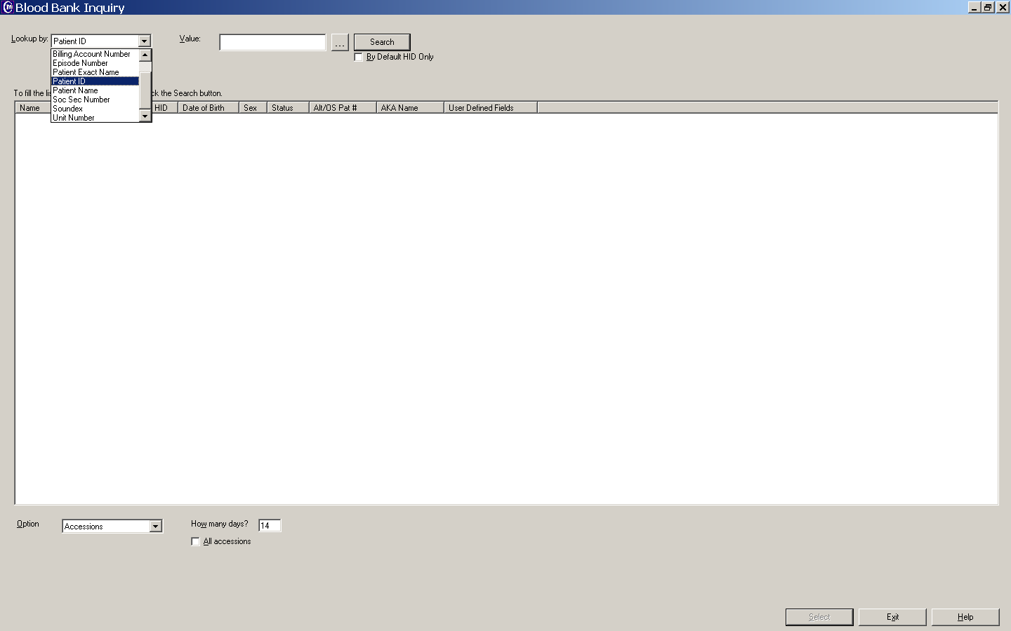  - Patient will appear as highlighted entry. Search will default to testing within 14 days which can be changed if desired. Select.  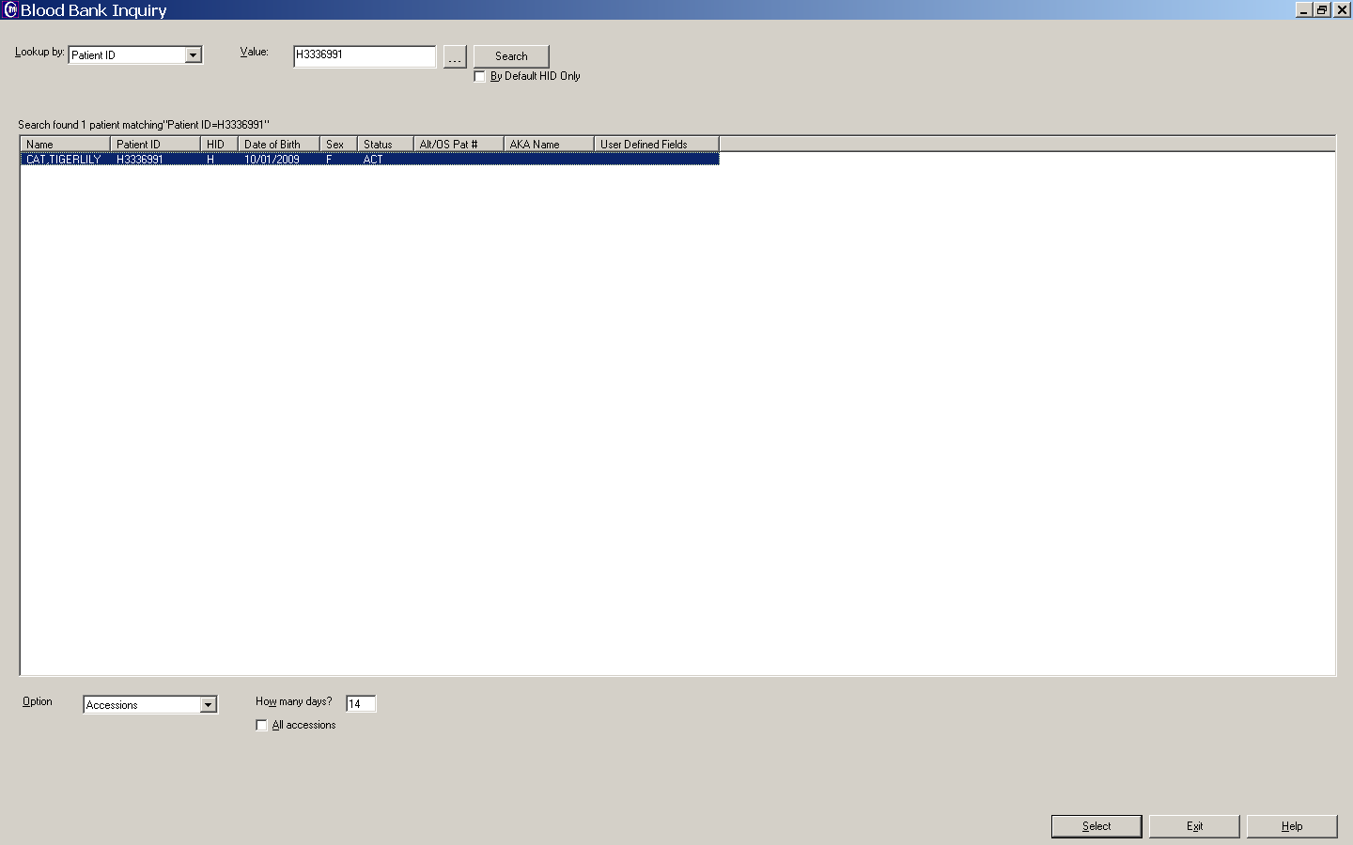  - List for patient will show in order of accession numbers, the most recent on top. Highlight the test order/accession # (i.e. TXM if the question is regarding crossmatched units).  - On bottom right of screen, select Show Units. This will show the corresponding units with that accession number. Be sure to check the status of the units, as all units on the order are listed even if issued or transfused.  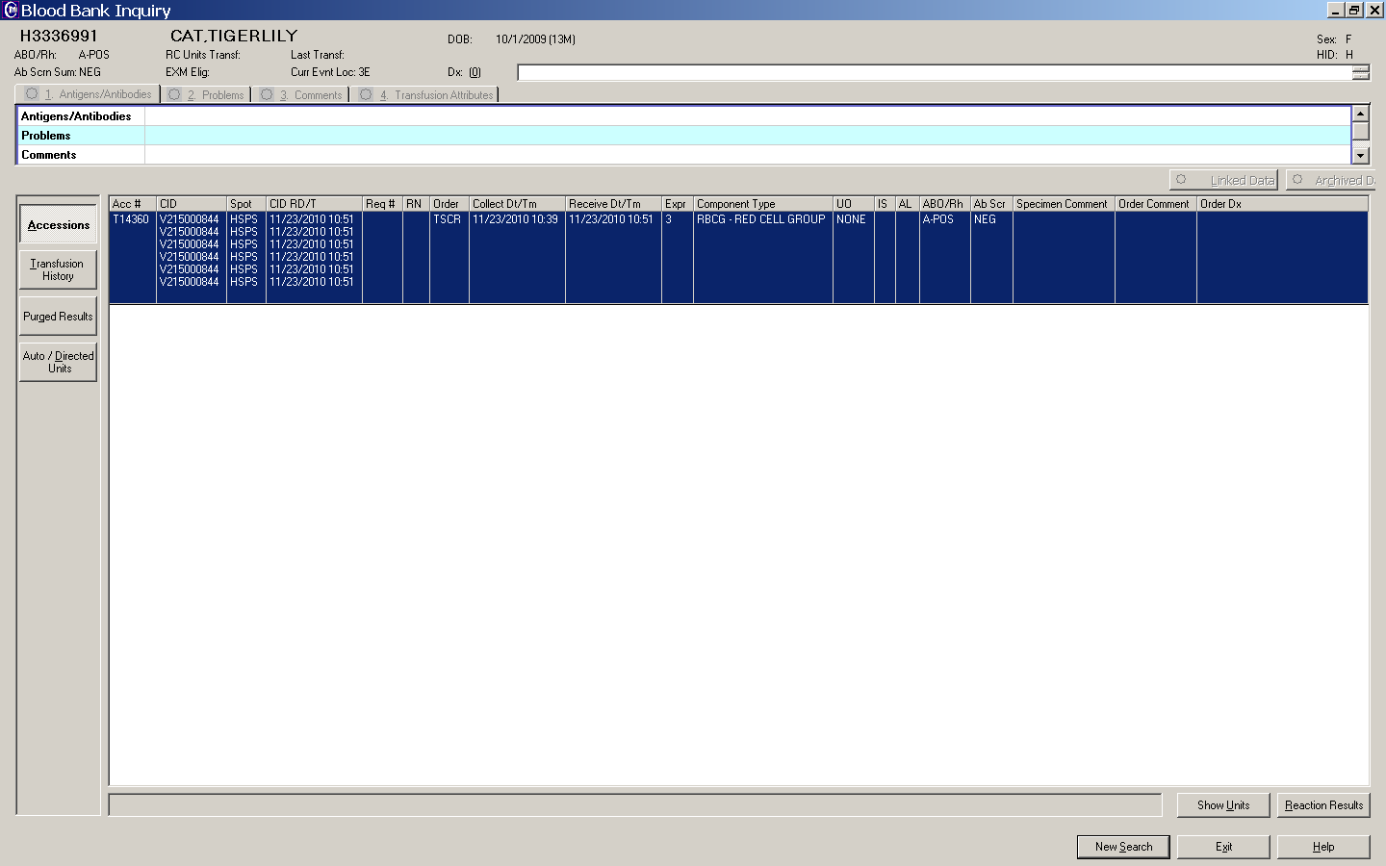  - Once the Show Units is activated, scrolling between the accession numbers will show associated units for each.  - To check history on a particular unit, highlight unit number and hit Unit Detail at the bottom right corner.  - Unit History will give what has happened to the unit such as when, where unit was issued, date and time, who unit was issued to and final status of unit.  - On left hand side of screen you can toggle between the accession#, transfusion history, purged results, and auto/directed units.  - The header will give information about patient and tabs will be active if there are any antibodies, problems, comments, or transfusion attributes required. These tabs will have a yellow sun if active, ghosted gray if inactive.
2 | Inquiries about an active specimen, when does active i  specimen expire? | - Open Blood Bank Inquiry.  - In the Lookup box, enter a patient identifier, such as patient ID, patient name, or alternate patient ID (SSN).  - Patient will appear as highlighted entry. Search will default to testing within 14 days which can be changed if desired. Select.  - List for patient will show in order of accession numbers, most recent on top to less recent on bottom.  - Select the most recent type and screen or type and cross if available. With that test highlighted, select reaction results in the lower right hand corner of screen.  - Underneath the results of the antibody screen you will see CROSSMATCH EXPIRATION date. This will be the last day the specimen can be used.

