Purpose

To provide instructions for accessing patient history files using an encrypted USB drive when the Sunquest system is not operational. (SQ Downtime)

Method

Select the USB drive used for Daily Patient History Back-up
1 | Remove the flash drive from the Downtime Folder.
2 | Drives are labeled ODD and EVEN. Select the flash drive that has the most current capture:  - If the capture has not been done yet, select the drive for the previous day.  - If the capture has been done, select the drive for the current day.  Example: Downtime starts at 0200 on the 15th. Capture is scheduled for dayshift. Select the EVEN drive to access the capture of the 14th.
Prepare USB drive:
1 | Insert the encrypted flash drive into the USB port on the hard drive.
2 | Found New Hardware appears on lower desktop tool bar. Box opens with “Removable Disk (:E)”.  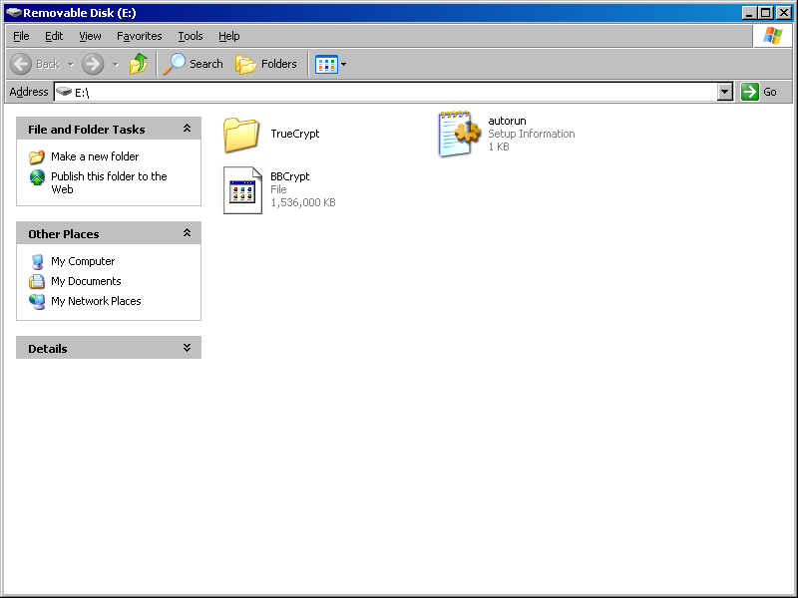
3 | Select folder “TrueCrypt”
4 | Select the TrueCrypt program (blue icon).  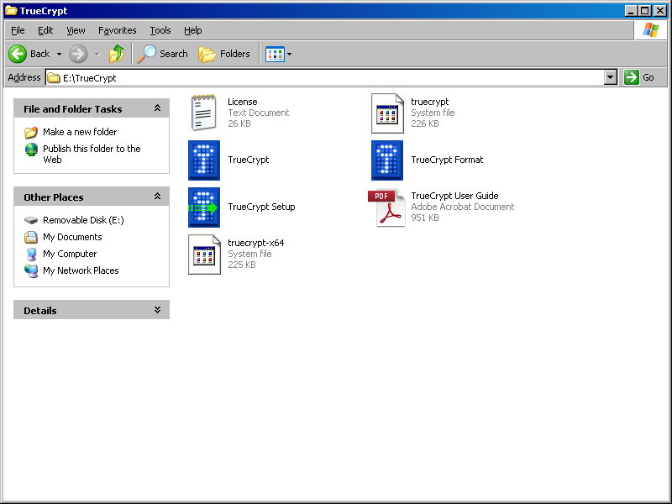
5 | Double-click on “Select File…” button  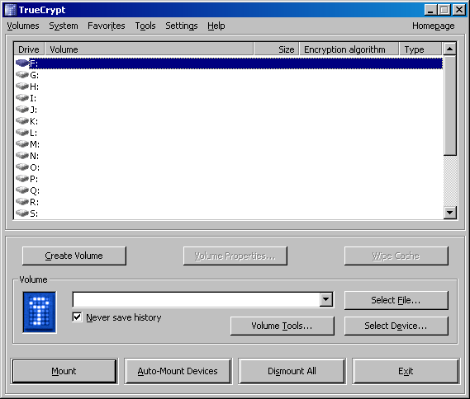
6 | In the “Select a TrueCrypt Volume” window:  - Select “My Computer” or “My Documents”  - Open “Removable Disk (E):”  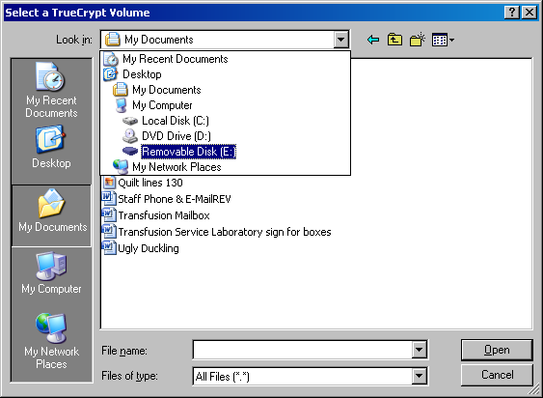
7 | Select BBCrypt and click “Open”.  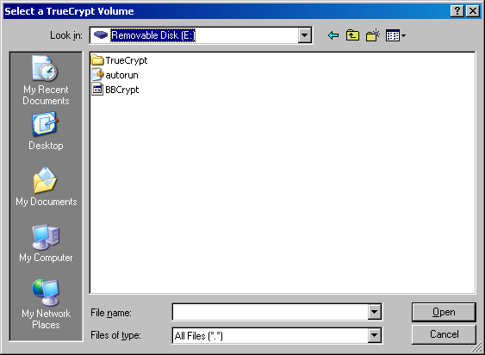
8 | Note: In TrueCrypt, the volume box displays “E:\BBCrypt”.  Click “Mount”. Notice that the USB drive now displays a pulsing light.
9 | Password prompt: Enter bl00db@nk. (o’s are zeros, a is @ symbol). Do not check any of the boxes and click on OK.  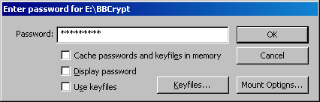
10 | Diminish this screen  Note: the F drive is now open. This encrypted part of the E drive (like a subfolder) contains the captured patient information.
Access Captured Files
1 | Open local disk (F):  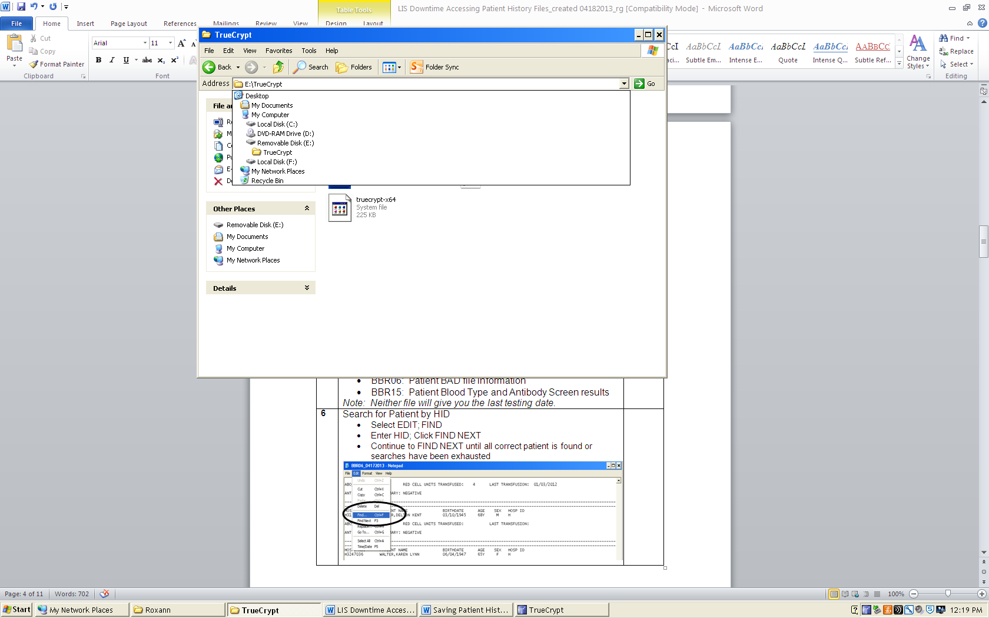
5 | Open folder “Transfusion Services Backup A or B”. Available files:  - BBR06: Patient BAD file information  - BBR15: Patient Blood Type and Antibody Screen results  Note: Neither file will give you the last testing date.
6 | Search for Patient by HID  - Select EDIT; FIND  - Enter HID; Click FIND NEXT  Note: HID can be scanned  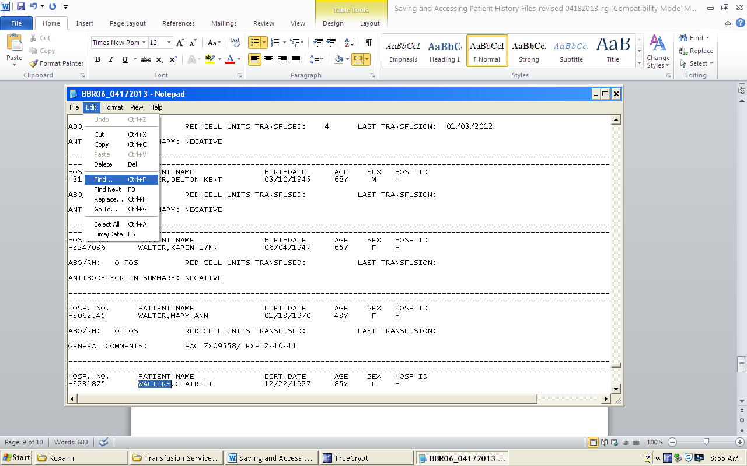
 | 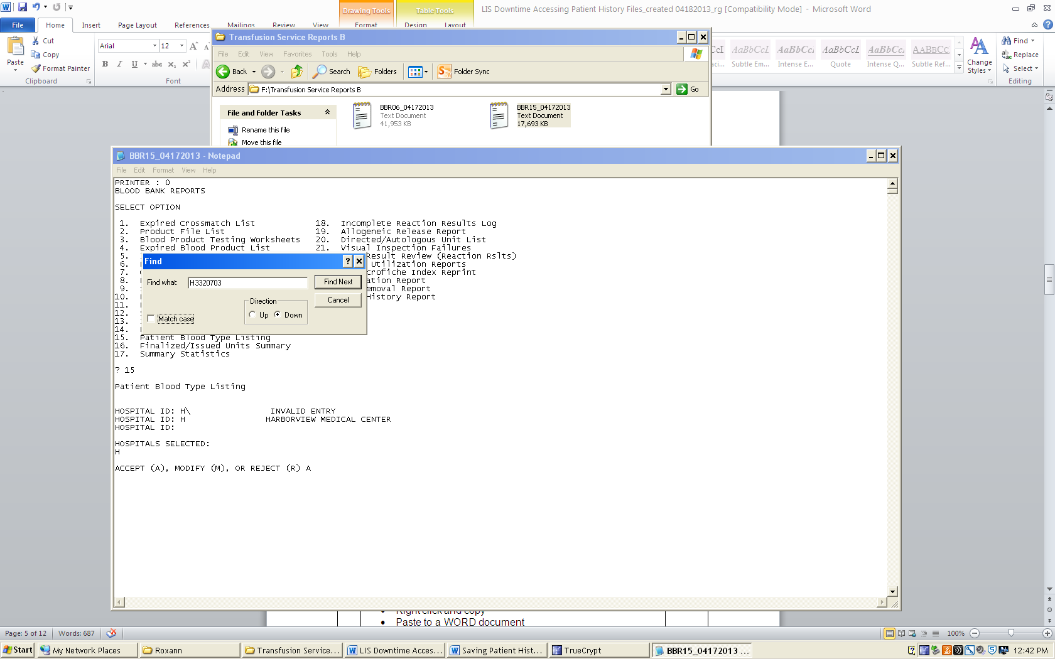
7 | - Highlight selected patient data  - Right click and copy  - Paste to a WORD document  - Print data from both files, if applicable
8 | Staple to Blood Request
9 | Close BBR06 and BBR15 after each use in order to search for next patient.  Clear WORD document after each printing.
10 | Repeat steps 6 through 9 until Sunquest is available.

Removing USB drive

1 | To remove the encrypted drive without damage to the files, perform Dismount.  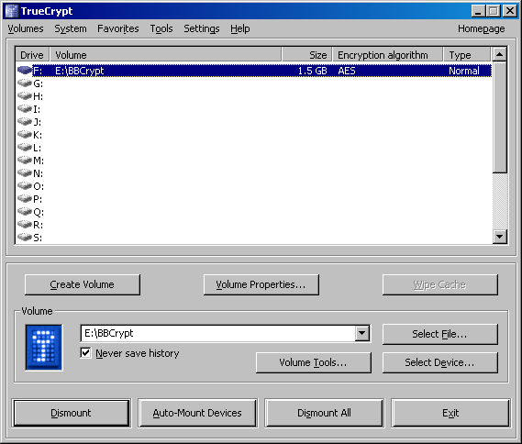  - Restore TrueCrypt session.  - Click DISMOUNT
2 | Watch the pulsing light on the USB drive change from a steady, rapid pulse to a slow pulse.
3 | Remove the encrypted flash drive from the USB port on the computer hard drive.
4 | Store USB drive in the Down Time folder.
5 | Click Exit button.

References:

AABB Standards for Blood Banks and Transfusion Services, Current Edition
Blood Bank User Guide, Misys Laboratory

