Purpose:

To provide instructions for saving patient history files using an encrypted USB drive in order that patient history information is available even when the Sunquest system is not operational.

Method:

 | Actions |  | Related Documents
Perform Report Capture in Sunquest:

1 |  | - Perform Function BEX in SmarTerm | Patient History Backup Reports in Sunquest
Prepare USB drive:

1 |  | Insert the encrypted flash drive into the USB port on the hard drive.  - Even days: “A”  - Odd days: “B”  NOTE: Alternate using the A and the B drives each day so that if one flash drive goes missing or becomes unusable the data is still recent on the other.
2 |  | Found New Hardware appears on lower desktop tool bar. Box opens with “Removable Disk (:E)”.  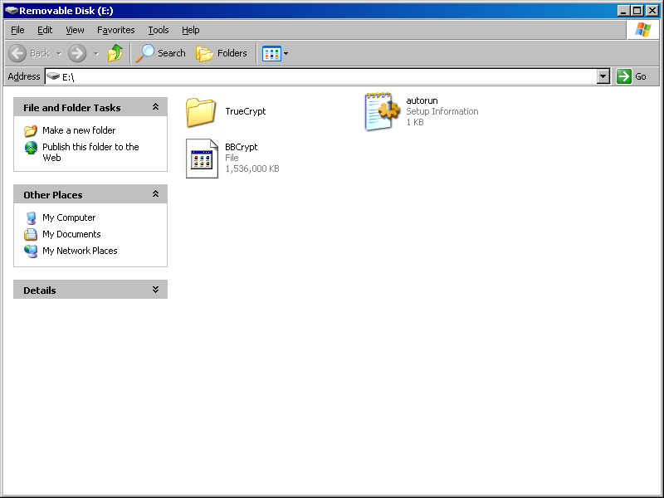
3 |  | Select folder “TrueCrypt”
4 |  | Select the TrueCrypt program (blue icon).  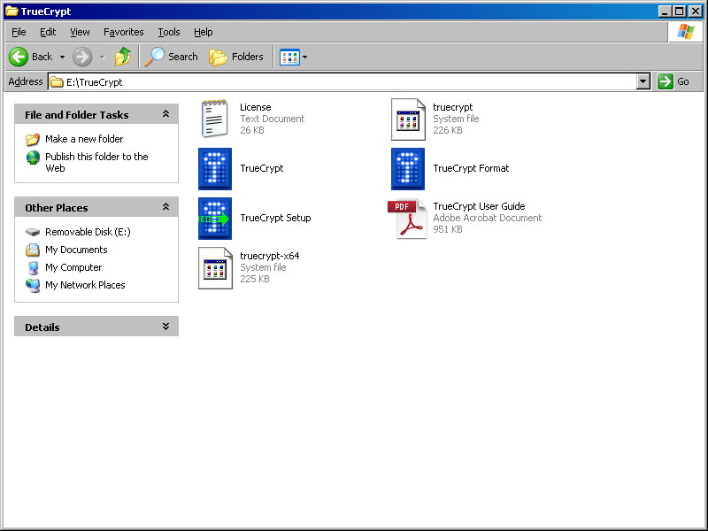
5 |  | Double-click on “Select File…” button  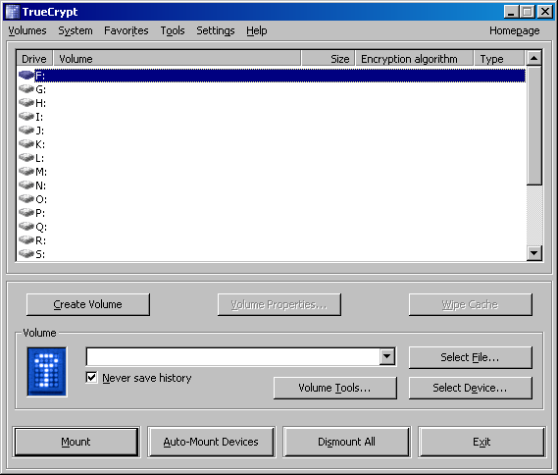
6 |  | In the Select a TrueCrypt Volume window:  - Select “My Computer” or “My Documents”  - Select “Removable Disk (E):”  - Click “Open”  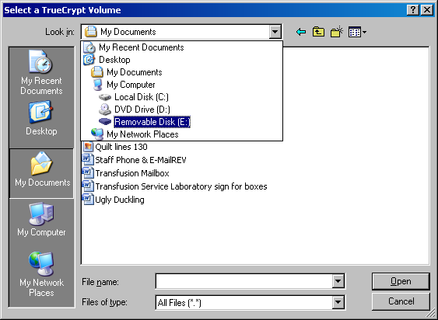
7 |  | Select BBCrypt and click “Open”.  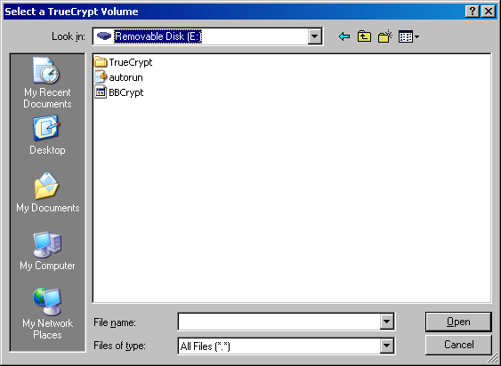
8 |  | Note: In TrueCrypt, the volume box displays “E:\BBCrypt”.  Click “Mount”. Notice that the USB drive is now displays a pulsing light.
9 |  | Password prompt: Enter bl00db@nk. (o’s are zeros, a is @ symbol). Do not check any of the boxes and click on OK.  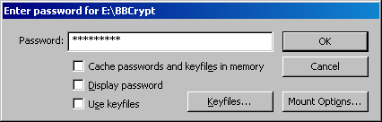
10 |  | - Volume for F: drive is E:\BBCrypt.  - Diminish the pop-up.  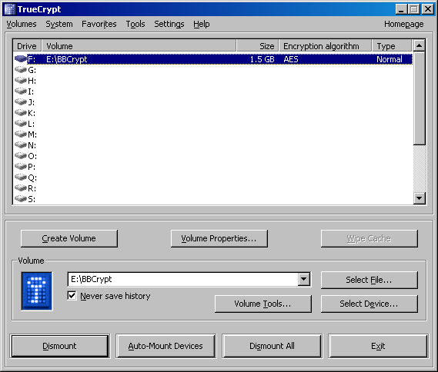
11 |  | The F drive is the encrypted part of the E drive (like a subfolder). This drive must be used for patient information. If only the E drive is selected, the information will not be encrypted!
Capture BEX Reports
1 |  | Open the SmarTerm Roll N Scroll area of MISYS. Log on.
2 |  |   On the Menu bar, under “Tools”, choose “Start Capture”.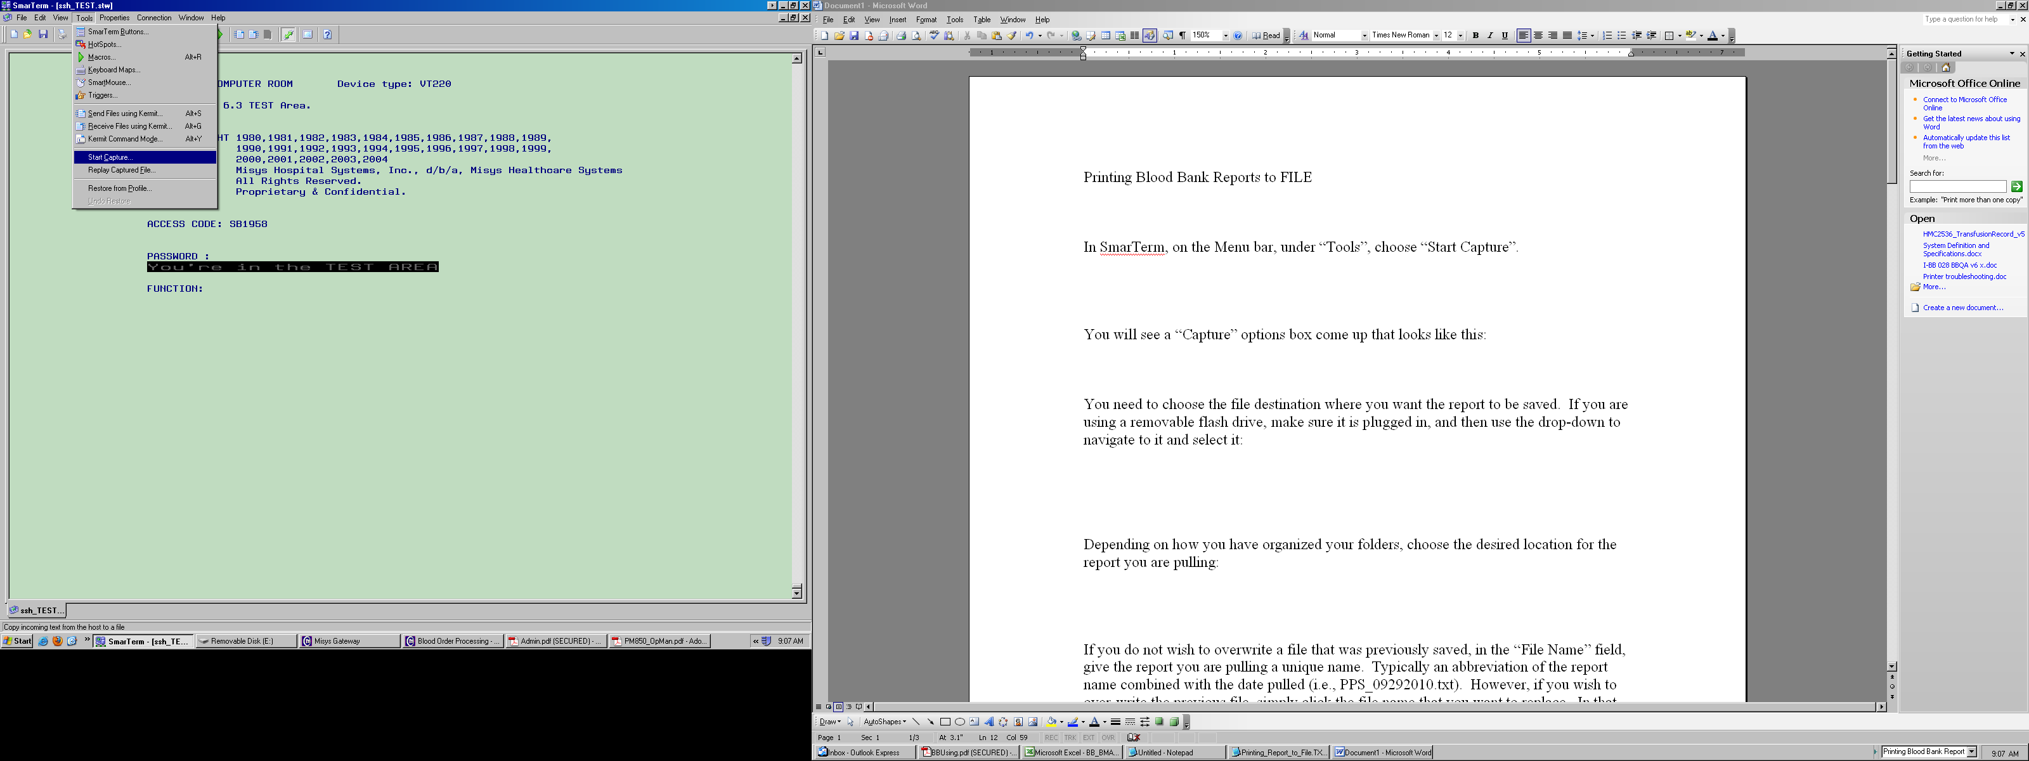
3 |  | “Capture” options box is displayed:  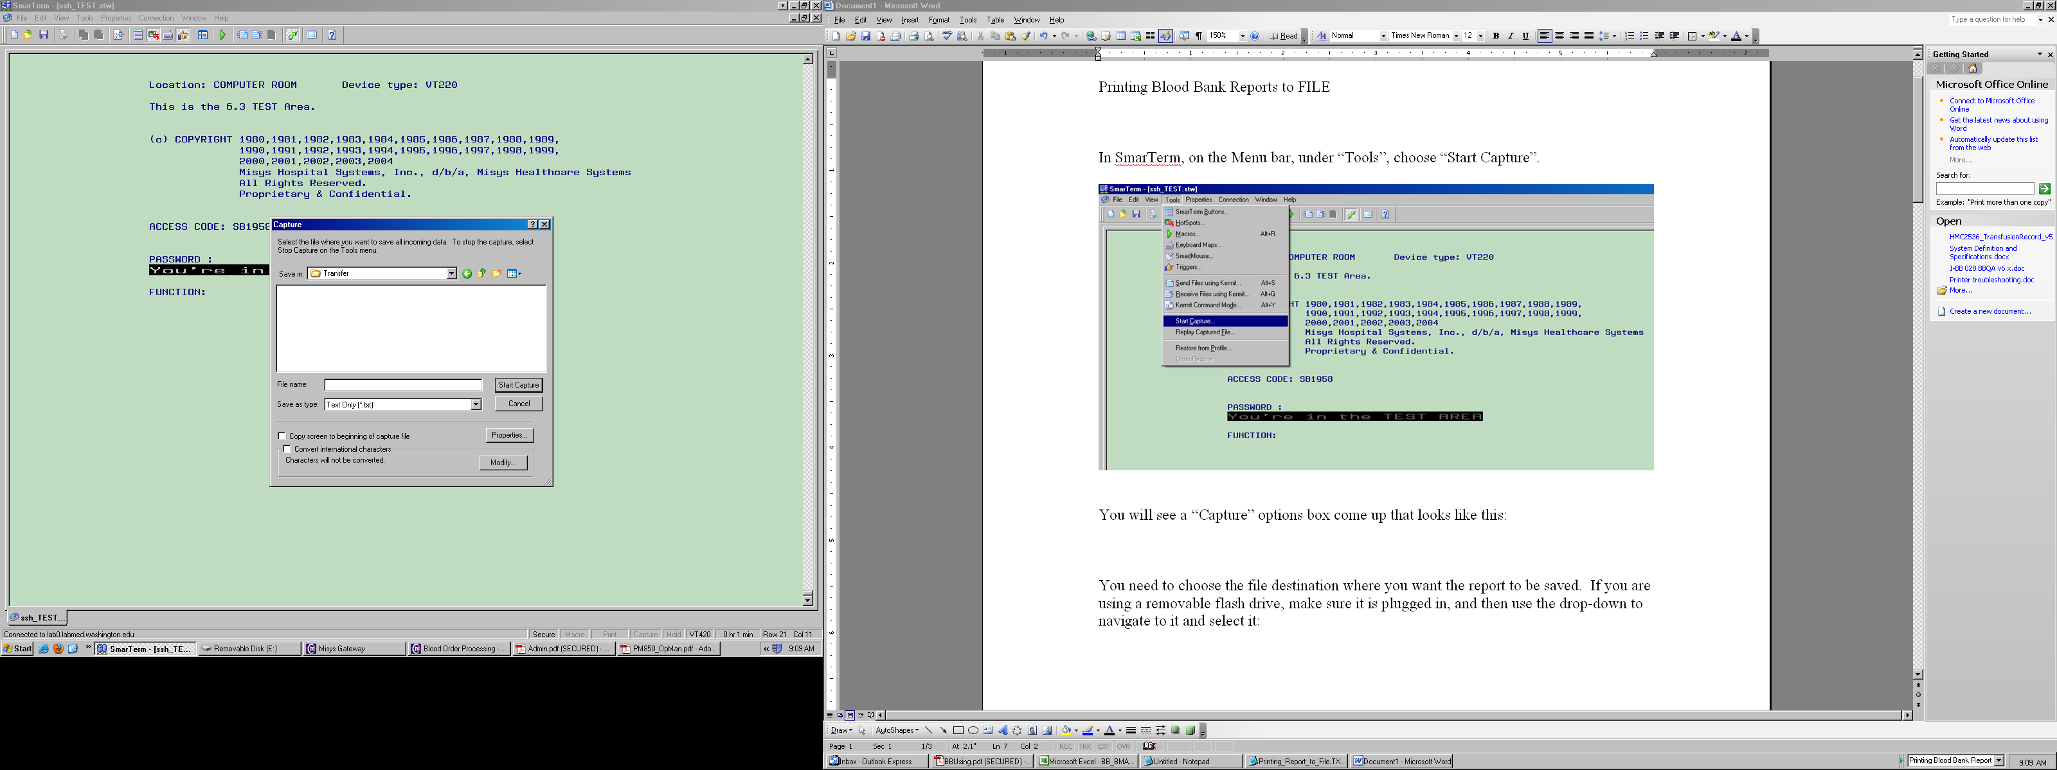
4 |  | Select “Removable disk (F:)” to identify the file destination where you want the report to be saved.  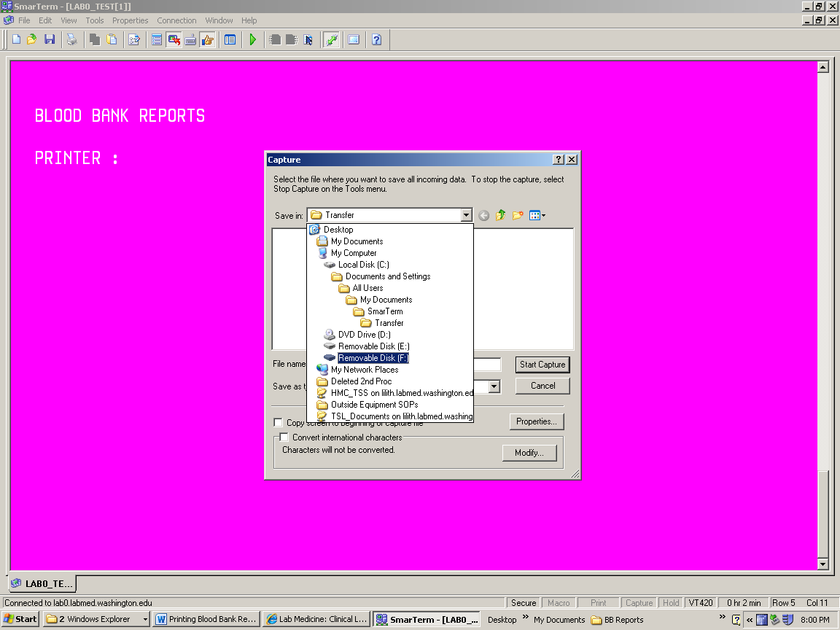
5 |  | Select the Transfusion Service Reports folder  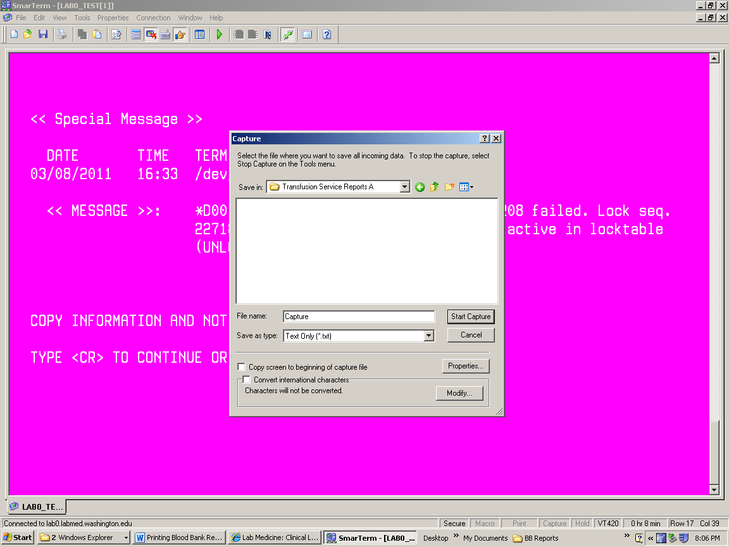
6 |  | - Assign a file name, typically an abbreviation of the report name combined with the date pulled (i.e., BBR15_04052011.txt). This will allow you to easily check the date.  - Click “Start Capture”.  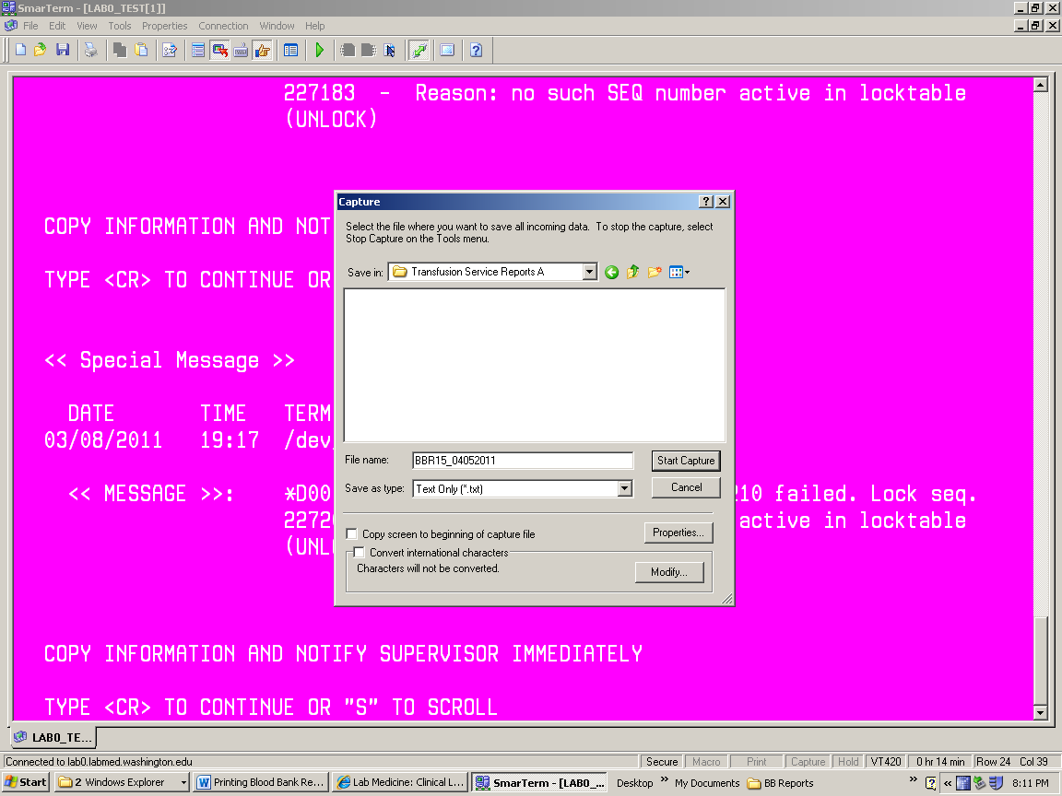
7 |  | - Perform extract from SmarTerm |  | Patient History Backup Reports in Sunquest
Cleaning Up

1 |  | Delete the 2 day old files from the USB drive. The files are all additive so there isn’t a need to keep multiple days’ worth.

Removing USB drive
1 | To remove the encrypted drive without damage to the files, perform Dismount.  - Restore TrueCrypt session.  - Click DISMOUNT
2 | Watch the pulsing light on the USB drive change from a steady, rapid pulse to a slow pulse.
3 | Remove the encrypted flash drive from the USB port on the computer hard drive.
4 | Store USB drive in the Down Time folder.
5 | Click Exit button.

References:

AABB Standards for Blood Banks and Transfusion Services, Current Edition
Blood Bank User Guide, Misys Laboratory

