UW Medicine - Pathology

100-02-01-07

Addendum and Amendment Reports in PowerPath Procedure

Adopted Date: 07/17/09
Revision Date:

PURPOSE
- To ensure that the appropriate Addendum and Amendment process is used when a PowerPath report needs to be modified

- To ensure the integrity of the medical record for patient safety, business record keeping and the ability to produce information in the same form as it existed at the time the electronically stored information was created.

SCOPE
For all department personnel who are authorized to issue Amendments and/or Addendums in PowerPath.

PROCEDURE
EXPLANATION:
Amendment are the preferred method to correct errors because:
- The modified report makes correct diagnoses clear.
- Amendments are the only way to correct data in tumor worksheets.

However, it is necessary to preserve the trail of amendment report modifications through:
- Assurance that there will be a statement of what changed and why in the amended report.
- Making edits in such a way that they are visible in MINDScape (the interface to MINDScape strips out formatting features of Word such as bold and strike-through fonts).
- Retention of previous report versions (being done in MINDScape, ORCA and PowerPath).

Addendums
An addendum does not alter the original report; it adds the revision or additional information as a new section at the end of the report and creates a new signature line after the addendum text. Because it leaves the original diagnosis and signature line intact, it is the preferred method at add information to a report.

PROCEDURE:
Decide whether to do an Amendment (correct report) or an Addendum (add information).

ADDENDUM procedure
- Bring up the case in PowerPath.
- Click the ellipsis next to the Case Status control and progress the case to Addendum.
- Select an appropriate Addendum Reason.
- Open the report in Word (PowerPath will automatically add a new page at the end of the previous report).
- Add a new heading at the beginning of the addendum called ADDENDUM REASON: (11pt Arial, all caps, bolded, with colon at the end).
- On the next line, enter a sentence describing why the addendum is being done.
- Complete the addendum report and sign out in the usual way.

AMENDMENT procedure
Contact Coding and Billing supervisor if the case has been billed before an amendment is issued.
- To correct data in the header or footer of the report: Submit a Clinical Admin request through CARS (InQ) to request an amendment sing Demographic Correction. Refer to Correcting Erroneously Accessioned Cases procedure and policy for more details.

- If a non-CG case was accessioned to the wrong MRN and was finalized refer to the Correction Erroneously Accessioned Cases procedure and policy.

- If a correction needs to be made anywhere in the body of the report, do the following:
  - Order an Amendment or Addendum report.
  - When prompted, choose one of the following 4 reasons for the Amendment.
    - Interpretation revised (for changes in diagnoses or clinically significant comments)
    - Patient or sample identification revised (including demographic corrections)
    - Specimen issue (including demographic corrections)
    - Change in non-diagnostic report section

  - Add an AMENDMENT REASON: heading at the beginning of the report (place cursor immediately in front of CLINICAL HISTORY: (on the same line) and use autotext to insert the heading -- see detailed instructions below).
  - In the new AMENDMENT REASON section, specify exactly what changed and why.
  - In the body of the report, delete any incorrect text.
  - Insert new text in ALL CAPS with asterisks before and after
*THIS IS CORRECTED TEXT*
  - Save the report and sign out as usual. Note that you will not be able to sign out an Amendment report unless an AMENDMENT REASON: heading is present and it must be entered exactly correctly or the computer won't recognize it.

Detailed instructions (with screen shots) go here.

First let's create an autotext entry. Open Word and type the heading AMENDMENT REASON: setting it to the correct font Arial and size 10 point and bold. Highlight the text.


Either click on Insert from the toolbar and select Autotext, New or use the keystroke combo Alt + F3.
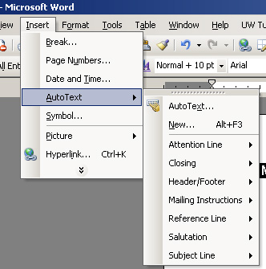

Click OK.
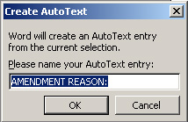

Now let's apply it to PowerPath. Start an Amendment just as you would an Addendum.
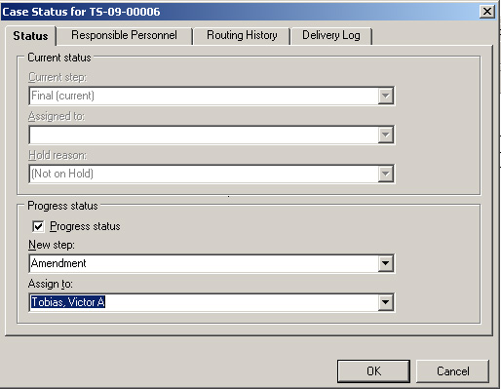

Select the reason for the amendment.
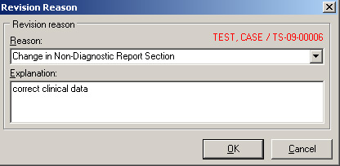

Place the cursor directly in front of the heading CLINICAL DATA: and enter the autotext.
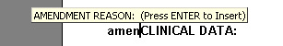

Enter the text for the amendment reason and make the correction.
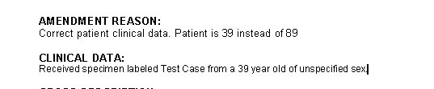

This is how the report will look.
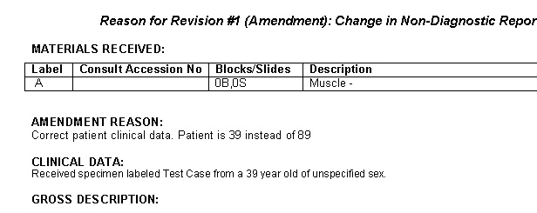
Progress the case to Amendment Faculty Review and you are ready to signout the case.

REFERENCE
Correcting Erroneously Accessioned Cases procedure, 100-02-01-09
Correcting Erroneously Accessioned Cases policy, 100-02-01-08

UWMC Pathology Chief of Service: HMC Pathology Chief of Service:
(Signature and Date) (Signature and Date)
5/23/13 5/23/13
____________________________ ___________________________
Suzanne Dintzis, MD, PhD Stephen Schmechel, MD, PhD

Written by: Revised by:
(Signature and Date) (Signature and Date)

_________________________ _________________________

