UW Medicine - Pathology

100-02-01-08

Correcting Erroneously Accessioned Cases Policy

Adopted Date: 06/07/02
Revision Date:

PURPOSE
To standardize the process of correcting erroneously accessioned cases in PowerPath.

SCOPE
For all department personnel manage PowerPath cases that have been accessioned in error.

POLICY
If a case is not finalized, correct as needed or enter a comment in the Results section and sign the case out, see Correcting Erroneously Accessioned Cases procedure, 100-02-01-09. If a case is finalized, issue an addendum or amendment for corrections. Cases are not to be deleted in PowerPath due to potential billing issues and report distribution in MINDscape and on hardcopy.

UWMC Pathology Chief of Service: HMC Pathology Chief of Service:
(Signature and Date) (Signature and Date)
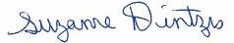5/22/13 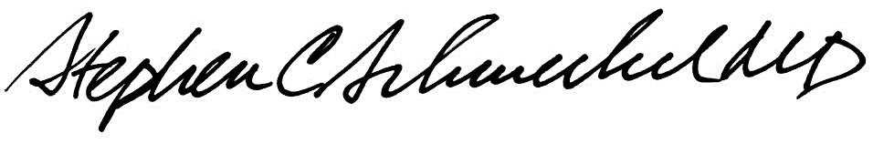5/22/13
____________________________ ___________________________
Suzanne Dintzis, MD, PhD Stephen Schmechel, MD, PhD

Written by: Revised by:
(Signature and Date) (Signature and Date)

_________________________ _________________________

