UW Medicine - Pathology

100-02-01-18
Test Ordering Policy

Adopted Date: 08/09/11
Revision Date:

PURPOSE
To ensure accuracy of test ordering from requisitions and verbal phone orders.

POLICY
Requisition Test Ordering:
If test orders provided on requisitions are unclear, laboratory personnel must confirm the ordering information with the sender to ensure accuracy of testing ordering.

Verbal / Phone Orders:
All verbal orders must be taken by a pathologist from a treating clinician. After receiving a verbal order, pathologists are required to perform a complete read-back of the order to the ordering clinician to verify order accuracy.

UWMC Pathology Chief of Service: HMC Pathology Chief of Service:
(Signature and Date) (Signature and Date)
6/4/13 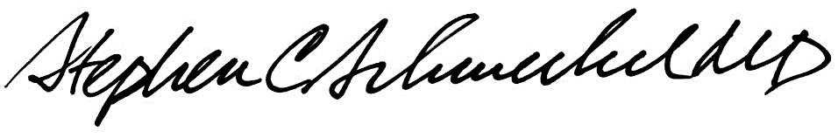6/4/13
____________________________ ___________________________
Suzanne Dintzis, MD, PhD Stephen Schmechel, MD, PhD

Written by: Revised by:
(Signature and Date) (Signature and Date)

_________________________ _________________________

