UW Medicine - Pathology

100-03-01-01

CAP Notification Policy

Adopted Date: 05/17/11
Revision Date: 03/02/13

PURPOSE
To comply with the CAP terms of accreditation.

SCOPE
For all department personnel.

POLICY
The laboratory director or designee will notify CAP regarding the following providing cooperation with CAP if subject to CAP investigation or inspection.

- Investigation of the laboratory by a government entity or other oversight agency, or adverse media attention related to laboratory performance; notification must occur no later than 2 working days after the laboratory learns of an investigation or adverse media attention. This notification must include any complaint investigations conducted or warning letters issued by any oversight agency (i.e. CMS, State Department of Health, The Joint Commission, FDA, OSHA).

- Change in laboratory test menu (notification must occur prior to starting new patient testing)

- Change in location or directorship of the laboratory; notification must occur no later than 30 days prior to the change(s); or, in the case of unexpected changes, no later than 2 working days afterwards.

In addition, the department agrees to provide an inspection team in comparable size and scope on request and agrees to remain in adherence to the terms of the Use for the CAP Certification Mark of Accreditation.

UWMC Pathology Chief of Service: HMC Pathology Chief of Service:
(Signature and Date) (Signature and Date)
5/23/13 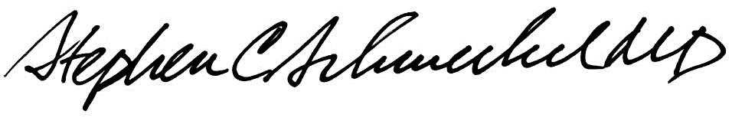5/23/13
____________________________ ___________________________
Suzanne Dintzis, MD, PhD Stephen Schmechel, MD, PhD

Written by: Revised by:
(Signature and Date) (Signature and Date)

Kim Simmons 05/17/2011_______ _________________________

