UW Medicine - Pathology

100-03-01-03

Proficiency Testing Policy

Adopted Date: 05/18/11
Revision Date:

PURPOSE
To provide departmental guidelines for participation, communication, testing referrals, workload integration, and evaluation for all proficiency testing (PT).

SCOPE
For all laboratories and personnel that participate in proficiency testing in Pathology.

POLICY
Participation of Laboratory Proficiency Testing:
The Medical Director will review the CAP Proficiency testing catalog and assure that all proficiency testing for testing done by each laboratory is ordered and completed.
Laboratories that perform tests which do not require or have annual CAP PT are at the minimum:
- Participating in external PT or,
- Exercising an alternative performance assessment system to determine the reliability of the testing.
Records of testing are kept in each individual laboratory.

Inter-laboratory Communication:
Inter-laboratory communication of PT samples / results is prohibited until after the deadline for submission of data to the PT provider.

Proficiency Testing Referrals:
Sending out PT to other laboratories for results is prohibited by all laboratories / personnel.

Workload Integration:
All PT materials are to be integrated into the routine laboratory workload. The PT samples are to be analyzed by personnel who routinely test patient samples using the same methods that are used for patient samples. Proficiency testing should be rotated throughout the laboratory to ensure involvement by all personnel who routinely participate in the related testing.

Evaluation of Proficiency Testing:
Prompt correction action is taken for all unacceptable PT results. This will include investigation by Medical Director and/or Laboratory Director and correction of problems identified.

Proficiency Testing not completed:
Laboratories will report PT not graded or completed and the reasons why to the Medical Director within 24 hrs notification or not submitting results. The reasons that PT may not be grades are:
- laboratory did not complete the results form correctly (ie submitting the wrong method code or recording the result in the wrong place)
- results submitted after the cut-off date
- laboratory did not submit the results.

REFERENCE
College of American Pathologists General Laboratory Checklist, Proficiency Testing section: 2010.

UWMC Pathology Chief of Service: HMC Pathology Chief of Service:
(Signature and Date) (Signature and Date)
5/23/13 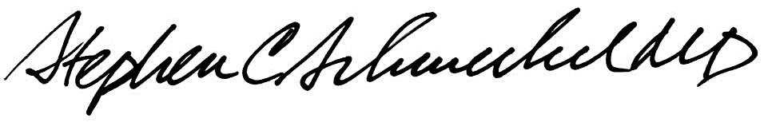5/23/13
____________________________ ___________________________
Suzanne Dintzis, MD, PhD Stephen Schmechel, MD, PhD

Written by: Revised by:
(Signature and Date) (Signature and Date)

Kim Simmons 05/18/2011______ _________________________

