**UW Medicine - Pathology**

100-04-01-01

Overtime Policy

|  |
| --- |
| Adopted Date: 04/06/11  Revision Date: |

PURPOSE

To establish a policy for prior approval of overtime in the Pathology Department.

POLICY

1. All overtime needs to have prior approval from Supervisor, Manager or Director.
2. If a Supervisor, Manager or Director is not readily available, page or call their emergency contact number.
3. If for some reason you can not get hold of any Supervisor, Manger or Director, overtime should only be done if patient care could be adversely affected. This needs to be documented and reviewed with your Supervisor, Manager or Director the following day.

UWMC Pathology Chief of Service: HMC Pathology Chief of Service:

(Signature and Date) (Signature and Date)

5/24/13 5/24/13

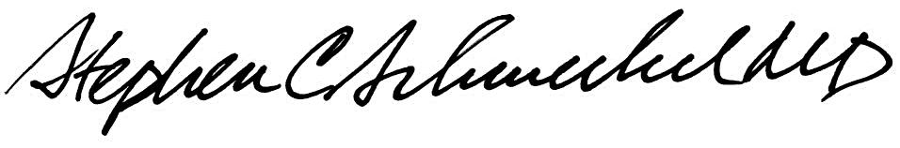

­­­­­­­­­­­­­­­­­____________________________ ___________________________

Suzanne Dintzis, MD, PhD Stephen Schmechel, MD, PhD

Written by: Revised by:

(Signature and Date) (Signature and Date)

_________________________ _________________________