**UW Medicine - Pathology**

100-05-01-02

Emergency Eye Wash Station Policy

|  |
| --- |
| Adopted Date: 12/13/10  Revision Date: |

PURPOSE

To ensure the proper functionality of eye washing stations through weekly quality assurance testing and document testing on log sheet.

SCOPE

All areas / laboratories where eye washing stations are present.

POLICY

Staff is to make sure plumbed emergency eyewashes and hand held drench hoses are activated weekly to check the proper functioning of the valves, hardware and availability of water.

All problems are to be reported immediately to Operations and Maintenance.

REFERENCES

1. UWMC APOP 117-55
2. WAC 296-800-15035

UWMC Pathology Chief of Service: HMC Pathology Chief of Service:

(Signature and Date) (Signature and Date)

5/24/13 5/24/13

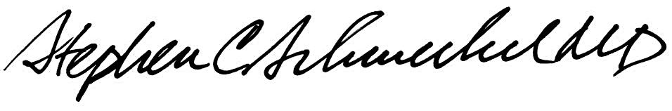

­­­­­­­­­­­­­­­­­____________________________ ___________________________

Suzanne Dintzis, MD, PhD Stephen Schmechel, MD, PhD

Written by: Revised by:

(Signature and Date) (Signature and Date)

Kim Simmons 12/13/2010_______ _________________________