**UW Medicine - Pathology**

100-05-01-03

Emergency Eye Wash and Shower Station Testing Procedure

|  |
| --- |
| Adopted Date: 05/17/11  Revision Date: |

PURPOSE

To ensure the proper functionality of eye wash stations through weekly quality assurance testing and document testing on log sheet and shower station are checked annually.

SCOPE

All areas / laboratories where eye washing stations are present.

PROCEDURE

**Emergency Eye Wash Station:**

1. Weekly, turn the station on and allow the water to flow out of the eyecups with sufficient flow to fully open the attached dust covers.
2. Run the water for a minimum of 15 seconds.
3. Shut off the water and place the dust covers over the eyecups.
4. On the eyewash log, write the date tested and initials.

**Emergency Shower Stations:**

Shower stations will be inspected annually by Operations and Maintanance.

REFERENCES

1. UWMC APOP 117-55
2. WAC 296-800-15035

UWMC Pathology Chief of Service: HMC Pathology Chief of Service:

(Signature and Date) (Signature and Date)

5/24/13 5/24/13

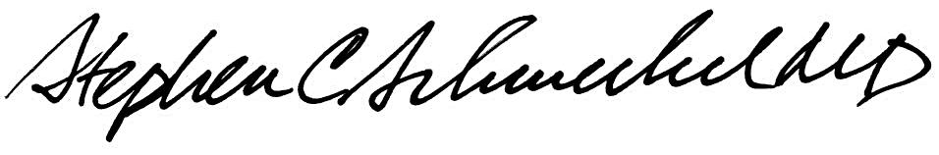

­­­­­­­­­­­­­­­­­____________________________ ___________________________

Suzanne Dintzis, MD, PhD Stephen Schmechel, MD, PhD

Written by: Revised by:

(Signature and Date) (Signature and Date)

Kim Simmons 05/17/2011_______ _________________________