**UW Medicine - Pathology**

400-11-01-19

**Microarray Scanning using Agilent Microarray Scanner**

|  |
| --- |
| Adopted Date: Nov. 12, 2011  Review Date: Nov. 21, 2011  Revision Date: Nov. 2011, Jan. 2012  Under Revision: November, 2012 |

PURPOSE

To collect the microarray image data by scanning the microarray slide at 3 micron level

PROCEDURE

### Material and Equipment

1. Agilent DNA Microarray Scanner (SureScan)
2. Computer
3. Printer
4. Agilent Feature Extraction software

### Procedures

1. **Agilent Scanner Settings**
2. Put assembled slide holders with or without the ozone-barrier slide cover into scanner carousel.
3. Select Start Slot *m and* End Slot *n*. The letter *m* represents the Start slot where the first slide is located and the letter *n* represents the End slot where the last slide is located.
4. Select **Profile AgilentG3_CGH** for G3 microarrays.
5. Verify scan settings (**Table 14)**

**Table 14.** Scanner scan setting for G3 microarray formats

|  |  |
| --- | --- |
| **Scan setting** | **For G3 Microarray Formats** |
| Dye channel | R+G (*red and green*) |
| Scan region | Agilent HD (61 x 21.6 mm) |
| Scan resolution | 3 μm |
| Tiff file dynamic range | 16 bit |
| Red PMT gain | 100% |
| Green PMT gain | 100% |

1. **Start Scan**
2. Check that **Output Path Browse** is set for desired location.
3. Verify that the Scanner status in the main window says Scanner Ready.
4. When the scanning is completed, print the scanning report
5. **Extract Data Using the Feature Extraction Program**

***Note:*** The Feature Extraction software v10.10 or higher (included in Agilent CytoGenomics 1.5 or higher) supports extraction of microarray TIFF images (.tif) of Agilent CGH+SNP microarrays scanned on the Agilent Scanner.

**Figure 3**. image of the slide

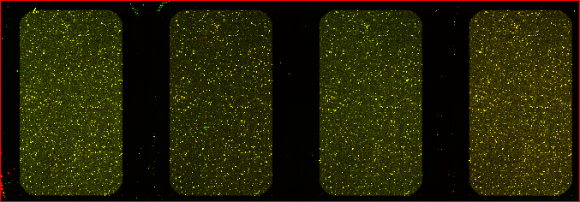

* 1. **Reference**

1. Agilent Arrays-based CGH for genomic DNA analysis protocol version 7.1 p. 70-76.
2. Agilent G4900DA SureScan Microarray Scanner System User Guide

Written By: Director Approval:

(Signature and Date) (Signature and Date)

­­­­­­­­­­­­­­­­­__________________________________ ________________________

Technologist: Yuhua Liu and Yang Zhou Yajuan Liu PhD, FACMG

**UW Medicine - Pathology**

**Cytogenetics and Genomics**

**SIGNATURE PAGE FOR POLICIES AND PROCEDURES**

Procedure / Policy Title: **Microarray Scanning using Agilent Microarray Scanner**

Procedure / Policy Number: 400-11-01-19

|  |  |  |
| --- | --- | --- |
| **STAFF NAME**: (printed) | **STAFF SIGNATURE** | **DATE REVIEWED** |
| Chen, Xiaoqin |  |  |
| Darrin, Delores |  |  |
| DeHoogh-Grigsby, Debi |  |  |
| Donovan, Chris |  |  |
| Kraus, Jean |  |  |
| Liu, Yuhua |  |  |
| McInnis, Donna |  |  |
| Mohapatra, Itu |  |  |
| Morgan, Catherine |  |  |
| Pilger, Carrie |  |  |
| Staley, Rong |  |  |
| Stampalia, Ann |  |  |
| Villiers, Catherine |  |  |
| Vogel, Jared |  |  |
| Wang, Sharon |  |  |
| Waychoff, Emma |  |  |
| Whalen, Sara |  |  |
| Zhou, Yang |  |  |