Refrigerator and Freezer Maintenance Form
Year: ________________
Equipment No._________________________________ Type of Equipment: _______________________
Programmed Alarm Parameters
Storage Equipment | Low Alarm Setting | High Alarm Setting
Blood Storage Refrigerator | 1.5ºC | 5.5°C
Reagent Storage Refrigerator | 2.5ºC | 7.5°C
Plasma Freezer | N/A | -20°C
Ultra Low Freezer | -90°C | -65°C

Date | Reason | High Alarm Test |  |  |  | Low Alarm Test |  |  |  | OK? Y/N | Tech ID | Comments
Date | Reason | Digital | Top | Low | Temp Trak | Digital | Top | Low | Temp Trak | OK? Y/N | Tech ID | Comments

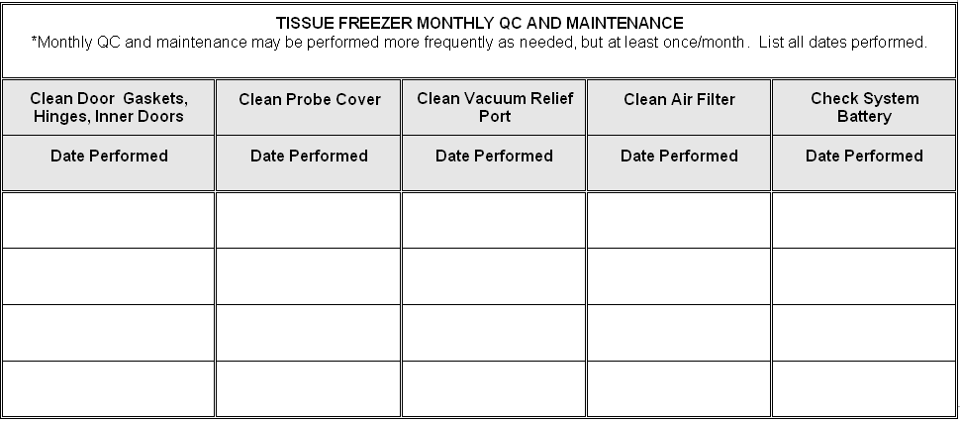

Date:___________________________Tech:__________________________________

Reason Codes:
Q = Quarterly, PC = Program Change, RTS = Return to Service
Comment Code Key:
RPR=Repeat LE=Late Entry CE=Corrected Entry CAL=Recalibrated RS=Referred to Supervisor
NC= Not corrected OTR=Explain EB=Explain on back of page

Reviewed by:____________________________________Date:____________________________________

