**Purpose**

To describe the quality control and maintenance procedures that are performed to ensure that blood components requiring monitored storage are maintained within regulatory temperature guidelines and required documentation is available for review.

**Policy**

* All HMC Transfusion Service refrigerators, freezers, and room temperature storage equipment is monitored 24/7.
* Temp Trak records temperatures every 5 minutes.
* When TempTrak is unavailable for periods exceeding 4 hours and the storage unit(s) containing blood components or bone, the internal temperature must be manually recorded.
* Following Temp Trak recovery, cached recorded temperatures are reviewed.
* Blood Storage Refrigerators are required to be 1-6°C. Alarms sound at 1.5 and 5.5°C.
* Reagent Storage Refrigerators are set for 2-8°C. Alarms sound at 2.5 and 7.5°C
* Freezers are required to be -18°C and lower. High alarm is set for -20°C.
* Ultra low freezers are required to be -40° C and lower. Alarms sound at -65 and -90°C
* Platelet incubators are required to be 20-24°C. Alarms sound at 20.5-23.5°C.
* Room temp is required to be 20-24°C. Alarms sound at 19.4-23.9°C.
* Room humidity should be between 15-55%. Alarm sounds at 15.5-54.5%.
* Administrative access is limited to staff designated and trained on those functions and reports.

**Procedure:**

|  |  |  |
| --- | --- | --- |
| **Step** | **Action** | **Related Documents** |
| **Daily Maintenance** | |  |
| **1** | * **Temperature Monitoring**   + Review TempTrak for any alerts, including temperature, communication and battery at least once on each shift.   + Resolve any alerts insuring thorough documentation and resolution. | CLT Shift Responsibility Checklist |
| **2** | * **Log onto TempTrak** * Go to the Clinical Links page and click on TempTrak * Or with a blue computer go to the Cooper Atkins website by typing in this URL <https://temptrak.mcis.washington.edu/Intelli-ware/>   Note: Save to favorites after first use for ease of entry. |  |
| **3** | * Log into the Intelli-ware program. * Change Organization to HMC if not already showing. * Login ID is your AMC user name. * The first time you Login your password is your Sunquest User ID. * To change your password:   + - Select HELP drop down     - Select Change Password and follow the prompts |  |

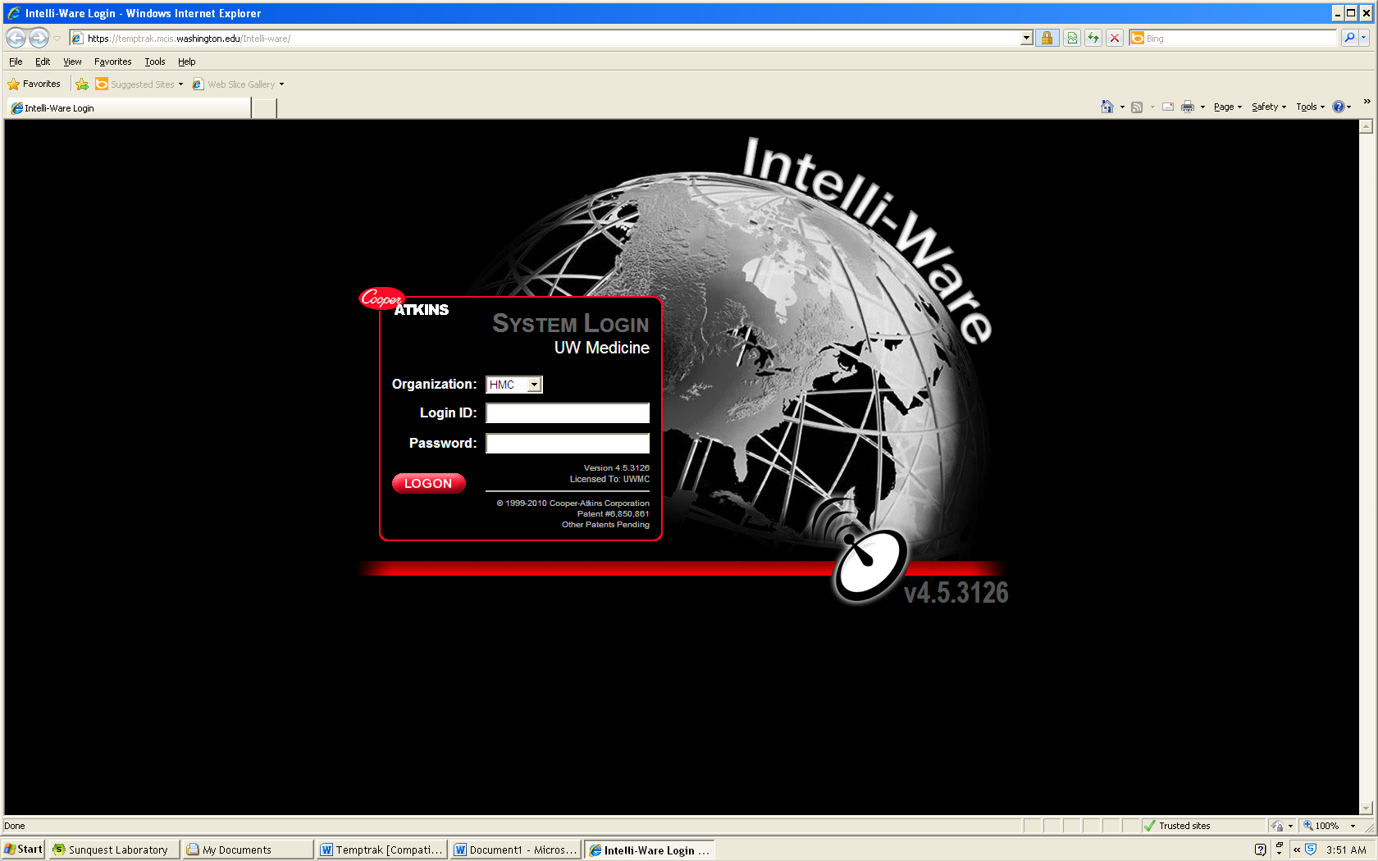

|  |  |  |
| --- | --- | --- |
| **4** | * After logging in, the main screen with all of our equipment and its current sensor readings should appear. * Review all temperatures by scrolling down the page**.** * Each device is identified by device name and temperature limitations. * If it is green the device is within acceptable limits.   + Any device not in green is out of range. How to respond to an alarm is referenced in Section C. * Review Alerts by clicking on the ALERTS menu option. |  |

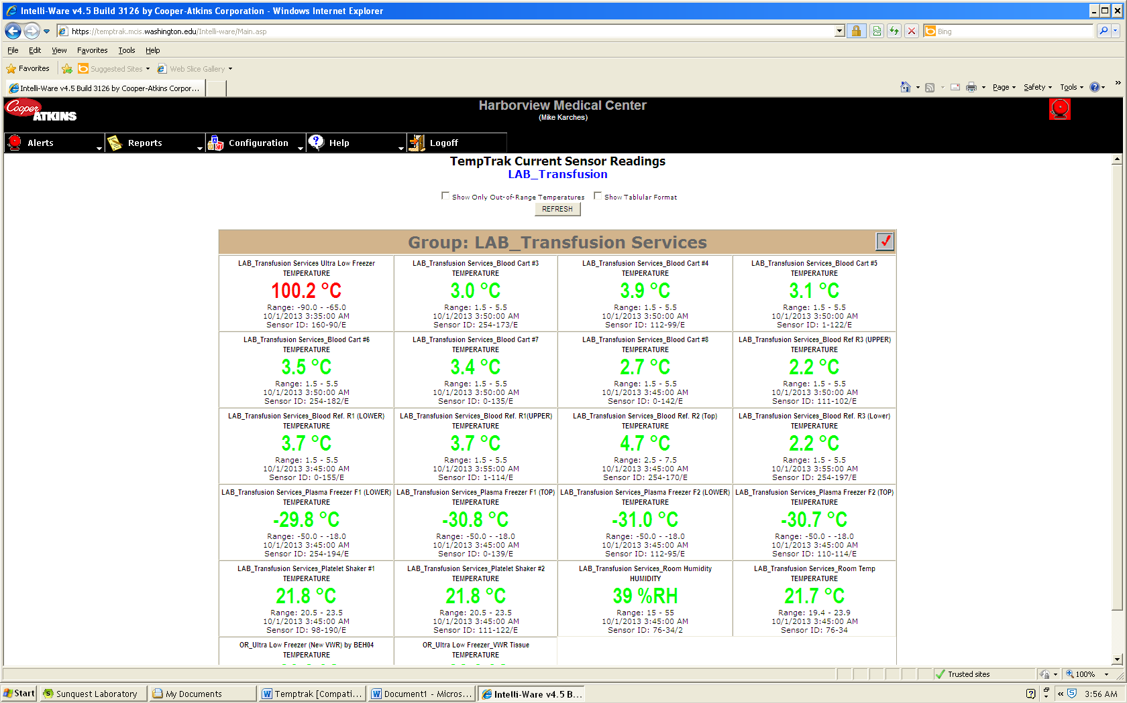

|  |  |  |
| --- | --- | --- |
| **5** | * + - **Document in TempTrak that all temperatures were reviewed.** * Click the red check mark **Record Group Audit/Snapshot** on the upper right hand portion of the table. * In the Audit Comments Box, type: Daily maintenance performed date/time – all sensors within range. Click “Save”. * Initial Daily Equipment, Temperature and Inventory Duties Checklist. | CLT Responsibility Checklist |

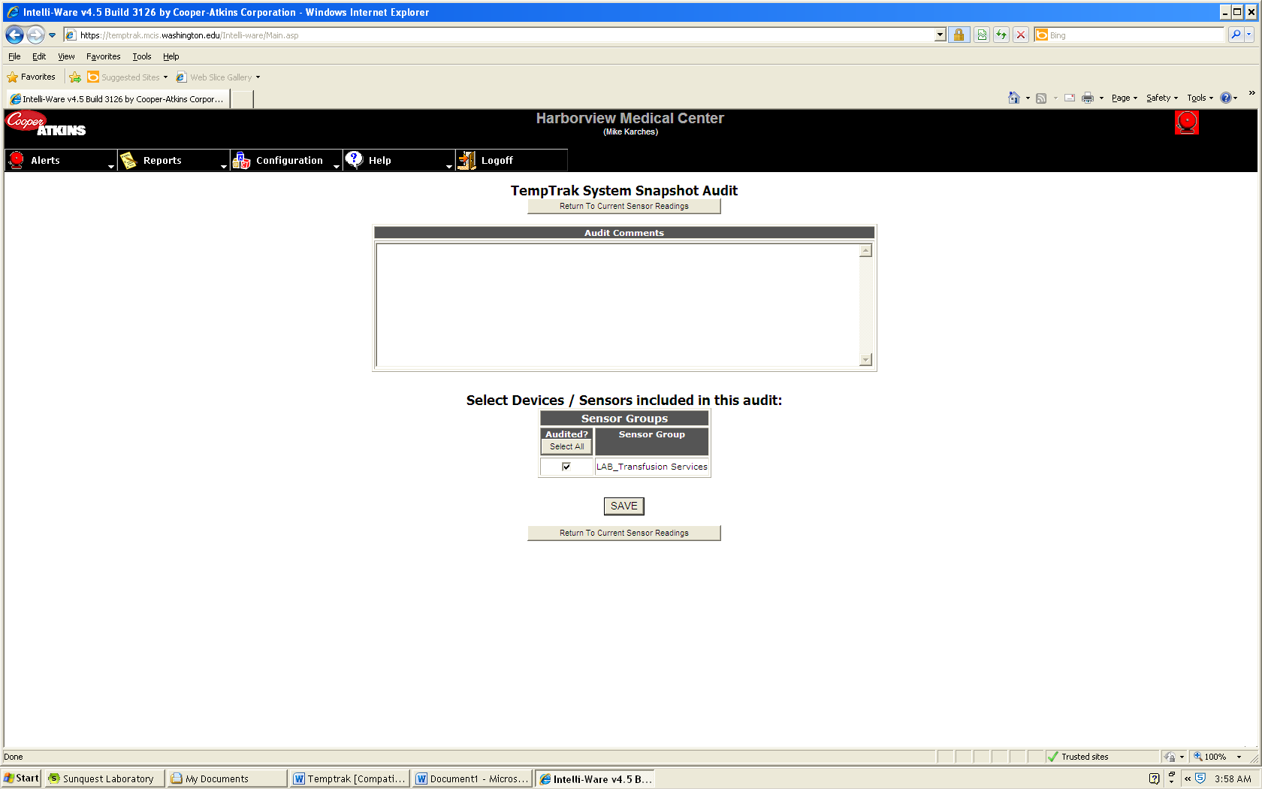

|  |  |  |
| --- | --- | --- |
| **Step** | **Action** | **Related Documents** |
| **6.** | * **At least once each day, a report will be generated of Temp Trak temperatures and alarm events:** * Reviewed by TSL staff and TSL Lead * Filed in Temp Trak notebook. |  |
| **Monthly Maintenance: Performed by system administrator** | | |
| **1** | * Perform comparison of Temp Trak temperature to internal thermometers and digital reading for each unit. * *Note: Humidity and Room Temperature are not included in monthly maintenance.* | Monthly Storage Unit Temperature Log |
| **2** | * Review Equipment QA Report * Go to TempTrak Main Page * Select [Reports] * Select [TempTrak] * Select [Equipment QA Report] * Select Period * Must review monthly report to ensure equipment maintains temperature readings within 99 percent or above. If not within the 99 percent, may be mechanical error. Notify Facilities Engineering and submit a work order. | Removing Equipment from Service |
| **3** | * Perform Audit * Go to TempTrak Main Page * Select [Reports] * Select [TempTrak] * Select [Sensor Audit Report] * Using the drop down menu at “Select Sensor Group”, choose Lab_Transfusion Services * Choose the “Reporting Period” by clicking on calendar iconPick Reporting Period. * Change “Select Period” to one month. * Select “Ending Date” by clicking on the last day of the month you are auditing. * Review the report to document that temperatures were reviewed daily. | Daily Equipment, Temperature, and Inventory Duties Checklist |

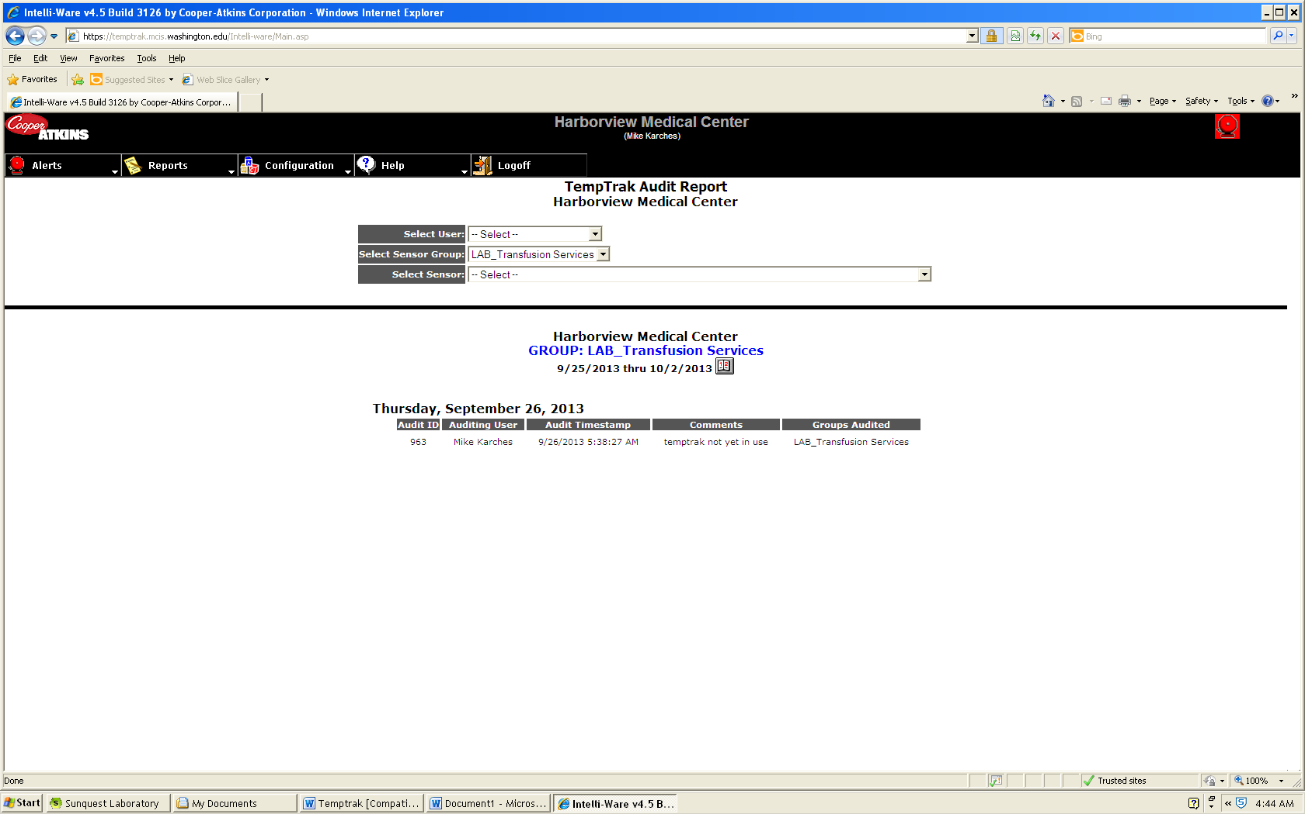

|  |  |  |  |
| --- | --- | --- | --- |
| **Step** | **Action** | | **Related Documents** |
| **Quarterly Maintenance** | | | |
| **1.** | * Perform Alarm Activation check.   + Maintenance and Troubleshooting of Storage Units | | Quarterly Alarm Activation Record |
| **Alarms** | | | |
| **1** | * There are three types of alarms which will sound the Temp Trak pager. * If the temperature for any of the sensors falls outside of the set parameters. * If there is a missed communication between the sensor and the server. * If any of the sensors has a low battery |  | |
| **2** | * If there is a temperature failure. * Log into TempTrak, you should be able to see which sensor is failing by the color code. Blue=low, Red=High, Green=normal. * Click on the Alarm icon https://temptrak.mcis.washington.edu/Intelli-ware/Images/AlarmTemp_ON.gif and all the alert information will appear.   NOTE: If the room temp or humidity fails, contact engineering for thermostat adjustments. |  | |

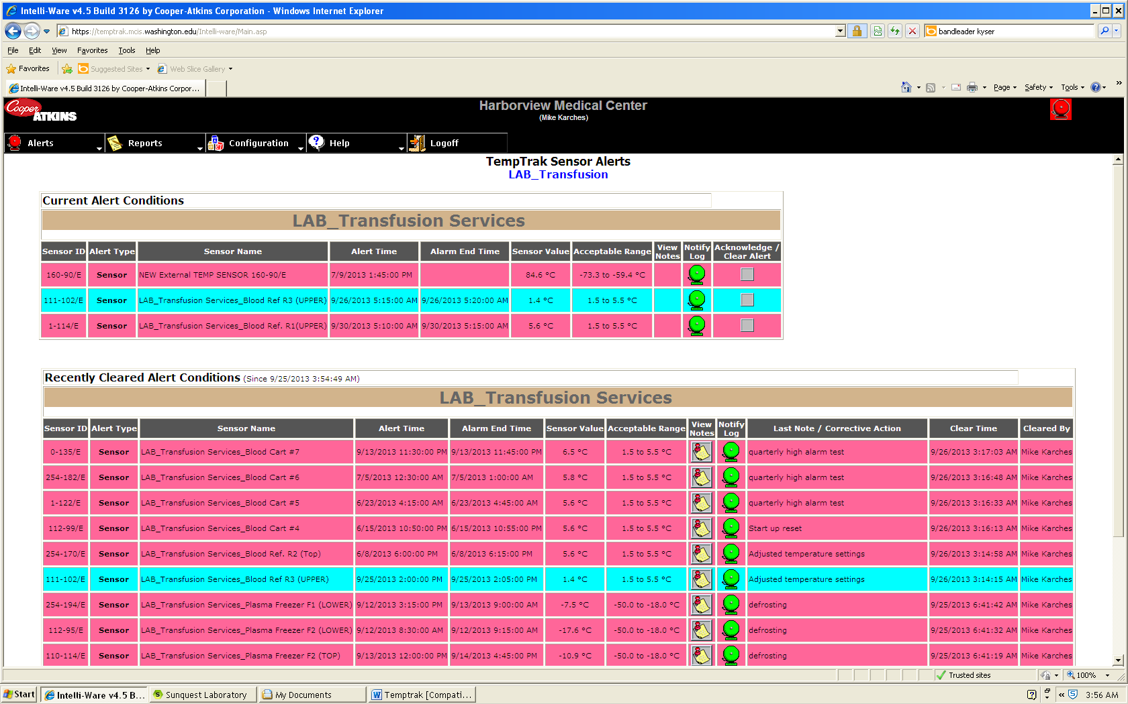

|  |  |  |
| --- | --- | --- |
| **3** | * Click in the “Acknowledge Clear Alerts” box. * You will see a set of standard comments on the left and a space to free text any action in the “Corrective Action/Notes” box. * Click on the arrow to move the comment into the notes area or free text the action taken.   i.e.: If Portable #3 alarms because of an open door and temperature was high.  In “Comments Action/Notes” type: Door open/closed door. Add digital and thermometer temperatures.   * Then click on the “Clear Alert” box. * **NOTE: If you do NOT clear the alert the pager will not sound with repeated temperature failures.** | Maintenance and Troubleshooting of Platelet Incubator |

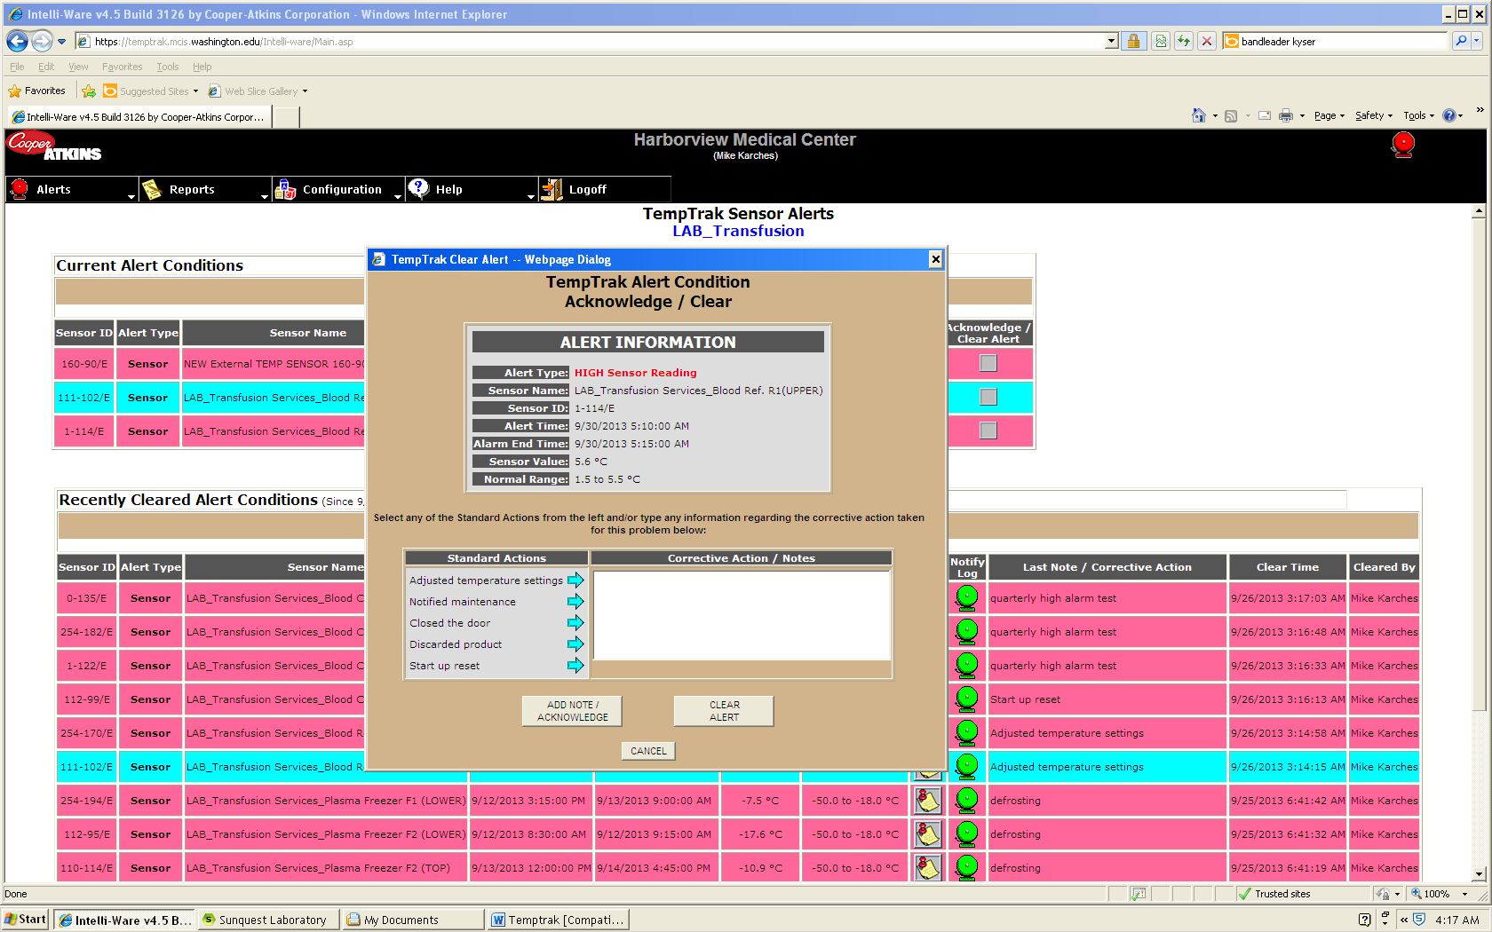

|  |  |  |
| --- | --- | --- |
| **4** | * When the temperature alert has been cleared the View Notes button will appear “Paper with Red Pushpin”. Clicking on the View Notes button will display the alert information and any notes associated with the temperature alert. |  |
| **5** | * Address any missed communication alerts. * Click on antenna icon and identify the communications errors.   i.e.: Monthly generator testing will trigger a missed communication.   * Call TempTrak at 1-888-533-6900 to see how long they will be down and if greater than four hours proceed to downtime procedure. | Downtime Refrigerator and Freezer QC |
| **6** | * Low battery Alert * Triggered when a transmitter detects a battery is becoming low (approximately three weeks before it will fail). * Pry open case with screwdriver or flat edge. * Replace with 2/3A lithium battery, 3V and document on Daily Equipment, Temperature, and Inventory Duties Checklist. | Daily Equipment, Temperature, and Inventory Duties Checklist |

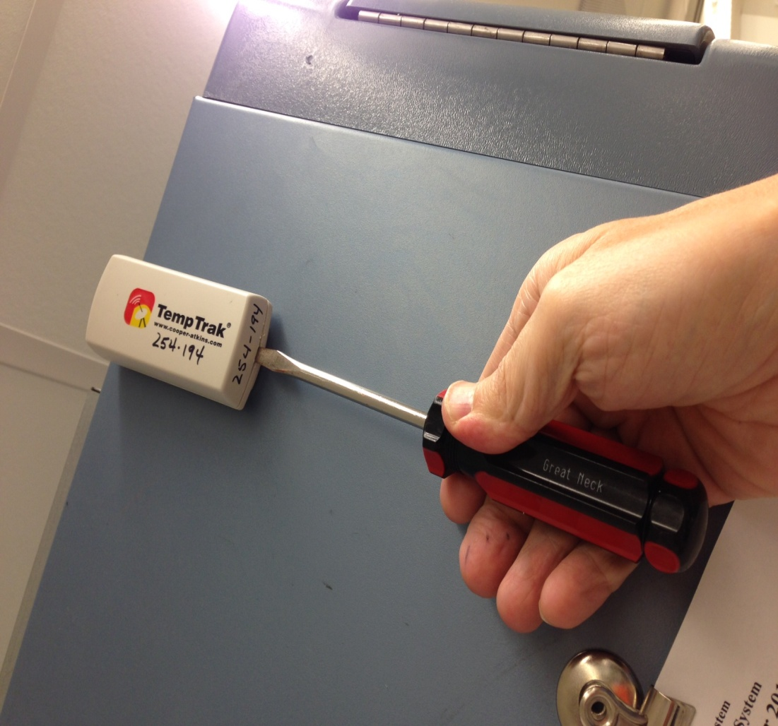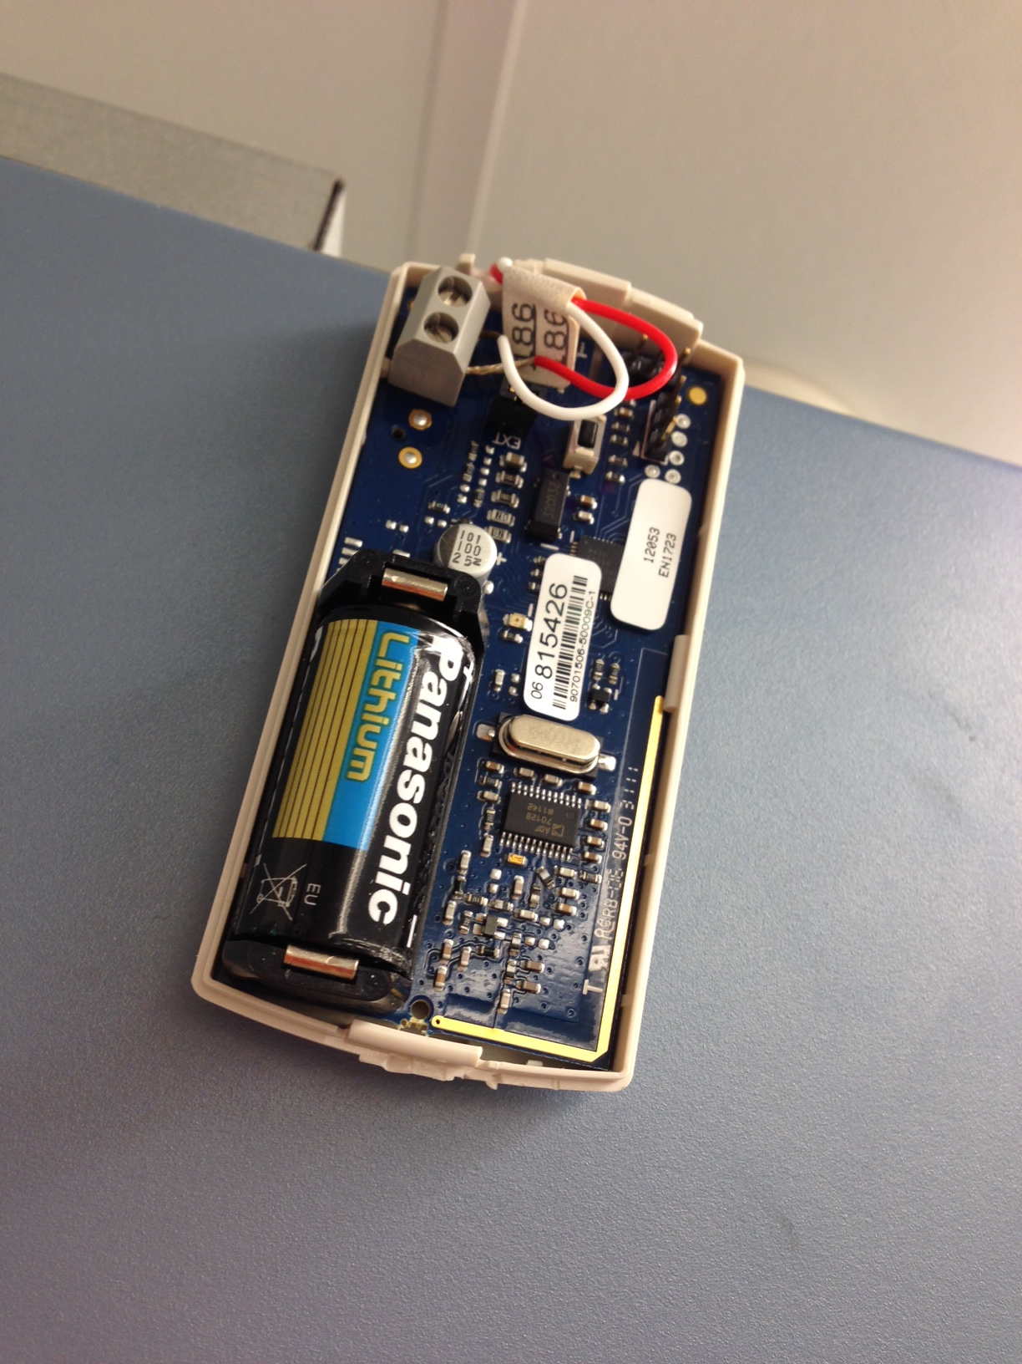

|  |  |  |
| --- | --- | --- |
| **Out of Service** | | |
| **Temp Trak** | **If Temp Trak system is not available**, is not responding or temperature differences indicate the Temp Trak is incorrect:   * Continue storage unit monitoring per downtime procedures. * Contact TempTrak at 1-888-533-6900 * Complete QIM   **Once Temp Trak is available and functioning:**   * Return to Temp Trak monitoring * Review all recovered data. * Document in Temp Trak and on QIM |  |
| **Equipment** | **If monitored equipment is removed from service:**   * Complete Out of Service form. * In Temp Trak:   + Do NOT clear alarm   + Add Note explaining the decision and disposition of product   Note: Disabling alarms is discouraged due to loss of data. Disabling alarms will be limited to the permanent removal of equipment and/or permission of the TSL Manager.  **Once equipment is returned:**   * Complete Return to Service paperwork * Clear alarm in Temp Trak * Document in Temp Trak (Add Note) | Equipment Out of Service form  Removing Equipment from Service |

References

TempTrak Design and Features Overview, January 2006

College of American Pathologists Accreditation Checklists.

Code of Federal Regulations, 21 Parts 200 to 299, parts 600-799

Circular of Information for the Use of Human Blood and Blood Components

Standards for Blood Banks and Transfusion Services, Current Edition. American Association of Blood Banks. AABB Press, Bethesda, MD.