Purpose

This procedure provides instructions for the Order Entry Process in HMC TSL, which includes the following:
- Computerized Provider Orders (CPOE), which print in TSL
- Manual Orders using HMC form 2596, Transfusion Services Testing and Blood Product Request Form
- Manual Orders using HMC form 2595, Transfusion Services Preadmission Testing & Red Blood Cell Request form
- Entry of orders into SQ using Lab Order Entry
- Receipt of orders in SQ
- Triage of orders in TSL

Step | Actions | Related Documents
IF | CPOE Order Prints in TSL:  - Timestamp order  - Perform SQ inquiry:  - Review patient information found in BBI and/or LI  - Check for a blood type on file, and, if needed, for a current sample in TSL that is acceptable and valid for testing  - Previous testing can also be found in Purged Results  - Determine if order is for additional product that can be added onto an existing order  - Notify clinical care staff if a sample is required for testing  - Request order clarification from clinical staff  - Notify CT staff of patients with antibody history  - Notify clinical care staff if a second sample is required for ABRH2  - Triage order by order type and urgency  - Place orders waiting for sample collection in organizer beside the printer  - Hand-off to CT Tech for blood order processing update  - Place duplicate orders in Completed Order file | Using Blood Bank Inquiry (BBI) in SQ  Laboratory Inquiry
IF | IF sample and/or order is received in Transfusion Services:  - Time stamp request form  - Perform sample acceptability evaluation.  - If sample or order is not acceptable, follow the related procedures.  - If the sample or order is acceptable, proceed. | Sample Acceptance Evaluation  Sample Rejection Process
Step | Actions | Related Documents
1 | Check the patient history and check for valid in-date specimen. Look for any patient history by reviewing information found in BBI and LI. Check for a blood type on file, and, if needed, for a current sample in TS that is acceptable and valid for testing.  - Check if previous in date sample is labelled with Doe name and update SQ with changed name.  - Check for Patient requirements, i.e. LR or IRR etc.  - Apply “Irradiated Products” sticker to all patient forms | Using Blood Bank Inquiry (BBI) in SQ  Laboratory Inquiry  Updating Patient Demographics in SQ to match EPIC
2 | New Order/No Current Sample  If the sample was originally ordered through CPOE it must be received in Sunquest  - Open General Laboratory and click Orders in the top left corner. In the drop down menu, click Order/Receipt Modify  - Enter the patient MRN and click “Get Patient” and “Display Orders”.  - If the order was placed on the previous day, alter the “From” date in the box “Date/Time/Events” to the date the order was placed before clicking “Display Orders”.  - A new box will open with a list of testing orders.  - If the test to be performed in TSL is an ABRH2 select the ABRH2 order.  - If it is any other test (TSCR, TXM, DAT, etc) select the OPINK test.  - If there are multiple orders displaying OPINK, select the one that matches the date and time of the order form received with the sample.  - Update the collection date and time in the bottom left corner with the collection date and time on the sample. Enter the date and time the sample was received by TSL.  - If the sample was drawn by phlebotomy click “Receive All” in the CID box and “Save”.  - If there are no CIDs listed, click “Save” and “Container and Specimen Entry” will open. In this box, click “Route”.  - If the provider orders multiple TSL tests and only one tube of blood is drawn two OPINKs will be generated in the computer. It is necessary to receive both when the sample arrives.  - If an OPINK was received in ORM, continue on to Order Entry  - It is not necessary to continue to Order Entry on samples that were entered in CPOE with a specific test code (i.e. ABRH2)  NOTE: If you receive a test in General Laboratory that is not performed by TSL it is necessary to inform SPS so they can correct the error.  If the sample was not originally ordered in CPOE  - Open Order Entry and scan or type in the patient HID. The highlighted blue area will give you the patient information. Compare patient information on sample, requisition, and screen information.  - Sample HID may start with an H, U, or N.  - NOTE: Check for any entries under User Defined Fields (i.e. SCCA: CCAR) at the far right of the highlighted blue area and note entry on paper requisition.  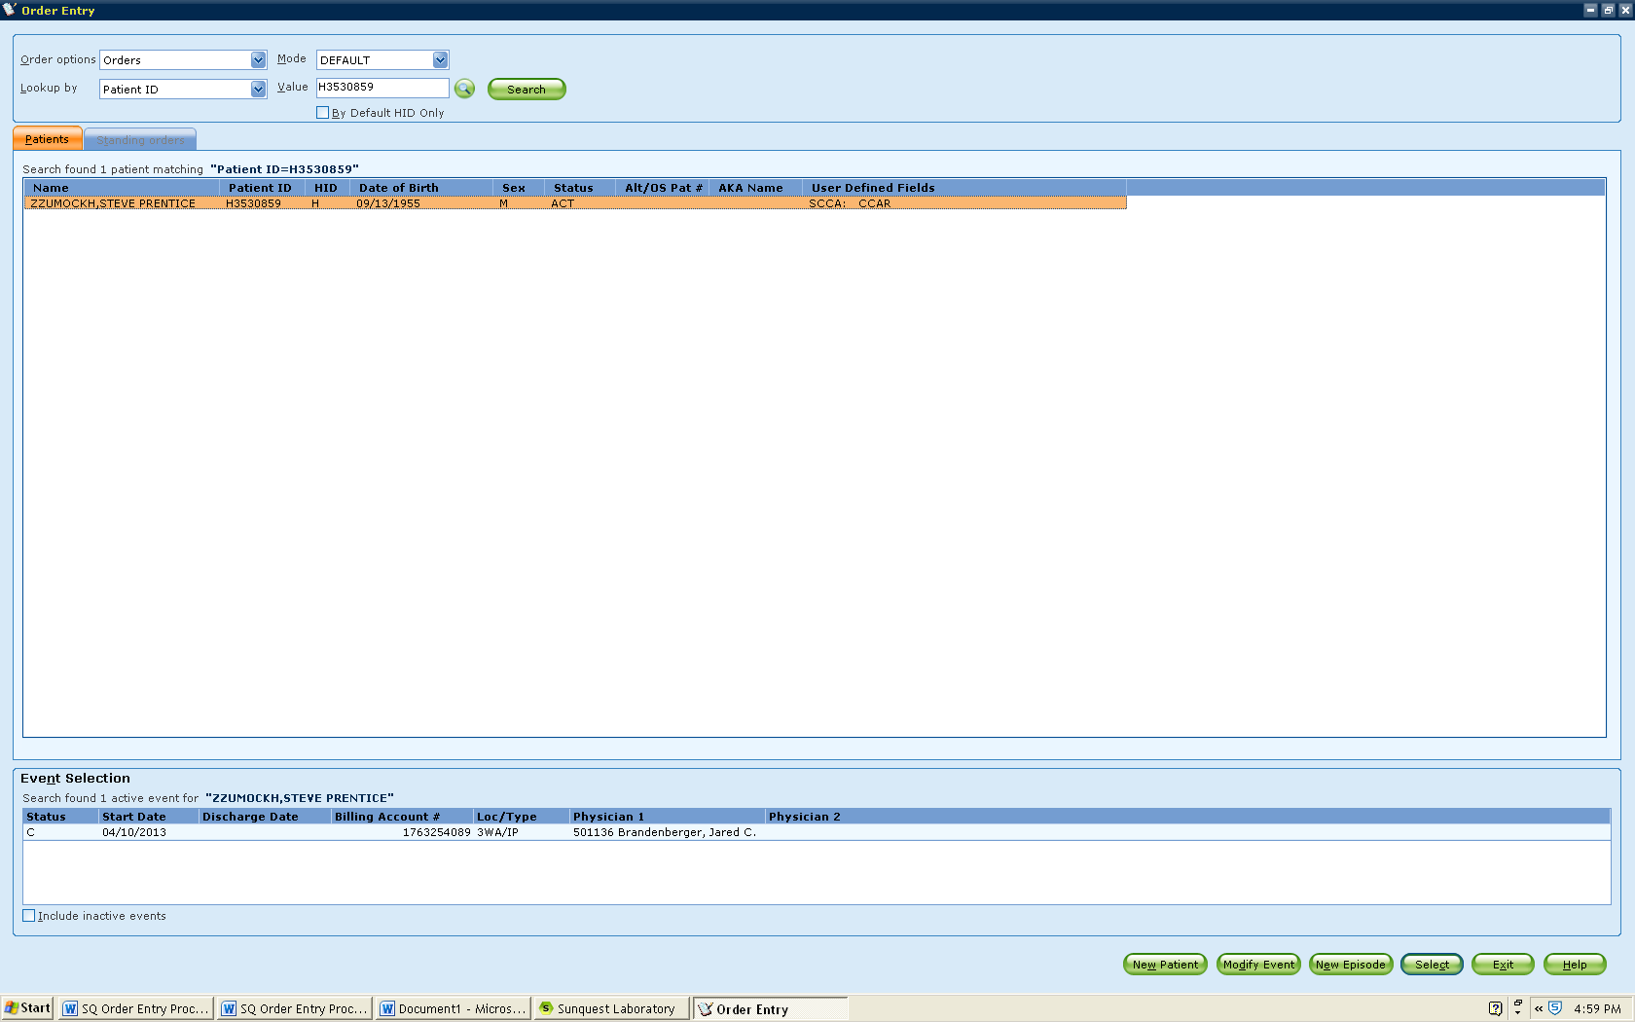  - The bottom of the screen will list the active events or episodes of the patient listed above. Choose the correct event by double clicking. If one event listed, you may use the Select key to continue.
3 | Creating a new order from a paper requisition using Lab Order Entry  - Enter location (if different), collected date and time, received date and time, the ordering physician, and the test code ordered. The required fields are highlighted yellow. Use the search key if unsure of code for each entry. If no sample (i.e. FFP order) use U for unknown in the collected time.  - Click Assign to give an accession number to each order. Click on SAVE.  - The next screen will ask what sample is required. Route the sample (defaults to Pink top or No Tube but can be changed if needed) which will print accession and CID labels.  - Put the accession label on the paper requisition and the CID label on the tube.  - If sample received, centrifuge it and notify the technologist that order needs to be processed.  If order is for components, then notify person in secondary processing of request
4 | Expand an existing order to add new testing  - If an order occurs and there is a current in-date sample in TS, then an additional order can be added to it. (Example: current Type and Screen and crossmatched units are requested.)  - Print or use paper requisition for test/component request and time stamp for receipt.  - Reprint the accession label or CID label  - Place accession label on paperwork.  - If order is for cellular products, locate the sample in the refrigerator that corresponds to that label and request. Notify technologist that order needs to be processed. | Blood Order Processing
Step | Actions | Related Documents
5 | Creating an order for duplicate samples  - Occasionally a second sample is requested or received:  - Additional volume is required for testing either to send out or complete in-house.  - Duplicate samples are drawn unintentionally.  - In order to track the sample, but not create a charge, an XPINK test is ordered and an accession label is created.  - Receive OPINK following instructions in Step 2 above  - Open Order Entry and enter collection date and time, and received date and time.  - Enter Order Code XPINK.  - Print Accession Label and affix to sample.  - Store the sample per SOP. | Sample and Unit Segment Management Process
6 | Creating an order from XPINK  - If an order occurs and there is a current in-date blood bank XPINK sample in TS, the sample can be used but a new accession must be ordered.  - Receive requisition and time stamp.  - Locate XPINK sample in refrigerator before placing new order in computer.  - Open Order Entry. Check location from requisition to see if update is needed for the order.  - Enter date and time collected that reflects when the XPINK tube was drawn. The received date and time should correspond to the current order.  - Order the test requested, and in the Modifier box select code SIL (sample in laboratory) with the free text entry of XPINK and accession number (XPINK ACC12345).  - Label the tube according to guidelines to allow both labels to be partially visible.  - Notify technologist that order needs to be processed.
References:
AABB Standards for Blood Banks and Transfusion Services, Current Edition

