[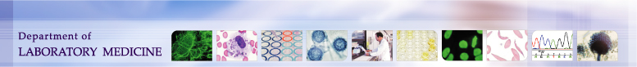](http://depts.washington.edu/labweb/index.htm)

|  |  |  |
| --- | --- | --- |
| **University of Washington,**  **Harborview Medical Center**  **325 9th Ave. Seattle, WA, 98104**  **Transfusion Services Laboratory**  **Policies and Procedures Manual** | **Original Effective Date:**  **August 15, 2011** | **Number:**  **1902-1** |
| **Revision Effective Date:** | **Pages:** |
| **TITLE: Quality Policy: Quality Indicators for Process Improvement** | | |

**Policy:**

The Harborview Medical Center Transfusion Service shall use data and information about its operational processes and quality management system performance to identify opportunities for improvement.

**Purpose:**

To provide direction for the processes and procedures for collecting the data and information about operational processes in order to identify process improvement opportunities.

|  |  |  |  |
| --- | --- | --- | --- |
| **Operational Process** | **Quality Indicator** | **Method** | **Frequency** |
| Transfusion Practice | SQ Blood Utilization Report of all transfusions that fall outside the following:   * Hgb >8 * INR <1.7 * Plt Ct >75,000 | * Medical Director Review | Monthly |
| Pretransfusion Testing | * Reagent QC documentation * QA over-ride report * Antibody Identification Accuracy | * Check by second technologist. * Manager/Lead review * Report reviewed by Manager | * Each occurrence * Daily * Each occurrence |
| Inventory Management | * Wastage * Expiration * Unit Age | * SQ Product File List Report * Custom inventory report | * Monthly * Monthly |
| Blood Product Ordering Practice | * C/T Ratio * Special Product Attributes | * SQ Finalized/Issued Report * Medical Director blood order review | * Monthly * Each order |
| Sample Collection | * Trauma Sample Collection Time * Sample Rejection | * Trauma log review * Rejection Report | * Monthly * Monthly |

**References**

AABB Standards for Blood Banks and Transfusion Services, Current Edition