**SCCA TEAM Display in Sunquest:** *See Translation Table for explanation of display code*

**ROLL AND SCROLL (SMARTERM)**

**Function: AD**

LAB ADMINISTRATIVE ENTRY

HOSP. ID: U

HOSP. NO.: U3801009 ZZZITFOUR,GEN ONC

1. PATIENT NAME: ZZZITFOUR,GEN ONC

2. BIRTHDATE: 04/07/1945

3. SEX: F

4. AKA NAME:

6. SOC SEC #: XXX-XX-9999

8. Alt/OS Pat #:

9. UWMC/HMC/UWPN/OS:

10.01. SCCA Team: SGenOn

ACCEPT (A), MODIFY (M), REJECT (R), OR EVENT ENTRY (E) ?

**Function: I or IQ**

Laboratory RESULT INQUIRY

Pat: ZZZITFOUR,GEN ONC (U3801009) Age/Sex: 69Y F HID: U

Phys:

Tests: (all)

Scca Team: SGenOn

T16580 COLL: 12/16/2014 13:59 REC: 12/16/2014 14:04

Req. No.: Account: 1800429493 Loc: SCLAB

Type and Screen CPOE Order

Type and Screen Order Status

Sample sent to PSBC (023)

<<Previous Typing on File?>>

Crossmatch hold sample for PSBC. (1466)

**GUI SCREENS**

**Laboratory Inquiry**

Initial Screen

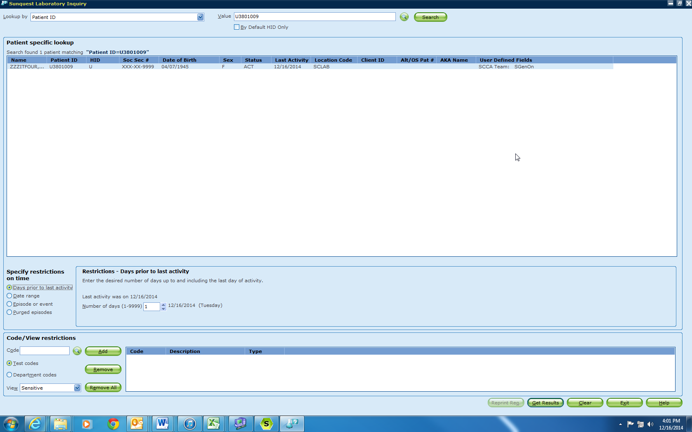

Secondary IQ Screen

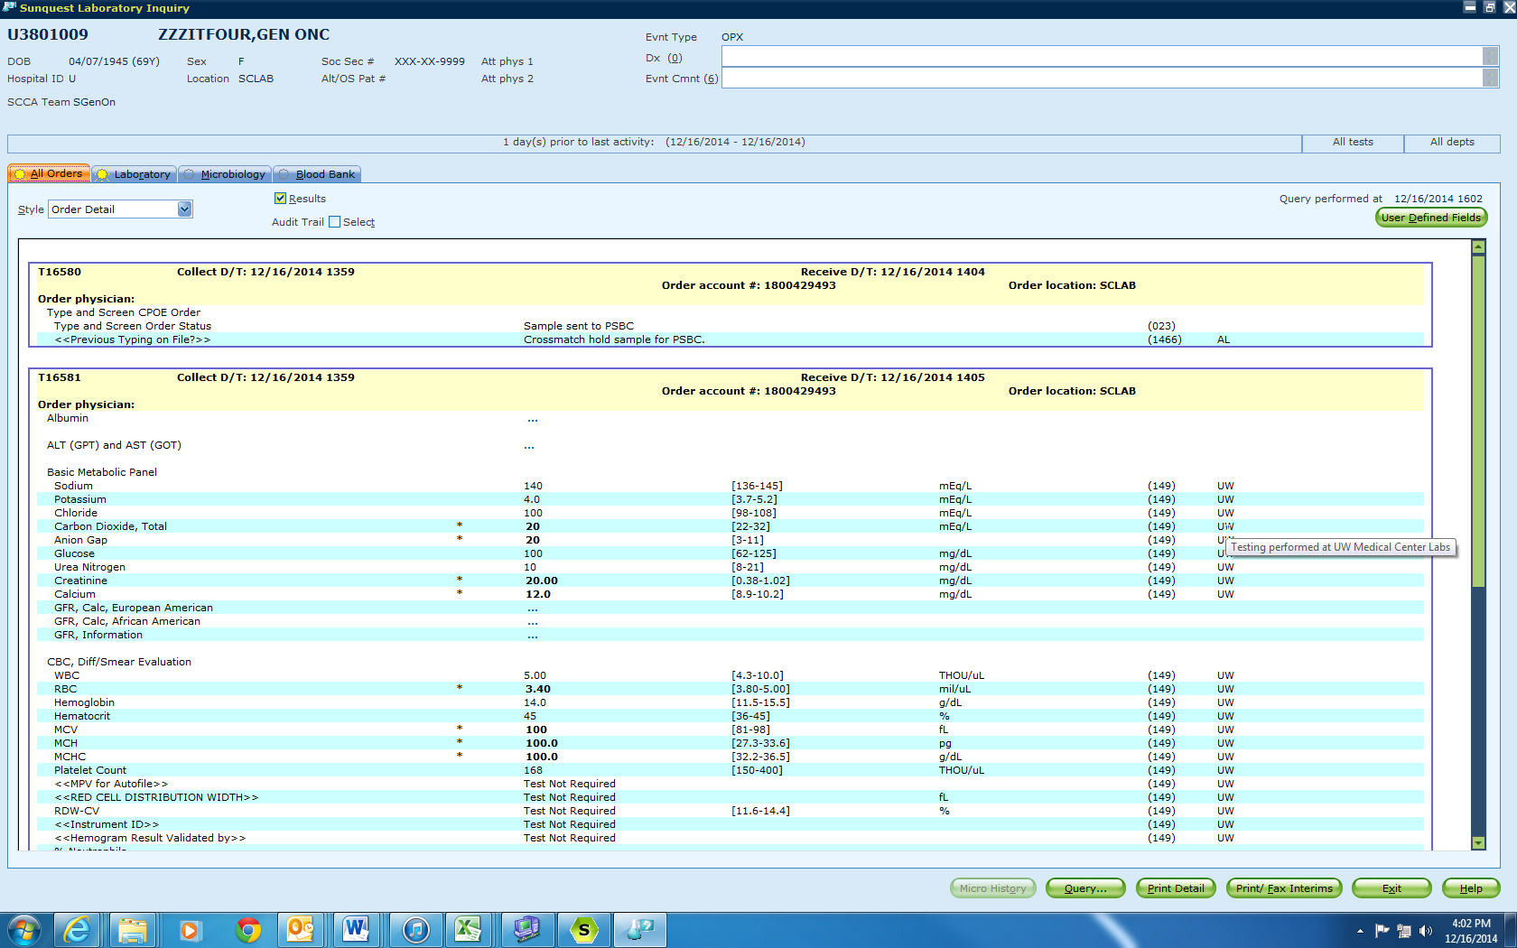

**Administrative Data Entry:**

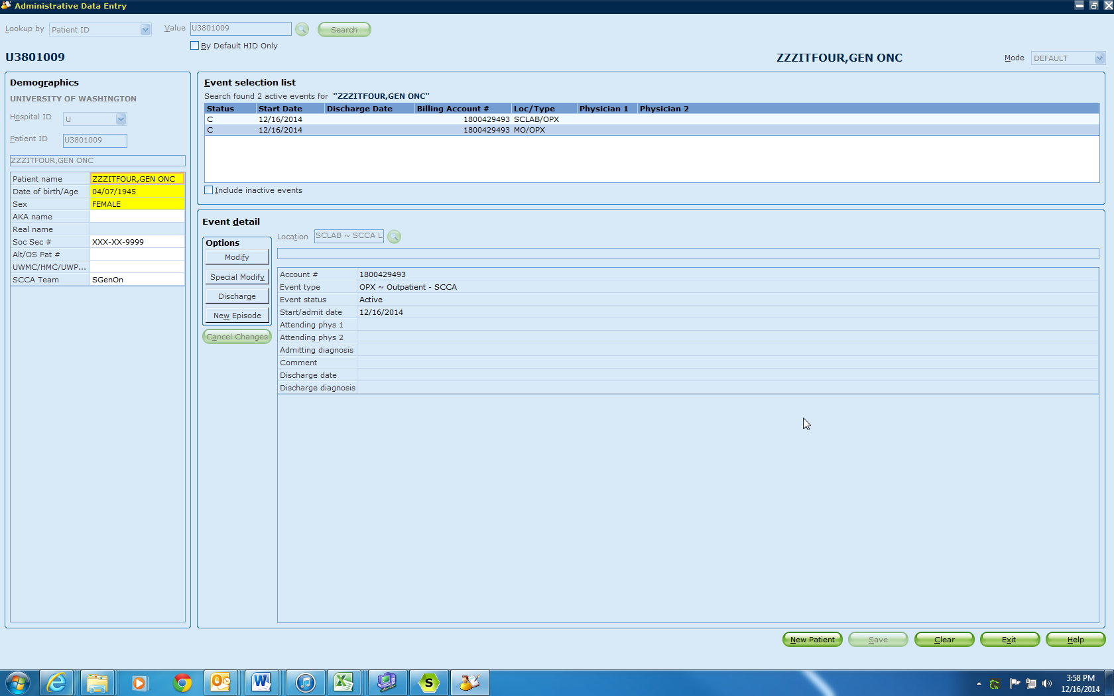

**Order Entry:**

Initial Screen:

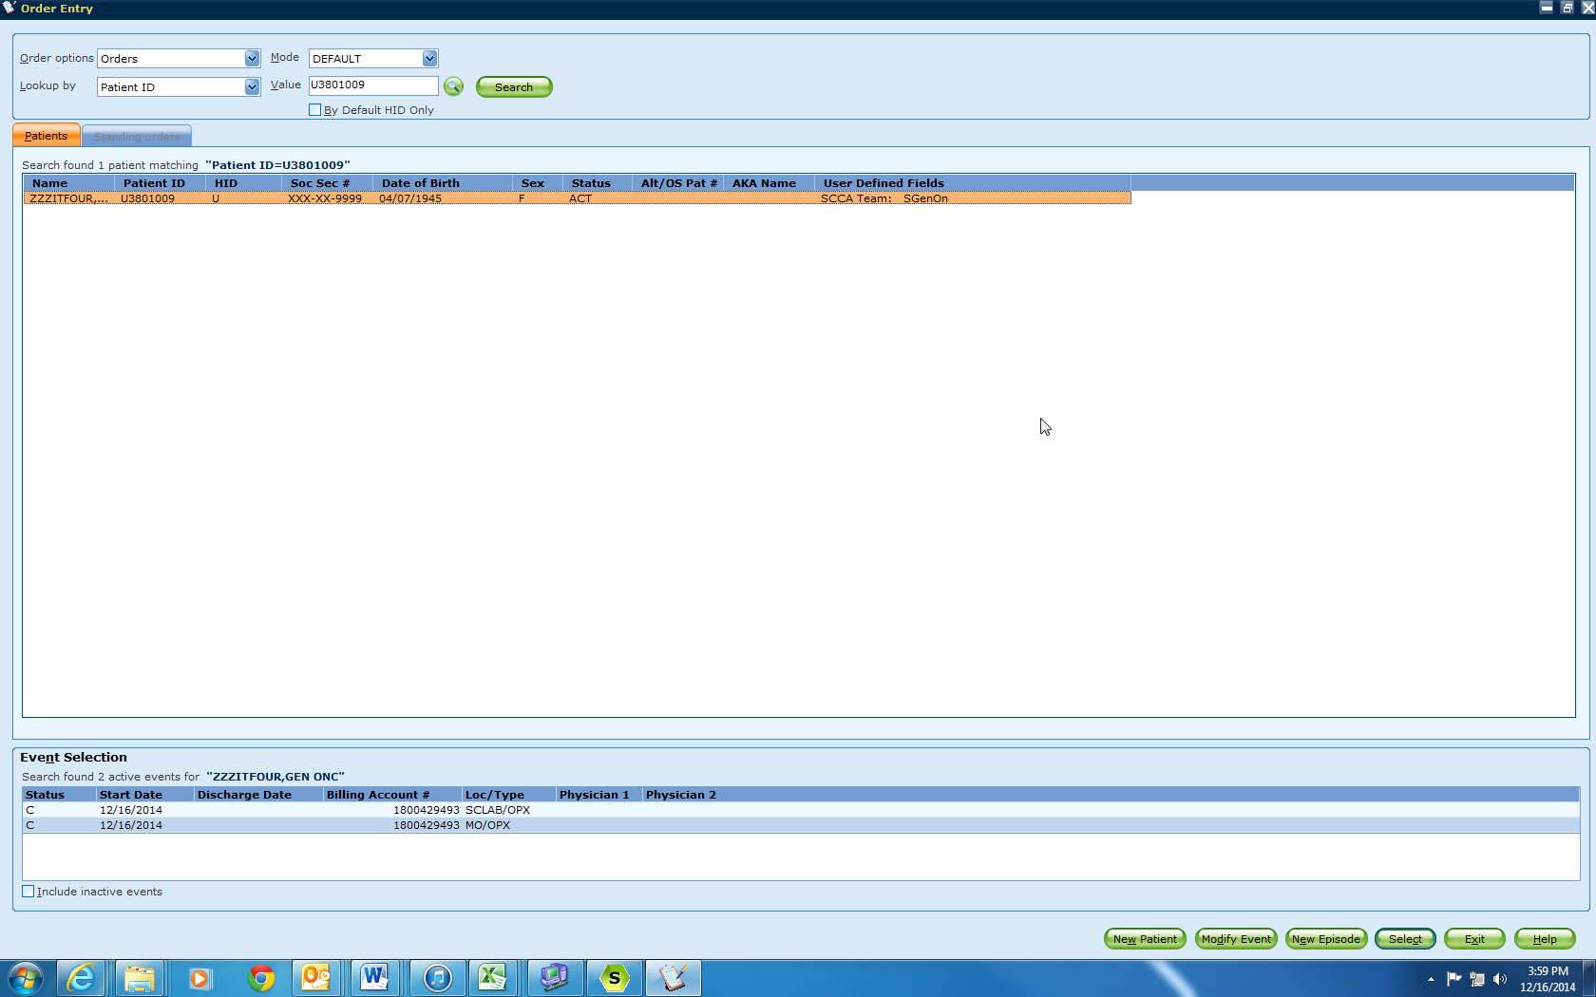

Selected Encounter Screen:

