**Purpose**

To describe the way SQ v 7.1 formats patient name displays in SQ Blood Bank functions.

**Background**

The version upgrade to SQ v. 7.1 changed the parameters for patient name display to include a limitation governed by the space required for the characters displayed. Because of this limitation, names with 22 characters or more, depending on the character size, may display with the middle name missing in the Function header. The complete name will be shown in the header, only if the mouse is hovered over it.

**Procedure**

|  |  |  |
| --- | --- | --- |
| **Step** | **Action** | **Related Documents** |
| **1** | * Patient names which exceed the character space limit will truncate in the header display in the following functions: * Blood Bank Inquiry * Blood Order Processing * Blood Order Processing Worklist * Blood Administrative Date Inquiry * The last show character may be followed by “……” indicating that the name is truncated. * However, if the cut-off for character space happens to be between the Last and middle names, the middle name may not show at all, and there may not be the “….” Indicating the truncation.   See diagram A. |  |
| **2** | ANY time the header displaying the patient name does not match the sample label and/or the paper requisition, the curser must be “hovered” over the name, and any truncation will disappear, as the full name will display in the bubble below the cursor.  See diagram B. |  |
| **3.** | If the full name does not appear when the cursor is hovered, the discrepancy must be resolved prior to testing. |  |

**DIAGRAM A**

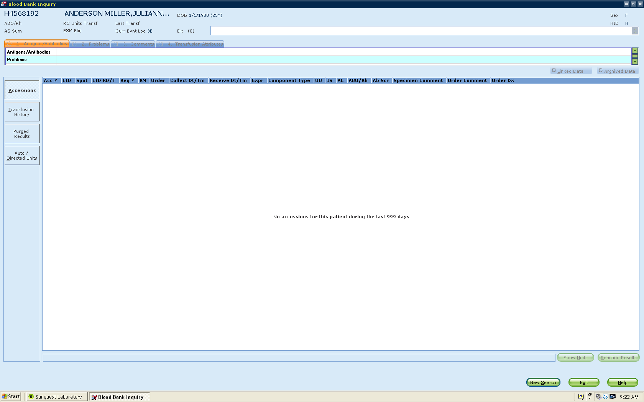

**DIAGRAM B**

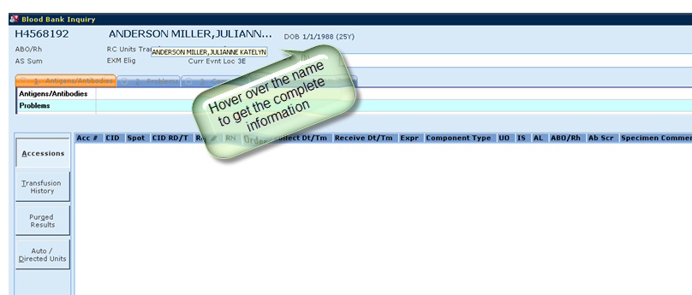

**References**

Blood Bank User Guide, Version 7.1, Misys Systems.