Purpose:
This procedure describes the operation, maintenance and calibration of the Rainin Pipet-Lite™ XLS single channel manual pipettes (Models L-100 XLS and L-1000 XLS).

Procedure:
Step | Action | Related Documents
SETTING VOLUME
- Turn the volume lock lever to the UNLOCK position. See Figure 1.

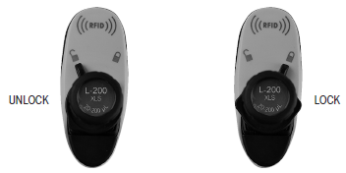Figure 1

- Rotate the plunger button to change volume – counter-clockwise to increase, and clockwise to decrease volume.
- Read the volume indicator from the top down:
- Model L-100 XLS: All digits black - µL.
- Model L-1000 XLS: Red digit – mL. Black digits – tenths, hundredths of mL.
- See Figure 2.

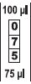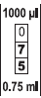

Figure 2

- When setting the volume, first turn the knob 1/3 turn above the desired volume. Then turn the knob clockwise until the desired volume is displayed.
- Always dial down to the desired volume.
- After selecting the volume, turn the volume lock lever to the LOCK position (see Figure 1) to prevent changes to the volume setting.

TIP SELECTION AND MOUNTING
- To mount a tip, press the shaft into the end of the tip with light force.
- Do not use more force than is required. The tip will seal properly with minimal force.
TIP IMMERSION DEPTH
- Tip immersion depth is critical and should not be exceeded, or the volume measurement may be inaccurate.
- Model L-100 XLS: 2-3 mm
- Model L-1000 XLS: 3-6 mm
- The tip angle is also important – the pipette should be used in a position within 20 degrees of vertical.
- See Figure 3.

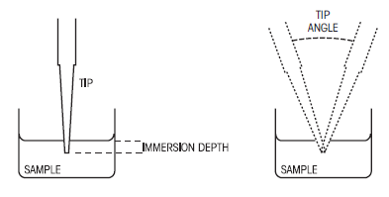Figure 3

ASPIRATION
- Press the plunger button to the first stop, and hold in this position.
- Holding the pipette vertically (or within 20° of vertical), place the tip into the sample to the proper depth.
- Relax thumb pressure on the plunger but do not let go of the plunger button. The piston spring will move the piston upward, aspirating the sample.
- Note: Do not let the piston snap up quickly. This may cause sample splash inside the mechanism.
- Withdraw the tip from the sample.

DISPENSING
- Touch the tip end against the side wall of the receiving vessel and press the plunger slowly past the first stop, to blowout.
- Withdraw the tip, sliding it along the wall of the vessel.
- Release the plunger.
- Press the tip ejector button lightly to discard the tip.

MAINTENANCE
- After each use, clean the shaft with distilled water and dry with lint-free tissue.
- Annually, or as needed:
- Remove the tip ejector arm by pressing the quick-release tabs and pulling the ejector arm down. See Figure 4.

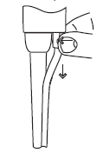Figure 4

- Unscrew the shaft coupling and remove the shaft. When removing the shaft from the pipette body, make sure the spring, seal and o-ring do not fall off the piston and note the way they fit on the piston.
- Inspect the piston assembly. The piston should be shiny and free of corrosion. Clean with distilled water or isopropyl alcohol and dry with lint-free tissue. Notify lead tech if corrosion or staining is present.
- Note: Do not lubricate any component. Pipet-Lite uses a dry sealing system.
- Inspect the seal and o-ring. Replace if necessary. Pull off the old seal and o-ring. Position the new seal and o-ring on the piston as shown in Figure 5.

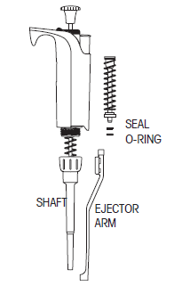Figure 5

- Inspect the interior of the shaft for contamination.
- Re-assemble the pipette.
- To replace the ejector arm, insert the shaft through the large opening, align the top with the tip ejector pushrod, and push until the arm snaps in place.
- Clean the shaft and inspect for splits and scratches.
- Inspect and clean the tip ejector mechanism.
- Recalibration is not necessary after seal and o-ring replacement.

- Replacement parts:

Model | Seal | O-Ring | Shaft | Tip Ejector Arm
L-100XLS | 6200-150 | 6200-151 | 6202-066 | 6202-073
L-1000XLS | 6200-161 | 6200-162 | 6202-068 | 6202-074

Model | Rainin Tip No.
L-100XLS | RT-L250
L-1000XLS | RT-L1000

CALIBRATION
 | - Each pipette is calibrated prior to being placed into use, and quarterly thereafter.  - The L-100XLS pipette volume setting for calibration is 100 µL. The L-1000XLS pipette will be calibrated at 500 µL and 1000 µL.  - Calibration is performed using deionized water at room temperature. Use the FLUKE 52II thermometer to take the temperature of the water.  - The Mettler 163A balance must be calibrated daily.  - Place a weigh boat on the pan.  - Tare the weigh boat.  - Take 5 sequential weighings. Re-zero the balance after each weighing.  - Change the pipette tip after 2 weighings.  - Calculate the % Error.  - To calculate using program in the computer:  - Access the TSL Pipette Calibration Worksheet for Rainin pipettes in the Equipment Folder on Lilith2.  - Enter the temperature of the water.  - The theoretical volume will be calculated using the density of the water.  - Enter the 5 weights taken.  - The computer will automatically calculate the measured volume and % Error when all 5 values are entered.  - Complete the worksheet by filling in the appropriate sections.  - Print the worksheet and sign off in the appropriate sections’  - Submit to manager for review.  - If computer is not available, calculate measured volume and % Error as follows:  Measured volume = Sum of observed final weights  Number of weighings  % Error = (Measured volume) – (Theoretical volume) X 100  Theoretical volume  - % Error and CV must be less than 3%. Repeat calibration if either value is higher than 3%.  - If % Error and CV remain high after repeat calibration, maintenance may be required to obtain acceptable results.  - Notify lead tech if results are still not acceptable after maintenance is performed. | Mettler 163A Balance Operation and Maintenance  TSL Pipette Calibration Worksheet
STORAGE
 | - After use, store the pipette in a clean safe place.

References:
Standards for Blood Banks and Transfusion Services, Current Edition: AABB Press, Bethesda, MD.

Rainin Pipet-Lite™ XLS User Manual

