**Refrigerator and Freezer Maintenance Form**

**Year: ________________**

**Equipment No._________________________________ Type of Equipment: _______________________**

**Programmed Alarm Parameters**

|  |  |  |
| --- | --- | --- |
| **Storage Equipment** | **Low Alarm Setting** | **High Alarm Setting** |
| Blood Storage Refrigerator | 1.5oC | 5.5°C |
| Reagent Storage Refrigerator | 2.5oC | 7.5°C |
| Plasma Freezer | N/A | -20°C |
| Ultra Low Freezer | -90°C | -65°C |

|  |  |  |  |  |  |  |  |  |  |  |  |  |
| --- | --- | --- | --- | --- | --- | --- | --- | --- | --- | --- | --- | --- |
| **Date** | **Reason** | **High Alarm Test** | | | | **Low Alarm Test** | | | | **OK? Y/N** | **Tech ID** | **Comments** |
| Digital | Chart | NIST/  Fluke | Temp Trak | Digital | Chart | NIST/  Fluke | Temp Trak |
|  |  |  |  |  |  |  |  |  |  |  |  |  |
|  |  |  |  |  |  |  |  |  |  |  |  |  |
|  |  |  |  |  |  |  |  |  |  |  |  |  |
|  |  |  |  |  |  |  |  |  |  |  |  |  |

***All recordings must agree within 1.0oC.***

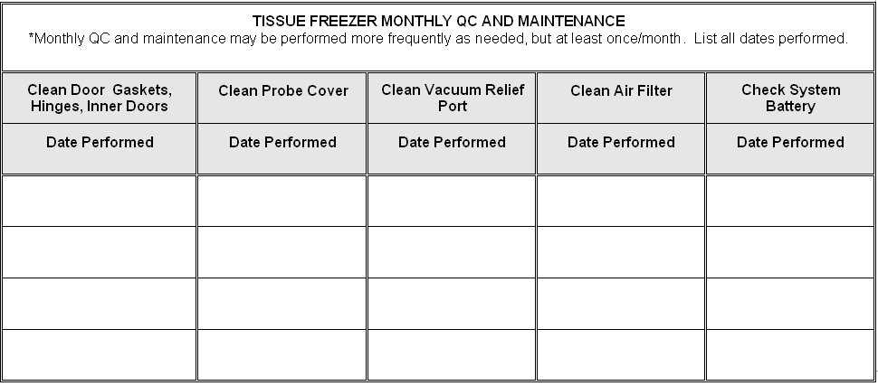

Date:___________________________Tech:__________________________________

Reason Codes:

Q = Quarterly, PC = Program Change, RTS = Return to Service

**Comment Code Key:**

RPR=Repeat LE=Late Entry CE=Corrected Entry CAL=Recalibrated RS=Referred to Supervisor

NC= Not corrected OTR=Explain EB=Explain on back of page

**Reviewed by:____________________________________Date:____________________________________**