Purpose
To provide instructions on the use of Marathon Micro DL temperature data loggers. This will include preparing the logger for recording, downloading data, and assessing data obtained during blood storage.

The Credo coolers are used for storing blood products that require storage at 1ºC to 6ºC. When a cooler is packed, a Marathon Micro DL Temperature Data Logger will also be placed in the cooler to record temperatures allowing assessment of blood product return to inventory or discard.

Equipment
- Micro DL Temperature Data Recorder
- Marathon Micro DL Reader Station

Procedure
Step | Action | Related Documents
Marathon Micro DL Temperature Data Logger (Micro DL) Model mDL4
1 | - User programmable data logger: EEPROM Memory 4K  - Displays real-time temperature  - Scrollable for recorded history information  - Set High and Low alarm status  - Water resistant (not water proof)  - FDA compliant (21CFR Part 11)
2 | Micro DL mDL4 Specifications from Marathon:  - Temperature range: -10ºC to +72ºC  - Temperature accuracy at center: 0.5ºC (1.0ºF)  - Temperature accuracy at extremes: 0.2ºC (0.4ºF)
3 | Data Loggers:  - Generally drift free for 5 years.  - Batteries should be replaced every 24 months.  - Manufacturer recommends returning for battery replacement and recalibration due to difficult replacing batteries without damaging electronics.
Micro DL Display
1 | With each press of the Start Button:  - REC: shows RECording and current temperature  - RUN: shows elapsed time in days  - HI: shows alarm has occurred and high temperature  - LOW: shows alarm has occurred and low temperature  - HI HR: shows alarm time hours over high threshold  - LOW HR: shows alarm time hours over low threshold  - Push to return to current temperature | Table A: Data Logger Display Examples
Step | Action | Related Documents
Programming MicroDL Temperature Data Loggers
1 | - Log into computer containing access to the Marathon Micro DL Reader Station  - Mount Reader Station  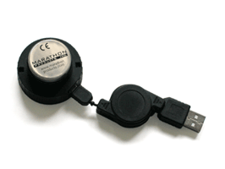  - Open Marathon software: MDAS-PRO  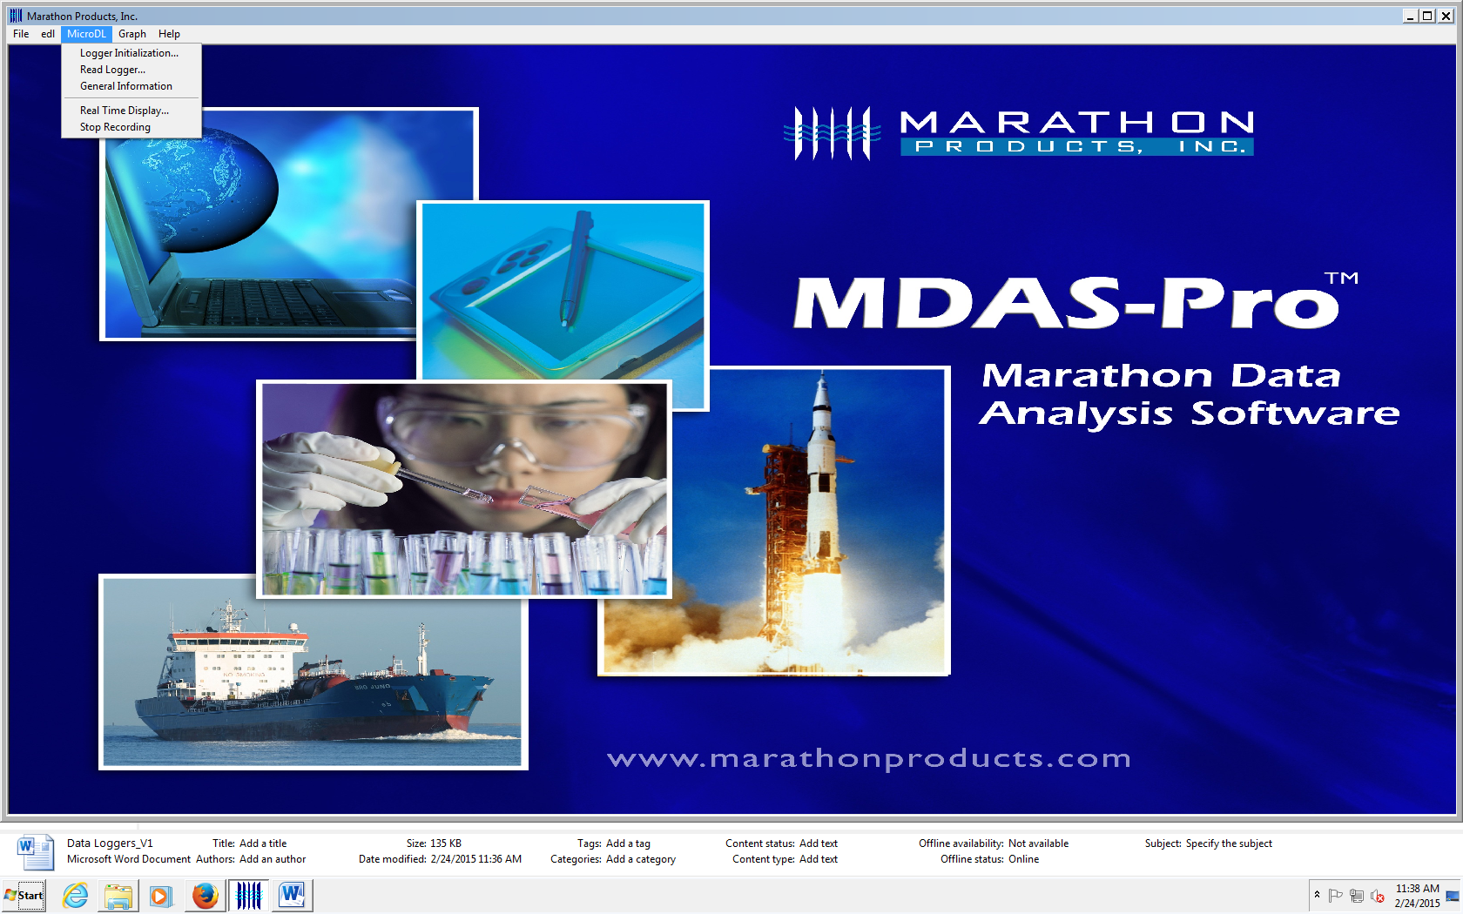
2 | Log Micro DL into Reader Station:  - Turn on the Micro DL display by pressing the Start button  - Note: Display is active for 4 minutes before hibernating.  - Place the Micro DL into the Reader Station by aligning the Start button with the hole in the reader.

Step | Action | Related Documents
Logger Initialization
1 | Drop Down Menu from MicroDL in the Task Bar  Setup Tab:  - Description: enter alphanumeric information  - TSL uses “Harborview Medical”  - Tracking Number: Logger Serial Number on side of data logger  - Logger Clock: Manual or PC time: Set to computer time  - Battery Status: installation date and percentage used is displayed  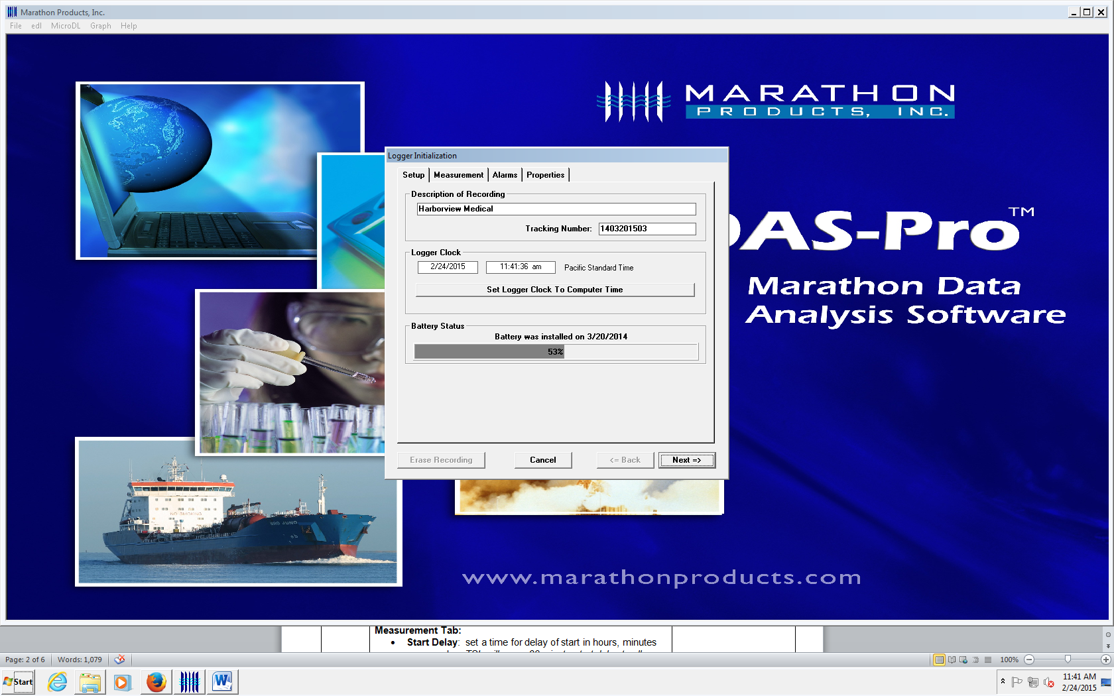  Click NEXT.
2 | Measurement Tab:  - Start Delay: set a time for delay of start in hours, minutes or seconds. TSL will use a 30 minute start delay to allow for the unit to come to temperature in the container.  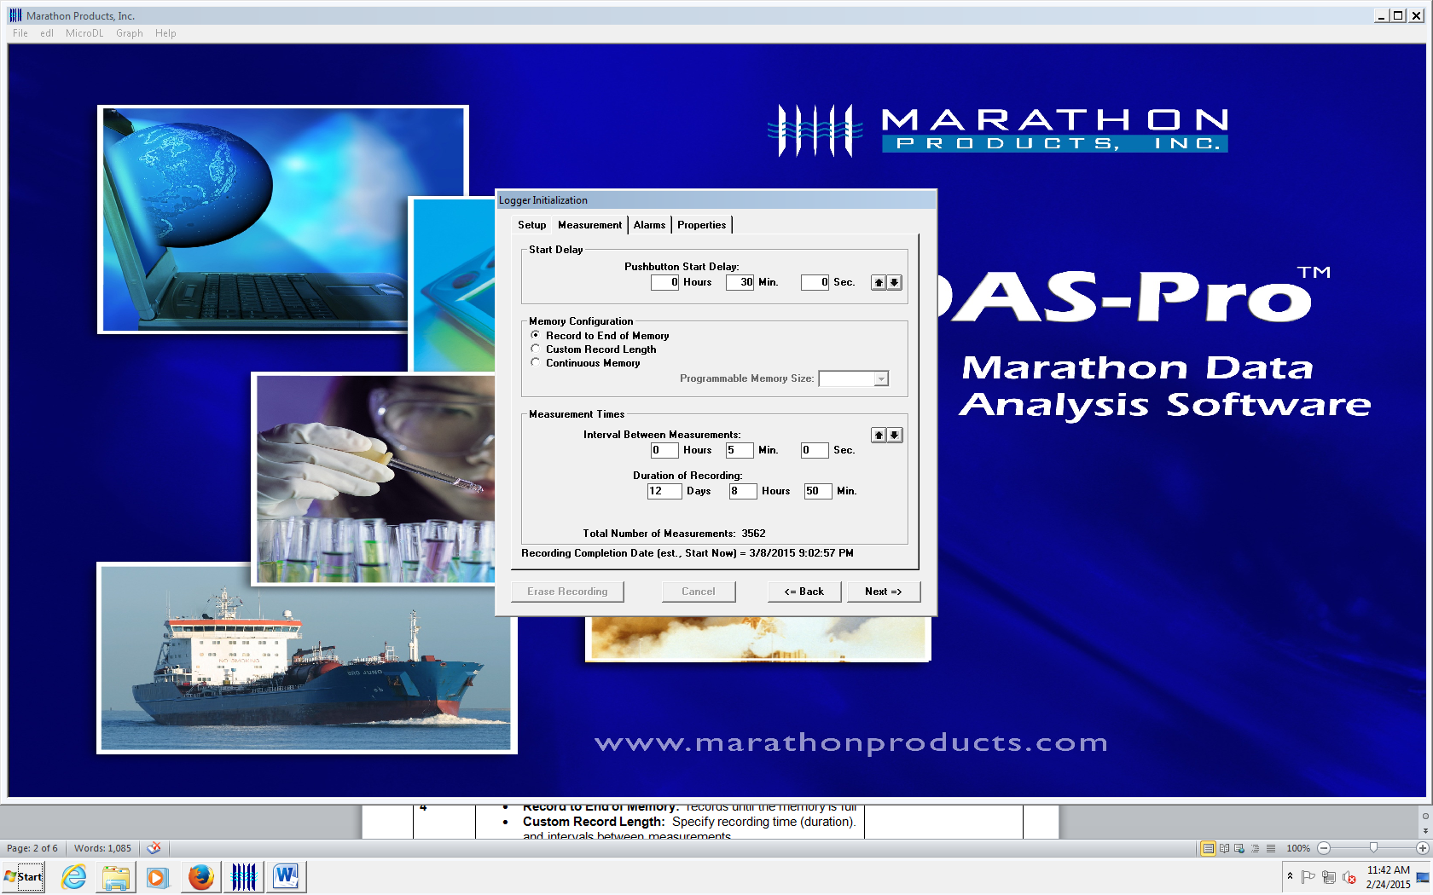  - Memory Configuration: 3 choices  - Record to End of Memory: records until the memory is full. TSL will utilize this option routinely  - Custom Record Length: Specify recording time (duration). and intervals between measurements.  - Continuous Memory: records continuously. When memory is full, loops back and overwrites the data
Step | Action | Related Documents
Logger Initialization (continued)
3 | Measurement Time: Duration and Interval are linked.  - Set the length of time in days or hours. Interval between measurements will be calculated.  - Example: Duration is 3 days. Interval between measurements is 34 seconds.  - Set the interval between measurements. Duration of recording will be calculated.  - Example: Interval between is 15 minutes. Duration will be 79 days and 21 hours.  - TSL: Set to 5 minute intervals. Recording should last 12 days, 8 hours, 50 minutes.  Click NEXT.
4 | Alarms Tab:  - Temperature Greater Than: Maximum temperature for alarm to be triggered.  - Temperature LESS Than: Minimum temperature for alarm to be triggered.  - Continuous: Time OVER or UNDER the alarm continuously  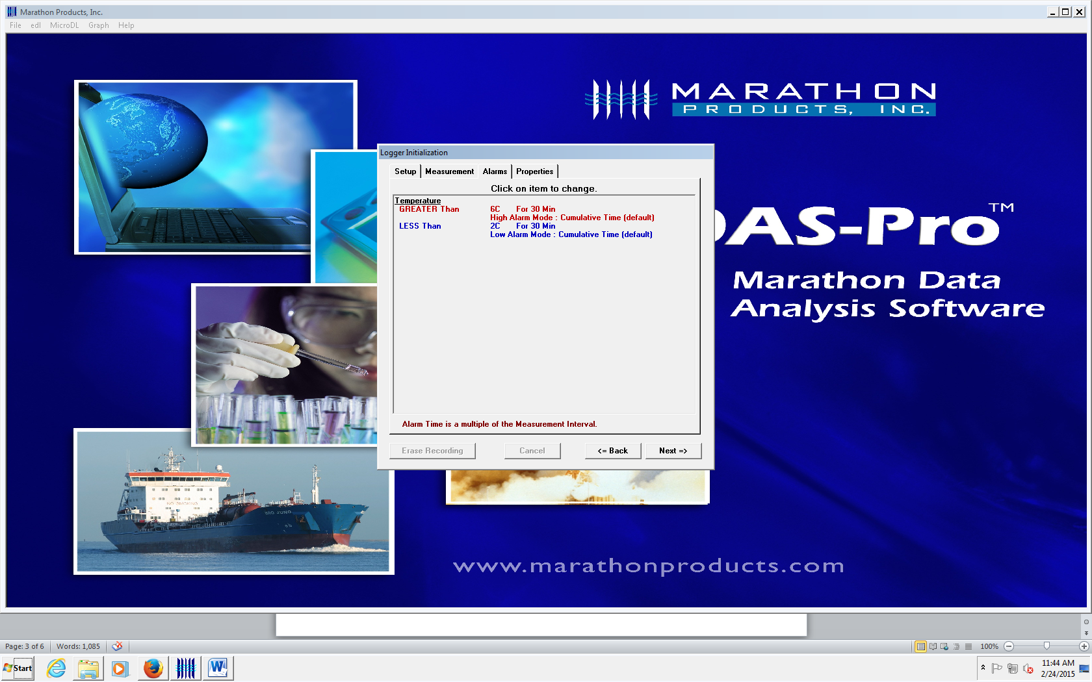  TSL will routinely use settings of:  - Greater than 6ºC for 30 minutes: High Alarm Mode: Cumulative Time  - Less than 2ºC for 30 minutes: Low Alarm Mode: Cumulative Time  Click NEXT.

Step | Action | Related Documents
Logger Initialization (continued)
5 | Properties Tab:  - STOP Condition: The Push Start button is enabled as a STOP button.  - Sensor: indicates the source of the measurement source: Internal or Probe (if applicable)  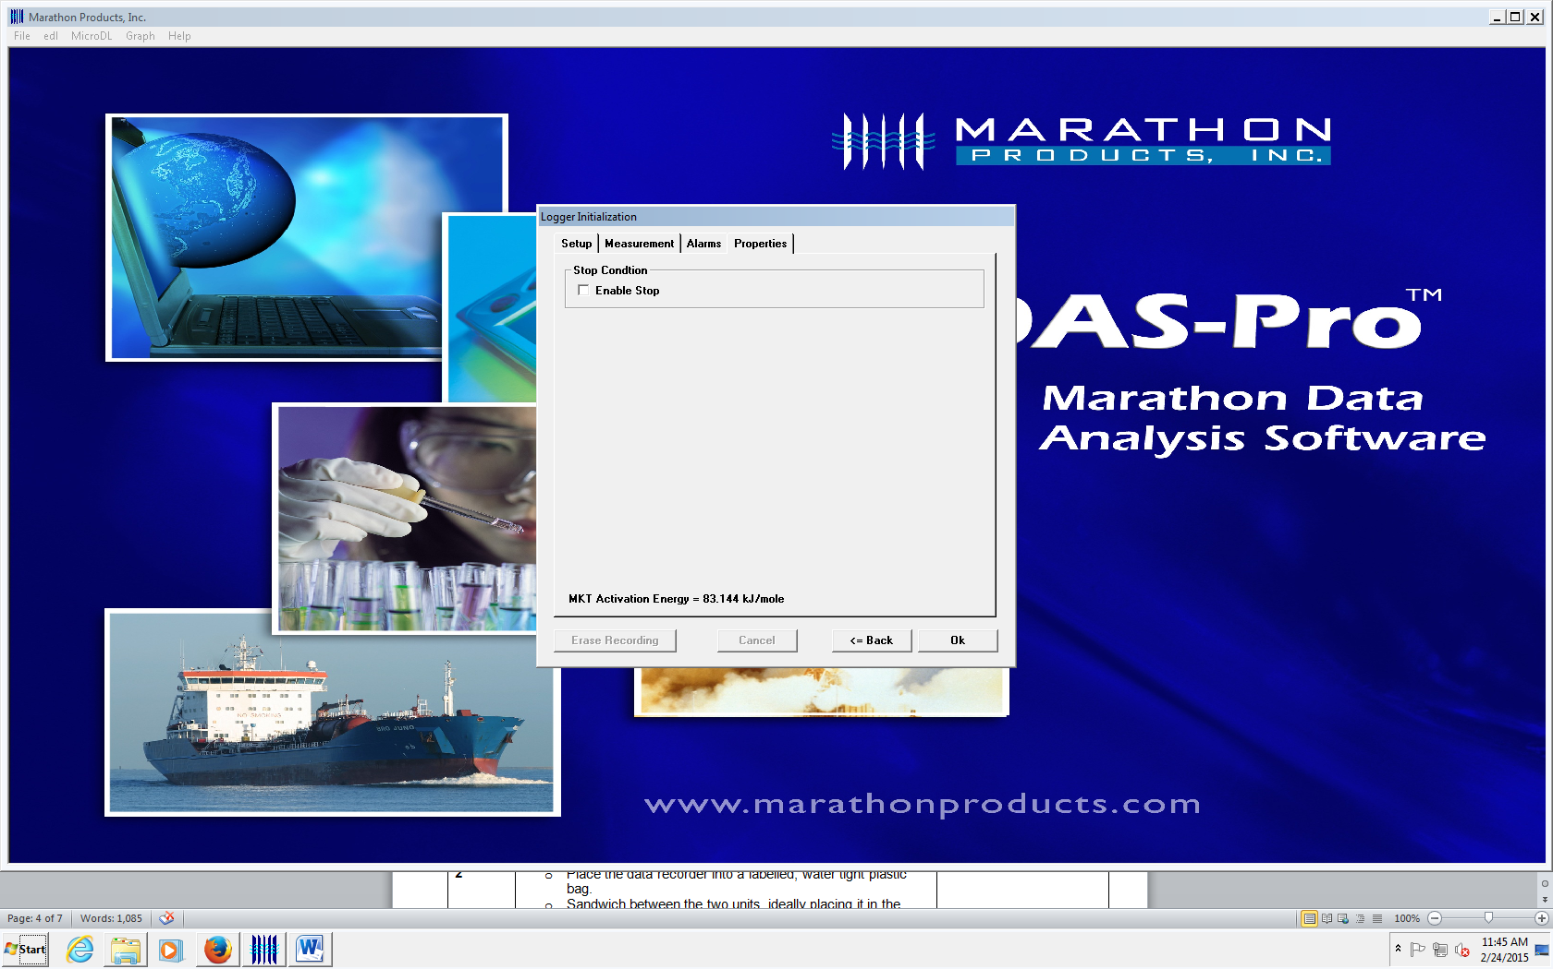  - Do NOT check box.  - STOP recording through software on a computer ONLY. Otherwise, REC can be accidently stopped by pressure on the Micro DL logger START button.
6 | Click OK.  - Popup will display Logger Update.  - FINISHED appears when update is completed.  - Popup window closes.
7 | Detach the Micro DL from the Reader Station.

Recording
1 | - Select a Micro DL.  - Note: Micro DLs in a bag have been downloaded, cleared, and reset. Do NOT use any other Micro DLs without permission of a TS Lead/Manager.
2 | Begin Recording:  - Activate by pressing and holding the button (approximately 7 seconds) until RUN appears on the screen (flashing)  - Release the START button and REC will appear in the upper left hand corner. Temperature will appear.  - Obtain 2nd Tech review of data recorder for REC display on screen.  - Place the data recorder back into the labelled, water tight plastic bag. | Table A: Display Examples
Step | Action |  | Related Documents
3 | Sandwich data recorder between the two units, ideally placing it in the middle of the container.

Data Evaluation
1 | - Receive Credo Cooler in TSL  - Process units per SOP | Using the Credo Series 4 EMT Coolers
2 | - Give the data recorder to an MLS Lead for analysis.  - Note: MLS Lead downloads, reviews, and stores the data as soon as possible. Any unacceptable findings will be investigated immediately.
3 | - Examine Data Logger screen:  - REC should be displayed  - Alarm symbol may be present | Table A: Display Examples
4 | - Log into computer containing access to the Marathon Micro DL Reader Station  - Open Marathon software: MDAS-PRO
5 | - Log Micro DL into Reader Station:  - Turn on the Micro DL display by pressing the Start button  - Note: Display is active for 4 minutes before hibernating.  - Place the Micro DL into the Reader Station by aligning the Start button with the hole in the reader.
6 | - Click YES to Stop Recording  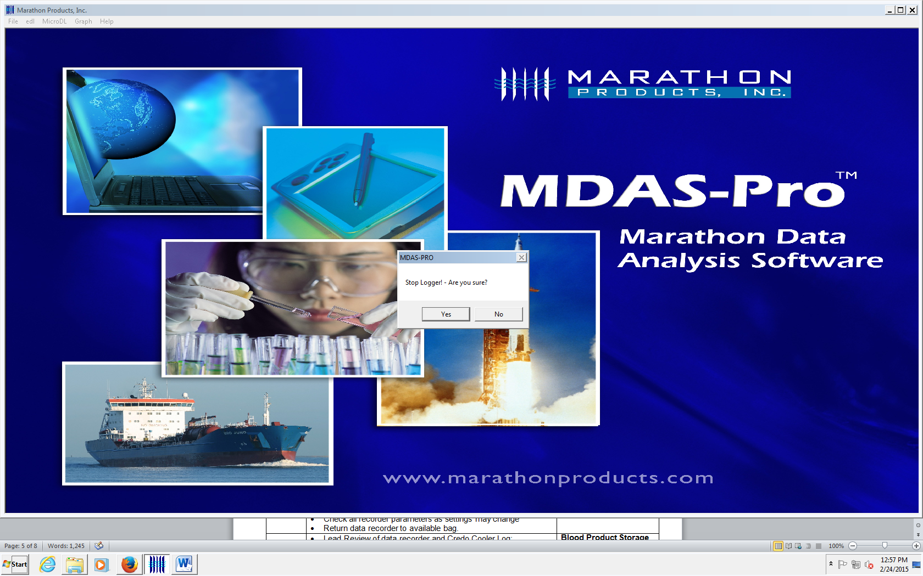
7 | - Open READ LOGGER to save data:  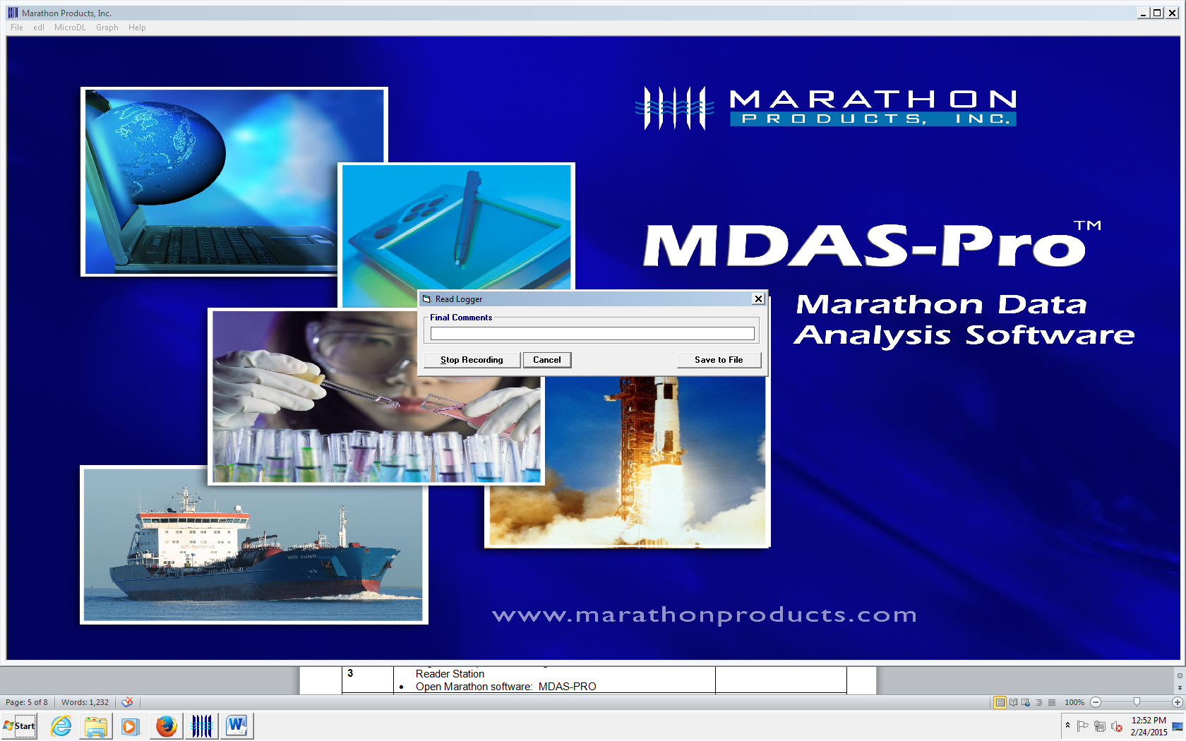  Final Comments: Enter information to identify recording  - Example: Cooler 1 02242015  Click SAVE TO FILE:  - Name file with “________.MP_lgr  - Save to Lilith2 folder.

Step | Action | Related Documents
Data Evaluation
8 | - Review data on graph.  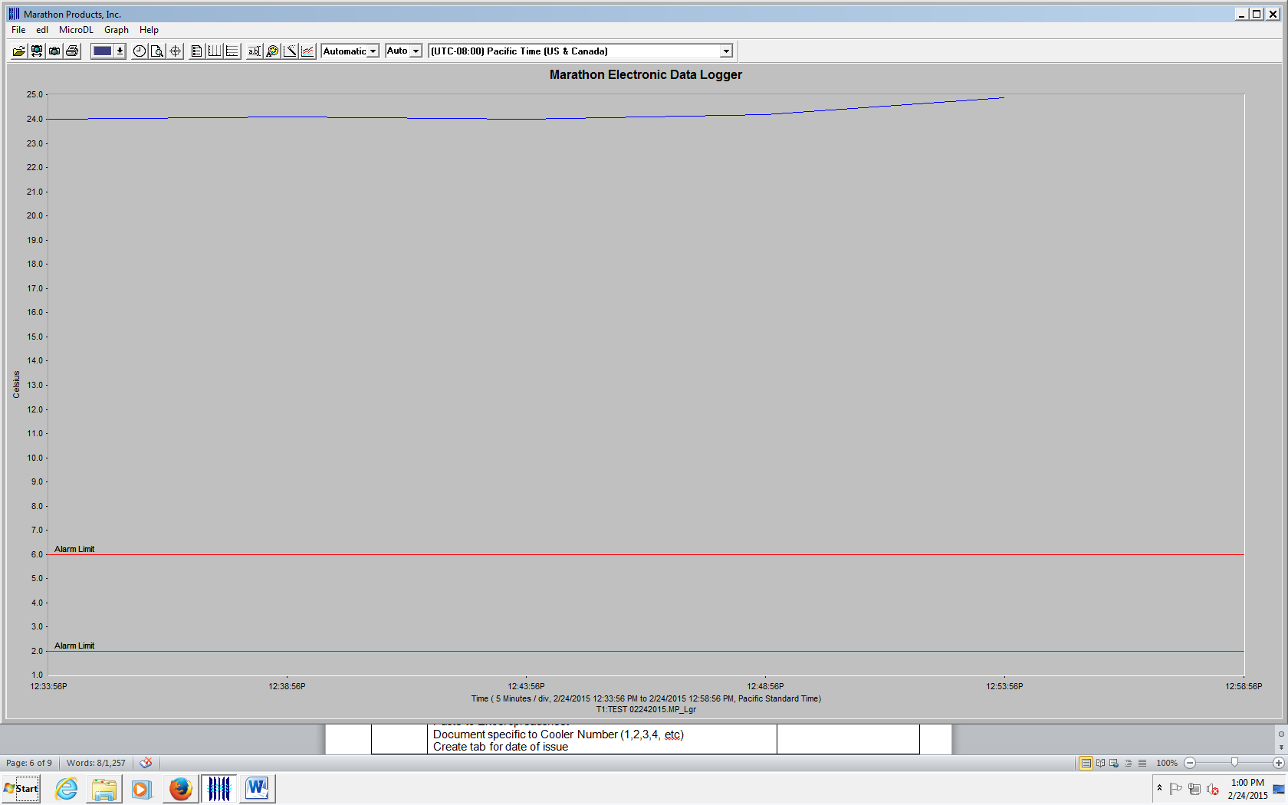  Red Lines identify Alarm settings. Blue line identifies temperature recordings.
9 | - Select GRAPH on Task Bar  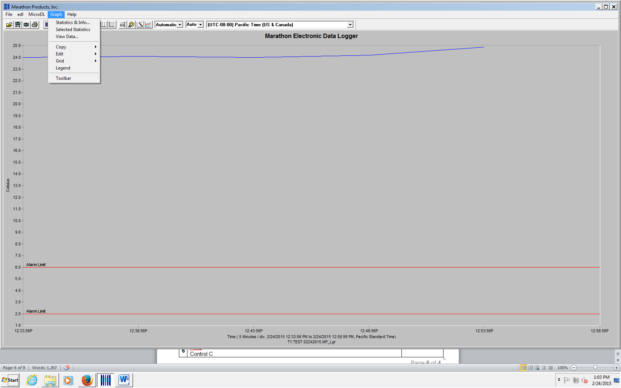  Statistics: allows review of all data. Printable view.  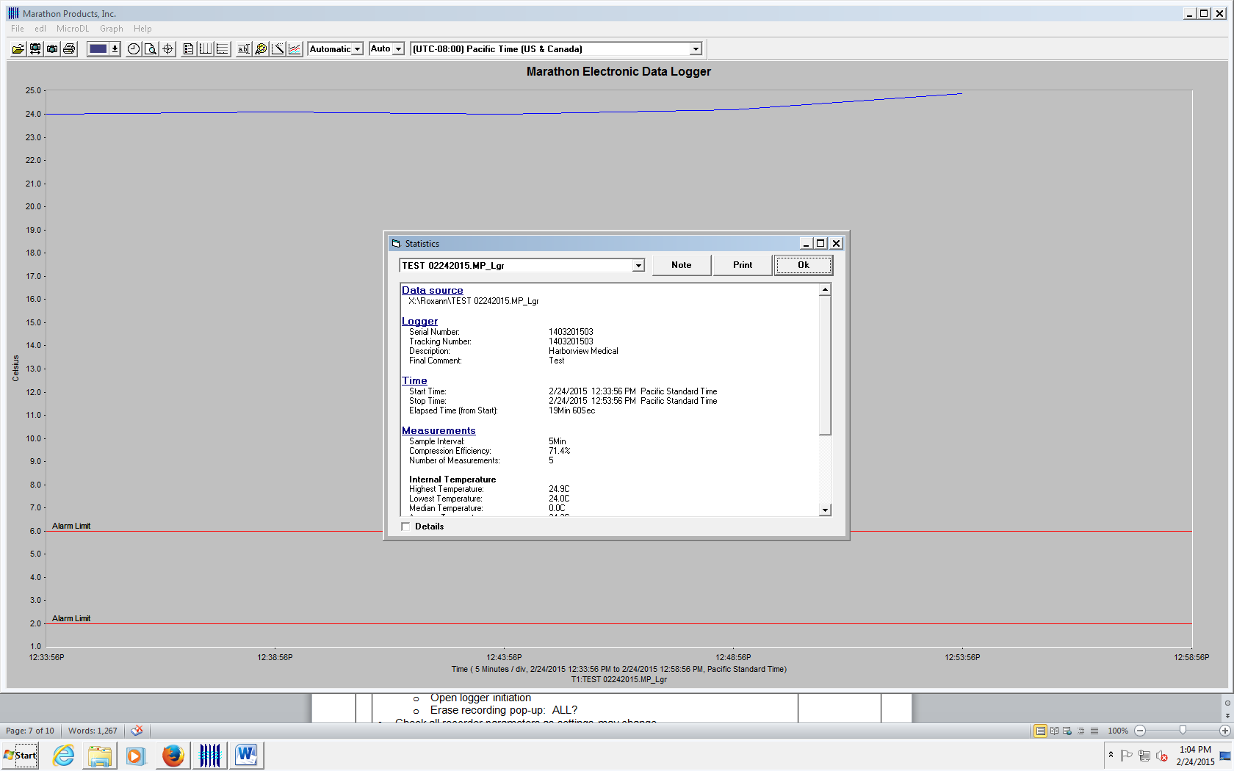  Selected Statistics: allows review of data by time. Display shows average, median, maximum and minimum  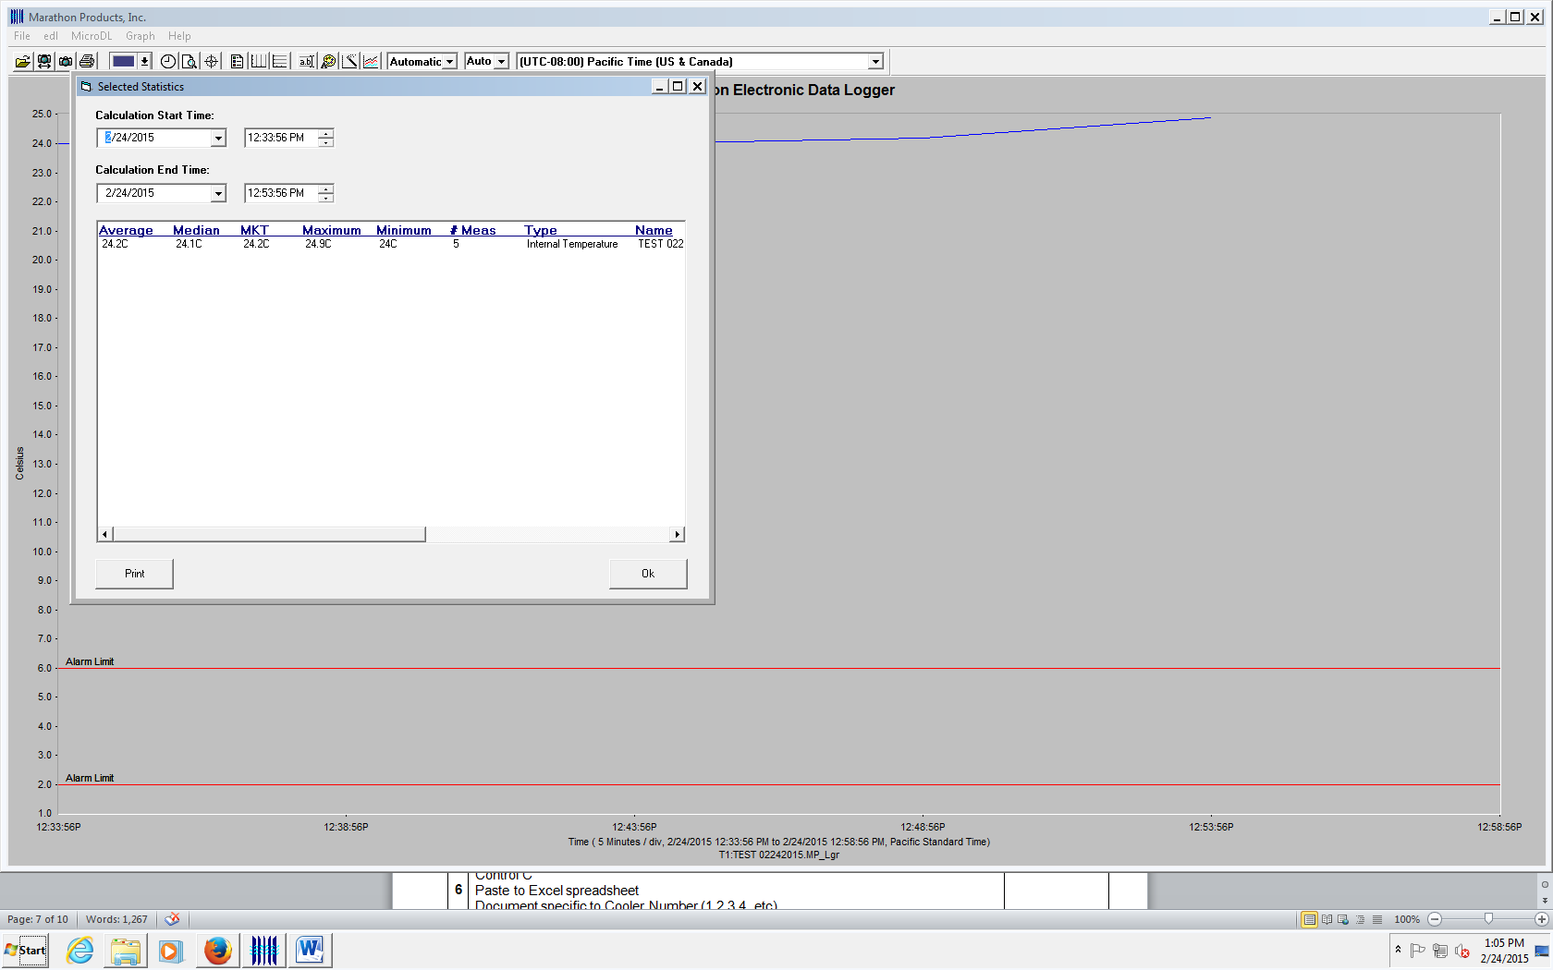  View Data:  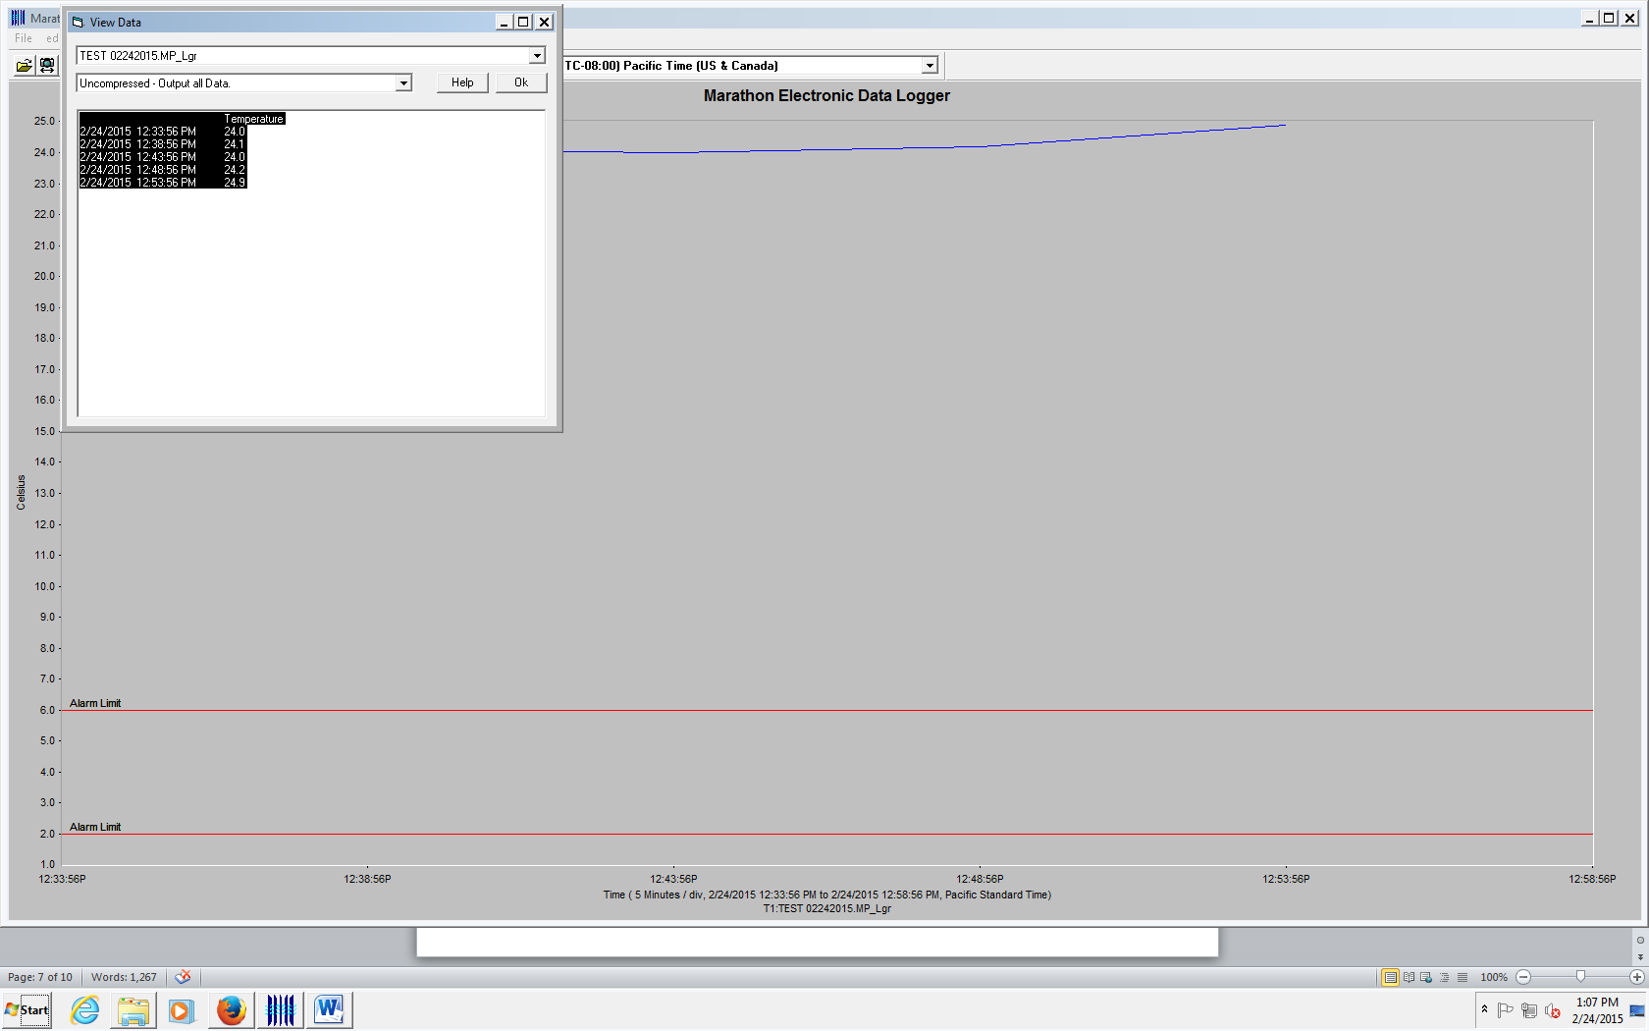  - Hilite data (ctrl A)  - Copy data (ctrl C)  - Paste to Excel spreadsheet on Lilith2 (ctrl V)  - Document specific to Cooler Number (1,2,3,4, etc)  - Create tab for date of issue
Step | Action | Related Documents
Data Evaluation
10 | - Wipe Data from recorder:  - Open Logger Initialization  - Pop-up: Erase ALL measurements in the logger? YES  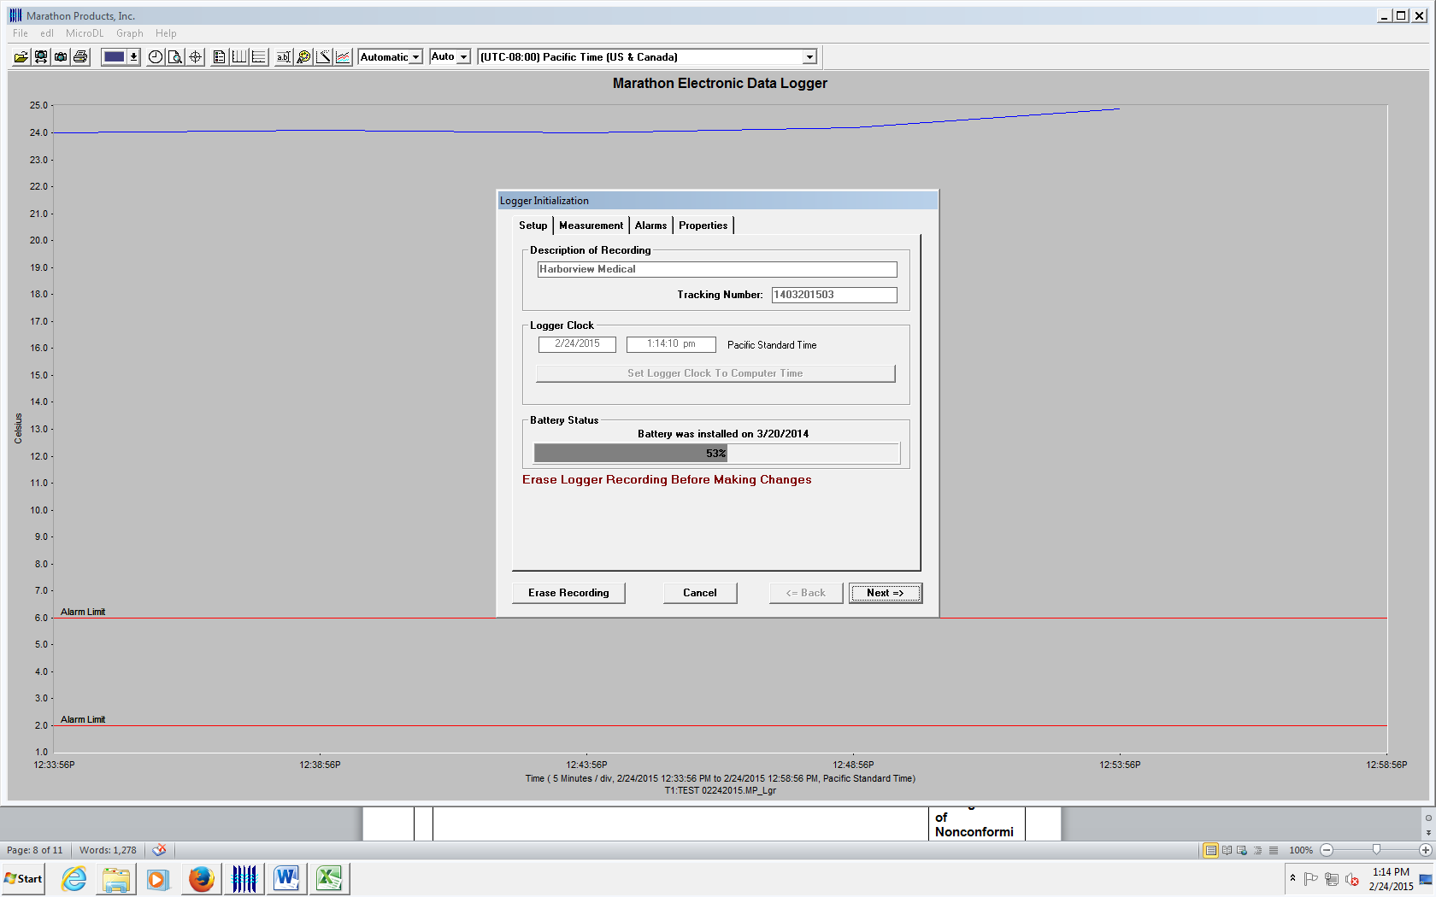  - Data erasure displays on screen  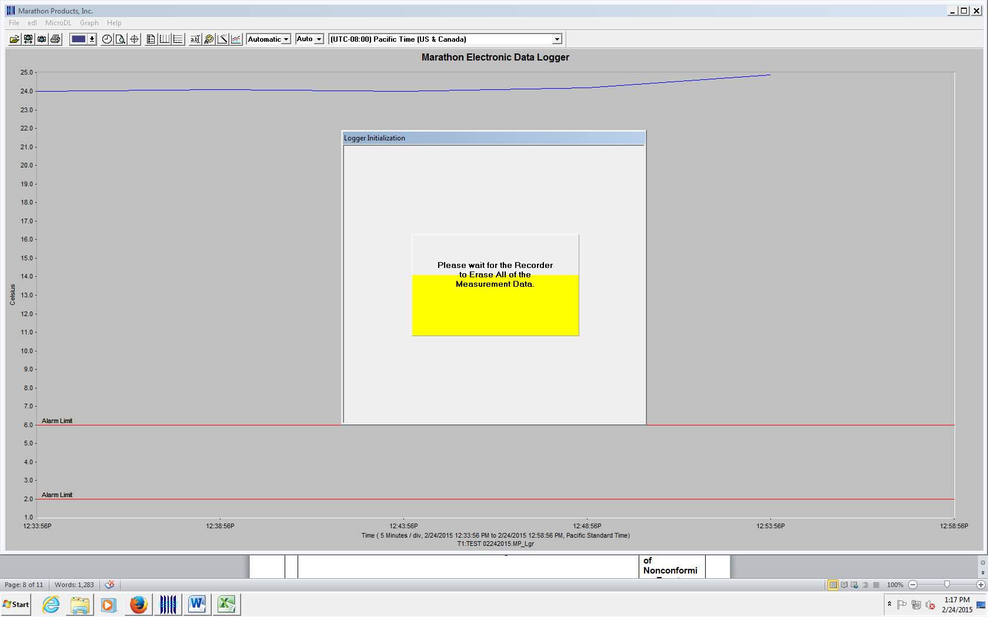  - Continue through Initialization screens to reset logger parameters.  - Check all recorder parameters as settings may change  - Return data recorder to available bag.
11 | - Review of data logger and Credo Cooler Log:  - Review data  - Credo Cooler Log:  - Record Data Downloaded and Reviewed; Tech ID, date/time  - Add additional Comments, if indicated  - Record returned blood product disposition  - Request 2nd data review from a trained staff member  - Record Review on bottom of Credo Cooler Log  - Release acceptable products from Quarantine and store in stock inventory  - Complete QIM for units found to be unacceptable.  - Discard unacceptable units after consultation with TS Manager and/or Medical Director | Blood Product Storage Policy  QP: Management of Nonconforming Events

Step | Action | Related Documents
Other MicroDL Software Options
1 | Review Settings under General Information Tab: Printable for QIM or other records.  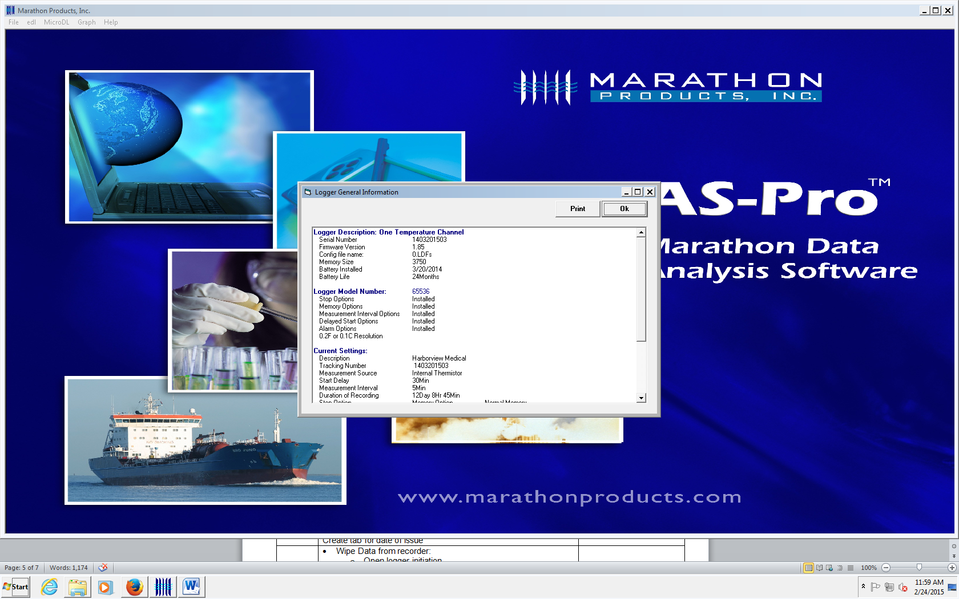
2 | Real Time Display  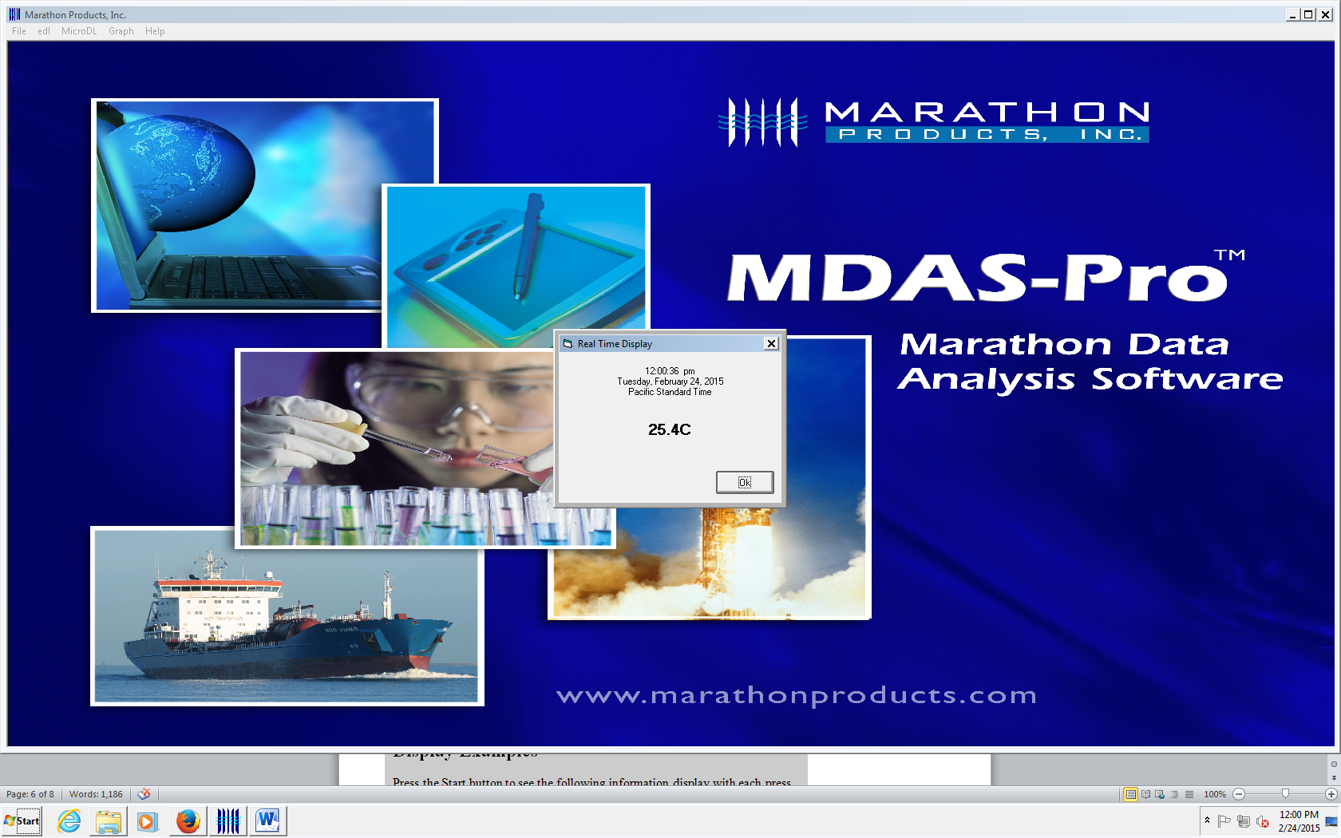

Table A: MicroDL Display Examples

Display Examples
Press the Start button to see the following information display with each press of the start button:
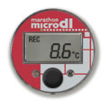 | 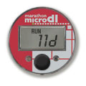 |  | 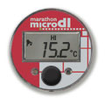
1. REC - 8.6C  shows RECording and current temperature | 2. RUN - 11 D  shows elapsed time in days |  | 4. HI - 15.2C  shows alarm has occurred and high temperature
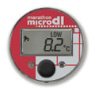 | 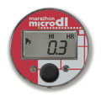 | 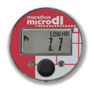 | 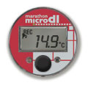
5. LOW - 8.2C  shows alarm has occurred and low temperature | 6. HI HR - 0.3  shows alarm time hours over high threshold | 7. LOW HR - 1.1  shows alarm time hours over low threshold | 8. 14.9C  Push to return to current temperature

References

Marathon Products, INC

Standards for Blood Banks and Transfusion Services, Current Edition, American Association of Blood Banks, Bethesda, MD

