1. Complete the following table:

|  |  |  |
| --- | --- | --- |
| **Component Type** | **Storage Temperature Range** | **Storage location in laboratory** |
| **Red Blood Cells** |  |  |
| **Platelets** |  |  |
| **Thawed Plasma** |  |  |
| **Thawed Cryoprecipitate** |  |  |
| **Granulocytes** |  |  |

1. Which of the following RBC units contains hemolysis? (circle one)

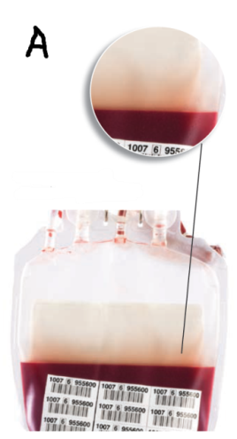 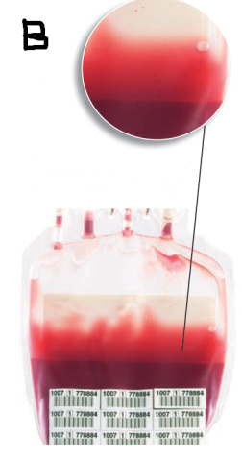

1. Which RBC is acceptable for transfusion?

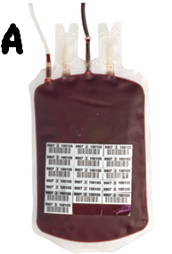 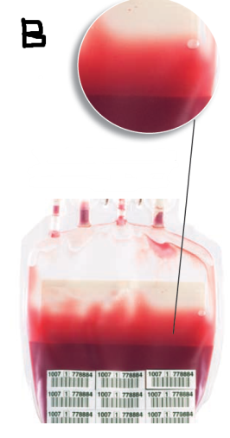 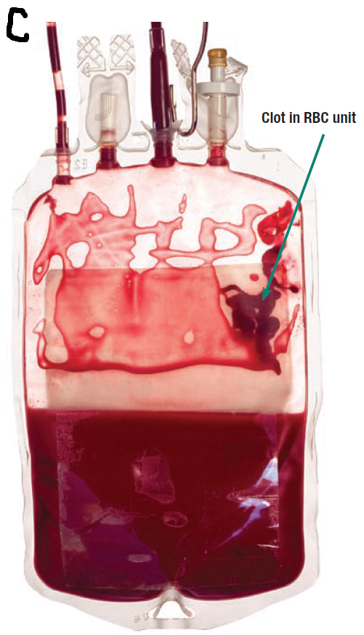

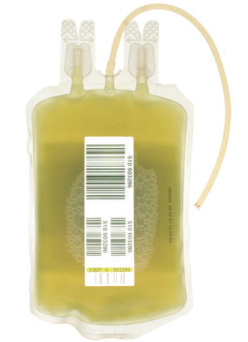

1. Looking at the plasma unit to the right:
   1. What can cause this greenish discoloration?

* 1. Is this plasma unit acceptable for transfusion?

1. Looking at the plasma unit to the right: 
   1. What is the cause of the discoloration?

* 1. Is this plasma unit acceptable fortransfusion?

Tech ID:__________________ Date:_______________

Score:____________________