**Blood Product Entry**

1. Number the sections on the ISBT label in the order they need to be scanned into Sunquest. (5 points)

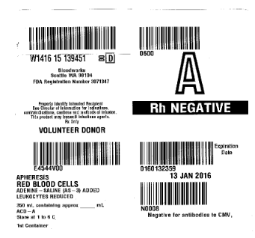

1

2

3

4

5

1. If the facility ID (the facility where the blood was drawn) is not recognized, what do you put in the Facility name spot? (3 points) OTHER
2. Why is it important to write down the Worklist number on the packing list after all units are received? (2 points) Useful for BPT both visual and type confirmation entry
3. FFP has a broken port. What **do** you do with the unit? What **don’t** you do with the unit? (4 points) Do NOT enter into SQ; quarantine; submit Component Complaint Form; follow BWNW instructions for disposition.
4. Describe the purpose of the:
   1. **Bagged** Segment (2 points) retention sample for any necessary additional testing once the unit is unavailable
   2. **Glass Tube** segment (2 points) type confirmation of RBC label type by MLS

**Blood Product Testing**

1. In BPT, which MODE do you use to result VIS inspection? (2 points) WORKLIST
2. What is the “hot key” for acceptable visual inspection? V (2 points)
3. What test is required on Red Blood Cells that is NOT required on plasma components? (2 points) Type confirmation

Score:____________________ (24/24 = 100%)