*Color document is available in MTS (medtraining.org).*

1. Complete the following table: 10 points

|  |  |  |
| --- | --- | --- |
| **Component Type** | **Storage Temperature Range** | **Storage location in laboratory** |
| **Red Blood Cells** | **1-6oC** | **refrigerator** |
| **Platelets** | **20-24 oC** | **Platelet chamber with agitation** |
| **Thawed Plasma** | **1-6oC** | **refrigerator** |
| **Thawed Cryoprecipitate** | **20-24 oC** | **Platelet chamber without agitation** |
| **Granulocytes** | **20-24 oC** | **Platelet chamber without agitation** |

1. Which of the following RBC units contains hemolysis? (circle one) 2 points

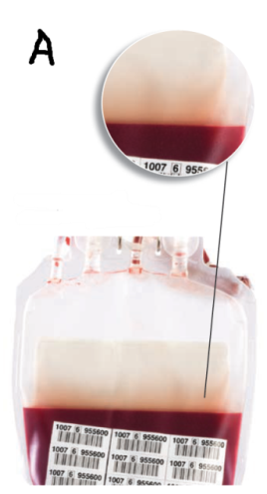 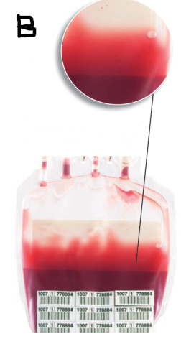

1. Which RBC is acceptable for transfusion? 2 points

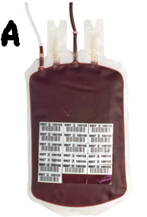 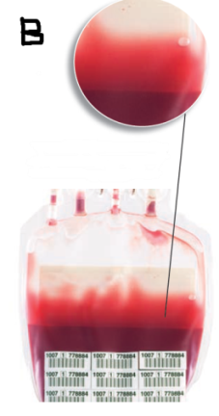 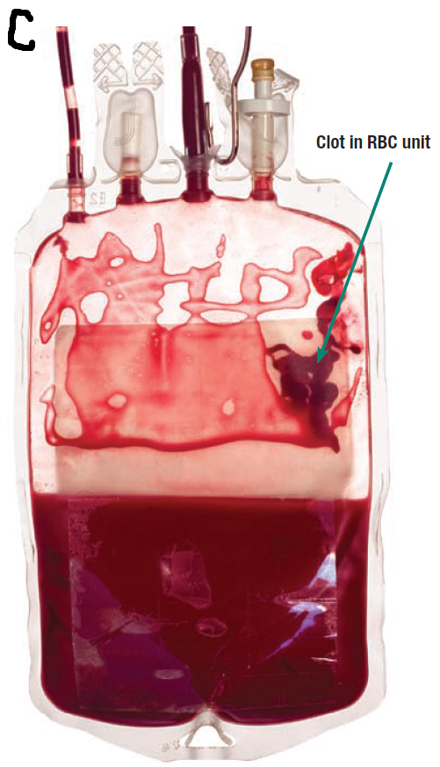

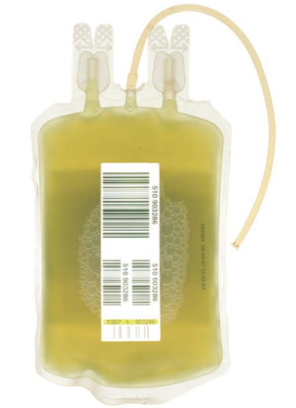

1. Looking at the plasma unit to the right: 2 points
   1. What can cause this greenish discoloration?

*Birth control pills or bilirubin*

* 1. Is this plasma unit acceptable for transfusion?

*Yes*

1. Looking at the plasma unit to the right: 2 points 
   1. What is the cause of the discoloration?

*Lipemia*

* 1. Is this plasma unit acceptable fortransfusion?

*Yes*

Also accepted Cloudy/Possible Bacterial Contamination: NO

Score:____________________ 18 out of 18 = 100%