Purpose
To describe the quality control and maintenance procedures that are performed to ensure that blood components requiring monitored storage are maintained within regulatory temperature guidelines and required documentation is available for review.

Policy
- All HMC Transfusion Service refrigerators, freezers, and room temperature storage equipment is monitored 24/7.
- TempTrak records temperatures every 5 minutes.
- When TempTrak is unavailable for periods exceeding 4 hours and the storage unit(s) containing blood components or tissue, the internal temperature must be manually recorded.
- Following TempTrak recovery, cached recorded temperatures are reviewed.
- Blood Storage Refrigerators are required to be 1-6°C. Alarms sound at <1.5 and >5.5°C.
- Reagent Storage Refrigerators are set for 2-8°C. Alarms sound at <2.5 and >7.5°C
- Freezers are required to be -18°C and lower. Alarms sound at <-50 and >-20°C
- Ultra-low freezers are required to be -40° C and lower. Alarms sound at <-90 and >-65°C
- Platelet incubators are required to be 20-24°C. Alarms sound at <20.1 and >23.9°C
- Room temperature is required to be 20-24°C. Alarms sound at <19.4 and > 23.9°C.
- Room humidity should be between 15-65%. Alarm sounds at <8 and >65%
- Administrative access is limited to staff designated and trained on those functions and reports.

Procedure:
Step | Action | Related Documents
Daily Maintenance
1 | Temperature Monitoring  - Review TempTrak for any alerts, including temperature, communication and battery at least once on each shift.  - Resolve any alerts insuring thorough documentation and resolution. | CLT Shift Responsibility Checklist
2 | Log onto TempTrak  - Go to the Clinical Links page and click on TempTrak  - Or with a blue computer go to the Cooper Atkins website by typing in this URL  https://temptrak.uwmedicine.org/TempTrak/Login.aspx  Note: Save to favorites after first use for ease of entry.
3 | Log into the Intelli-ware program.  - Change Organization to HMC if not already showing.  - Login ID is your AMC user name.  - The first time you Login your password is your Sunquest User ID.  - To change your password after logging in:  - Select “Password” from the top bar and follow the on screen prompts

Step | Action | Related Documents
4 | After logging in, click “Sensors” on the left bar and then LAB_Transfusion Services to see all of our equipment and their current sensor readings  - Review all temperatures by scrolling down the page.  - Each device is identified by device name and temperature limitations.  - If it is green the device is within acceptable limits.  - Any device not in green is out of range and will generate an alarm  - Review Alerts by clicking “Reports” on the left bar and then “Current Alarms”
5 | Document in TempTrak that all temperatures were reviewed.  - After reviewing temperatures, click “Group Audit”  - In the Audit Comments Box, type: Daily maintenance performed date/time – all sensors within range. Click “Save”.  - Initial Daily Equipment, Temperature and Inventory Duties Checklist. | CLT Shift Responsibility Checklist
6 | At least once each day, a report will be generated of TempTrak temperatures and alarm events:  - Select [Reports]  - Select [Sensor Audit Report]  - Select [Sensor Group]  - Select LAB_Transfusion Services  - Input Start Date  - Input End Date  - Click “Run”  - Click the “Export” icon, which is denoted by a blue disk icon, and select PDF  - Open the generated PDF file and print  - Reviewed by TSL staff  - Filed in TempTrak Daily Report binder
Monthly Maintenance: Performed by system administrator
1 | Perform comparison of TempTrak temperature to internal thermometers and digital reading for each unit.  Note: Humidity and Room Temperature are not included in monthly maintenance. | Monthly Temperature Validation Log for Blood Storage Devices
2 | Review Equipment QA Report  - Go to TempTrak Main Page  - Select [Reports]  - Select [Equipment QA Report]  - Select Period  - Uncheck “Sensors Not in A Group”  Must review monthly report to ensure equipment maintains temperature readings within 99 percent or above. If not within the 99 percent there may be mechanical error. Notify Facilities Engineering and submit a work order. | Removing Equipment from Service

Step | Action | Related Documents
3 | Perform Audit  - Go to TempTrak Main Page  - Select [Reports]  - Select [Sensor Audit Report]  - Using the drop down menu at “Select Sensor Group”, choose Lab_Transfusion Services  - Select the “Start Date”  - Select “Ending Date”.  - Review the report to document that temperatures were reviewed daily. | Daily Equipment, Temperature, and Inventory Duties Checklist
Quarterly Maintenance
1 | Perform Alarm Activation check. | Quarterly Alarm Activation Record  Maintenance and Troubleshooting of Storage Devices
Alarms
1 | There are three alert types in TempTrak: Sensor Alarm, Battery Alarm, and Communication Alarm. Anytime an alarm is generated by one of the three alert types a red blinking alert indicator appears at the top of the screen.  - Sensor Alarm: a condition failure such as a temperature being out of range or the ED fridge door being opened.  - Battery alarm: the battery in a transmitter is low on energy and needs to be replaced  - Communication alarm: TempTrak has not received scheduled data from a sensor.  Each alarm indicator displays the alarm type and how many alarms have triggered. Clicking on one of the alarm indicators will take you to the associated alarm’s page.
2 | If there is a temperature failure.  - Log into TempTrak, you will see which sensor is failing by the color code. Blue=Low, Red=High, Green=Normal.  - Click on the Alarm icon and all the alert information will appear.  - Click in the “Acknowledge Clear/Alerts” link  - You will see a set of standard comments on the left and a space to free text any action in the “Corrective Action/Notes” box.  - Click on the arrow to move the comment into the notes area or free text the action taken i.e.: If Portable #3 alarms because of an open door and temperature was high, in “Comments Action/Notes” type: Door open/closed door. Add digital and thermometer temperatures.  - Click on the “Clear” box to clear and reset the alarm or click “Acknowledge” to add a note regarding the event but not to reset the alarm  NOTE: If you do NOT clear the alert the pager will not sound with repeated temperature failures.  If the room temp or humidity fails, contact engineering for thermostat adjustments. | Maintenance and Troubleshooting of Platelet Incubator
Step | Action | Related Documents
Alarms (continued)
3 | When the temperature alert has been addressed, any notes can be viewed by clicking on the “View Notes” link which will display the alert information and any notes associated with the temperature alert.
4 | Address any missed communication alerts.  - Click on antenna icon and identify the communications errors.  i.e.: Monthly generator testing will trigger a missed communication.  - Call TempTrak at 1-888-533-6900 to see how long they will be down and if greater than four hours proceed to downtime procedure. | Downtime Refrigerator and Freezer QC
5 | Low battery Alert  - Triggered when a transmitter detects a battery is becoming low (approximately three weeks before it will fail).  - Pry open case with screwdriver or flat edge.  - Replace with 2/3A lithium battery, 3V and document on Daily Equipment, Temperature, and Inventory Duties Checklist.  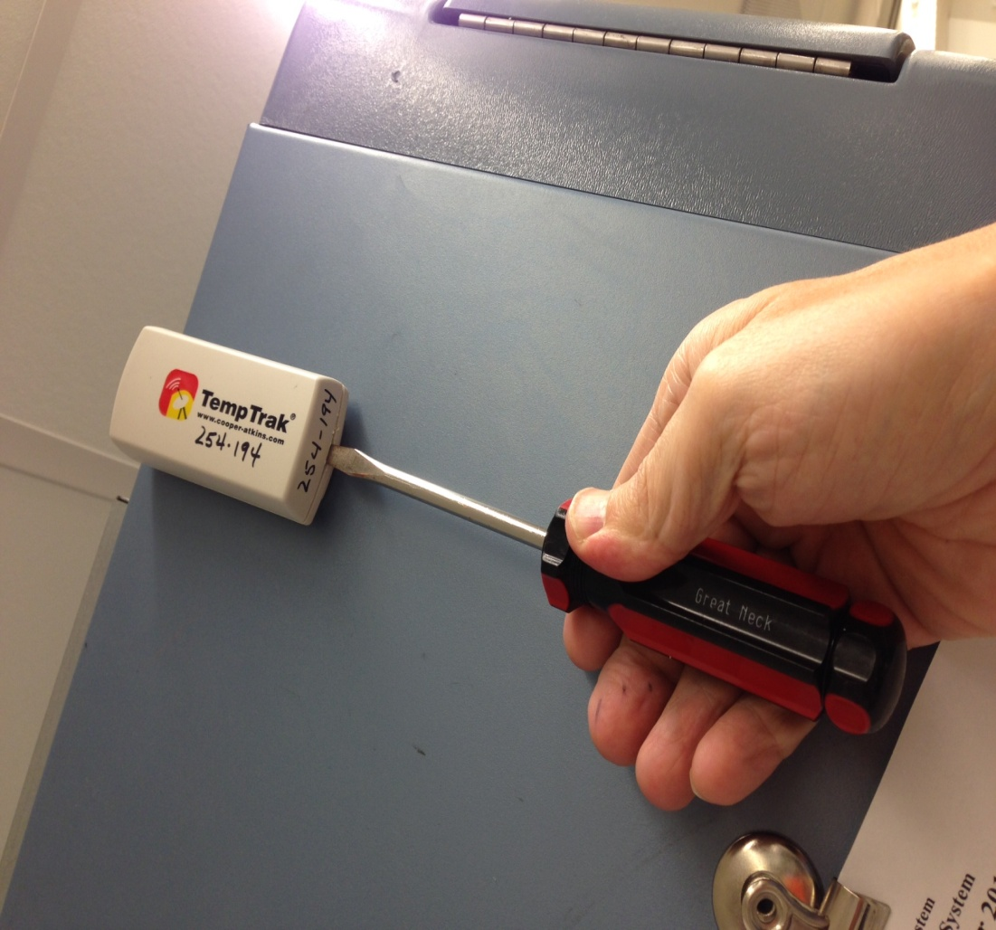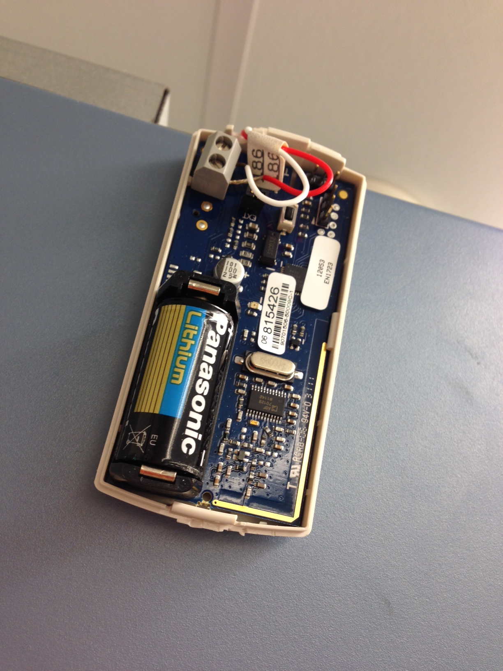 | Daily Equipment, Temperature, and Inventory Duties Checklist

Step | Action | Related Documents
Out of Service
TempTrak | If TempTrak system is not available, is not responding, or temperature differences indicate the TempTrak is incorrect:  - Continue storage unit monitoring per downtime procedures.  - Contact TempTrak at 1-888-533-6900  - Complete QIM  Once TempTrak is available and functioning:  - Return to TempTrak monitoring  - Review all recovered data.  - Document in TempTrak and on QIM | Quality Improvement Monitoring Tool
Equipment | If monitored equipment is removed from service:  - Complete Out of Service form.  - In TempTrak:  - Do NOT clear alarm  - Add Note explaining the decision and disposition of product  Note: Disabling alarms is discouraged due to loss of data. Disabling alarms will be limited to the permanent removal of equipment and/or permission of the TSL Manager.  Once equipment is returned:  - Complete Return to Service paperwork  - Clear alarm in TempTrak  - Document in TempTrak (Add Note) | Equipment Out of Service form  Removing Equipment from Service

References
- TempTrak Enterprise. Design and Features Overview. Cooper Atkins Cooperation. Revision K
- TempTrak Training Documentation v5.0. Cooper Atkins Cooperation. Revision A, May 2014
- College of American Pathologists Accreditation Checklists.
- Code of Federal Regulations, 21 Parts 200 to 299, parts 600-799
- Circular of Information for the Use of Human Blood and Blood Components
- Standards for Blood Banks and Transfusion Services, Current Edition. American Association of Blood Banks. AABB Press, Bethesda, MD.

