[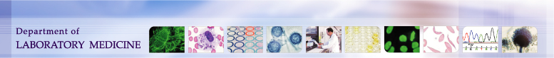](http://depts.washington.edu/labweb/index.h)

|  |  |  |
| --- | --- | --- |
| **University of Washington,**  **Harborview Medical Center**  **325 9th Ave. Seattle, WA, 98104**  **Transfusion Services Laboratory**  **Policies and Procedures Manual** | **Original Effective Date:**  **July 20th, 2016** | **Number:**  **C6000-1** |
| **Revision Effective Date:** | **Pages: 1** |
| **TITLE: Autograft Skin Tissue Tracking, Storage and Release Policy** | | |

**Purpose**

To document how the Harborview Medical Center Transfusion Service complies with regulatory agency requirements for tracking, storage, and releasing of Autograft Skin for re-grafting.

**Policy Statements**

* **HMC Transfusion Services maintains a standardized process for receiving, maintaining, and releasing Autograft Skin for re-grafting which provides the following:**
* Traceability of all Autograft skin tissue from procurement to final disposition.
* Monitored storage at required temperatures. Skin can be refrigerated and stored between 0-10C
* Compliance with American Association of Tissue Banks (AATB) standards.
* **HMC Transfusion Services maintains a database of all Autograft skin tissue received.**
* **HMC Transfusion Services discards Autograft Skin tissue under the following circumstances:**
* Tissue exceeds the 3 day storage limit. Day of storage is considered day 0.
* Tissue donor expires
* Damage or loss of integrity of skin tissue package.
* Temperature failure of the storage device such that the skin tissue is out of temperature.
* **HMC Transfusion Services limits autologous tissue accepted under this policy to skin. Autograft skin cannot be rebanked once it has been released.**
* **HMC Operating Room maintains non-autologous skin storage in a separate location.**

**Supporting Documents**

* Autograft Skin Processing- Surgical Services OR Policies

**References**

Standards for Tissue Banking, 13th Edition, American Association for Tissue Banks. AATB, Bethesda, MD.