**INSTRUCTIONS:**

1. Read the following information. If you have any questions concerning this information, or would like additional information or training, please let a lead or manager know.
2. Sign off in MTS to indicate you have read and understood the information below.

**OBJECTIVE:**

* Review utilization of Blood Inventory Search in Sunquest for determining available products for allocation
* Identify selection decisions to reduce wastage of thawed plasma

**Thawed Plasma**

* 5 day expiration
* 4 AB plasma in EMR inventory locations
* At this time there are no established “stock” thawed plasma inventory levels in TSL
* Thawed Plasma located in NN601 and BB2

**Selection to Fill Thawed Plasma Orders**

***Depends on the situation…***

|  |  |  |
| --- | --- | --- |
| **Situation** | **Inventory Location** | **Action** |
| **MTP**  **OB Hemorrhage** | * **EMR Inventory** * **Thawed Plasma, if available** | * **All Hands on Deck!** * **Replace issued product STAT** |
| **O.R.** | **Stock** | **Look in BIS\*\***   * **BB2** * **6th**   **Allocated Short Dates?**   * **Release for BPR orders**   **Nothing or Not Enough?**   * **Thaw frozen plasma** |
| **Blood Product Release** |
| **Routine Blood Order** | **SQ** | * **Perform history check** * **Confirm TFFP ready to fill when requested** * **Do NOT pre-allocate except for plasma exchange** |

***\*\*Use Blood Inventory Search to find other available thawed plasma to be utilized BEFORE thawing more plasma***

**Snapshot of BIS – BB2 SPECIFIC**

6th floor should not be thawing any plasma until these units are allocated and/or issued.

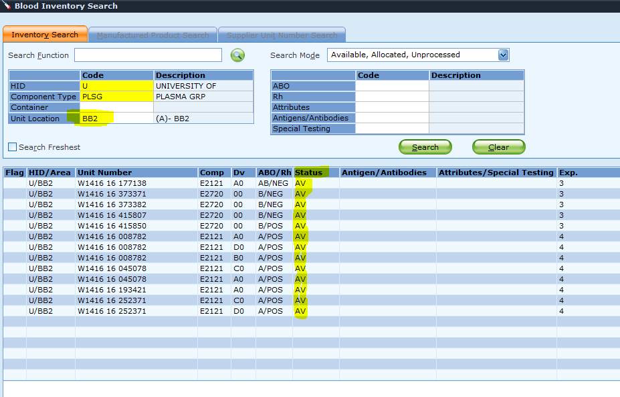

**Snapshot of BIS – ALL LOCATIONS**

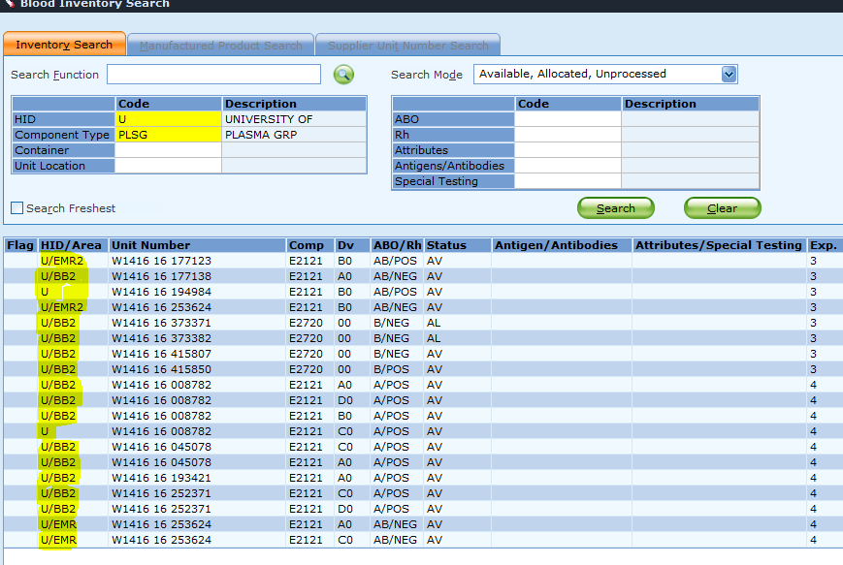

**Summary**

* **Blood Inventory Search** in SQ is accessible on the **Main Menu** (inventory review) and **through BOP** (selection and allocation)
* **Blood Inventory Search** through BOP is routinely used for remote allocation at BB2 and SCCA
* **Blood Inventory Search (Main Menu)** provides up to date information about short dates and availability before additional processing (thawing, irradiation) is performed
* Short dates are utilized 1st with compatible substitutions encouraged
* **BB2 inventory is available before thawing frozen plasma**
* **Release shorter date plasma from allocation** to fill a BPR order and replace product later
* **Inventory is reviewed every shift** and adjusted as needed to maximize use of thawed plasma and short date RBCs

**Scenarios for MTS**

1. Liver transplant order is received for 8pm cut time. Patient is APOS. 6 thawed plasma are requested. Which of the following is your choice for filling this order?
   1. Allocate from existing BB2 inventory expiring at midnight.
   2. Thaw plasma or select plasma with 1-5 days expiration remaining
   3. Neither option is appropriate
2. Two AB plasma expire today. An **emergency order** for 2 plasma comes in and you allocate these two AB plasma. Neither unit has been issued 3 hours later but a plasma BPR comes in for a different patient. Which of the following is your choice for filling the BPR order?
   1. Release AB plasma from the first patient and send on the BPR. Don’t replace the plasma for patient 1.
   2. Release AB plasma from the first patient and send on the BPR. Determine if there is a transfuse plasma order for the emergency order (1st patient) before re-allocation.
   3. Thaw new plasma for the BPR order. Notify the floor of the 20 minute delay.
3. BB2 tech confirms 2 refrigerators are out on 5SA with a total of 8 thawed plasma. Patients left surgery at least 4 hours ago. Which of the following inventory management options might you use to reduce wastage?
   1. No action is necessary.
   2. Contact clinical care and ask if plasma can be returned, even if it is only part of the issued plasma.
   3. Return all plasma to TSL. Tell clinical staff they can order plasma individually as needed.
4. Plasma Orders – Allocated or Unallocated – are good for:
   1. 48 hours
   2. Length of admission – check ORCA
   3. 24 hours
   4. Indefinitely
5. Allocators on each shift are responsible for which of the following?
   1. Thawing plasma based on the CPOE order rather than having a BPR in hand or O.R. asking for a refrigerator.
   2. Releasing allocated plasma after 24 hours or when refrigerators are returned/patient stabilized
   3. Releasing and reallocating shorter dates to a BPR in order to reduce wastage
   4. Two choices are correct
   5. Three choices are correct