
Tango infinity® Training Quiz #2

Erytype® S

1. For ABD Rev typing, patient red cells are diluted with

A. bromelin
B. patient serum
C. alsevers + MLB2
D. saline

2. For DAT testing, patient cells are diluted with

A. bromelin
B. patient serum
C. alsevers + MLB2
D. saline

3. Bromelin

A. minimizes false positives
B. serves as a preservative
C. enhances reactivity
D. has an on board shelf life of 7 days

4. Incubation time for ABD Rev A1&B plates is

A. 5 minutes
B. 10 minutes
C. 15 minutes
D. 20 minutes

5. Erytype® S ABD+ Rev. A₁,B wells are coated with

A. dried monoclonal antisera
B. liquid antisera
C. protein A
D. red cell stroma

Tango infinity® Training Quiz #2, Page 2

Solidscreen® II

6. Protein A has a high affinity for the Fc portion of

A. anti-IgE
B. anti-IgA
C. anti-IgG
D. reagent red blood cells

7. MLB2 is Bio-Rad’s version of

A. reagent screening cells
B. solidscreen plates
C. anti-human globulin
D. LISS

8. Answer the following questions about the schematic Solidscreen® II reaction:

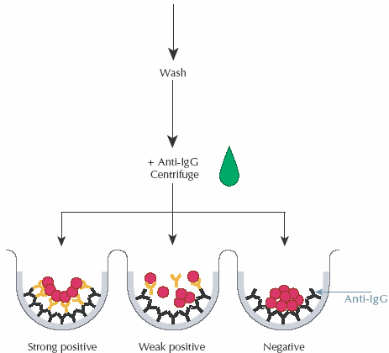
What does the black Y represent?

A. patient red blood cells
B. patient antibody
C. anti-IgG
D. protein A

9. Which of the following assays does not use Solidscreen® II strips?

- AB confirmation
- DAT
- Crossmatch
- Antibody ID

Tango infinity® Training Quiz #2, Page 3

Overview

10. Please label the following picture:

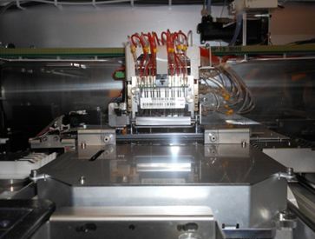

11. All of the following except this takes place in the centrifuge

A. washing
B. centrifugation
C. addition of anti-IgG
D. addition of MLB2

12. The plate stacker can hold up to _____ plates

A. 5
B. 8
C. 10
D. 12

13. A solid yellow light at the front panel of the sample station over a rack indicates:

A. testing complete - OK to remove patient rack
B. empty track – OK to add rack
C. actively being sampled or will be sampled samples – do not remove rack
D. rack loaded with no orders

14. Sample is added at the

A. centrifuge
B. orbital shaker
C. linear shaker
D. incubator

Tango infinity® Training Quiz #2, Page 4

Test Run / QC

15. Cell mixers ensure a

A. homogeneous suspension of reagent red cells
B. homogeneous suspension of patient red cells
C. thorough mixing of patient plasma and cells in Erytype® S strip
D. thorough mixing of wells post centrifugation

16. After hitting the start button the status screen will notify you of

A. the time for completion of testing
B. insufficient resources needed to complete your run
C. result flags present
D. who is logged on to operating system

17. Buttons available from the daily journal screen include these except:

A. validate
B. export
C. import
D. delete

18. The icon in the daily journal indicates a

A. completed specimen
B. active specimen
C. missing sample
D. flagged sample

19. Which of the following combination of specimens are acceptable QC
controls for Erytype® S ABD+Rev. A_{1,}B testing?

A. A neg and B pos
B. O pos and O neg
C. AB neg and O pos
D. AB pos and AB Neg

20. QC must be run in the following scenarios except:

A. after daily maintenance
B. post service
C. once every 24 hours
D. upon opening a new lot of reagent bottle

Tango infinity® Training Quiz #2, Page 5

Extra credit

21. When running Solidscreen® II control with a 3 cell screen target value is:

- P1
- P1P2
- P1P2P3
- P2P3

Name: _____________________________

