
Tango infinity® Training Quiz #3

1. Pictures of reactions are taken in the

A. measurement chamber
B. orbital shaker
C. while centrifuging
D. optical filter

2. An Erytype® S ABD+Rev. A1,B plate strip includes

A. anti-A B. anti-A C. anti-A1 D. anti-A anti-A2 anti-B anti-B anti-B
anti-B anti-A,B anti-A,B anti-D
2 clones of anti-D 2 clones of anti-D 2 clones of anti-D neg control
neg control neg control neg control A1 cell
2 empty wells 2 empty wells 2 empty wells B cell 2 empty wells

3. This Erytype® S reaction well represents what reaction?

A. Negative
B. ±
C. 1+
D. 4+

4. What type is this? ________________________

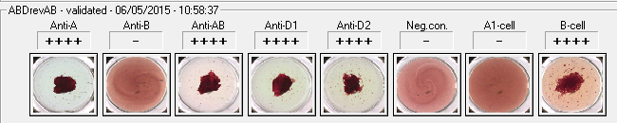

TANGO infinity Training Quiz #3, Page 2

5. This Solidscreen® II reaction well represents what reaction?

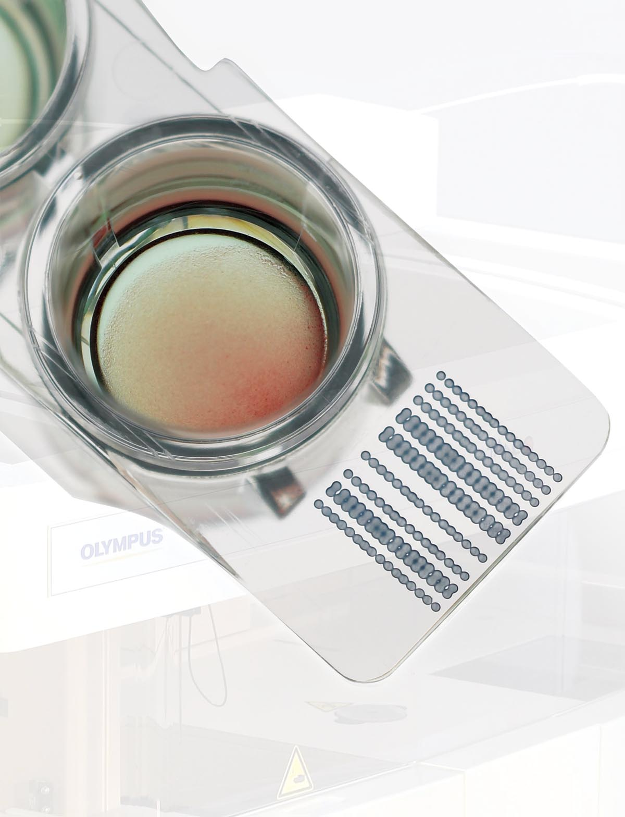
A. Negative
B. ±
C. 1+
D. 4+

6. If you are using the duo screening cells, how many samples could you run on one
Solidscreen® II plate?

A. 12
B. 24
C. 48
D. 96

7. An example of an unexpected reaction due to a rare patient condition is

A. bone marrow recipient sample
B. hemolyzed patient sample
C. patient sample 10 days old
D. clotted patient sample

8. If you have no plasma left in your patient sample your Solidscreen® II reaction may
appear like:

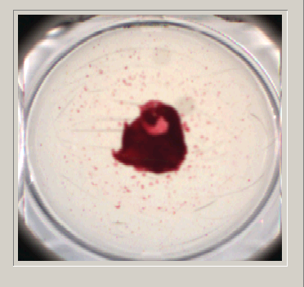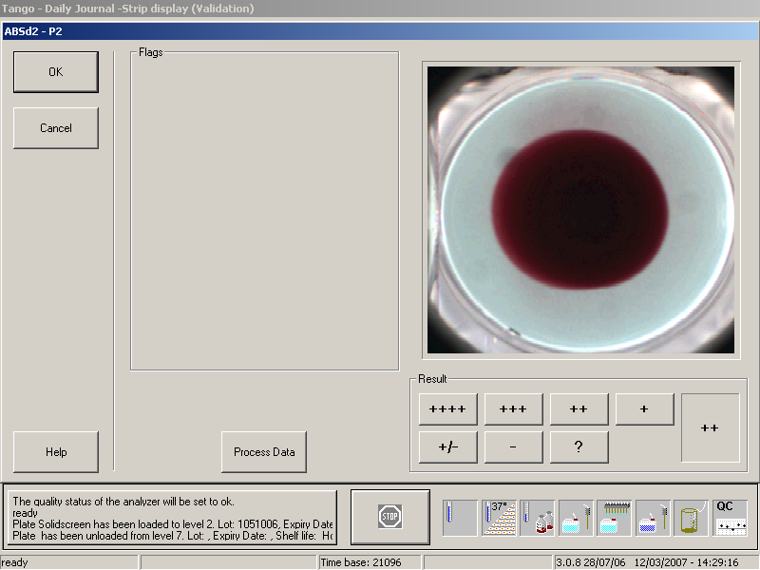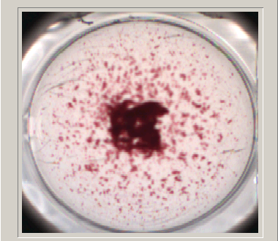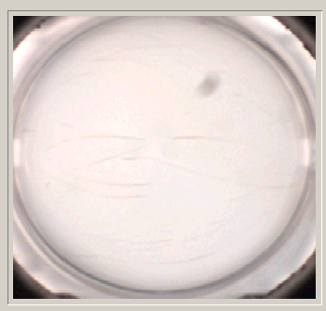
A. B. C. D.

TANGO infinity Training Quiz #3, Page 3
9. Which wells are positive? _________________________________________

Which well would you enlarge for a better view? _______________________

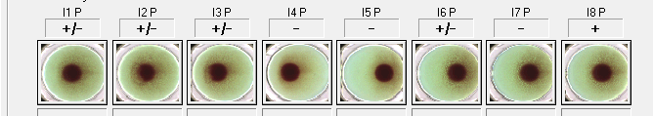

10. Daily care includes:

A. checking the inner lighting
B. checking the suspension cup
C. checking the Lab Journal
D. checking the temperatures

11. Weekly maintenance includes:

A. cleaning the system liquid container
B. replacing the optical filter
C. cleaning the suspension cup
D. cleaning the pipettor rinse station

12. Monthly maintenance includes:

A. changing the suspension cup
B. changing the SPOLV pipettor
C. changing the wash manifold tubing
D. changing the SPLOV pipettor coordinates

Name: _____________________________

