Purpose

To provide instructions for accessing patient history files using an encrypted USB drive when the Sunquest system is not operational. (SQ Downtime)

Method

Step | Action
Select the USB drive used for Daily Patient History Back-up
1 | Remove the flash drive from the Downtime Folder.
2 | Drives are labeled ODD and EVEN. Select the flash drive that has the most current capture:  - If the capture has not been done yet, select the drive for the previous day.  - If the capture has been done, select the drive for the current day.  Example: Downtime starts at 0200 on the 15th. Capture is scheduled for dayshift. Select the EVEN drive to access the capture of the 14th.
Prepare USB drive:
3 | Insert the encrypted flash drive into the USB port.  A Microsoft Pop-up scan/fix may appear, choose “continue without scanning”
4 | A password prompt will appear. Enter password bl00db@nk (the O’s have replaced with zeros and the A is an “at” sign). The flash drive’s assigned letter will appear in the title, denoted here with a black circle.  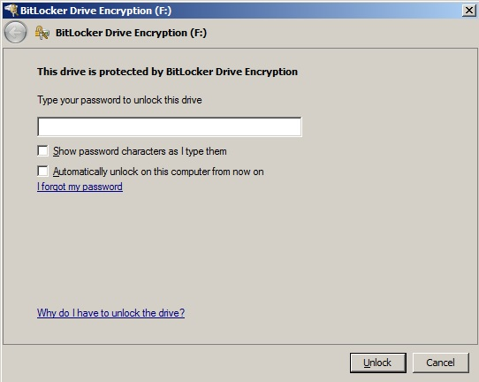
Step | Action
Access Captured Files
5 | Open the flash drive’s assigned drive.
6 | Open folder “Transfusion Services Backup A or B”. Available files:  - BBR02: Product File List  - BBR06: Patient BAD file information  - BBR15: Patient Blood Type and Antibody Screen results  - BBR22: Test Result Review  BBR22 will tell you if the patient had a testing performed in the last three days. Patients not tested within that window will have results in BBR06 and BBR15 but those reports will not state the last testing date.
7 | Search for Patient by HID  - Select EDIT; FIND  - Enter HID; Click FIND NEXT  Note: HID can be scanned  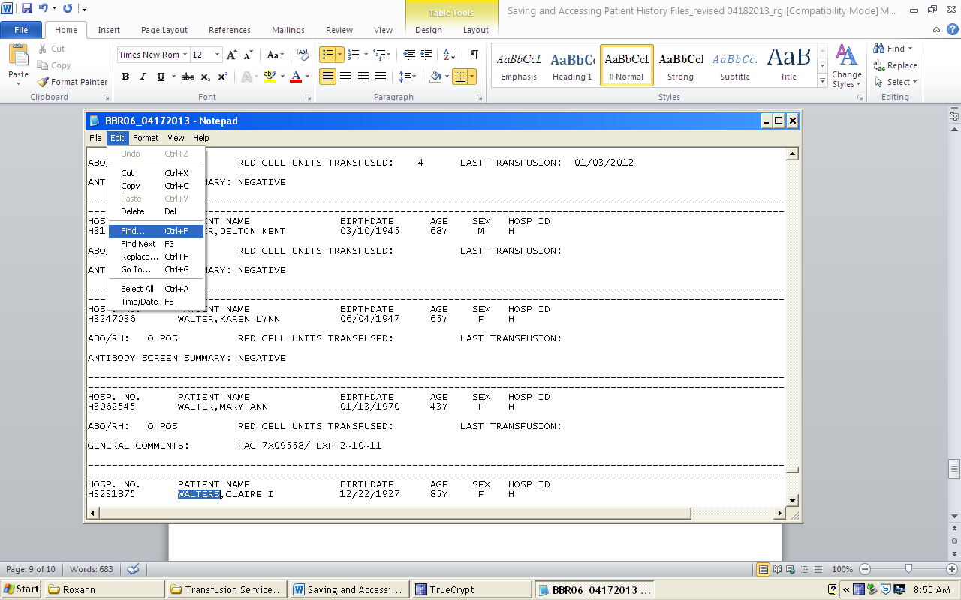
8 | 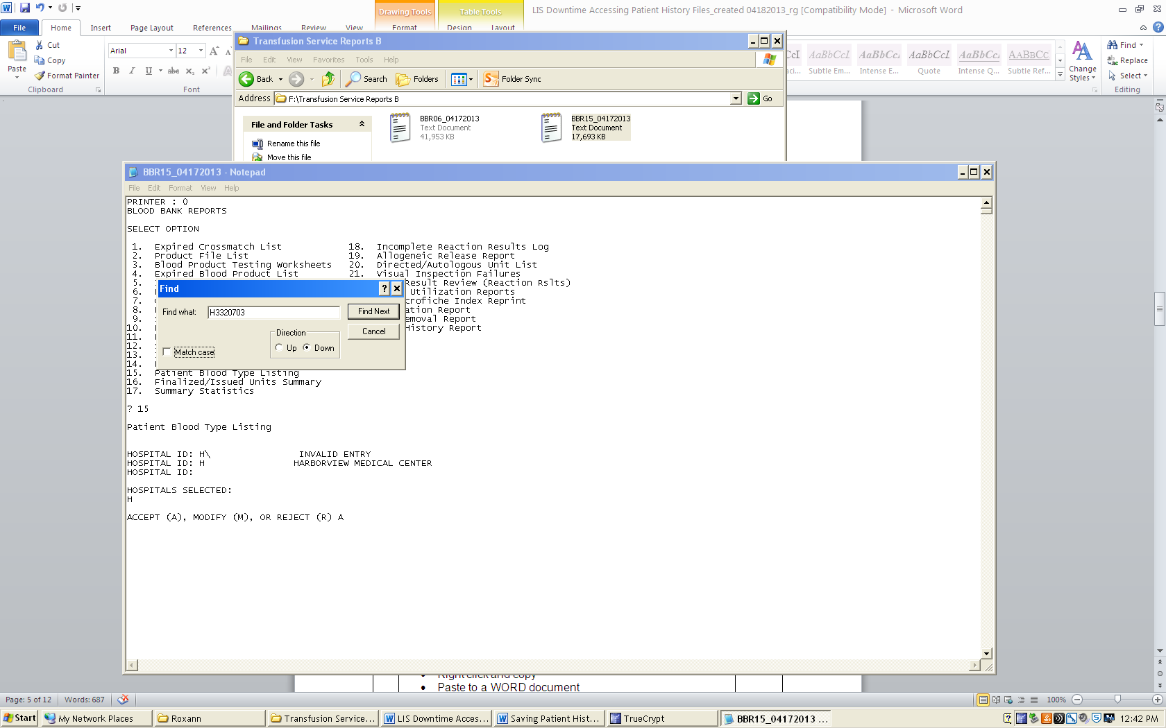
9 | Highlight selected patient data  - Right click and copy  - Paste to a WORD document  - Print data from both files, if applicable
10 | Staple to Blood Request
11 | Close BBR02, BBR06, BBR15, and BBR22 after each use in order to search for next patient.
Step | Action
Removing USB drive
12 | To remove the encrypted drive without damage to the files, eject the flash drive.  - Right click ejection icon (denoted here with a black circle)  - Click Eject Cruzer Micro  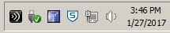
13 | Watch the light on the flash drive turn off.
14 | Remove the encrypted flash drive from the USB port on the computer hard drive.
15 | Store USB drive in the Downtime folder.

References:

Standards for Blood Banks and Transfusion Services, Current Edition. American Association of Blood Banks. AABB Press, Bethesda, MD.

Blood Bank User Guide, Misys Laboratory

