Purpose:
To provide instructions for saving patient history files using an encrypted USB drive in order to provide patient history information in the event Sunquest system is not operational.

Method:
Step | Actions | Related documents
Perform Report Capture in Sunquest:
1 | Perform Function BEX in SmarTerm | SQ Patient History Backup Reports in Sunquest
Prepare USB drive:
2 | Insert the encrypted flash drive into the USB port on the hard drive.  Found New Hardware may appear on lower desktop tool bar and can be ignored.  - Even days: “A”  - Odd days: “B”  NOTE: Alternate using the A and the B drives each day so that if one flash drive goes missing or becomes unusable the data is still recent on the other.  A Microsoft Pop-up scan/fix may appear, choose “continue without scanning”

Step | Actions | Related documents
Prepare USB drive (continued):
3 | A password prompt will appear. Enter password bl00db@nk (the O’s have replaced with zeros and the A is an “at” sign) and then click “Unlock”. The flash drive’s assigned letter will also appear in the title, denoted here with a black circle.  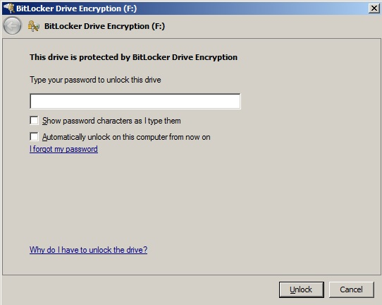
Capture Reports
1 | Open SmarTerm Roll N Scroll. Log on.
2 | On the Menu bar, under “Tools”, choose “Start Capture”    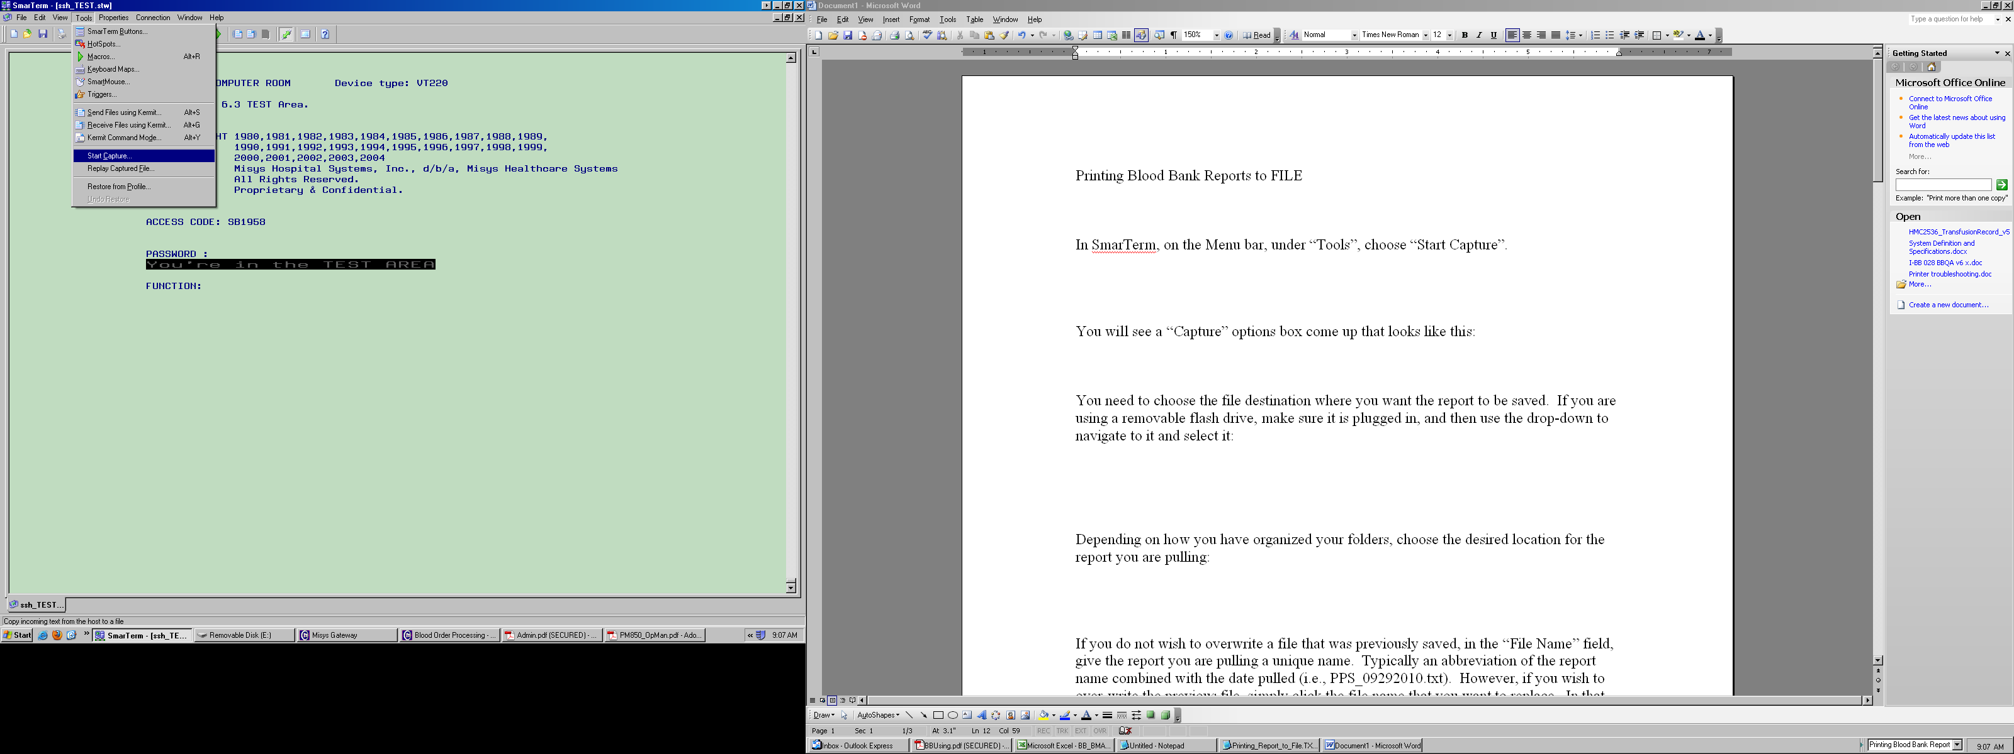

Step | Actions | Related documents
Capture Reports (continued):
3 | “Capture” options box is displayed:  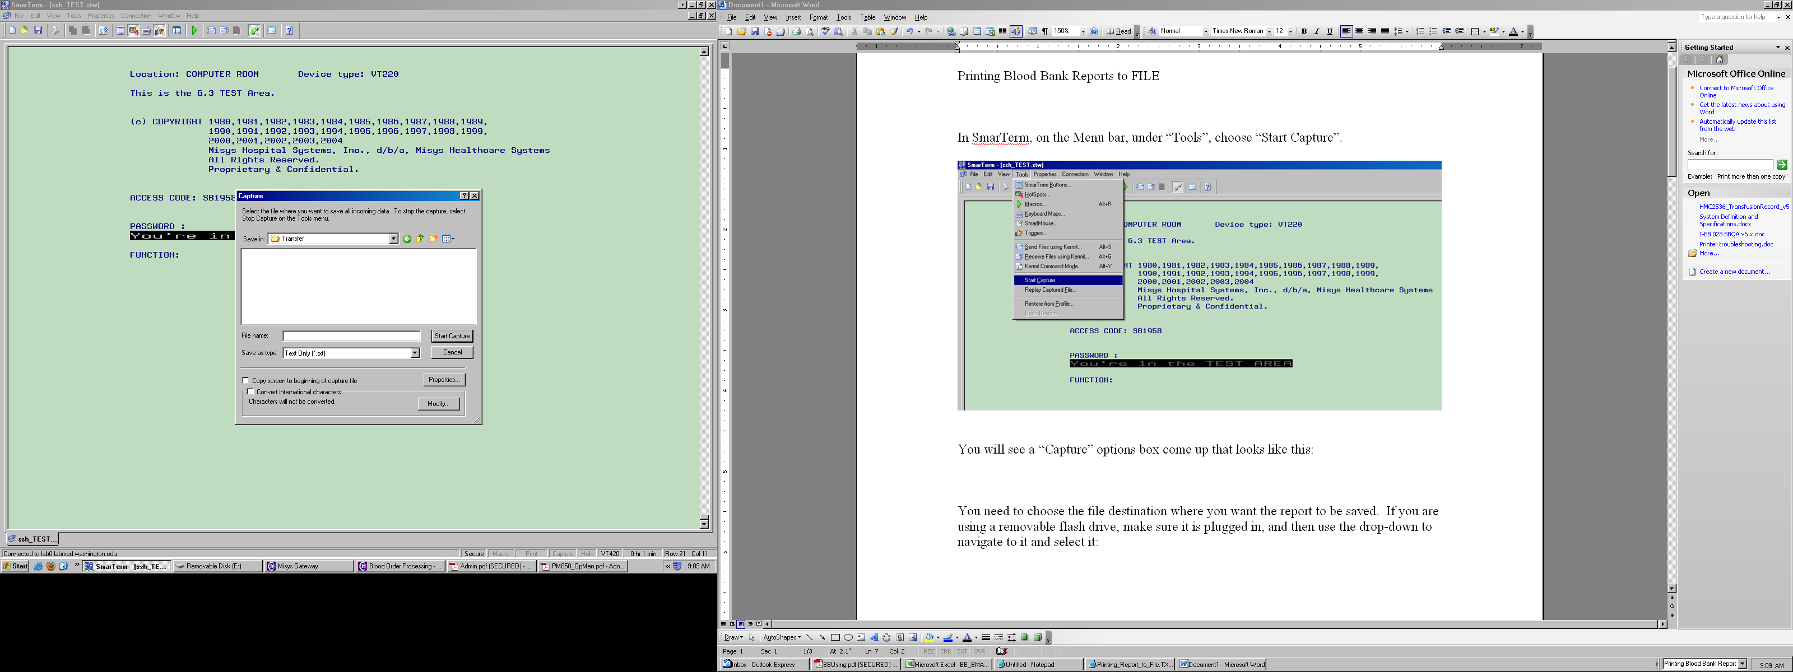
4 | Select the flash drive’s assigned drive to identify the file destination where you want the report to be saved.  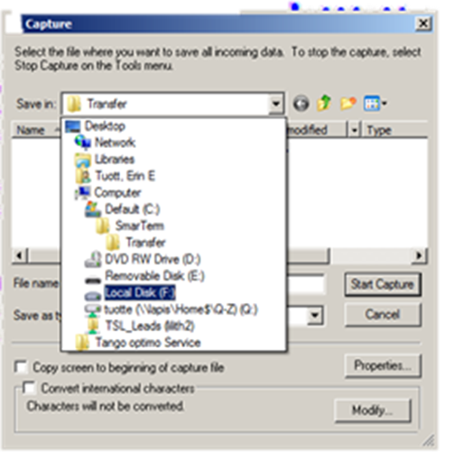

Step | Actions | Related documents
Capture Reports(continued)
5 | Select the Transfusion Service Reports folder  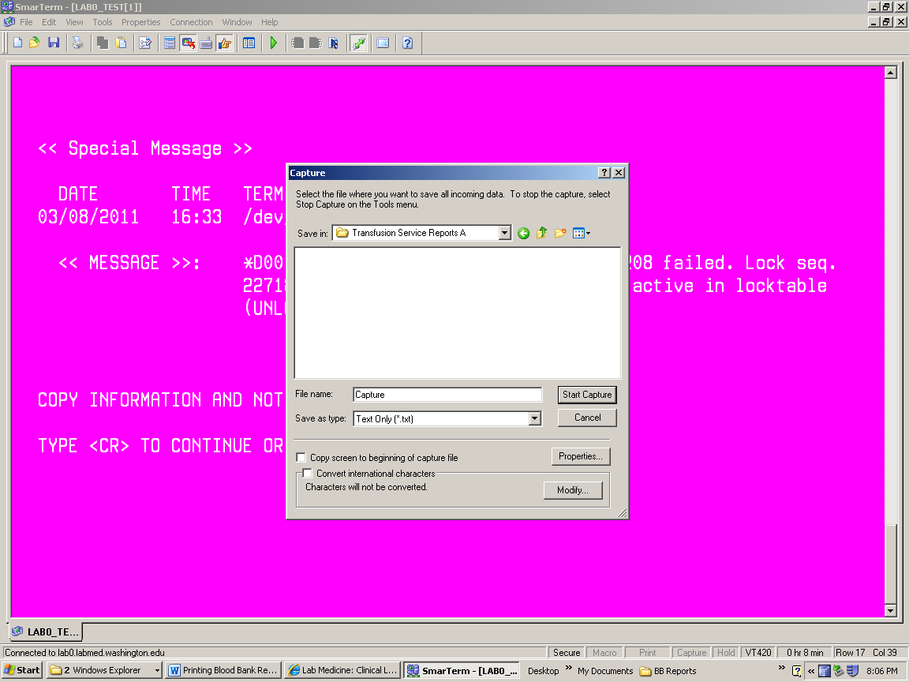
6 | Assign a file name, typically an abbreviation of the report name combined with the date compiled (i.e., BBR15_040511.txt).  - Click “Start Capture”.  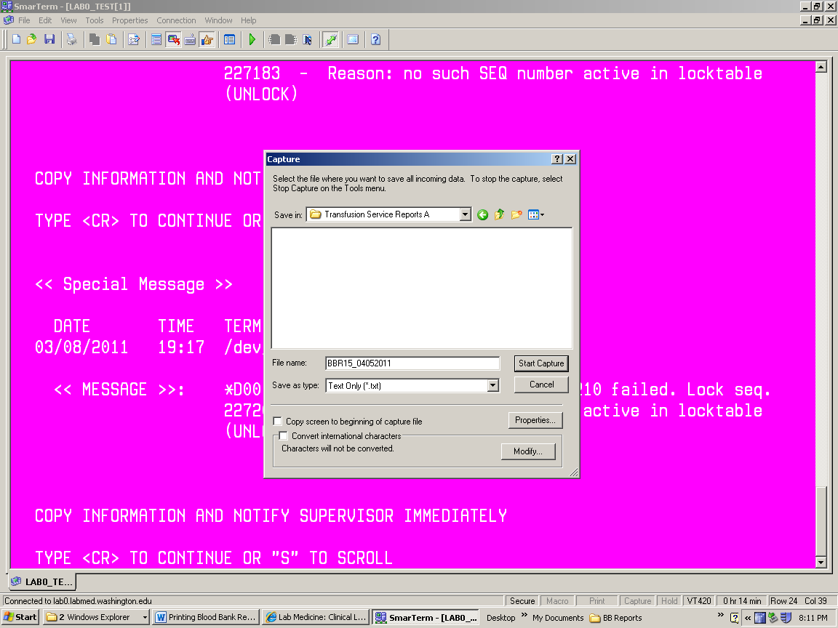
7 | Once complete, on the Menu bar under “Tools”, choose “Stop Capture”.
8 | Repeat steps 2-7 until all of the following reports have been extracted:  - BBR2  - BBR6  - BBR15  - BBR22 | Patient History Backup Reports in Sunquest
Cleaning Up
1 | Review to ensure reports have been saved. Delete previously saved reports.
Step | Actions | Related documents
Removing USB drive
1 | To remove the encrypted drive without damage to the files, eject the flash drive.  - Right click ejection icon (denoted here with a black circle)  - Click Eject Cruzer Micro  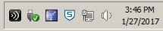
2 | Watch the light on the flash drive turn off.
3 | Remove the encrypted flash drive from the USB port on the computer hard drive.
4 | Store USB drive in the Downtime folder.

References:
Standards for Blood Banks and Transfusion Services, Current Edition. American Association of Blood Banks. AABB Press, Bethesda, MD.

Blood Bank User Guide, Misys Laboratory

