Purpose
To provide instructions on the use of Marathon Micro DL temperature data loggers. This will include preparing the logger for recording, downloading data, and assessing data obtained during blood storage.

Policy
The data loggers will be used for the transport and storage blood in credo coolers. The data loggers must be validated and have adequate battery life prior to use. Loggers that have low battery and/or expired calibration will be replaced annually.

Equipment
- Micro DL Temperature Data Recorder
- Marathon Micro DL Reader Station

Procedure
Step |  | Action | Related Documents
Marathon Micro DL Temperature Data Logger (Micro DL)
1 | Mdl4 Mdl8  Memory 4K 8K  Weight 0.3 ounces 0.6 ounces  Range (Celsius) -10C to 72C -30C to 72C  Temperature Accuracy At zero/extremes 0.5C/1.0C 0.2C/0.5C  Power Source 3V lithium 3V lithium  Alarm Setting Yes Yes |  | Marathon Products –microDL
Micro DL Display
1 | With each press of the Start Button:  - REC: shows RECording and current temperature  - RUN: shows elapsed time in days  - Push to return to current temperature |  | Table A: Data Logger Display Examples
Initial Programming of MicroDL Temperature Data Loggers
1 | Log into computer containing access to the Marathon Micro DL Reader Station
2 | Log Micro DL into Reader Station:  - Turn on the Micro DL display by pressing the Start button  - Note: Display is active for 4 minutes before hibernating.  - Place the Micro DL into the Reader Station by aligning the Start button with the hole in the reader.  - Open Marathon Software: MDAS-PRO  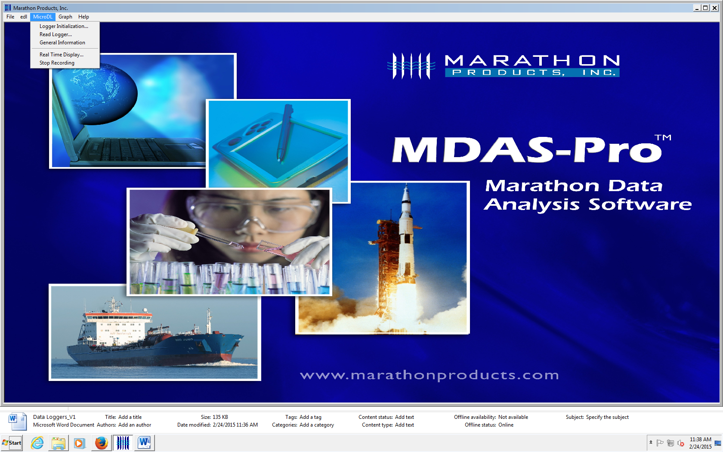
Step | Action |  | Related Documents
Initial Programming of MicroDL Temperature Data Loggers (continued)
3 | Drop Down Menu from MicroDL in the Task Bar  Setup Tab:  - Description: enter alphanumeric information  - Harborview Medical  - Tracking Number: Logger Serial Number on bottom or side of data logger  - Logger Clock: Set to computer time  - Battery Status: installation date and percentage used is displayed  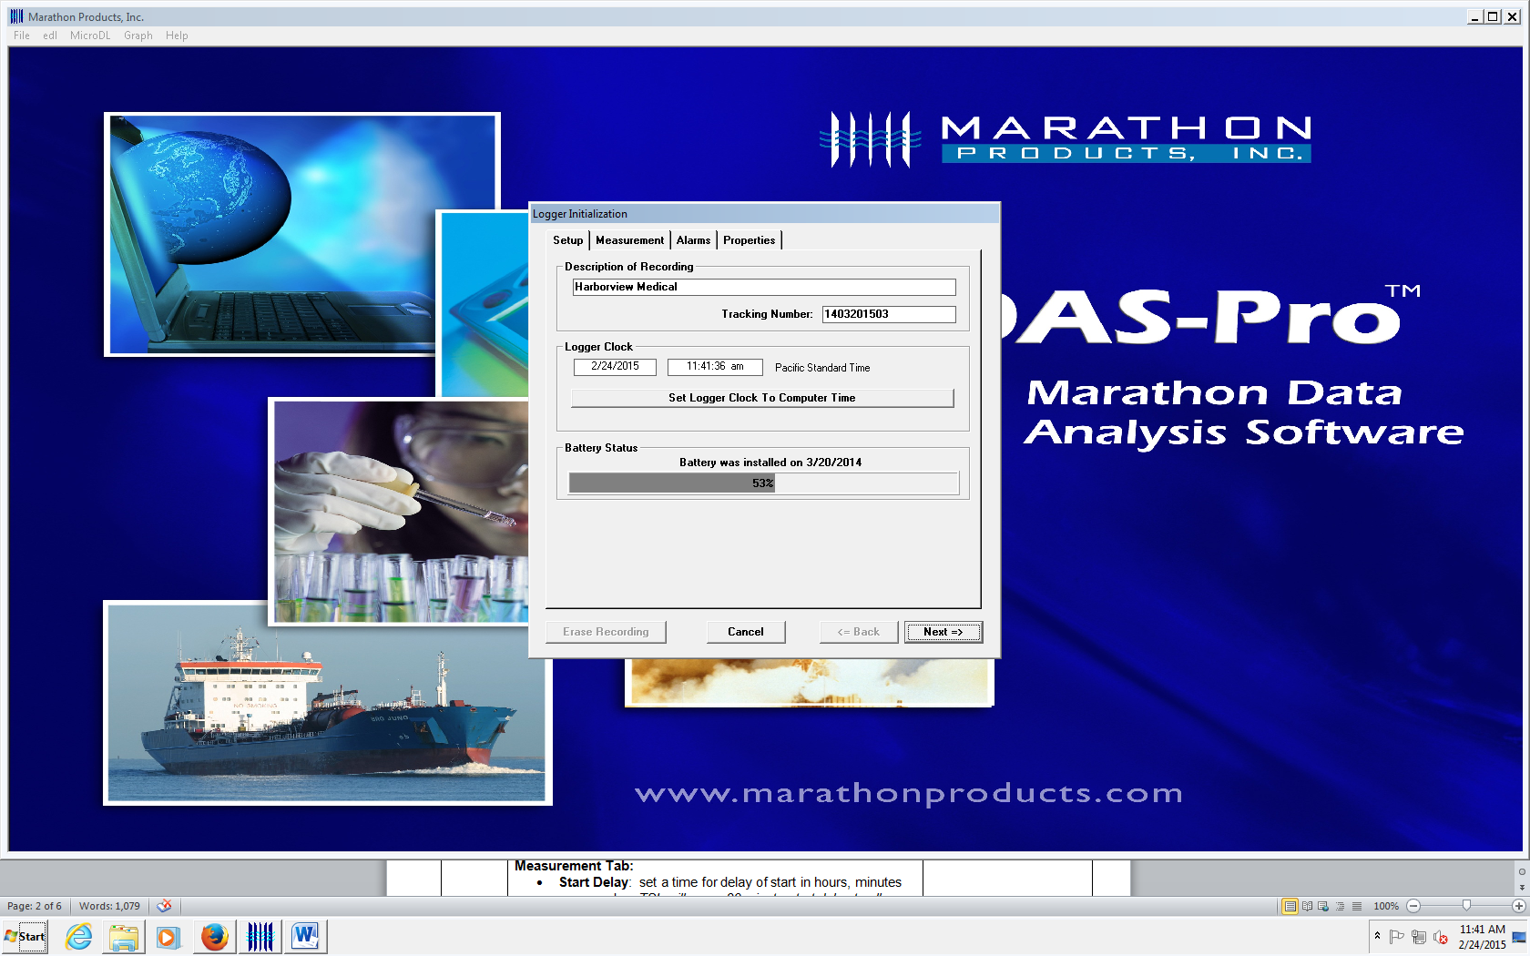  Click NEXT.

Step | Action | Related Documents
Initial Programming of MicroDL Temperature Data Loggers (continued)
4 | Measurement Tab:  - Start Delay: sets time for delay of 30 minutes to allow for the unit to come to temperature in the container.  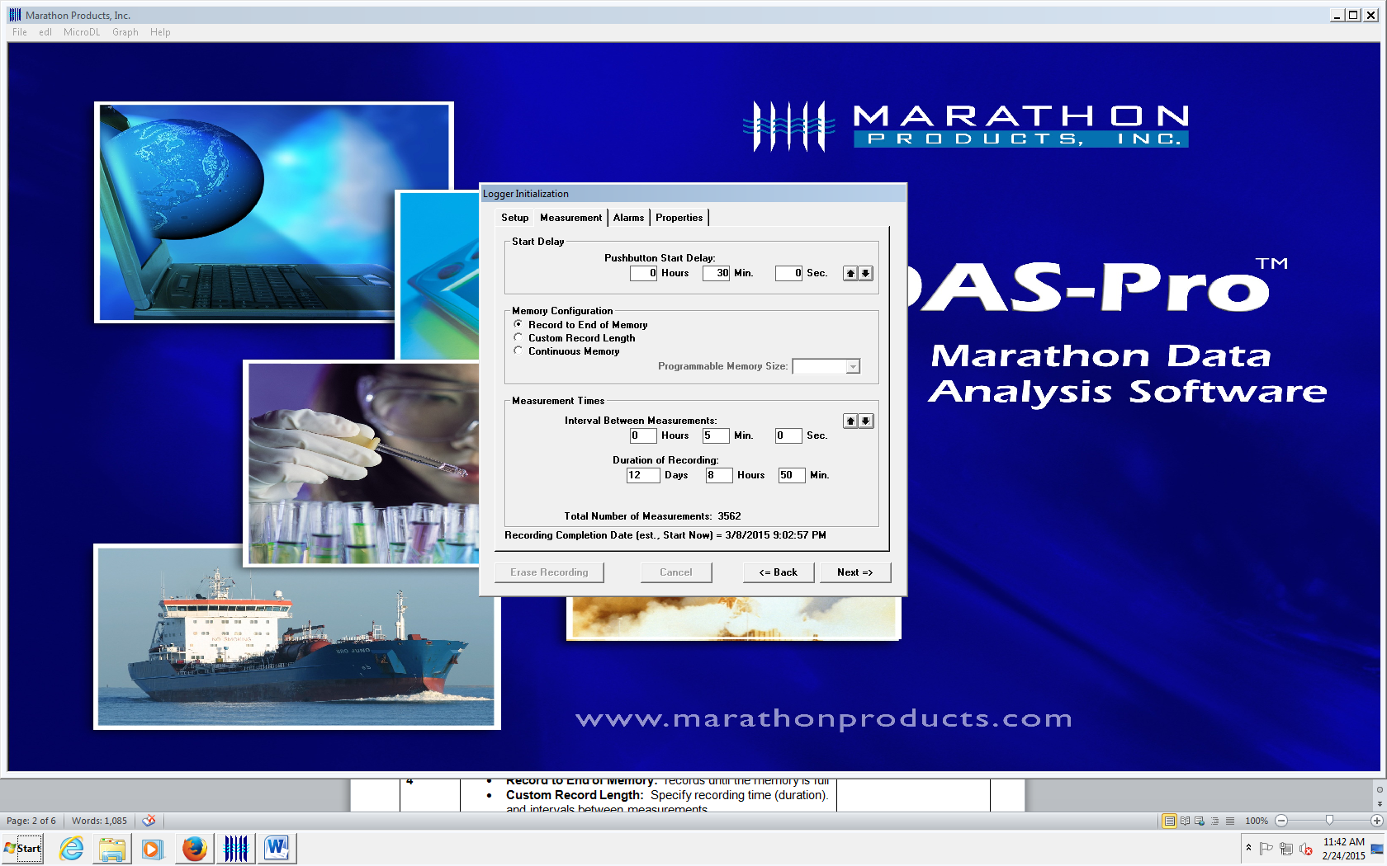  - Memory Configuration:  - Record to End of Memory: It will record until the memory is full.
5 | Measurement Time: Duration and Interval are linked.  - TSL: Set to 5 minute intervals. For Mdl4, recording should last 12 days, 8 hours, 50 minutes. For Mdl8, recording should last 25 days, 21 hours, 10 minutes.  Click NEXT.
6 | Alarms Tab:  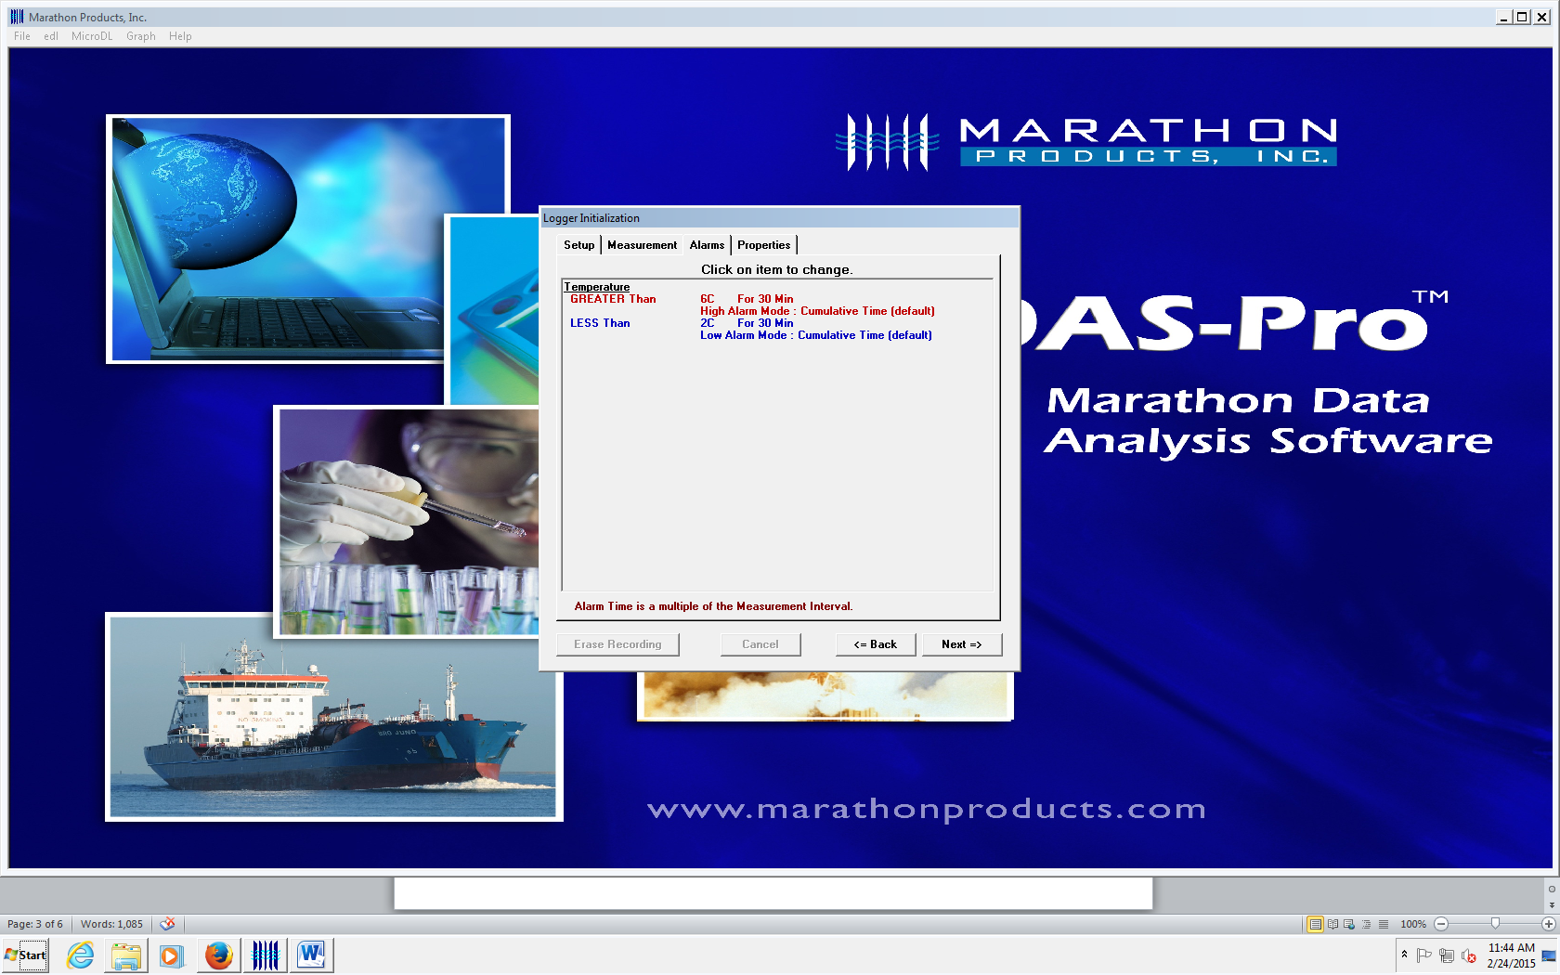  TSL will routinely use settings of:  - Greater than 6ºC for 30 minutes: High Alarm Mode: Cumulative Time  - Less than 2ºC for 30 minutes: Low Alarm Mode: Cumulative Time  Click NEXT.

Step | Action | Related Documents
Initial Programming of MicroDL Temperature Data Loggers (continued)
7 | Properties Tab:  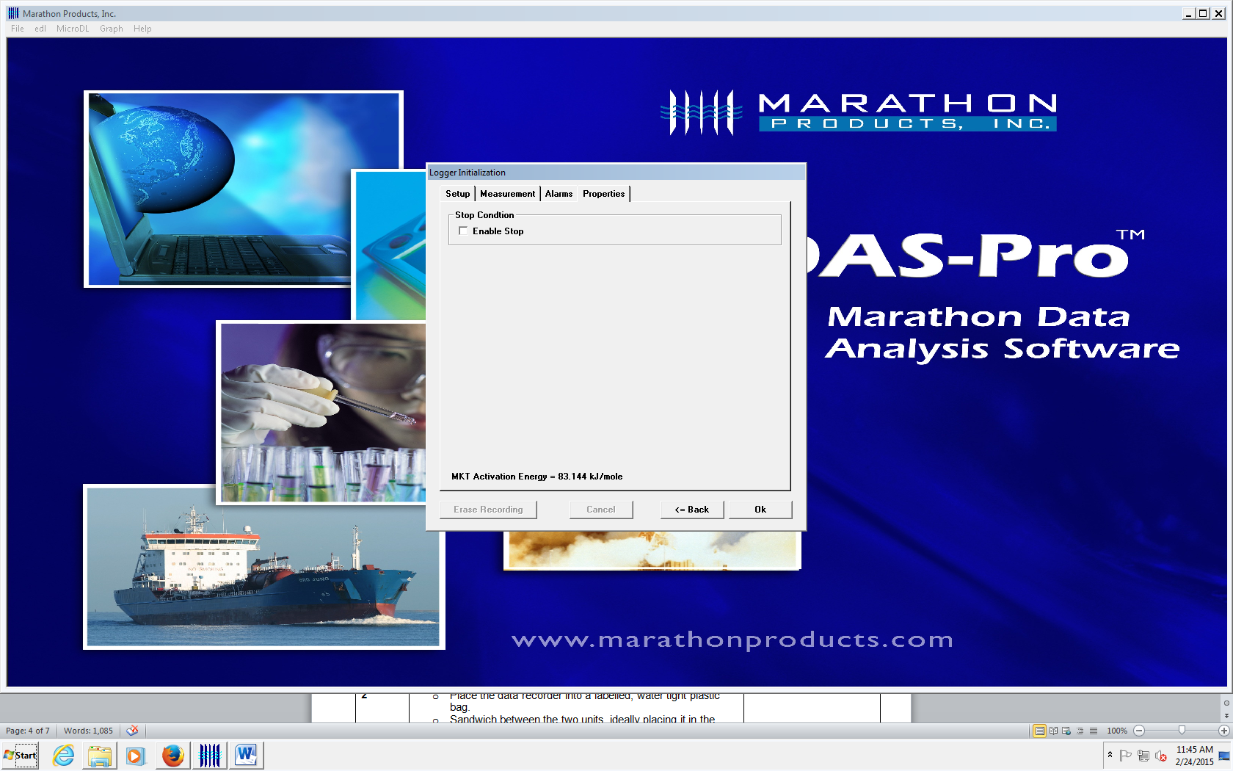  - Do NOT check box.  - STOP recording through software on a computer ONLY. Otherwise, REC can be accidently stopped by pressure on the Micro DL logger START button.
8 | Click OK.  - Popup will display Logger Update.  - FINISHED appears when update is completed.  - Popup window closes.
9 | Detach the Micro DL from the Reader Station.
Setting MicroDL to Record
1 | Select a Micro DL.
2 | Begin Recording:  - Activate by pressing the button once to turn on the data logger and then once the temperature appears holding the button (approximately 7 seconds) until RUN appears on the screen (flashing)  - Release the START button and REC will appear in the upper left hand corner. Temperature will appear.  - Obtain 2nd Tech review of data recorder for REC display on screen.  - Place the data recorder back into the water tight plastic bag. | Table A: Display Examples
3 | Sandwich data recorder between the two units, ideally placing it in the middle of the container.
Downloading Data
1 | Receive Credo Cooler in TSL  - Process units per SOP | Using the Credo Series 4 EMT Coolers
2 | Give the data recorder to an MLS Lead, MLS2 or CLT Lead for analysis.  Note: Lead or MLS2 downloads, reviews, and stores the data as soon as possible. Any unacceptable findings will be investigated immediately.
3 | Examine Data Logger screen:  - REC should be displayed  - Alarm symbol may be present | Table A: Display Examples

Step | Action | Related Documents
Downloading Data (continued)
4 | Log into computer containing access to the Marathon Micro DL Reader Station  - Open Marathon software: MDAS-PRO
5 | Log Micro DL into Reader Station:  - Turn on the Micro DL display by pressing the Start button  - Note: Display is active for 4 minutes before hibernating.  - Place the Micro DL into the Reader Station by aligning the Start button with the hole in the reader.
6 | At top menu bar, select MicroDL, then open “READ LOGGER” to save data:  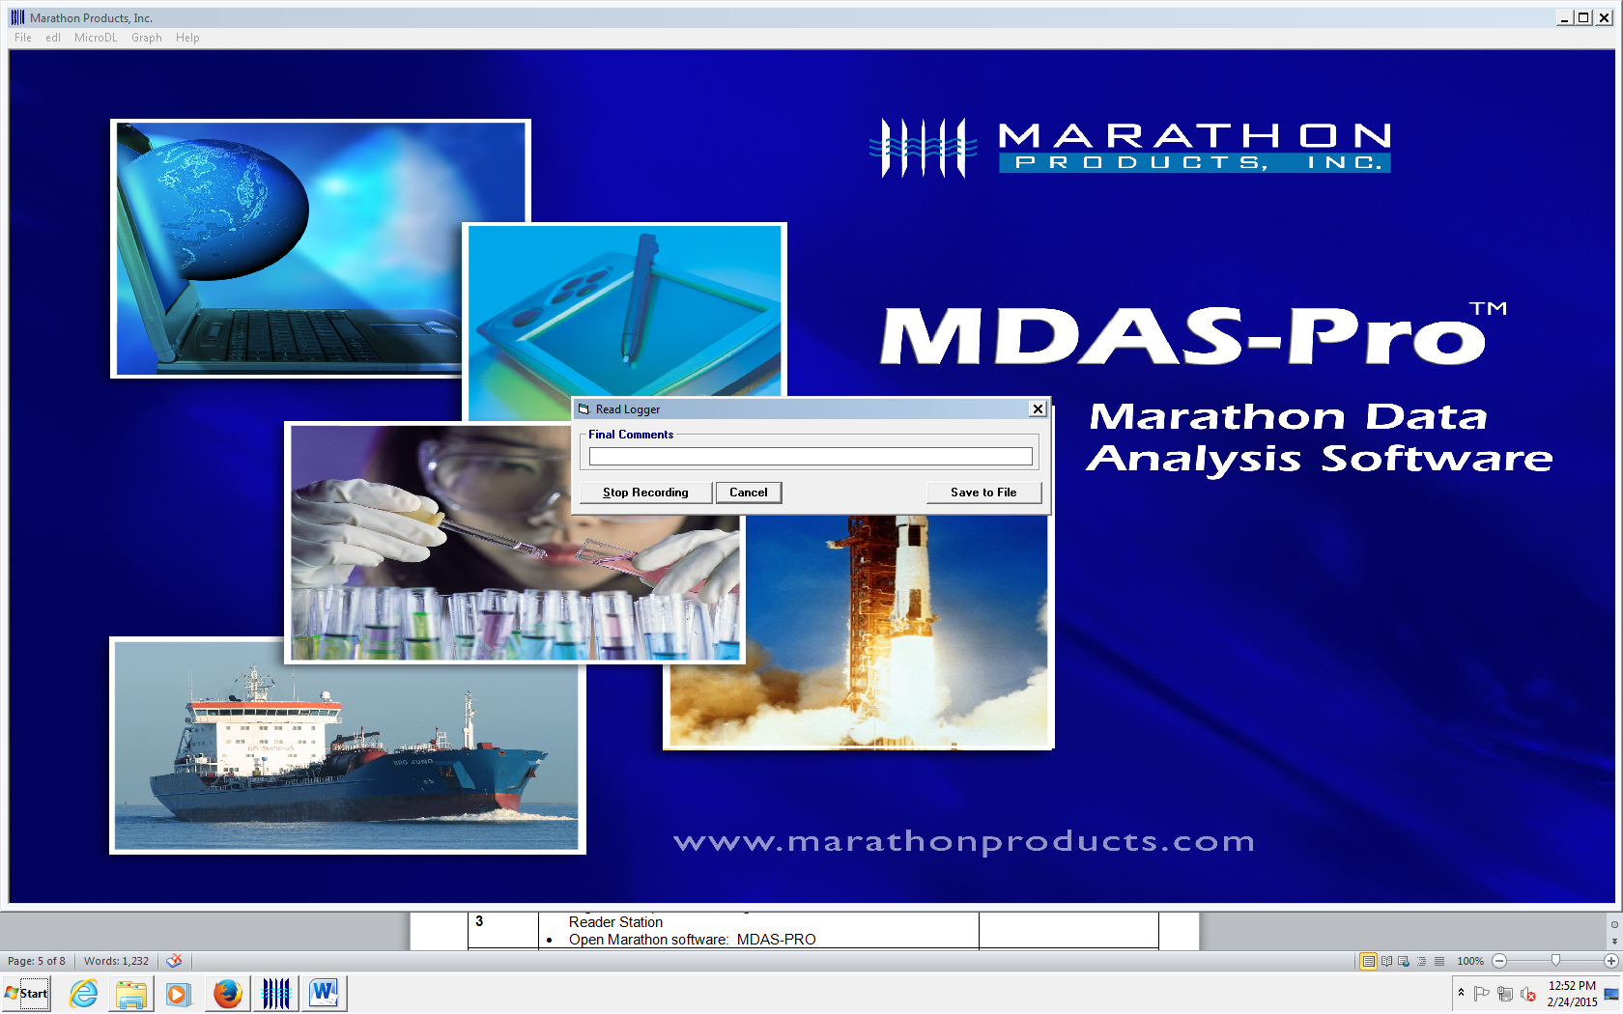  Click ‘Stop Recording”  Click “Save to File”:  - Click on desktop to open HMC_TSS Lilith folder  - Save to \\lilith2.labmed.washington.edu\HMC_TSS\Data Loggers  - Select appropriate cooler number folder and year  - Type file name (cooler # and date sent out)

7 | Review data on graph.  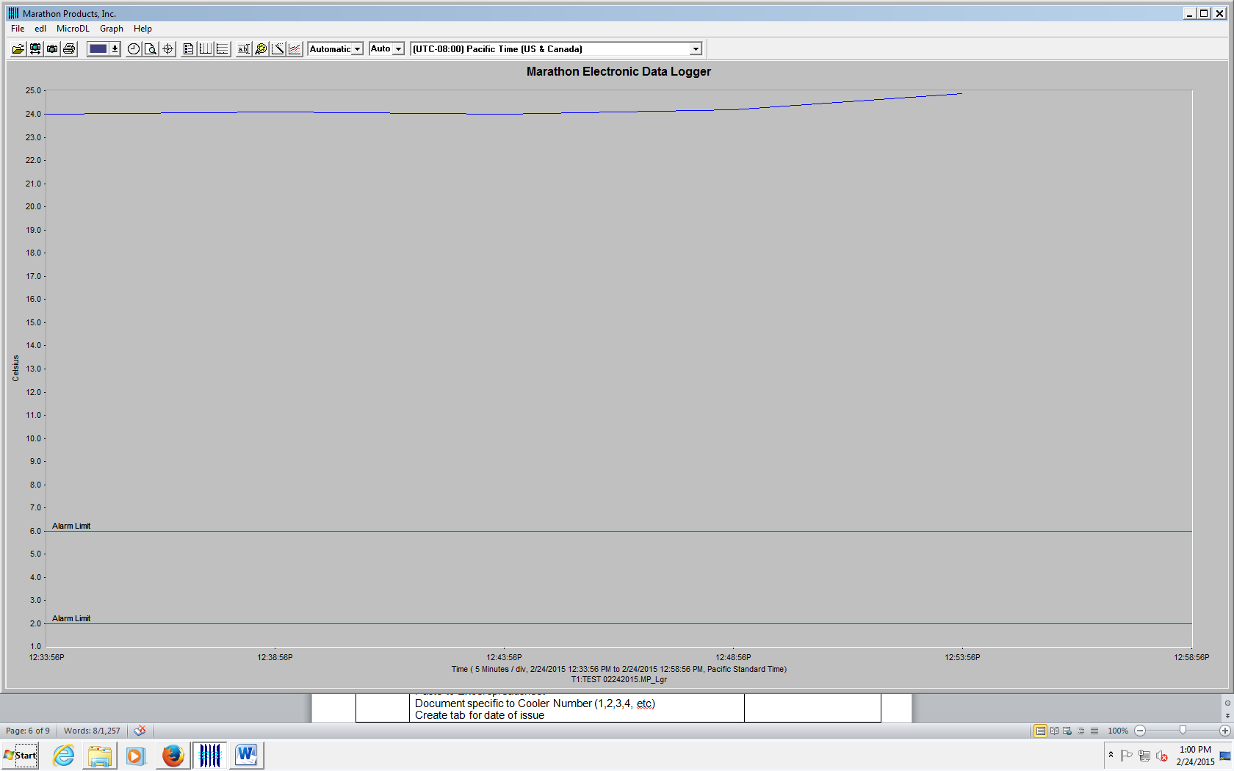  Red Lines identify Alarm settings. Blue line identifies temperature recordings.
Downloading Data (continued)
8 | Select GRAPH on Task Bar, View Data  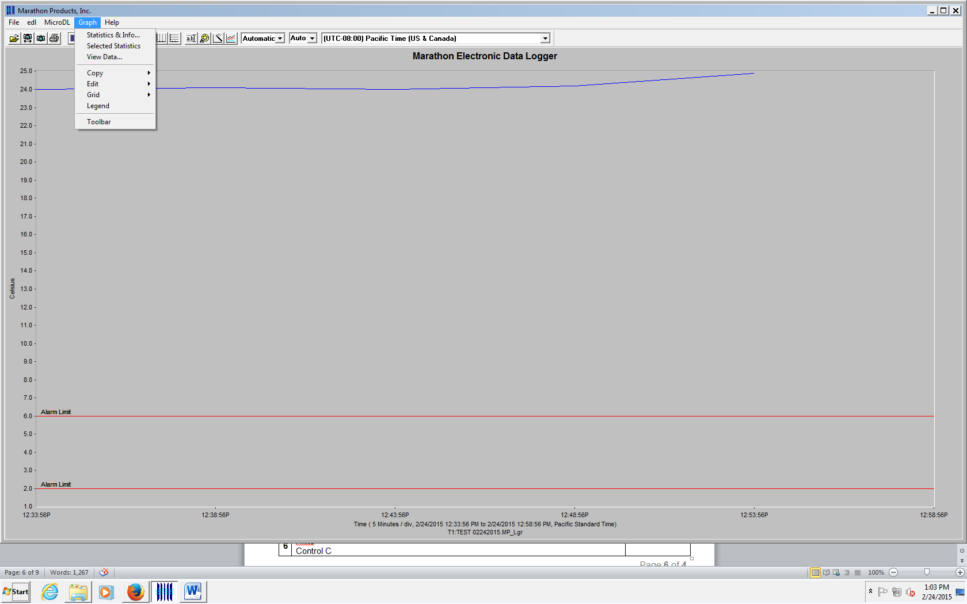  View and Copy Data:  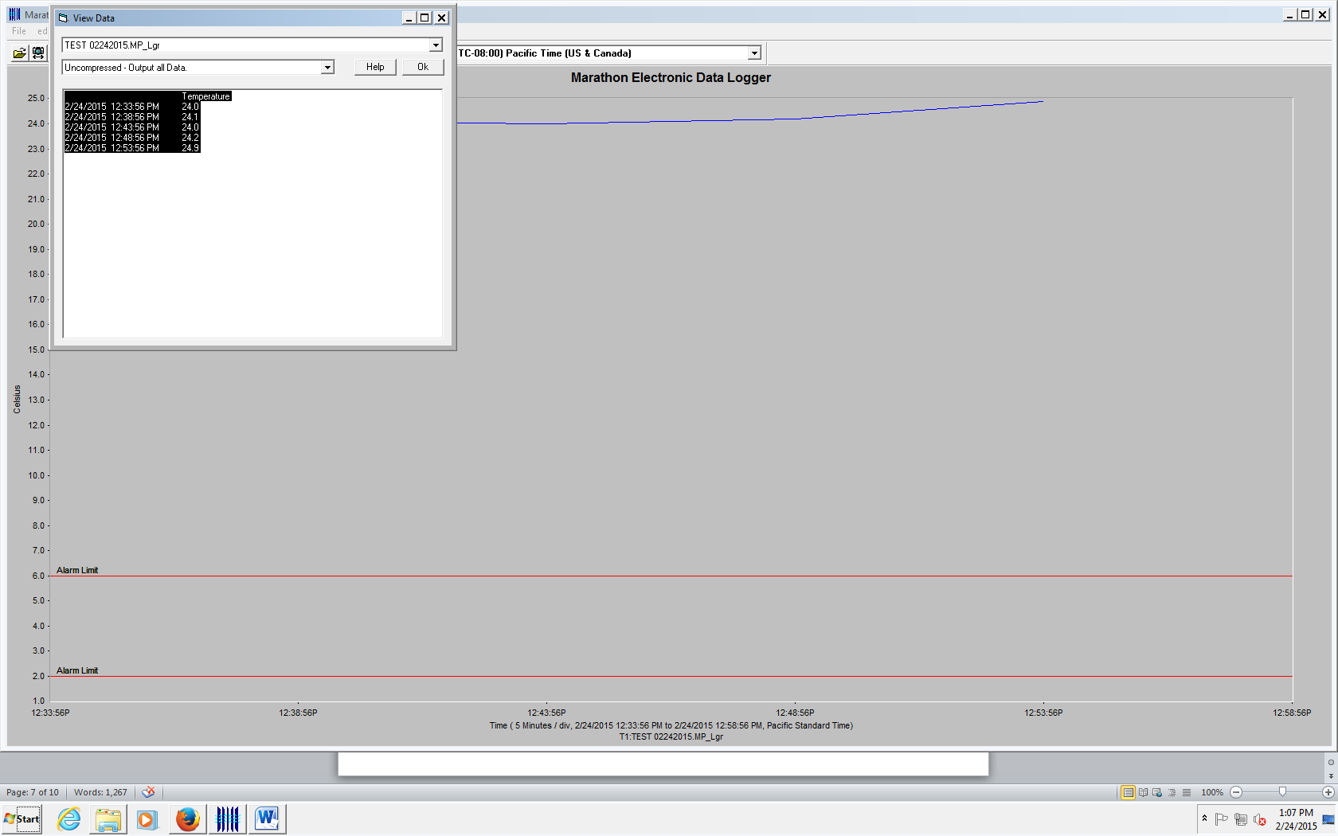  - Click on “uncompressed – output all Data”  - Click anywhere in the data box and highlight data (ctrl A)  - Copy data (ctrl C)  - Paste to Excel spreadsheet on Lilith2 (ctrl V)  - \\lilith2.labmed.washington.edu\HMC_TSS\Data Loggers  - Select specific Cooler Number (1,2,3,4, etc) and year  - Create and name tab for date of issue  - Document Data logger serial number at top of spreadsheet  - Document location (i.e. Olympia, Boeing, etc) at top of spreadsheet  In MDAS-PRO software, Copy Graph  - Click on Graph  - Select “copy”  - Select “bitmap”  - Paste in Lilith Excel spreadsheet next to data  In MDAS-PRO software, print Data to save with logs  - Click on “File”  - Select “Print”  - Select “Graph”  - Select “Full”  - Staple to Cooler log | Credo Cooler Log

Step | Action | Related Documents
Clearing data from logger and review of logs
1 | Wipe Data from recorder:  - Open MicroDL in MDAS-PRO software  - Open Logger Initialization, click on “Erase Recording”  - Pop-up: Erase ALL measurements in the logger? YES  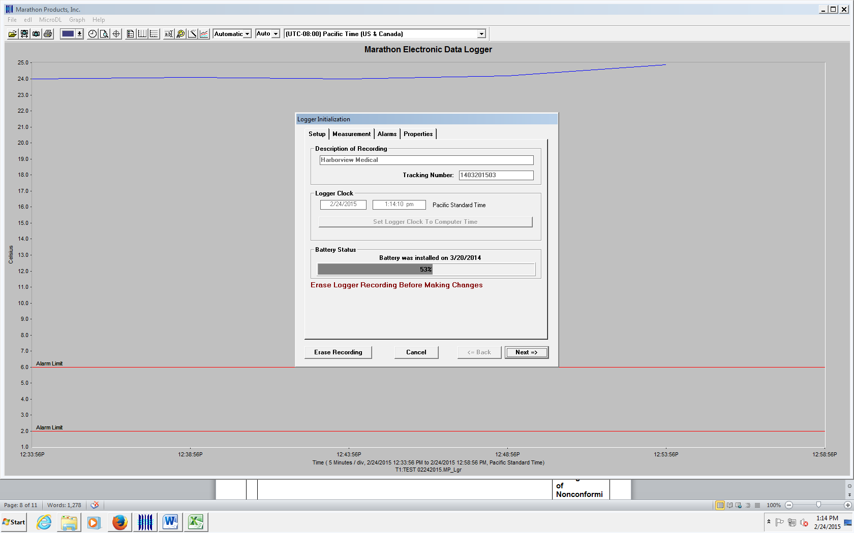  Data erasure displays on screen  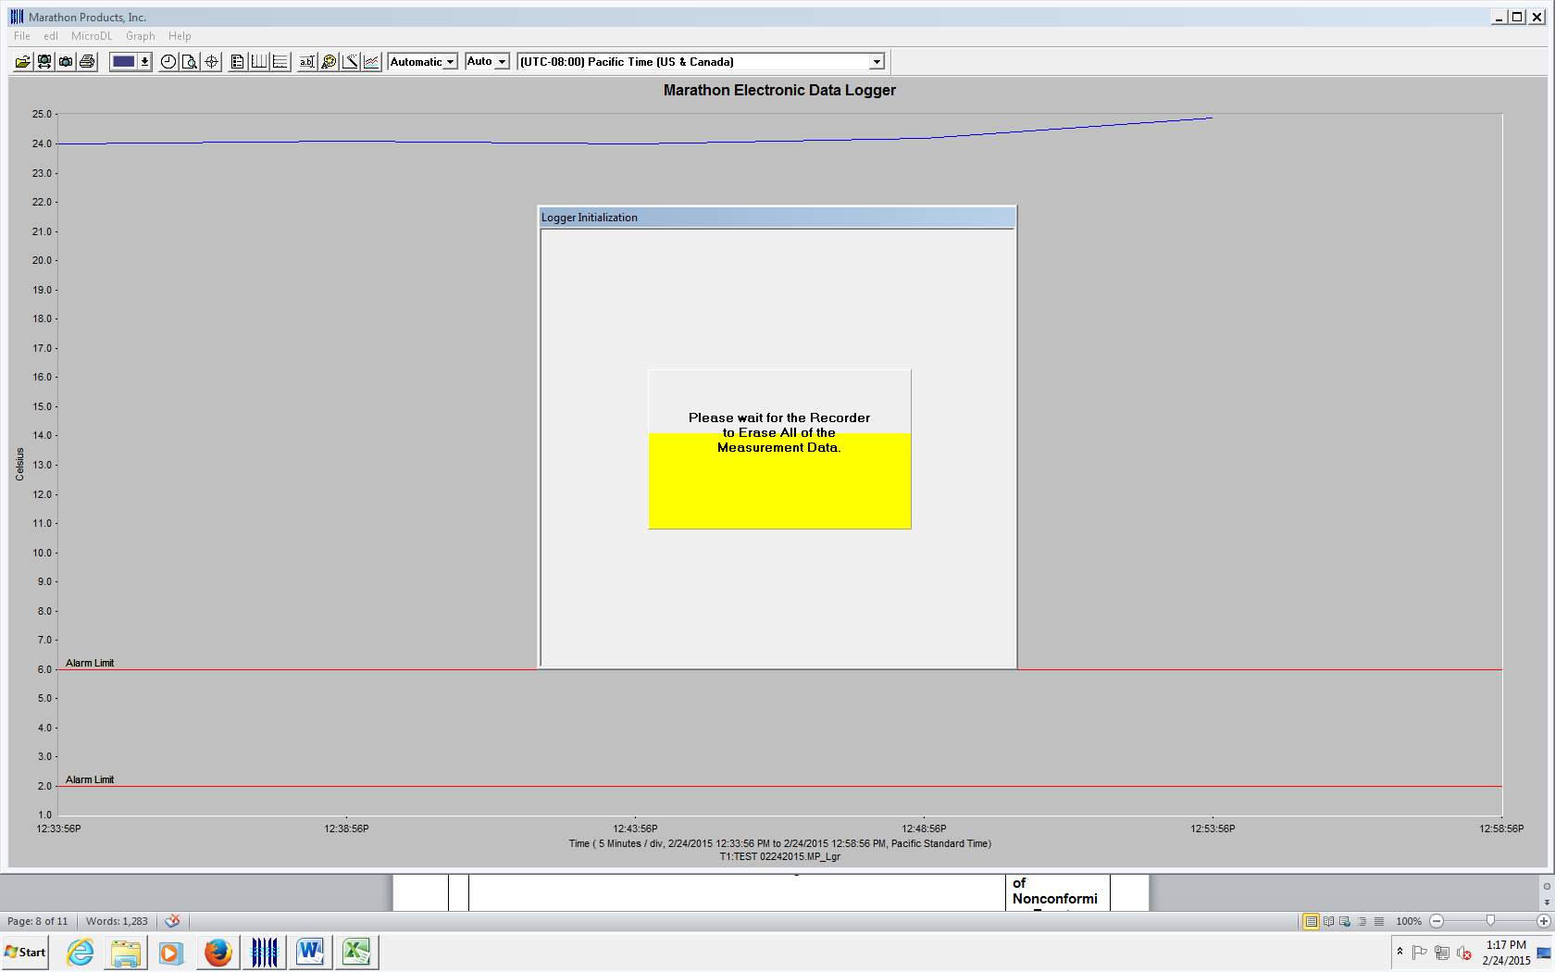  Continue through Initialization screens to reset logger parameters.  - Check all recorder parameters as settings may change by clicking “next = >” through the tabs and finally clicking ‘ok’  - Return cleared data recorder to bucket in refrigerator.
2 | Review of data logger and Credo Cooler Log:  - Review data  - Credo Cooler Log:  - Record Data Downloaded and Reviewed; Tech ID, date/time  - Add additional Comments, if indicated  - Record returned blood product disposition  Request 2nd data review from a trained staff member and record review on bottom of Credo Cooler Log  Release acceptable products from Quarantine and store in stock inventory  - Complete QIM for units found to be unacceptable.  - Discard unacceptable units after consultation with TS Manager and/or Medical Director | Blood Product Storage Policy  QP: Management of Nonconforming Events  QIM

Table A: MicroDL Display Examples

Display Examples
Press the Start button to see the following information display with each press of the start button:
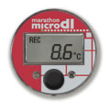 | 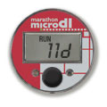
1. REC - 8.6C  shows RECording and current temperature | 2. RUN - 11 D  shows elapsed time in days

References

Marathon Products, INC

Standards for Blood Banks and Transfusion Services, Current Edition, American Association of Blood Banks, Bethesda, MD

