**PURPOSE:**

To provide instructions for ordering, receiving, storing and selecting appropriate blood component(s) for platelet transfusion in patients enrolled in the MIPLATE protocol.

**PRINCIPLE & CLINICAL SIGNIFICANCE:**

**Principle**

The MIPLATE study is a prospective, multi-center, randomized controlled trial to determine the clinical effectiveness of standard versus Mirasol-treated apheresis platelets in patients with hypoproliferative thrombocytopenia.

Mirasol Pathogen Reduction Technology (PRT) system for platelets is intended to reduce the pathogen load and inactive residual white blood cells in donor platelet concentrates for transfusion. The goal of the study is to determine if the hemostatic efficacy of Mirasol PRT platelets are non-inferior to standard plasma stored apheresis platelets.

Research protocol patients are consented by the study coordinator prior to enrollment in the MIPLATE protocol and are randomized to receive either standard plasma stored apheresis platelet products or platelets treated with Mirasol PRT by the TSL MDs. Once randomized, a comment will be added to the patient’s Sunquest BAD file indicating which study arm they have been randomized to receive.

The Mirasol treated units will appear a darker/deeper yellow due to the addition of Riboflavin during processing. Also, the treated units will have a broken frangible free floating inside the unit and usually is not easy to see (see Appendix 1 for a picture of a Mirasol treated platelet unit where the frangible pieces are isolated for reference)

This study is not blinded but the study coordinator and hospital/clinic care staff will not be aware of the patient’s treatment arm. TSL management or MD will randomize the patient to a study arm.

**Clinical Significance**

Adherence to the protocol helps to ensure the validity of the results while supporting the patients’ transfusion needs.

**POLICIES:**

Patients with the following transfusion related criteria will be excluded from enrollment in the protocol:

* Volume reduced or washed platelet products
* HLA matched platelets or pooled platelets only

Any additional attributes or requirements (including irradiation) listed on the physician’s order or in the patient’s Blood Administrative Data (BAD) file must be honored for all study patients unless approval to deviate has been obtained from the TSL MD.

* If a patient requires volume reduced or washed platelets during the study, apheresis platelets stored in plasma (PAS platelets may not be given) will be provided and considered an off-protocol transfusion. Mirasol-treated platelets have not been validated and approved for volume reduction or washing.

Mirasol PRT platelets are stored at 20-24°C with agitation and are segregated from standard platelets to prevent inadvertent use by non-study patients and to protect from UV light exposure

Mirasol PRT platelets that are not transfused should be returned to BWNW for QC and final disposition

Mirasol PRT platelets are ordered from BWNW thru BloodHub or by faxing a BWNW Inventory Order upon determination of an anticipated need.

**INSTRUCTIONS:**

**Updating the Blood Administrative Data Record**

**Ordering and Assigning Study Platelets**

**Receiving and Storing Study Platelets**

**Updating the Blood Administrative Data Record**

|  |  |
| --- | --- |
| **STEP** | **ACTION** |
| 1 | Upon receipt of randomization notice from TSL MD, enter the appropriate randomization comment in the study patients BAD file |
| 2 | |  |  | | --- | --- | | **If** | **Enter** | | Control Arm | * MIPLATE give apheresis platelets – nonPAS | | Study Arm | * MIPLATE give Mirasol platelets | |

**Ordering and Assigning Study Platelets**

|  |  |
| --- | --- |
| **STEP** | **ACTION** |
| 1 | Review the patient’s BAD file to determine which study arm the patient is enrolled |
| 2 | |  |  | | --- | --- | | **If enrolled in** | **Assign** | | Control Arm | Apheresis platelet stored in plasma | | Study Arm | Mirasol PRT platelet from available subject specific inventory or order from BWNW using Bloodhub and attach CTS-5030: MIPLATE Study PLT Order Form to the order prior to submission | |
| 3 | Ensure the selected platelet is irradiated if the patient requires irradiated blood components (see SOP *Irradiating Blood Components*) |

**Receiving and Storing Study Platelets**

|  |  |
| --- | --- |
| **STEP** | **ACTION** |
| 1 | Receive platelets into inventory according to SOP *Receiving Blood Products into Inventory* |
| 2 | Irradiate Mirasol PRT platelet if the patient’s transfusion profile indicates irradiation is required (see SOP *Irradiating Blood Components*) |
| 3 | Store Mirasol PRT platelets into the designated area of a monitored 20-24°C incubator with agitation until issue |

**CALCULATIONS/INTERPRETATIONS/RESULTS REPORTING/NORMAL**

**VALUES/CRITICAL VALUES:**

NA

**PROCEDURE NOTES/LIMITATIONS:**

* The study is expected to last for three years and will be monitored by an independent data monitoring committee
* Patients may participate in the study for up to 77 days and the study comment should be removed from the patients record as soon as possible following notification by a TSL MD that they are no longer a participant
* Mirosol PRT platelets that do not pass visual inspection or are unacceptable for any reason may require submission of a deficiency report to the study coordinator in addition to a UWMC TSL QI form. Refer issue to TSL management for a determination of need to complete a Deficiency Report
* Both study and non-study products will be billed using the standard method and no additional cost will be added for the use of study platelets.
* Although studies have shown that Mirasol treatment prevents GvHD, all study products issued to patients requiring irradiation must be irradiated prior to transfusion
* The MIPLATE products will contain broken frangibles as a result of the manufacturing process and is not associated with any adverse condition of the product (see **Appendix A**)

**REFERENCES:**

* Technical Manual. Bethesda, MD: AABB Press, current edition
* Standards for Blood Banks and Transfusion Services. Bethesda, MD: AABB Press, current edition
* Mirasol RPT System for Platelets Investigator’s brochure Terumo BCT Biotechnologies LLS Edition 5.0: 28 Sept 28 2016

**RELATED DOCUMENTS:**

SOP Ordering Blood Components

SOP Receiving Blood Products into Inventory

SOP Irradiating Blood Components

SOP Selection of Blood Components for Transfusion

FORM CTS-5030: MIPLATE Study PLT Order Form

APPENDIX Mirasol Treated Platelet Unit with Broken Frangible

**Appendix A: Mirasol Treated Platelet Unit with Broken Frangible**

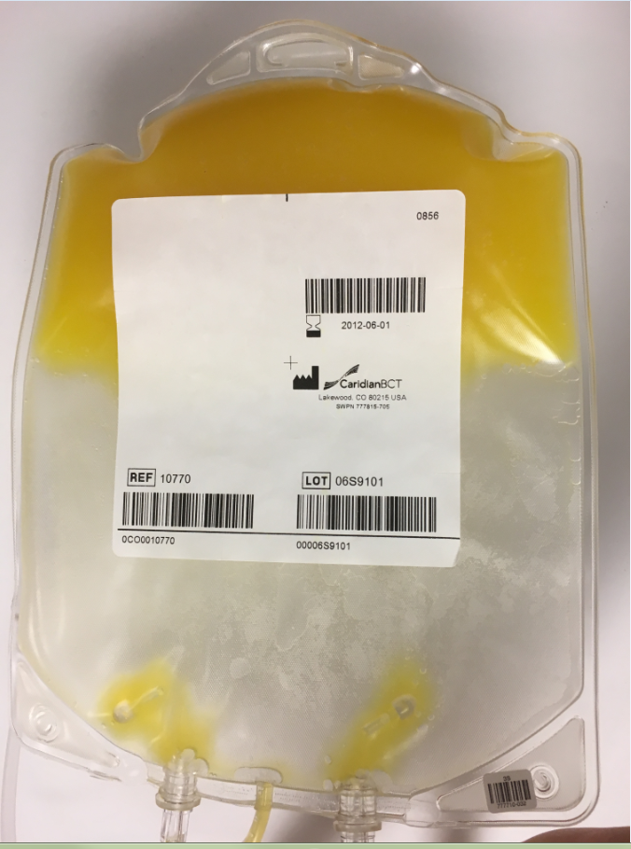

The photo above shows “broken frangibles” in a storage bag.  This is the last step of the Mirasol treatment process. The frangibles were purposefully isolated in this picture so they can be clearly seen.  They will typically be free floating in the platelets and not easily seen, but they will occasionally be visible when near the side of the bag.

|  |  |  |  |
| --- | --- | --- | --- |
| **UWMC SOP Approval:** | | | |
|  |  |  |  |
| **UWMC CLIA Medical Director** |  |  |  |
|  | Mark H. Wener, MD | Date |  |
|  |  |  |  |
| **Transfusion Service Manager** |  | Date |  |
|  | Deanne Stephens |  |  |
|  |  |  |  |
| **Compliance Analyst** |  | Date |  |
|  | Christine Clark |  |  |
| **Transfusion Service**  **Medical Director** |  | Date |  |
|  | John R. Hess, MD |  |  |
|  |  |  |  |
| **UWMC Biennial Review:** | |  |  |
|  |  |  |  |
|  |  | Date |  |
|  |  |  |  |
|  |  | Date |  |
|  |  |  |  |