University of Washington Medical Center

Clinical Microbiology Laboratory Document # 612.U.315.01

|  |  |  |
| --- | --- | --- |
| Quality Control Manual  **Steam Sterilization** | | Effective: 11/28/17 |
| Process Document | Written by: L. Bui | Reviewed by:  Debra Smith  Brett Norquist |
| Revises or supersedes: NEW | | Revised by: |

|  |  |  |  |  |  |
| --- | --- | --- | --- | --- | --- |
| ANNUAL REVIEW | | | | | |
| Reviewed by: | Date | Reviewed by: | Date | Reviewed by: | Date |
|  |  |  |  |  |  |
|  |  |  |  |  |  |

**I. Purpose**

This document outlines the use of steam sterilization to decontaminate laboratory waste and to sterilize lab supplies for routine use. Autoclave and sterilizing are used interchangeably in this document.

**II. Personal Protective Equipment (PPE)**

Employees who clean and decontaminate items to be sterilized will wear PPE appropriate to the task. This includes gloves, a fluid resistant gown, and face and eye protection.

**III. Training**

Staff involved in the sterilization process will receive training on how to properly use the sterilizer by an experienced user. This is documented in the training folder for each trained person.

**IV. Handling of Biohazardous Waste**

A. All appropriate blood-borne pathogen precautions will be observed when handling or transporting contaminated items in the laboratory to the autoclave room.

B. Biohazard bags containing waste will be closed off by twisting the bag and wrapping autoclave tape to safely secure the waste. However, it must be loose enough to allow steam to penetrate through the bag.

C. **See the Section VI on how to use the sterilizer.**

D. Biohazardous materials are placed in the red bin for autoclaving.

E. The autoclave tape indicator must have changed color (brown/black) to indicate complete decontamination.

F. Decontaminated biohazardous materials are placed in the blue bin for Environmental Services pick-up for disposal.

**V. Sterilization of Laboratory Products**

A. Reuseable items (e.g. tube racks, stainless steel measuring cups) should have autoclave tape affixed prior to sterilization.

B. Products packaged for sterilization (e.g. swabs, wooden sticks, scissors, forceps) should be in sterilizer pouches with color indicators.

C. Items are considered sterilized when the indicators turn black on the tape or packaging. Sterilizer pouches are considered sterile until open unless the integrity of the packaging is compromised.

**VI. How to Use the Sterilizer**

A. Each load will have a steam chemical integrator strip included to test the effectiveness of the sterilizer process.

B. Items are loaded on the racks that push into the autoclave.

C. The door is closed and locked by turning the outside wheel.

D. The sterilization temperature is set at121°C with different settings for each cycle.

1. Cycle 1: All biohazardous waste and boxes with glass (60 minutes)

2. Cycle 2 or 4: Swabs/sticks, pipettes, tubes, hardware (30 minutes sterilization, 20 minute dry)

3. Cycle 3: All liquid media (20 minutes; except thiogycollate (4 minutes)

D. When the cycle is complete, it will prompt to open the door slightly to release the pressure. Allow it to cool down for a minimum time of 10 minutes before removing any items from the autoclave. The autoclave will countdown the time and alert when it is safe to remove the sterilized items.

E. Prior to removing the sterilized items, examine the steam chemical integrator strip in each load. Also examine each item that has sterilizer tape. It must turn black for it to be considered sterilized.

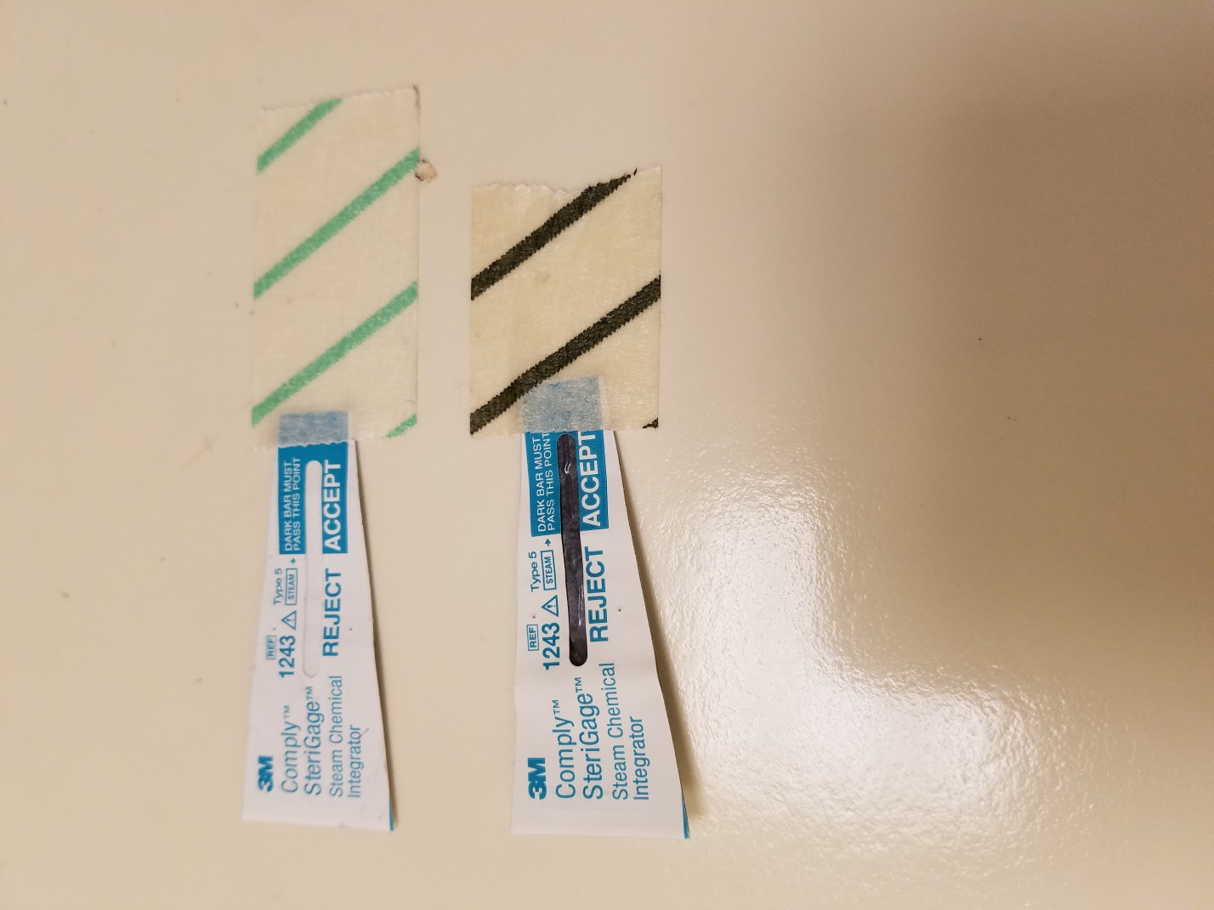

**AFTER (QUALITY CONTROL OK)**

**BEFORE**

1. If it has failed, troubleshoot by repeating the sterilization process, place new autoclave tape and review the cycle settings.

2. Refer to Steris technical service for additional troubleshooting assistance or repair.

F. Sterilized biohazardous waste bags will be placed into the **blue** bin within the autoclave room for Environmental Services to pick-up for disposal.

**VII. Quality Control**

A. Steam chemical integrator strip results will be recorded PER RUN in the “Steam Chemical Intragrator Log”. The 3M Comply SteriGage utilizes a chemical pellet which melts and migrates with exposure to steam and temperature. Acceptable results must show a black are in the “Accept” window” of the strip as shown above. Results that do not pass must be communicated with the CLT Lead or manager (available lead).

B. Biological indicators containing*Geobacillus stearothermophilus* will be run weekly AND after any significant repairs to assess the effectiveness of the sterility process.

B. See the “Spore Strip” procedure for additional testing information.

C. Test results go to Infection Prevention when completed. A monthly summary report is emailed by the CLT lead to the director of clinical engineering.

D. If the autoclaves are out of service, notify the managers so arrangements can be made with Environmental Services as a back-up.

**VIII. Maintenance/Service**

A. Steris Technical Service

1-800-333-8828

B. Sterilizer Serial Numbers:

1. Autoclave 1: 0120597-03

2. Autoclave 2: 0120997-10

**IV. References**

A. University of Washington Medical Center, Environmental Services Policy No. 64, Sterilization of Regulated Medical Waste, 12/1/13.

B. University of Washington Medical Center, Administrative Policy No. 117-5, Biomedical Waste (Non Sharps), 8/25/2010

C. College of American Pathologists Checklist (08/21/17), GEN75000 Sterilizing Device Monitoring, MIC.63250 Hazardous Waste Disposal.

D. Eagle 3041-S Gravity Sterilizer Operating Procedure (located in media room manuals)

E. 3M Comply (Sterigage) Steam Chemical Integrator, www.3m.com