**University of Washington Medical Center**

Clinical Microbiology Laboratory Document # 617.U.323.02

|  |  |  |
| --- | --- | --- |
| Setup Manual  **COMPUTER DOWN TIME INSTRUCTIONS** | | Effective: 4/10/18 |
| Process Document | Written by: Heather Berger | Reviewed by: Sarah Jensen |
| Revises or supersedes: 1/20/14 | | Revised by: Jennifer Vong |

|  |  |  |  |  |  |
| --- | --- | --- | --- | --- | --- |
| Annual Review | Date | Annual Review | Date | Annual Review | Date |
|  |  |  |  |  |  |
|  |  |  |  |  |  |

**I. PRINCIPLE**  
To ensure patient orders are processed as efficiently as possible when the LIS or ORCA is unavailable.

**II. DEFINITIONS**

* **LIS:** Laboratory Information System. The main database used by the UW Medicine laboratory system. Where patient data and testing information are stored within the laboratory system.
* **MRN:** Medical Record Number, hospital ID, patient ID, U#, H#, N#
* **AMC:** Academic Medical Center, this is also known as a "UW Medicine Account" or "HMC/IRIS Account".
* **ORM:** Order/Receipt/Modify. A function in the General Lab program in Mysis.
* **OLTG:** “On Line Test Guide” An online catalogue of the test menu offered at UWMC and HMC. OLTG also has testing that is not offered at either locations and is sent out for testing.
* **CPOE:** Computerized Physician Order Entry is a process that allows physicians to place orders electronically. Orders are placed in Epic or ORCA and interfaced with the Laboratory Information System (LIS/Sunquest).
* **MayoAccess:** A computer interface specimen batching system used by Mayo Medical Laboratories and other client laboratories to reduce manual data entry for specimen samples. Also known as MayoNet.

**III. MATERIALS**

A Downtime Materials Binder is located in the setup area of the Microbiology Laboratory at UWMC. It contains:

1. Downtime Master Logs
2. Printed copies of the Downtime procedures.
3. Positive Blood Culture Slips
4. Direct Exam Report Slip

**\*\*If the LIS is down, the first step is to always retrieve the Downtime Materials Binder\*\***

**IV. LIS DOWNTIME PROCEDURE**

1. Retrieve the Downtime Materials Binder
2. Access the NiceLabel Program. This program allows the user to enter data for the accessioning label and print. The program is on a separate hard drive connected to one of the accessioning computers. To access:
3. Power on the HP EliteDesk minicomputer, if not already on.
4. Press on the KVM switch button so that the yellow LED light on the switch moves to the “2” position. This will transfer the connection of mouse, keyboard, and monitor to the HP EliteDesk computer.
5. Sign in to the HP EliteDesk computer

Username: downtime

Password: labels@2018

1. Transfer barcode scanner connection from USB port on main accessioning computer to a USB port on the front of the HP EliteDesk Computer. This will allow use for barcode entry of downtime number, MRN, and other barcoded information.
2. Once logged in, double click on the “NiceLabel Print 2017” icon on the desktop to start the application.
3. After the form has loaded, select printer to “ZDesigner GX430t”
4. Assign the next available downtime "Z" series accession number, located in the Downtime Materials Binder to all incoming samples using the Downtime Maser Log. Be sure to mark off the “Z” numbers as they are used.
5. Fill out the NiceLabel form. See Image 1 below for reference.

a. Enter the collect date using the small gray “v” button at the right of the field to bring up the calendar option.

1. Enter the collect time. If the collection time is unknown, enter “UNK” into the field.
2. Use the barcode scanner to fill in the “Z” number and MRN as applicable. Otherwise, manually enter the information.
3. Type in the patient’s name in the format “Last name, First and middle name”
4. Enter the patient’s location. This field does not have to match the Sunquest location code.
5. Use the STAT flag pull down menu to add an “S” to the label if required.
6. Order Codes: The “Order Code Buttons” on the lower right side of the form contains frequently used order codes and their descriptions. Select one of these order codes and it will automatically fill in the “Order Codes” and “SDES” fields. Complete the “SDES” field with additional specimen description. If the order is not listed, fill in the order code and specimen description manually.   
   If there are multiple orders on one accession, click on the “Clear Order Codes” button at the bottom and fill in the remaining orders. The “Clear Order Codes” button will clear only Order Codes while maintaining the other patient demographic information.
7. The barcode label display on the upper right side of the form shows an example of what the label will look like when printed. Change the label quantity to as many as needed. When ready, press the “Print” button on the bottom.   
     
   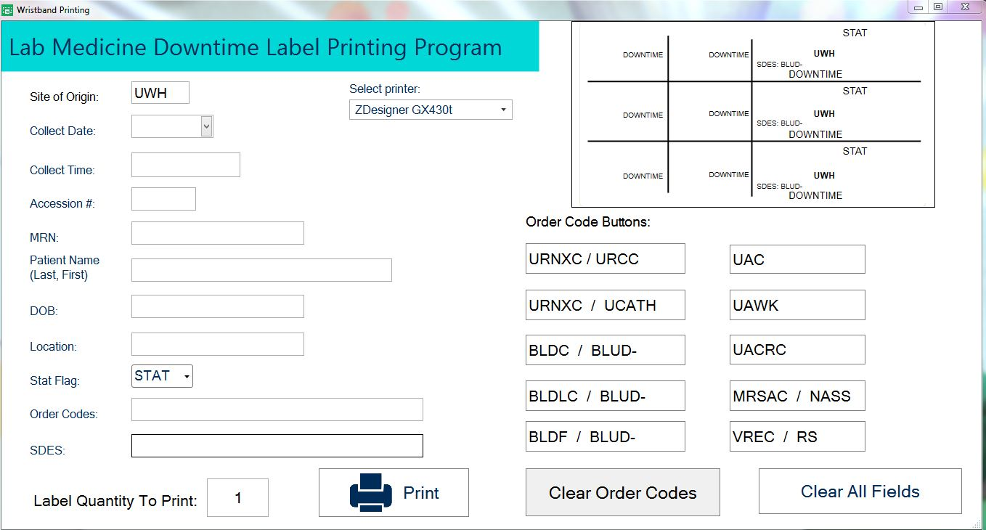

Image 1. Blank NiceLabel Form

1. Be sure to click on “Clear All Fields” in between each patient. Note: the Clear All Field button will clear all data fields except “Site of Origin” and “Collect Date”.

6. Place a large "Z" number label to the requisition.

7. Ensure that all tests and patient information is accurate. Hold requisitions in the setup area until the downtime is complete.

8. If you are unsure of the test to be ordered or the specimen requirements refer to the OLTG. If the OLTG is inaccessible, a static campus version of the OLTG at can be viewed at [**http://depts.washington.edu/labweb/static_oltg/staff.html**](http://depts.washington.edu/labweb/static_oltg/staff.html). This site is updated every night at 12pm.

9. Prioritize and process all specimens.

10. Once downtime is over, exit the NiceLabel program by clicking on the X in the upper right corner of the data entry form. Log out from the start menu. Switch back to the primary workstation computer by clicking on the KVM button switch so that the yellow LED moves to the “1” position. Transfer the barcode scanner USB plug from the HP EliteDesk mini-computer back to the primary workstation computer.

**V. ORCA SYSTEM OR ORCA INTERFACE DOWNTIME, LIS IS OPERATIONAL**

1. Remove the requisition from the specimen transport bag.
2. Look for tests marked on the requisition and any handwritten on the form.
3. Open the Misys Order Entry function.
4. Scan or type the patient's MRN # into the *Value* press **Search.**
5. Check that the patient name and MRN # listed in the computer matches the name and MRN# on the sample and the requisition. Please see the Mislabeled/Unlabeled Specimen Procedure in this manual for further information if needed.
6. Select an encounter that best matches the order.
7. Log the tests ordered.
8. Process the specimens.
9. In-patient CPOE Orders may remain un-received indefinitely after a downtime. They need not be received or canceled

**VI. RESULT REPORTING DURING LIS DOWNTIME**

1. If patient results are requested during downtime, call and inform the location that the Laboratory is experiencing computer downtime, and results will not be available in the system until the downtime is over.
2. Record the provider's name, contact number and the tube stop or fax number to which results should be sent in the case of Urinalysis.
3. UA Technologists will be responsible for faxing Stat urinalysis results using the UA downtime fax cover sheet. When system is operational again, the UA tech will retransmit results in the manually entered accession number.
4. The Setup Technologist will be responsible for filling out the Direct Exam Report slip and calling the location to give verbal results. Call all Stat and sterile sites. Document the time, date and person called when giving verbal results. These will be written on the slip and entered into the computer when the system is operational.
5. The BC2 Technologist should fill out Positive Blood Culture slip for each positive blood culture. When calling results inform floor that the computer system is down and the results will be entered when the computer is back up. The NiceLabel application can be used to print labels. See section IV for instructions.
6. When the computer is operational the BC2 Technologist will print labels for the positive blood culture book (if the NiceLabel application was not used) and enter results into the LIS with workups.

**VII. PROCEDURE FOR AFTER LIS DOWNTIME**

1. Orders should be entered into LIS when it is operational. Gather the requisitions held in setup during the downtime.
2. Log using Order Entry, enter the MRN number, enter the collection date and time and the received date and time as recorded by the time stamp.
3. Order the test(s) specified by the requisition in the order code field.
4. Assign the "Z" series accession number listed on the requisition. To assign accessions manually, click on the Acc# field type the "Z" number, and press Save. (see example below) If the wrong accession number is saved, that order must be cancelled and credited.
5. Place a newly printed large Micro label on the requisition and write your initials in the "logged by" box. The AD lead will verify that the correct accession number was ordered during the checking of slips and the Master Log.
6. Epic orders should be received and canceled using the "YDATA" cancel code and add the free text comment "specimen relogged to separate accession number due to lab system downtime".
7. In-patient CPOE Orders may remain un-received indefinitely after an LIS downtime. They need not be received or canceled.
8. Stat direct exam results should be entered by the setup Technologist. The slip should be paired with the requisition for review.
9. Give requisitions and Master Logs the AD Lead for slip review.

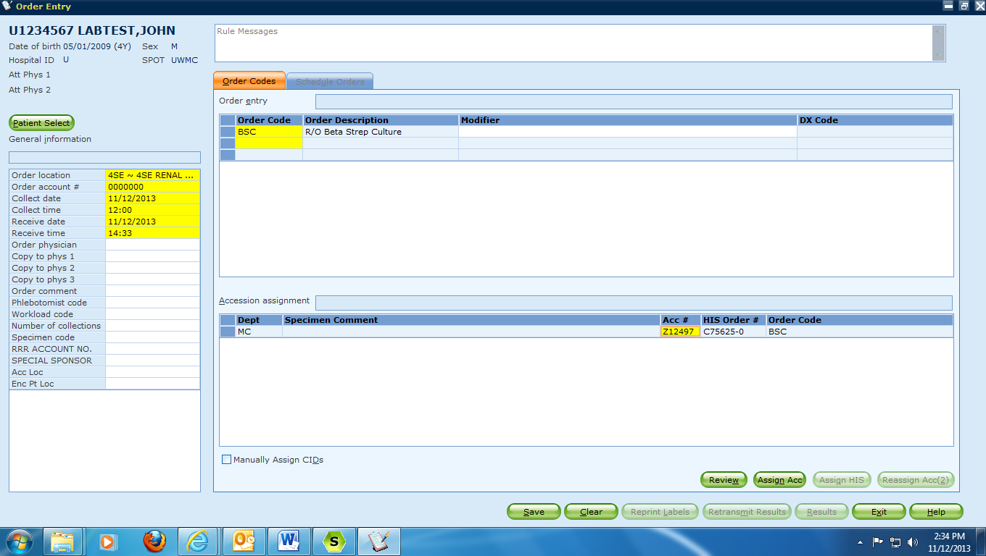

**VIII. REFERENCES**

1. SP.PR.S.DTM LIS Downtime - LabMed Protocols Wikki
2. SP.PR.S.DTM Ordering Interface Downtime (ORCA and MayoAccess) LabMed Protocols Wikki
3. SP.PR.S.ADT Logging Partially Interfaced Orders-LabMed Protocols Wikki

**IX. REVISION HISTORY**

* 1. 4/4/18: Revised Section IV: Changed method of creating downtime labels from handwritten to use of NiceLabel application.

Revised section VI: Added for all Stat and sterile site gram stains to be called. Updated UA result report from tubing results to faxing results and added for BC2 to use the NiceLabel application for reprinting labels.