**SITUATION:**

The SCCA flag is no longer displays in SQ.

**BACKGROUND & ASSESSMENT:**

The user defined field in the current version of Sunquest (8.1) does not work as design. This is the field where the SCCA flag displayed in version 7.2. This issue was discovered just a couple days before go-live.

**PRE GO-LIVE: SQ 7.2**

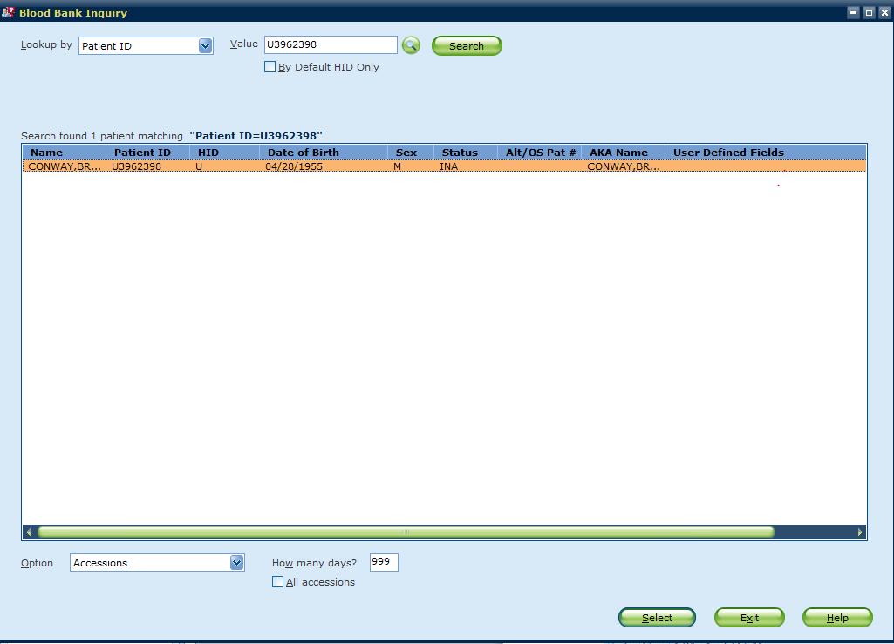

LabMed IT proposed using Laboratory Inquiry as a solution to this problem. Although not ideal because this module in not part of BB workflows, it was adopted as the only known means to identify SCCA patients who do not have the IRR attribute, BMT transfusion instructions, or a current order for irradiated blood components.

**POST GO-LIVE 8.2**

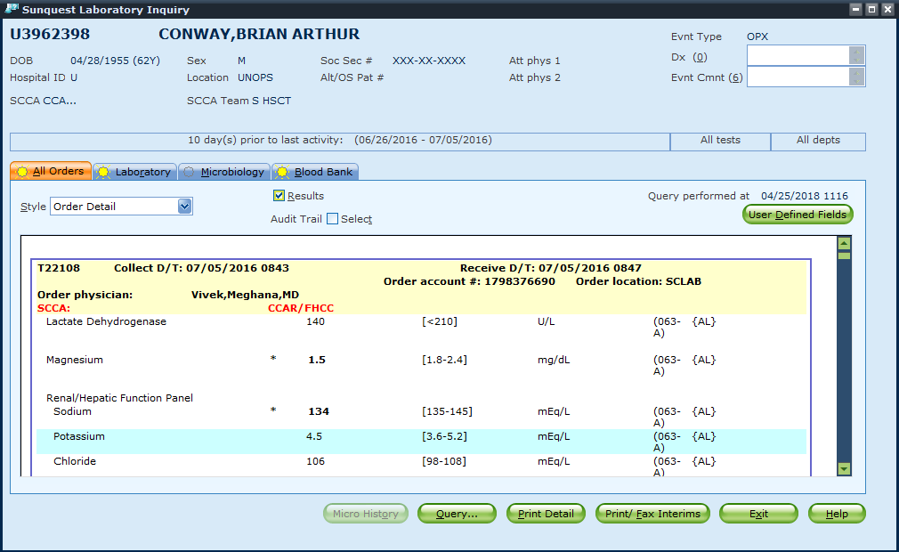

After go-live, it was discovered the red highlighted flag will not display for new patients or patients who do not have completed tests on file the day a BB order is received/filled. In these cases, the patient may incorrectly be identified as a non-SCCA patient.

**CORRECTIVE ACTION:**

**Until we have a different solution for identifying this population of patients, we will irradiate all red blood cell components as well as platelets.** Currently, approximately 80% of RBC inventory is irradiated. This change in policy is expected to result in irradiation of an average of 350 more RBCs per months than currently are irradiated. Because irradiation may shorten the expiration date of red blood cells, all red blood cell components will not be irradiated at receipt.

The following outlines the new policy:

**HISTORY CHECK**

1. History checks should be performed as per policy with the following change:
   * No longer need to check for the SCCA flag in any blood bank modules – it no longer displays
   * No longer need to verify the presence or absence of the SCCA Flag in ‘Laboratory Inquiry’ as part of the history check.
     + However, if you are in Laboratory Inquiry and see the SCCA flag is present, verify the patient has irradiation listed as an attribute on their record. If the attribute is not listed, add IRR as an attribute
2. When orders are received, history check should still include use of the irradiation stamp and the irradiation attribute added to the patient record as per policy

**FILLING PRODUCT ORDERS**

1. MTP, OB Bleeds, bleeding emergencies, request for uncrossmatched RBCs:
   * MTP packs should be prepared with irradiated RBCs and ready for issue as per current policy
   * When notifying the TSL MD of the bleeding emergency: verify the need to continue providing irradiated RBCs
   * Issuing blood products in a bleeding emergency should not be delayed if irradiate blood components are not available, especially when the patient’s clinical status does not require irradiated blood components
2. High volume red cell transfusions, such as red cell exchange: It may be better to provide non-irradiated RBCs
   * Refer the order to the TSL MD to determine if non-irradiated blood should be provided

**INVENTORY MANAGEMENT**

1. Irradiate RBC with expiration of 28 days or less first, to prevent unnecessary waste due to shortened expiration dates. The following is a guideline for the number of irradiated RBCs to maintain in inventory:
   * SCCA = 100% irradiated (no change)
   * BB2 (MOR) = 100% irradiated
   * NN601 irradiated inventory levels (if these levels will result in short-dating more than a couple RBCs, please let Nina or Christine know so the levels can be reevaluated)

|  |  |  |  |  |  |  |  |  |  |  |  |
| --- | --- | --- | --- | --- | --- | --- | --- | --- | --- | --- | --- |
| **OPOS** | | **ONEG** | | **APOS** | | **ANEG** | | **BPOS** | | **BNEG** | |
| MIN | MAX | MIN | MAX | MIN | MAX | MIN | MAX | MIN | MAX | MIN | MAX |
| 20 | 30 | 5 | 10 | 20 | 30 | 5 | 10 | 5 | 10 | 2 | 3 |

1. RBC inventory should be stored in a manner that separates available irradiated from available non-irradiated RBCs.