Purpose

This procedure provides instructions for the Order Entry Process in HMC TSL, which includes the following:
- Computerized Provider Orders (CPOE), which print in TSL
- Manual Orders using HMC form 2596, Transfusion Services Testing and Blood Product Request Form
- Manual Orders using HMC form 2595, Transfusion Services Preadmission Testing & Red Blood Cell Request form
- Entry of orders into SQ using Lab Order Entry and General Laboratory
- Receipt of orders in SQ
- Triage of orders in TSL
Policy
HMC TSL will process all testing and blood product requests in a timely manner.
Step | Actions | Related Documents
IF | CPOE Order Prints in TSL:  - Perform SQ inquiry:  - Review patient information found in BBI and/or LI  - Check for a blood type on file, and, if needed, for a current sample in TSL that is acceptable and valid for testing  - Previous testing can also be found in Purged Results  - Determine if RBC order is for additional product that can be added onto an existing TSCR  - Notify clinical care staff if a sample is required for testing  - Request order clarification from clinical staff  - Notify MLS staff of patients with antibody history  - Notify clinical care staff if a second sample is required for ABRH2  - Triage order by order type and urgency  - Place orders waiting for sample collection in organizer beside the printer  - Hand off duplicate orders to MLS for cancelation | SQ Using Blood Bank Inquiry  SQ Laboratory Inquiry  SQ: Canceling Order and Correcting Results
IF | IF sample and/or order is received in Transfusion Services:  - Time stamp request form  - Perform sample acceptability evaluation.  - If sample or order is not acceptable, follow the related procedures.  - If the sample or order is acceptable, proceed. | Sample Acceptance Evaluation  Sample Rejection Process
Step | Actions | Related Documents
1 | Check the patient history and check for valid in-date specimen. Look for any patient history by reviewing information found in BBI and LI. Check for a blood type on file, and, if needed, for a current sample in TSL that is acceptable and valid for testing.  - Check if previous in date sample is labelled with Doe name and update SQ with changed name.  - Check for Patient requirements, i.e. LR or IRR etc.  - Apply “Irradiated Products” sticker to all patient forms | SQ Using Blood Bank Inquiry  SQ Laboratory Inquiry  Updating Patient Demographics in SQ to match EPIC
2 | New Order/No Current Sample/Product order  If the sample was originally ordered through CPOE it must be received in Sunquest  - Open General Laboratory and click Orders in the top left corner. In the drop down menu, click Order/Receipt Modify  - Enter the patient MRN and click “Get Patient”  - If the order was placed on the previous day, alter the “From” date in the box “Date/Time/Events” to the date the order was placed  - Check “unreceived” under Order Status, leave both boxes checked  - Click on “Display Orders”  - A new box will open with a list of testing orders. Select the test to be performed in TSL  - Update the collection date and time in the bottom left corner with the collection date and time on the sample or product order. Enter the date and time the sample was received by TSL.  - Update order comments (if applicable)  - If the sample was drawn by phlebotomy click “Receive All” in the CID box and “Save”.  - If there are no CIDs listed, click “Save” and “Container and Specimen Entry” will open. In this box, click “Route”.  - TRBC and TGRAN will have a popup saying “Could Not Route: No order codes were routable (result at request, Bill only, etc)”, click ok  - Hand product orders to MLS for resulting history check  NOTE: If you receive a test in General Laboratory that is not performed by TSL it is necessary to inform SPS so they can correct the error. | Ordering and Resulting Doe Patients
3 | Creating a new order from a paper requisition using Lab Order Entry  If the sample was not originally ordered in CPOE  - Open Order Entry and scan or type in the patient HID. The highlighted blue area will give you the patient information. Compare patient information on sample, requisition, and screen information.  - Sample HID may start with an H, U, or N.  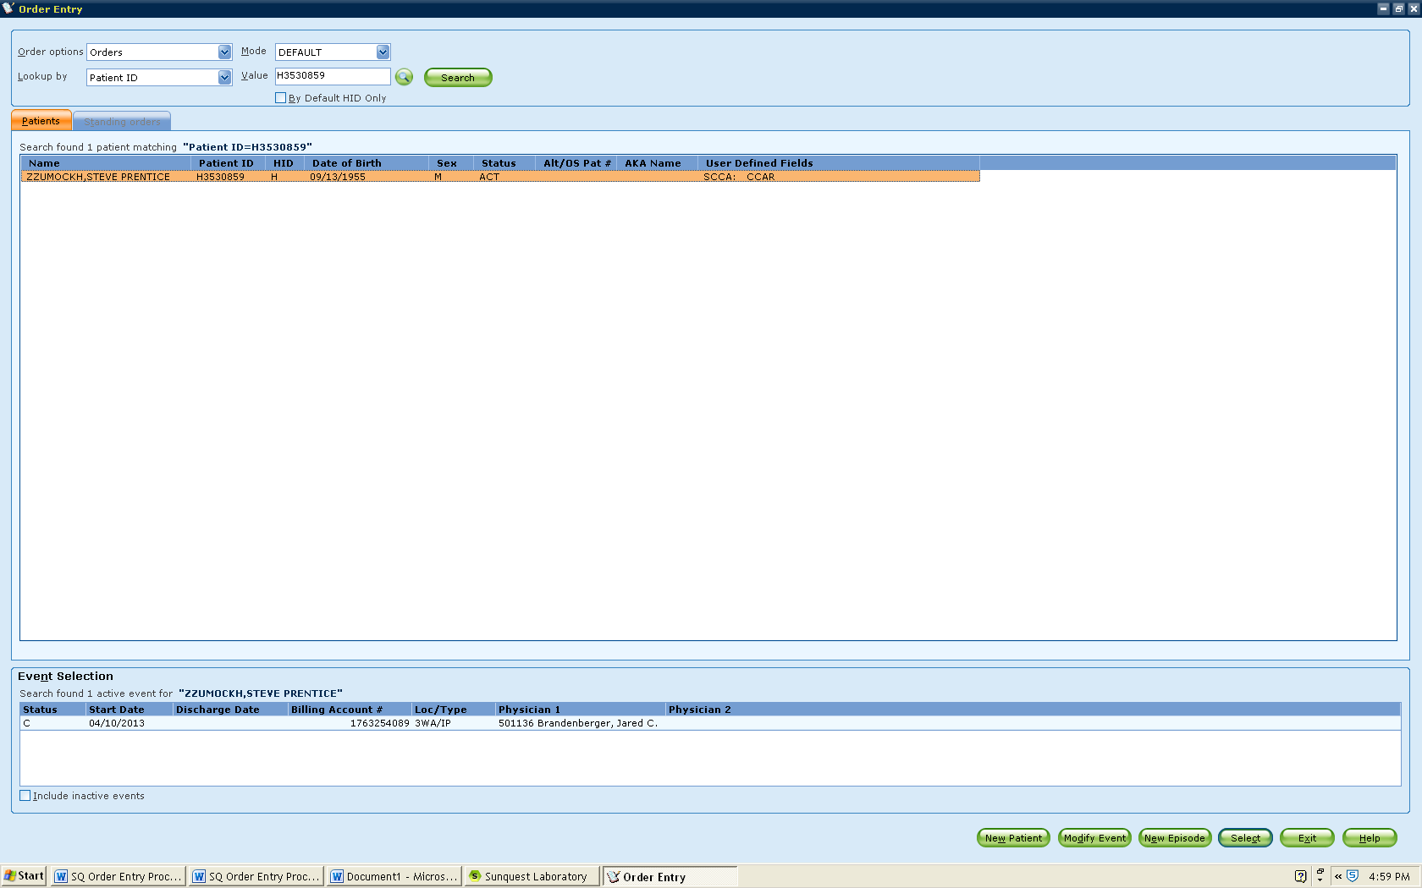  NOTE: Never use a discharged event, which are noted with a status of “C,D”  - If there is no current event:  - Click New Episode  - Click the magnifying glass icon by Event Detail, type the patient’s current location based on ORCA, and click search  - Select the appropriate location  - If no location is listed call HMC Admitting at 744-3085 to determine patient location or determine patient location using ORCA/Epic  - Use location UNOPU for unknown outpatient locations  - In the Account # field:  - For UW Medicine locations, enter the Encounter Number listed on the CPOE order or the Epic Label. If no Encounter Number is listed, leave the field blank.  - Click Save to save the new episode  - The bottom of the screen will list the active events or episodes of the patient listed above. Choose the correct event by double clicking. If one event listed, you may use the Select key to continue.  - Enter location (if different), collected date and time, received date and time, the ordering physician, order comment (if applicable), and the test code ordered. The required fields are highlighted yellow. Use the search key if unsure of code for each entry. If no sample (i.e. FFP order) use U for unknown in the collected time.  - Click on SAVE.  - The next screen will ask what sample is required. Route the sample (defaults to Pink top or No Tube but can be changed if needed) which will print accession and CID labels.  - Put the accession label or small CID label on the paper requisition and the larger CID label on the tube.  - If sample received, perform clot check on it, centrifuge it and notify the technologist that order needs to be processed.  If order is for components, then notify person in secondary processing of request | Ordering and Resulting Doe Patients
Step | Action | Related Documents
4 | Expand an existing order to add new testing  If order placed by location not using CPOE or during an MTP:  - If an RBC order is placed and there is a current in-date sample in TSL, then additional RBCs can be added to the TSCR.  - Plasma component orders (Plasma, Cryoprecipitate, Platelets) are good for MTP or non-CPOE duration.  - Print or use paper requisition for test/component request and time stamp for receipt. Document ordering provider, location, and person taking order  If order placed by location using CPOE:  - RBC are ordered and there is a current in-date sample in TSL then the additional RBC product order is received through ORM and added to the TSCR order.  - Plasma component orders (Plasma, Cryoprecipitate, Platelets) are received in ORM | SQ Blood Order Processing
5 | Creating an order for duplicate samples  - Occasionally a second sample is requested or received:  - Additional volume is required for testing either to send out or complete in-house.  - Duplicate samples are drawn unintentionally.  - In order to track the sample but not create a charge, an XPINK test is ordered and an accession label is created.  - Enter Order Code XPINK.  - Print Accession Label and affix to sample.  - Store the sample per SOP.  - Cancel unnecessary CPOE generated test using ORM | Sample and Unit Segment Management Process  SQ: Canceling Order and Correcting Results
6 | Creating an order from XPINK  If an order occurs and there is a current in-date blood bank XPINK sample in TSL, the sample can be used but a new accession must be ordered.  - Receive requisition and time stamp.  - Locate XPINK sample in refrigerator before placing new order in computer.  If order placed by location not using CPOE:  - Open Order Entry. Check location from requisition to see if update is needed for the order.  - Enter date and time collected that reflects when the XPINK tube was drawn. The received date and time should correspond to the current order.  - Order the test requested, and in the Modifier box select code  - Label the tube according to guidelines to allow both labels to be partially visible.  If order placed through CPOE:  - Open General Laboratory and click Orders in the top left corner. In the drop down menu, click Order/Receipt Modify  - Enter the patient MRN and click “Get Patient” and “Display Orders”.  - A new box will open with a list of testing orders. Select the test to be performed in TSL  - Update the collection date and time in the bottom left corner with the collection date and time on the sample. Enter the date and time the sample was received by TSL.  - Update order comments (if applicable)  - If there are no CIDs listed, click “Save” and “Container and Specimen Entry” will open. In this box, click “Route”.  Notify technologist that order needs to be processed.
References:
Standards for Blood Banks and Transfusion Services, Current Edition. American Association of Blood Banks. AABB Press, Bethesda MD
Blood Bank User Guide, Mysis Laboratory, Version 8.1

