**Purpose**

To provide instructions for the use of RC-AID (Red Cell Antibody Identification) web-based software. RC-AID is a tool for selecting antigen specific cells for antibody panels and electronic analysis.

**Background**

Antibody identification and resolution process must follow HMC Transfusion Services Laboratory Policies and Procedures.

RCAID provides the following:

* Database of antigen specific cells available in TSL for antibody identification purposes.
* A rule-out analysis based on the cells and criteria selected.
* ePanel technology for entering/saving results and analysis electronically.

**Procedure**:

|  |  |  |
| --- | --- | --- |
| **Step** | **Action** | **Related Documents** |
| **Logging on to RCAID** | | |
| 1 | Log onto RC-AID v3.1 system:  Username: SQ ID  Password: *your chosen password* |  |
| 2 | On the RCAID screen and depending on your user level, the following functions are displayed in the upper right corner as tabs on the menu bar:   * Site Admin ᳰ쌘 **:** Administrative use only * Inventory ᳰ쌘 **:** Administrative use only * Select Cellsᳰ쌘 **:** Cell selection for testing and/or e-panel * ePanelᳰ쌘 **:** Test results and status list * Pretestingᳰ쌘 **:** Pre-testing analysis and create pre-analysis worksheets * QCᳰ쌘 **:** Not currently in use at HMC TSL. | Table A |
| **Select Cells for Testing** | | |
| 3 | Click on the Select Cells tab.  Note: Screen should show the inventory of panel cells and lot numbers. |  |
| **Step** | **Action** | **Related Documents** |
| **Selecting Cells for Testing (continued)** | | |
| 4 | The Basic Search tab is the default screen RCAID opens to upon login.  To perform Basic Search, select any combination of the parameters displayed and type into the appropriate window, then click the Search tab. To reset the search parameters, click on Reset   * Lot# ___________ * Donor ID ____________ * Testing Medium ____________   + This field always defaults to ALL, change as necessary. * Rh-hr ________   + Use dropdown box if looking for a particular phenotype   + Leave blank if not needed * Extended Antigen Search tab shows additional special antigens |  |
| 5 | Antigens are listed at the top.   * Use dropdown boxes to select desired phenotype * Blank boxes = no filter * “+” displays cells that are “+”, or “W” (weak), or “S” (strong) for that antigen * “0” displays only cells negative for that antigen   Click Search to find cells matching the selected criteria  Click Reset to clear the selected antigens |  |
| 6 | Select cells for testing   * Ignore Analysis cells; these are used for validation only. * Click 🗆 checkbox on the right column to select cells that fit search antigen profile.   + Bold lot # indicates cells that are in-date   + Cells with duplicate donor IDs and enzyme treated cells are highlighted in pink. |  |
| 7 | The selected cells are highlighted in orange.  **Note:** The Clear Selections tab can be used to deselect all selected cells. Click the Reset tab if starting over; this will clear all phenotype criteria. |  |
| **Step** | **Action** | **Related Documents** |
| **Selecting Cells for Testing (continued)** | | |
| 8 | Once cell selections have been made, one or more of the following options can be selected:   * Pretesting Analysis; click on the Pretesting tab * Create a pre-analysis worksheet; click on the Pretesting tab * Generate an electronic panel; click on the ePanel tab |  |
| **Pretesting Analysis** | | |
| 9 | * Selected cells will show up on screen, only negative reacting cells must be used for analysis. * Check any antibodies that have been previously identified or suspected or is currently demonstrating (these will not be included in the rule-out analysis). * Click the Run Analysis tab on the top right of the ruleout bar chart. A listing and count of homozygous & heterozygous ruleouts will display as a helpful aid for the antibody workup. | Example A |
| 10 | Color-coded rule-outs for each antigen are shown below the antigens.   * Homozygous rule outs are displayed in the first row – these include all homozygous rule-outs and rule-outs of antigen without alleles * Heterozygous rule outs are displayed on the second row. | Example A  Example C |
| 11 | Rule-out color codes:   * + Red no rule outs   + Yellow one (1) rule-out   + Green two (2) or more rule-outs   + Blue suspected or previously identified antibody | Example A |
| **Creating Worksheets** | | |
| 12 | Creating Worksheets for testing selected cells.  Click on the Pretesting tab, then click on Create Pretesting Worksheets from the dropdown menu.   * Enter Patient name, HID, and date of birth in the appropriate window. * The Standard Worksheet tab provides access to a worksheet to record the initial manual bench test results * The Extended Worksheet tab includes extended antigen typing. * Click on a Worksheet option; a prompt to Open, Save, or Cancel the selected Worksheet will appear at the bottom of the screen, in the format displayed below:   Do you want to open or save RC-AID XXXX.pdf (XX.X KB) from v31.rcaid.net?   * To print the selected worksheet, click Open, then click on the printer icon in the middle of the menu bar. * Follow screen prompts to print selected worksheet. | Example B |
| **Step** | **Action** | **Related Documents** |
| **Creating an ePanel** | | |
| 13 | **Selecting cells:**  Selected cells may be added to an ePanel, as either a complete panel of cells via Lot# search, or individual cells by setting up a search for a specific phenotype.   * Click on the Select Cells tab * To download an entire panel of cells, enter the selected panel’s lot # in the Lot # ________ window, click Search, click the top 🗆 checkbox to select the entire panel of cells. If a select group of cells are needed for their phenotype, click on the individual box next to each specific cell. * To search for cells of a specific phenotype, click on the ⯆ down arrow under the desired antigen tab; Then click either + or 0 from the dropdown box. Click Search. * These selected cells may be added to an ePanel by accessing the **Add Selected to ePanel** window and selecting the patient ID desired.   **Adding cells to start a new ePanel:**   * Click on New ePanel ᳰ쌘 * Click on GO to add the cells selected. * Enter the patient demographics & the sample’s collection date/time in the appropriate window displayed: * Patient ID, Name, DOB, Collected:   **Entering test results on the ePanel:**   * Verify that auto-analysis is ON, indicated by a check in the box ☑. * After adding the selected cells to an ePanel, proceed to enter Phase #1 results: Go to the Testing Conditions window, there are three boxes labelled Additive, Time, and Testing. Click on the ᳰ쌘 down arrow next to each box, to select the appropriate test condition. * Enter results of each cell by clicking on its associated result box ____ ᳰ쌘 . Select the reaction grade from the dropdown menu. * Under the Commands window are four tabs: Save, Save & Next, Save & Close, Exit. * Click the Save tab to save entered results. * Click on the Save & Next tab to advance to the next column for the next phase of testing. * Repeat until test results for all phases of testing are recorded. * Avoid using the CC results as part of the auto-analysis by deselecting the CC phase in the auto-analysis box. * Click the Exit tab to keep the ePanel in “In-Progress” status. * Only the owner of an ePanel can make changes to an In-Progress ePanel. * To reopen an In-Progress ePanel, click on the ePanel tab, then click on the Status List tab, followed by clicking on phase header (1, 2, 3, 4, or NEXT) to enter the workup.   **Note:** An ePanel will no longer be editable once it is closed, do not useSave & Close if an “In-Progress” status for reentry to the ePanel is desired. Once the antibody workup is completed the creator of the ePanel must Save & Close to allow the reviewer access to the ePanel for a final review. | Example C |
| **Step** | **Action** | **Related Documents** |
| **Creating an ePanel (continued)** | | |
| 14 | **Rule-outs:**   * Rule-outs for each antigen follows the same rules as the pretesting analysis * Analysis grids shading are color coded. Refer to RC-AID User Manual pages 27 and 28 for color coding chart.   **Note:** When using enzyme treated cells, antigens denatured or depressed must be manually discounted. RCAID cannot distinguish enzyme treated panels from non-treated panels. | Example C  RC-AID User Manual  Antibody Panel by Tube IAT Method Using Enzyme Treated Cells. |
| 15 | Closely evaluate any antigens with no rule-outs.   * Remember to consider any antigens displaying no homozygous rule-outs to potentially have the corresponding antibody, since dosage would allow heterozygous rule outs to appear. |  |
| 16 | Compare worksheet to manual workup for discrepancies before attempting to resolve antibody ID. | Guidelines for Antibody Identification |
| 17 | Worksheet and coversheet will be generated in Adobe Reader format which can be printed or saved. |  |
| **Continuing an ePanel that is in progress by another user** | | |
| 18 | To continue an In Progress ePanel that was started by another user:   * Open desired panel from the Status List * Click Copy and Close * A statement is added to the ePanel history and the status is changed to from In Progress to Continued * An In Progress copy of the ePanel is created under the new owner’s user name. |  |

|  |  |  |
| --- | --- | --- |
| **Step** | **Action** | **Related Documents** |
| **Updating Site Inventory (Inventory Managers only)** | | |
| 1 | Any corrections, deletions or additions are made by users with Inventory Management access. Log in with an inventory manager account username and password. The menu bar displays an Inventory ᳰ쌘 option which opens to a dropdown list with following tabs:   * Manage Inventory * Import Lots * Add new lot * Inventory reports |  |
| 2 | Select Manage Inventory to make changes to the site inventory.   * Changes can be made on the lot or cell level. * Lot information consists of lot number, supplier, test media and outdate. Deleting a lot removes all cells within the lot. * To update or delete an individual cell, expand the lot listing. |  |
| 3 | Select Add new lot to manually add lots to the inventory |  |
| 4 | Lots can be imported from the RC-AID master inventory. From the Inventory ᳰ쌘menu, select Import Lots. |  |
| 5 | After importing cells to inventory, verify the added cells against the supplier product insert. This validation is essential to the integrity of the inventory and is saved in either printed or electronic format, along with the original manufacturer antigrams for 5 years.   * Screenshot panel antigram in RCAID and print * Paperclip together and file in antigram master binder |  |
| 6 | Delete the panel from RCAID when discarding the physical panel   * Pull antigram and RCAID printout from antigram master binder and file in discarded antigram binder * Once all panel/screening cells from the previous year have been removed from use, scan the antigram and printouts and save into designated folder in TSS drive * Discard paper copies after verifying electronic version |  |
| **ePanel Review (ePanel Managers only)** | | |
| 1 | Select ePanelᳰ쌘, then click on Status List from the dropdown listing of ePanels. Locate the identifier of the ePanel to be reviewed and click on Review. ePanels with Closed status can be reviewed by designated reviewers  The following status can be seen under Status List:   * In Progress - remains editable by the initiating tech * Closed - ePanel is ready to be reviewed * Reviewed - Final Review has been done, no changes or review comments can be made to the ePanel |  |
| 2 | Review ePanel per SOP   * Add comments under Review Comments (bottom left tab) * Update rule outs if needed * Multiple reviews can be done before final review * Save | Guidelines for Antibody Identification |
| 3 | Click Final Review if all reviews are complete and no changes and additions are to be made. |  |

**Table A: RC-AID User Access Levels**

|  |  |
| --- | --- |
| **Staff** | **User Level** |
| MLS Trainee and MLS 1 | Default Settings |
| MLS 2 and MLS Lead | ePanel Manager, Inventory Manager |
| Education Lead and TSL Manager | ePanel Manager, Inventory Manager, Site Manager |

**Example A: Process Selected Cells and Analysis Run**

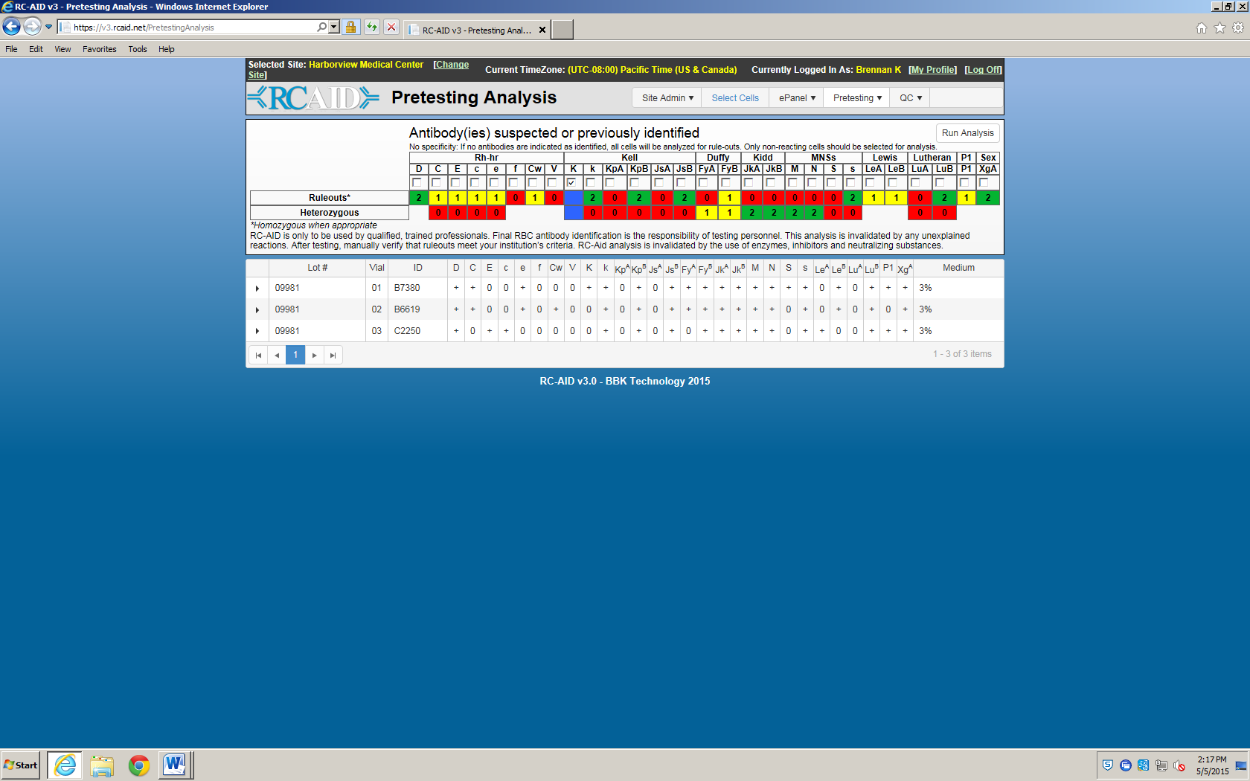

**Example B: Standard Worksheet**

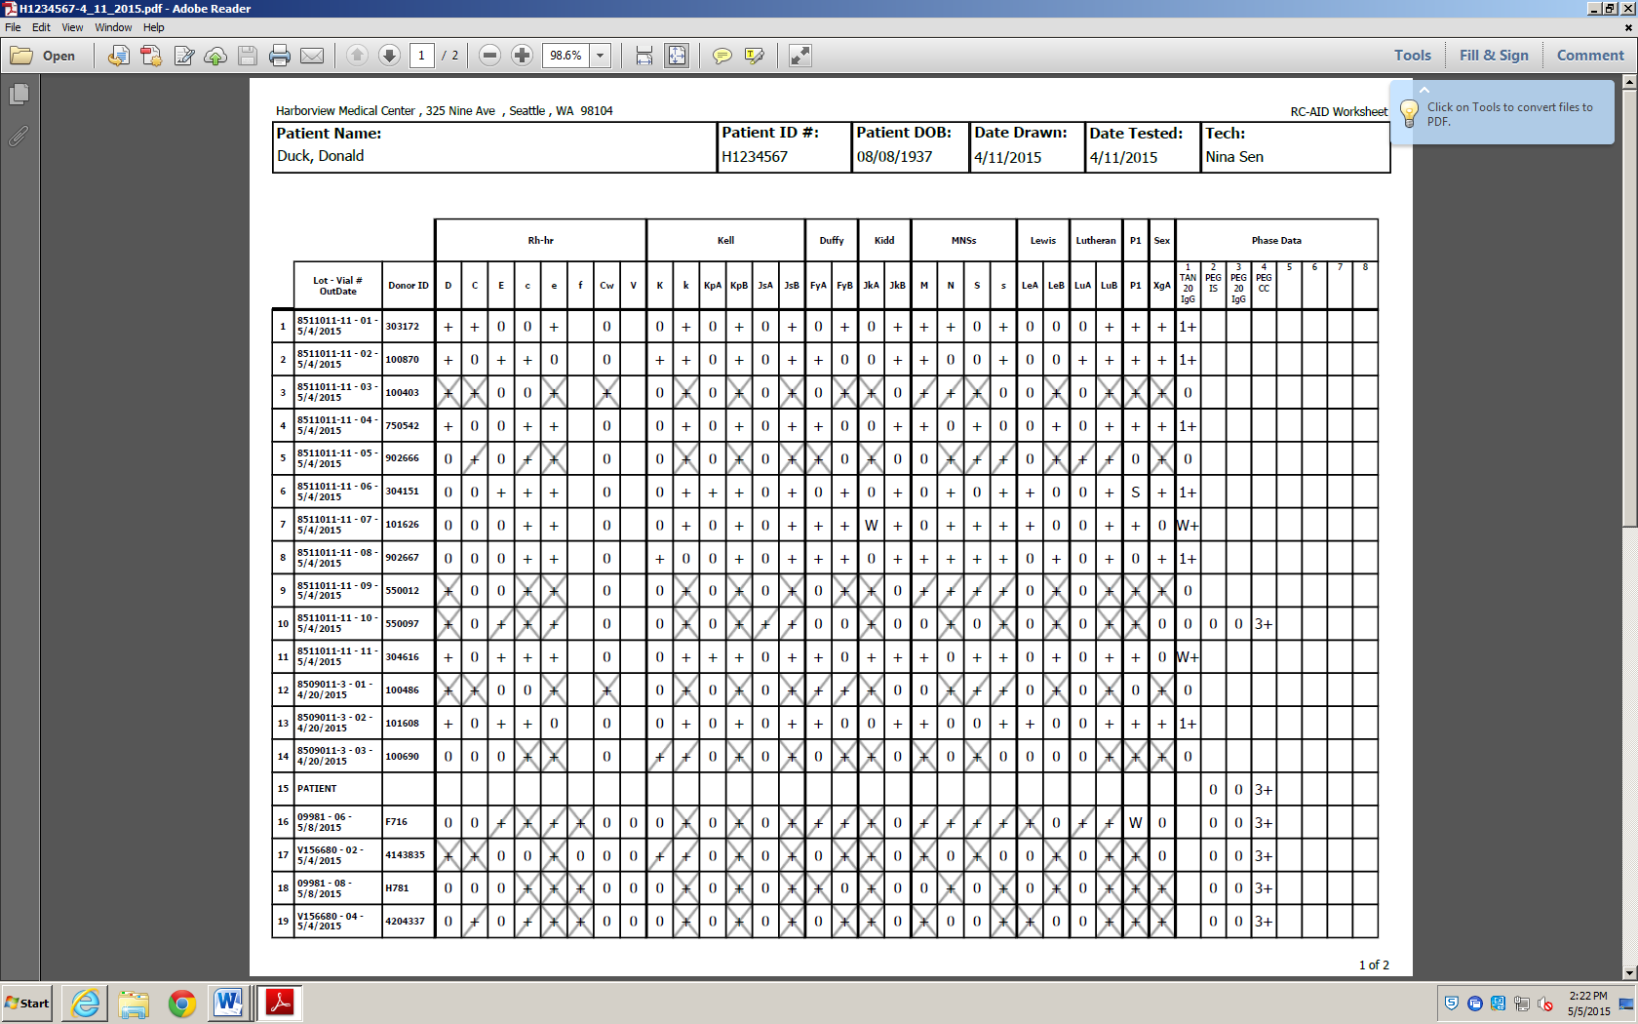

**Example C: ePanel Analysis**

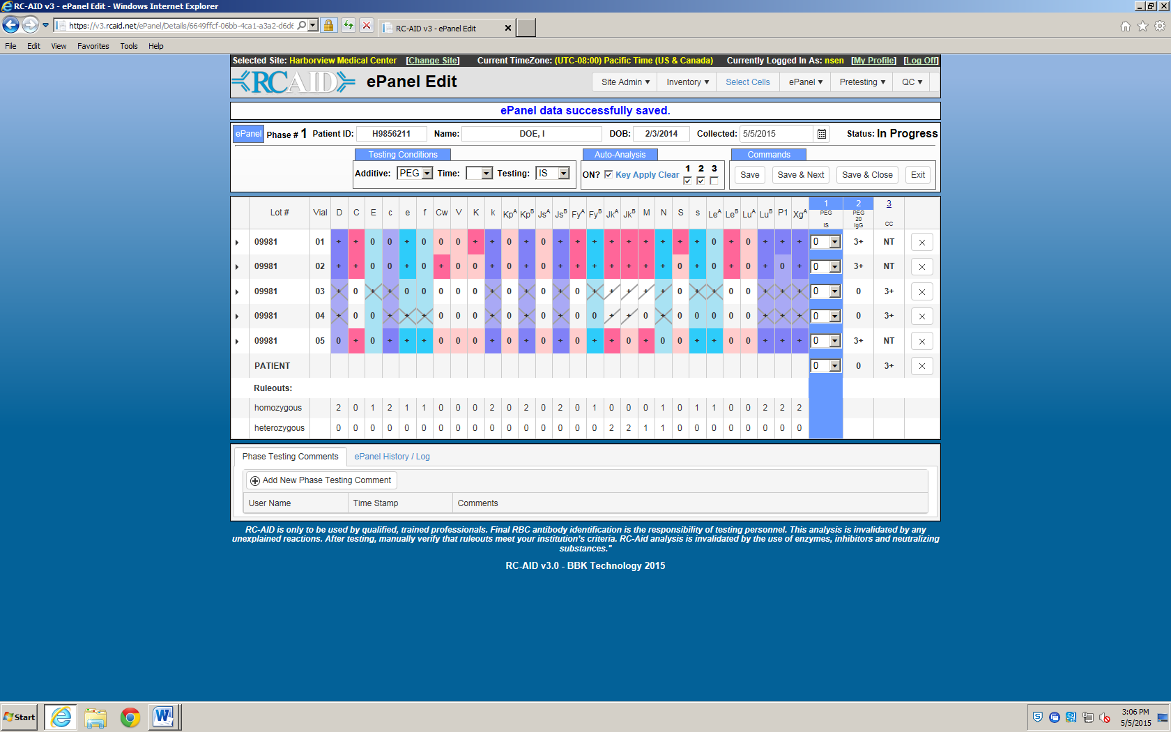

**References:**

RCAID User Manual Version 3.1